**REPORT PROJECT:**

**“DATABASES 2022-2023”**

**DATABASES LAB**

**CEID1124**

**ΣΤΟΙΧΕΙΑ ΕΠΙΚΟΙΝΩΝΙΑΣ**

**Ράικος Ιάσων** ->**ΑΜ : 1084552**

**e-mail:** [**up1084552@upnet.gr**](mailto:up1084552@upnet.gr)

**Έτος: 3o**

**Μακρής Ορέστης - Αντώνης** -> **ΑΜ : 1084516**

**e-mail:** [**up1084516@upnet.gr**](mailto:up1084516@upnet.gr)

**Έτος: 3o**

**Δελημπαλταδάκης Γρηγόρης** ->**ΑΜ : 1084647**

**e-mail:** [**up1084647@upnet.gr**](mailto:up1084647@upnet.gr)

**Έτος: 3o**

**Περιεχόμενα**

**Μέρος Α: Σχεδιασμός ΒΔ και SQL** 3

**Κεφάλαιο 1 - Περιγραφή Βάσης** 3

**Περιγραφή παραδοχών** 3

**Κώδικας CREATE-INSERT** 16

**Κεφάλαιο 3 - Triggers** 54

**3.1.4.1** 54

**3.1.4.2** 60

**3.1.4.3** 61

**Μέρος Β: GUI** 64

**Κεφάλαιο 4 – Java** 64

**GUI Κώδικας** 48

# **Μέρος Α: Σχεδιασμός ΒΔ και SQL**

# **Κεφάλαιο 1 - Περιγραφή Βάσης**

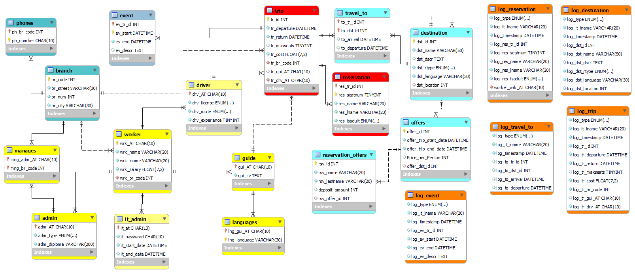Σχεσιακό διάγραμμα της συνολικής αναθεωρημένης ΒΔ.

## **Περιγραφή παραδοχών**

Για την σχεδίαση της βάσης δεδομένων μας κάναμε της παρακάτω παραδοχές:

* *Υποκαταστήματα (Branches)*

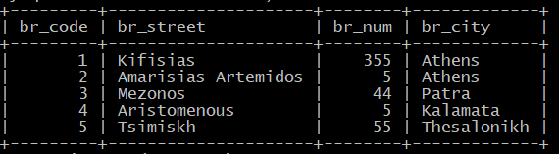

Δημιουργήσαμε πέντε branches. Δύο στην Αθήνα και από ένα στην Πάτρα, Καλαμάτα και Θεσσαλονίκη.

•Τηλέφωνα (Phones)

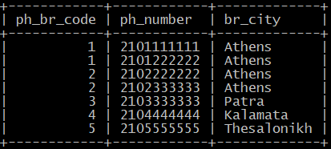

Τα δύο υποκαταστήματα της Αθήνας έχουν από δύο τηλέφωνα, επειδή τα γραφεία τους είναι μεγαλύτερα, ενώ τα υπόλοιπα υποκαταστήματα έχουν από ένα.

* *Εργαζόμενοι (Workers)*

*Εικόνα που περιέχει κείμενο

Περιγραφή που δημιουργήθηκε αυτόματα*

Συνολικά όλα τα υποκαταστήματα μαζί έχουν 39 εργαζόμενους. Οι εργαζόμενοι χωρίζονται σε admins (διαχειριστές), it_admins (υπεύθυνοι πληροφορικής), drives (οδηγούς) και guides (ξεναγούς). Κάθε branch έχει τρεις διαχειριστές, από έναν για την κάθε κατηγορία διαχείρισης (logistics, accounting, administrative). Σε κάποια υποκαταστήματα (branches 1 και 5) έχουμε θέσει κάποιους διαχειριστές να εκτελούν και αρμοδιότητες ξεναγού.

**Branch 1:**

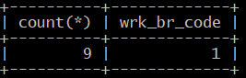

Το Branch 1, έχει συνολικά 9 εργαζόμενους.

**Admins:**

Εικόνα που περιέχει κείμενο

Περιγραφή που δημιουργήθηκε αυτόματα

**IT Admins:**

Εικόνα που περιέχει κείμενο

Περιγραφή που δημιουργήθηκε αυτόματα

**Drivers:**

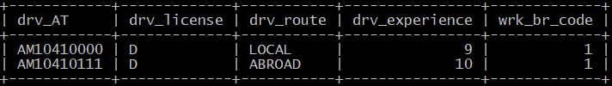

Έχουμε δύο drivers για το branch 1 έναν για ταξίδια στο εξωτερικό και έναν για το εξωτερικό.

**Guides:**

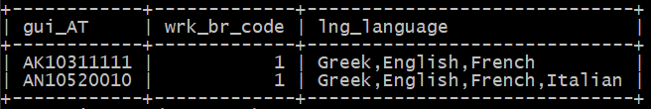

Παρατηρούμε πως ο logistics admin του branch 1 με ΑΤ = ΑΚ10311111 είναι και guide.

**Branch 2:**

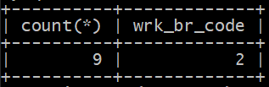

Το Branch 2, έχει επίσης 9 εργαζόμενους.

**Admins:**

Εικόνα που περιέχει κείμενο

Περιγραφή που δημιουργήθηκε αυτόματα

**IT Admins:**

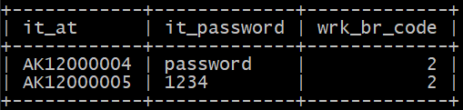

**Drivers:**

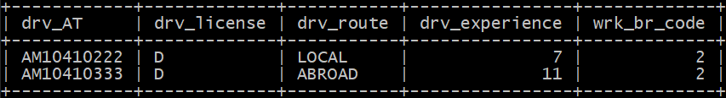

Έχουμε δύο drivers για το branch 2 έναν για ταξίδια στο εξωτερικό και έναν για το εξωτερικό.

**Guides:**

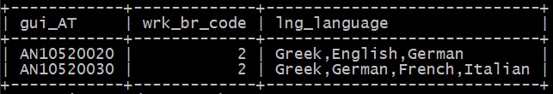

**Branch 3:**

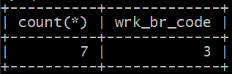

Το Branch 3, που είναι στην Πάτρα έχει συνολικά 7 εργαζόμενους.

**Admins:**

Εικόνα που περιέχει κείμενο

Περιγραφή που δημιουργήθηκε αυτόματα

**IT Admins:**

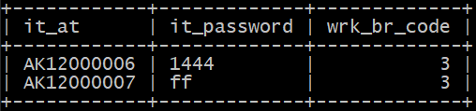

**Drivers:**

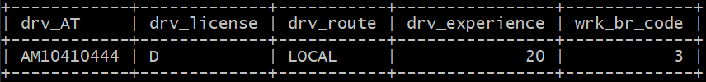

Έχουμε έναν driver για το branch 3, ο οποίος ταξιδεύει μόνο στο εσωτερικό. Το υποκατάστημα 3 στην Πάτρα δηλαδή κάνει μόνο ταξίδια στο εσωτερικό.

**Guides:**

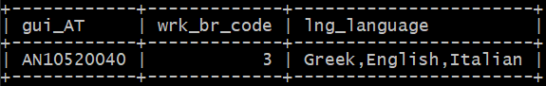

**Branch 4:**

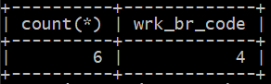

Το Branch 4, που είναι στην Καλαμάτα έχει συνολικά 4 εργαζόμενους.

**Admins:**

Εικόνα που περιέχει κείμενο

Περιγραφή που δημιουργήθηκε αυτόματα

**IT Admins:**

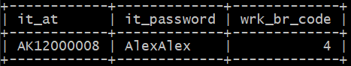

Βλέπουμε πως αυτό το branch έχει μόνο έναν υπεύθυνο πληροφορικής.

**Drivers:**

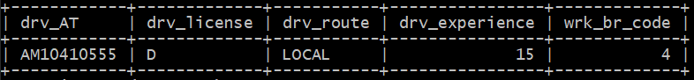

Έχουμε έναν driver για το branch 4, ο οποίος ταξιδεύει μόνο στο εσωτερικό. Το υποκατάστημα 4 στην Καλαμάτα δηλαδή κάνει μόνο ταξίδια στο εσωτερικό.

**Guides:**

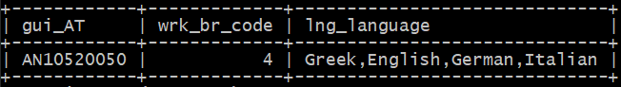

**Branch 5:**

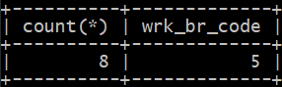

Το Branch 5, που είναι στην Θεσσαλονίκη έχει συνολικά 8 εργαζόμενους.

**Admins:**

Εικόνα που περιέχει κείμενο

Περιγραφή που δημιουργήθηκε αυτόματα

**IT Admins:**

Εικόνα που περιέχει κείμενο

Περιγραφή που δημιουργήθηκε αυτόματα

**Drivers:**

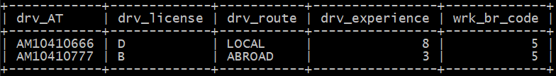

Έχουμε δύο driver για το branch 5, έναν για ταξίδια στο εξωτερικό και έναν για το εσωτερικό. Το υποκατάστημα 5 στην Θεσσαλονίκη δηλαδή διοργανώνει ταξίδια και των δύο ειδών.

**Guides:**

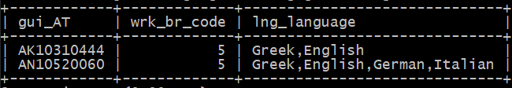

Παρατηρούμε, ότι όπως και στο branch 1, ένας από τους ξεναγούς του branch 5 είναι logistics admin.

* **Ταξίδια (Trips)**

Συνολικά το ταξιδιωτικό γραφείο διοργανώνει 30 ταξίδια.

*Εικόνα που περιέχει κείμενο

Περιγραφή που δημιουργήθηκε αυτόματα*

Κάθε υποκατάστημα διοργανώνει 6 διαφορετικά ταξίδια.

Εικόνα που περιέχει κείμενο

Περιγραφή που δημιουργήθηκε αυτόματα

Για αυτά τα ταξίδια υπάρχουν 18 πιθανοί προορισμοί, 13 στο εσωτερικό και 5 στο εξωτερικό.

Εικόνα που περιέχει κείμενο

Περιγραφή που δημιουργήθηκε αυτόματα

Οι προορισμοί που δεν έχουν το πεδίο dst_location NULL, είναι υπο-προορισμοί, δηλαδή αποτελούν έναν προορισμός που μπορούν να επισκεφτεί οι πελάτες ενός ταξιδιού μόνο αν το ταξίδι τους περιλαμβάνει τον υπερ-προορισμό. Υπο-προορισμού αποτελούν αυτοί με dst_id = 6(Kalavrita Ski Resort), 8(Parnassos), 13(Ano Hora) και ανήκουν στους προορισμούς με dst_id = 5(Kalavrita), 7(Arachova), 12(Nafpaktos) αντίστοιχα.

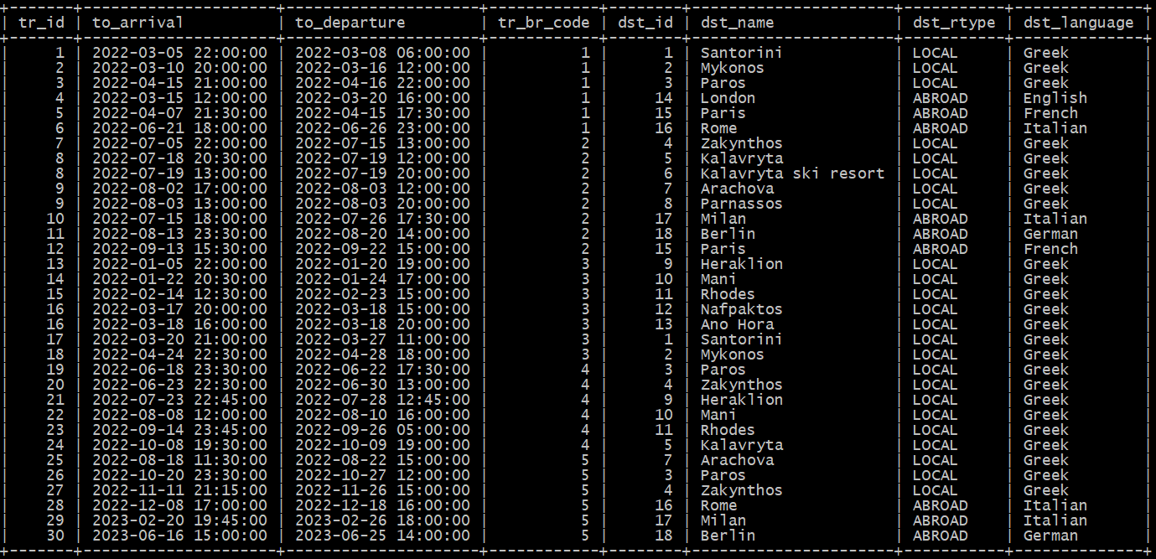Παρακάτω φαίνονται όλα τα ταξίδια του ταξιδιωτικού γραφείου μαζί με τους αντίστοιχους προορισμούς τους.

Εικόνα που περιέχει κείμενο, ηλεκτρονικές συσκευές, συνθεσάιζερ

Περιγραφή που δημιουργήθηκε αυτόματαΣε αυτό το σημείο μπορούμε να επιβεβαιώσουμε ότι μόνο τα υποκαταστήματα της Αθήνας και της Θεσσαλονίκης έχουν ταξίδια στο εξωτερικό.

Φυσικά έχουμε φροντίσει όλοι οι οδηγοί σε ταξίδια του εξωτερικού να έχουν το πεδίο drv_route = ‘ABROAD’.

Εικόνα που περιέχει κείμενο, πίνακας αποτελεσμάτων

Περιγραφή που δημιουργήθηκε αυτόματα

Αντίστοιχα για ταξίδια του εσωτερικού να είναι LOCAL.

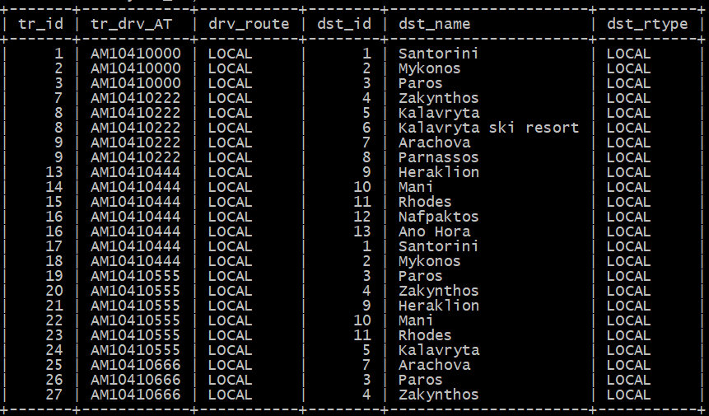

Επίσης σε κάποια ταξίδια χρησιμοποιούνται οδηγοί που κατέχουν άδεια οδήγησης τύπου Β (για βανάκι), κάτι που αντιπροσωπεύεται από των μέγιστο αριθμό θέσεων.

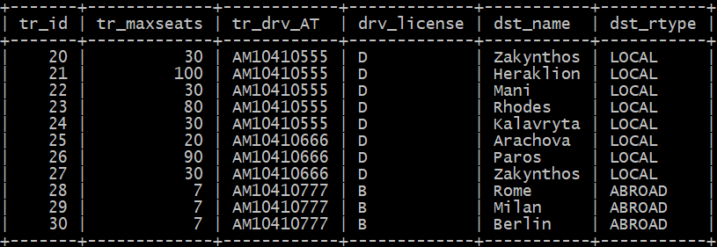

Στα trips 28-30 βλέπουμε ότι ο μέγιστος αριθμός θέσεων είναι 7 και οι οδηγός για αυτά τα ταξίδια έχει δίπλωμα τύπου Β.

* **Δραστηριότητες (Events)**

Κάθε trip μπορεί να περιλαμβάνει ένα ή περισσότερα events.

Παράδειγμα trip με ένα event.

Εικόνα που περιέχει κείμενο

Περιγραφή που δημιουργήθηκε αυτόματα

Παράδειγμα trip με δυο events.

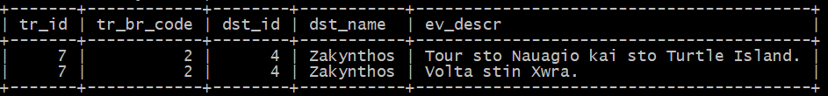

Φυσικά έχουμε φροντίσει όλες οι ώρες αποχώρησης και άφιξη να βγάζουν νόημα.

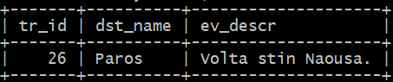Για παράδειγμα στο trip 26 στην Πάρο.

Βλέπουμε ότι το ταξίδι ξεκινάει στις 20/10, 14:30 και η ώρα άφιξης είναι στις 23:30. Η ημερομηνία έναρξης της προγραμματισμένης βόλτας στην Νάουσα είναι 23/10 από τις 12:30 μέχρι τις 14:30. Τέλος η αποχώρηση από το νησί γίνεται στις 27/10 12:00 και οι πελάτες επιστρέφουν στα σπίτια τους στις 21:00. Συνολικά δηλαδή το ταξίδι κράτησε 7 μέρες αν δεν μετρήσουμε την μέρα της επιστροφής.

* **Κρατήσεις (Reservations)**

Όσον αφορά τις κρατήσεις έχουμε κάνει τρείς κρατήσεις για κάθε ταξίδι. Στις οποίες σιγουρευτήκαμε να συμπεριλάβουμε και ADULTS και MINORS.

Για παράδειγμα βλέπουμε τις πρώτες 9 κρατήσεις παρακάτω.

Εικόνα που περιέχει κείμενο

Περιγραφή που δημιουργήθηκε αυτόματα

**Νέοι Πίνακες**

Φτιάχνουμε τον πίνακα it_admin που έχει τέσσερα πεδία και τον χρειαζόμαστε για το GUI και για να αναπαραστήσουμε έναν υπεύθυνο πληροφορικής (IT) ενός πρακτορείου. Την βάση δεδομένων την χειρίζεται ένας από τους υπεύθυνους πληροφορικής (IT) του πρακτορείου. Είναι worker, και έχει μοναδικό κλειδί το it_at (char(10) ) το οποίο είναι ξένο κλειδί στο worker.wrk_AT. Επίσης έχει ένα κωδικό 10 χαρακτήρων με default τιμή ‘password’ με τον οποίο θα κάνουμε login στην βάση μέσω του GUI, ημερομηνία (start_date) που ανέλαβε τον ρόλο αυτόν η οποία είναι not null. Επίσης υπάρχει end_date ημερομηνία για όσους it_admins έχουν φύγει από το πρακτορείο.

Κάθε φορά που κάνουμε insert σε αυτόν τον πίνακα πρέπει να καλέσουμε την stored procedure create_user() ή create_select_user() (ανάλογα με τα δικαιώματα που θέλουμε να του δώσουμε), για να δημιουργηθεί ένας user στην βάση με τα στοιχεία του καινούριου it_admin. Η υλοποίηση των procedures εξηγείται στο κεφάλαιο 2.

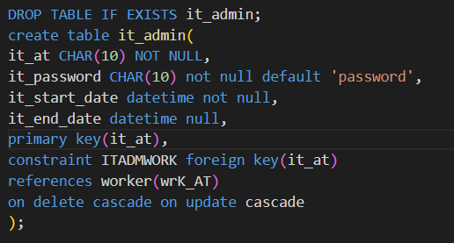

**Offers:**

Ο πίνακας offers έχει πέντε πεδία και τον χρειαζόμαστε για να υπάρχει η δυνατότητα να καταχωρούνται προσφορές ταξιδιών. Το πρώτο πεδίο είναι ο κωδικός της προσφοράς ο οποίος είναι μοναδικός. Το δεύτερο και τρίτο πεδίο είναι η περίοδος που μπορεί να πραγματοποιηθεί ένα ταξίδι (δεν προσδιορίζει την διάρκεια του ταξιδιού αλλά το διάστημα που είναι δυνατόν να πραγματοποιηθεί). Το τέταρτο πεδίο είναι το κόστος ανά άτομο και το πέμπτο πεδίο είναι ο κωδικός του προορισμού(dst_id) ο οποίος είναι ξένο κλειδί στο destination.dst_id.

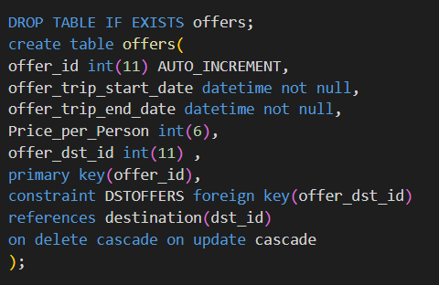

**Reservation Offers:**

Ο πίνακας reservation_offers έχει πέντε πεδία και αναπαριστά τις κρατήσεις στις προσφορές ταξιδιών. Το πρώτο πεδίο είναι ο κωδικό κράτησης ο οποίος είναι μοναδικός. Το δεύτερο και τρίτο πεδίο είναι το όνομα και επώνυμο του πελάτη. Το τέταρτο πεδίο είναι το ποσό προκαταβολής και το πέμπτο πεδίο είναι ο κωδικός προσφοράς ταξιδιού ο οποίος είναι ξένο κλειδί στο offers.offer_id. Με τους δύο πίνακες offers και reservation_offers το ταξιδιωτικό πρακτορείο σχεδιάζει μελλοντικές εκδρομές.

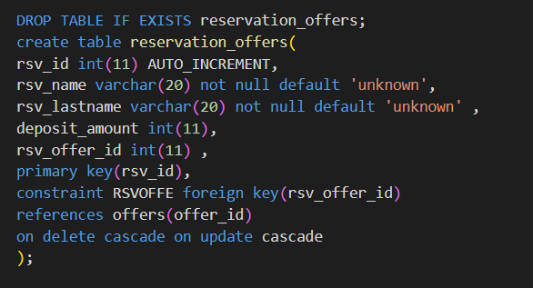

**Log Tables:**

Για να μπορούμε να κρατάμε ιστορικό των αλλαγών που εκτελούμε στους πίνακες trip, reservation, event, travel_to και destination δημιουργήσαμε αντίστοιχα τους πίνακες **log_trip**, **log_ reservation**, **log_travel_to** και **log_destination.** Όλοι οι πίνακες περιλαμβάνουν τα πεδία: log_type τύπου ENUM, που αναπαριστά το είδος της δράσης που εκτελέστηκε, log_it_lname, που αναπαριστά το username του it_admin που έκανε την δράση και log_timestamp, που δείχνει την ώρα που έγινε η δράση. Η διαφορά των πινάκων βρίσκεται στα υπόλοιπα πεδία, τα οποία ταυτίζονται με τα πεδία του πίνακα στον οποίο αναφέρονται. Έτσι μπορούμε να αποθηκεύουμε τις τιμές που είχε ο πίνακας πριν κάνουμε UPDATE ή DELETE και τις καινούριες τιμές όταν κάνουμε INSERT.

Για παράδειγμα μπορούμε να δούμε τα πεδία του πίνακας log_trip:

Εικόνα που περιέχει κείμενο

Περιγραφή που δημιουργήθηκε αυτόματα

Φυσικά η εισαγωγή εγγραφών στους πίνακες log, γίνεται με χρήση triggers, κάτι που εξηγείται αναλυτικά στο κεφάλαιο 3.

## **Κώδικας CREATE-INSERT**

DROP TABLE IF EXISTS branch;

CREATE TABLE branch (

    br_code INT(11) NOT NULL AUTO_INCREMENT ,

    br_street VARCHAR(30) DEFAULT 'unknown' NOT NULL,

    br_num INT(4) DEFAULT 0 NOT NULL,

    br_city VARCHAR(30) DEFAULT 'unknown' NOT NULL,

    PRIMARY KEY (br_code)

) ;

DROP TABLE IF EXISTS phones;

CREATE TABLE phones (

    ph_br_code INT(11) NOT NULL ,

    ph_number CHAR(10)  DEFAULT 'unknown' NOT NULL,

    PRIMARY KEY (ph_br_code , ph_number),

    CONSTRAINT branch_Phone FOREIGN KEY (ph_br_code) REFERENCES branch(br_code)

    ON DELETE CASCADE ON UPDATE CASCADE

) ;

DROP TABLE IF EXISTS worker;

CREATE TABLE worker (

    wrk_AT CHAR(10) NOT NULL ,

    wrk_name VARCHAR(20) DEFAULT 'unknown' NOT NULL,

    wrk_lname VARCHAR(20) DEFAULT 'unknown' NOT NULL,

    wrk_salary float(7,2)  DEFAULT 0 NOT NULL,

    wrk_br_code Int(11) NOT NULL,

    PRIMARY KEY (wrk_AT),

    CONSTRAINT branch_Worker FOREIGN KEY (wrk_br_code) REFERENCES branch(br_code)

    ON DELETE CASCADE ON UPDATE CASCADE

) ;

DROP TABLE IF EXISTS driver;

CREATE TABLE driver (

    drv_AT CHAR(10) NOT NULL,

    drv_license ENUM('A','B', 'C' , 'D') NOT NULL,

    drv_route ENUM('LOCAL','ABROAD') NOT NULL,

    drv_experience TINYINT(4)  DEFAULT 0 NOT NULL ,

    PRIMARY KEY (drv_AT),

    CONSTRAINT Worker_Driver FOREIGN KEY ( drv_AT) REFERENCES worker(wrk_AT)

    ON DELETE CASCADE ON UPDATE CASCADE

) ;

DROP TABLE IF EXISTS guide;

CREATE TABLE guide (

    gui_AT CHAR(10) NOT NULL,

    gui_cv TEXT NOT NULL,

    PRIMARY KEY (gui_AT),

    CONSTRAINT Worker_Guide FOREIGN KEY (gui_AT) REFERENCES worker(wrk_AT)

    ON DELETE CASCADE ON UPDATE CASCADE

);

DROP TABLE IF EXISTS languages;

CREATE TABLE languages (

    lng_gui_AT CHAR(10) NOT NULL,

    lng_language varchar(30),

    PRIMARY KEY (lng_gui_AT , lng_language),

    CONSTRAINT Guide_Languages FOREIGN KEY (lng_gui_AT) REFERENCES guide( gui_AT)

    ON DELETE CASCADE ON UPDATE CASCADE

);

DROP TABLE IF EXISTS admin;

CREATE TABLE admin (

    adm_AT CHAR(10) NOT NULL,

    adm_type ENUM('LOGISTICS' ,'ADMINISTRATIVE', 'ACCOUNTING') NOT NULL ,

    adm_diploma VARCHAR(200) DEFAULT 'unknown' NOT NULL,

    PRIMARY KEY (adm_AT),

    CONSTRAINT Worker_admin FOREIGN KEY (adm_AT) REFERENCES worker(wrk_AT)

    ON DELETE CASCADE ON UPDATE CASCADE

);

DROP TABLE IF EXISTS manages;

CREATE TABLE manages (

    mng_adm_AT CHAR(10) NOT NULL,

    mng_br_code INT(11) NOT NULL,

    PRIMARY KEY (mng_adm_AT , mng_br_code),

    CONSTRAINT Admin_Managers FOREIGN KEY (mng_adm_AT) REFERENCES admin(adm_AT)

    ON DELETE CASCADE ON UPDATE CASCADE,

    CONSTRAINT Branch_Managers FOREIGN KEY (mng_br_code) REFERENCES branch(br_code)

    ON DELETE CASCADE ON UPDATE CASCADE

);

DROP TABLE IF EXISTS trip;

create table trip (

tr_id int(11) not null auto_increment,

tr_departure datetime not null,

tr_return datetime not null,

tr_maxseats tinyint(4),

tr_cost float(7,2) not null default 0,

tr_br_code int(11) not null,

tr_gui_AT char(10),

tr_drv_AT char(10) not null,

primary key(tr_id),

constraint BRCH

foreign key(tr_br_code)

references branch(br_code)

on delete cascade on update cascade,

constraint DRVR

foreign key(tr_drv_AT)

references driver(drv_AT)

on delete cascade on update cascade,

constraint GUID

foreign key(tr_gui_AT)

references guide(gui_AT)

on delete cascade on update cascade

);

DROP TABLE IF EXISTS event;

create table event(

ev_tr_id int(11),

ev_start datetime not null,

ev_end datetime not null,

ev_descr text,

primary key(ev_tr_id, ev_start),

constraint TRIP

foreign key(ev_tr_id)

references trip(tr_id)

on delete cascade

on update cascade

);

DROP TABLE IF EXISTS destination;

create table destination(

dst_id int(11) auto_increment ,

dst_name varchar(50) not null,

dst_dscr text,

dst_rtype enum('LOCAL', 'ABROAD') not null,

dst_language varchar(30) not null,

dst_location int(11) ,

primary key(dst_id),

constraint LOC

foreign key(dst_location)

references destination(dst_id)

on delete cascade

on update cascade

);

DROP TABLE IF EXISTS travel_to;

create table travel_to(

to_tr_id int(11),

to_dst_id int(11),

to_arrival datetime,

to_departure datetime,

primary key(to_tr_id, to_dst_id),

constraint TRP

foreign key(to_tr_id)

references trip(tr_id)

on delete cascade on update cascade,

constraint DEST

foreign key(to_dst_id)

references destination(dst_id)

on delete cascade on update cascade

);

DROP TABLE IF EXISTS reservation;

create table reservation(

res_tr_id int(11),

res_seatnum tinyint(4) not null,

res_name varchar(20) not null default 'unknown',

res_lname varchar(20) not null default 'unknown',

res_isadult enum('ADULT','MINOR') not null,

primary key(res_tr_id, res_seatnum),

constraint TR

foreign key(res_tr_id)

references trip(tr_id)

on delete cascade on update cascade

);

DROP TABLE IF EXISTS it_admin;

create table it_admin(

it_at CHAR(10) NOT NULL,

it_password CHAR(10) not null default 'password',

it_start_date datetime not null,

it_end_date datetime null,

primary key(it_at),

constraint ITADMWORK foreign key(it_at)

references worker(wrK_AT)

on delete cascade on update cascade

);

DROP TABLE IF EXISTS log_trip;

CREATE TABLE log_trip (

log_type ENUM('INSERT', 'UPDATE', 'DELETE') NOT NULL,

log_it_lname VARCHAR(20) DEFAULT 'unknown' NOT NULL,

log_timestamp DATETIME NOT NULL,

log_tr_id int(11) not null,

log_tr_departure datetime not null,

log_tr_return datetime not null,

log_tr_maxseats tinyint(4),

log_tr_cost float(7,2) not null,

log_tr_br_code int(11) not null,

log_tr_gui_AT char(10),

log_tr_drv_AT char(10) not null

);

DROP TABLE IF EXISTS log_reservation;

CREATE TABLE log_reservation(

log_type ENUM('INSERT', 'UPDATE', 'DELETE') NOT NULL,

log_it_lname VARCHAR(20) DEFAULT 'unknown' NOT NULL,

log_timestamp DATETIME NOT NULL,

log_res_tr_id INT(11),

log_res_seatnum TINYINT(4) NOT NULL,

log_res_name VARCHAR(20) NOT NULL,

log_res_lname VARCHAR(20) NOT NULL,

log_res_isadult enum('ADULT','MINOR') NOT NULL

);

DROP TABLE IF EXISTS log_event;

CREATE TABLE log_event(

log_type ENUM('INSERT', 'UPDATE', 'DELETE') NOT NULL,

log_it_lname VARCHAR(20) DEFAULT 'unknown' NOT NULL,

log_timestamp DATETIME NOT NULL,

log_ev_tr_id INT(11),

log_ev_start DATETIME NOT NULL,

log_ev_end DATETIME NOT NULL,

log_ev_descr TEXT

);

DROP TABLE IF EXISTS log_travel_to;

CREATE TABLE log_travel_to(

log_type ENUM('INSERT', 'UPDATE', 'DELETE') NOT NULL,

log_it_lname VARCHAR(20) DEFAULT 'unknown' NOT NULL,

log_timestamp DATETIME NOT NULL,

log_to_tr_id INT(11),

log_to_dst_id INT(11),

log_to_arrival DATETIME,

log_to_departure DATETIME

);

DROP TABLE IF EXISTS log_destination;

CREATE TABLE log_destination(

log_type ENUM('INSERT', 'UPDATE', 'DELETE') NOT NULL,

log_it_lname VARCHAR(20) DEFAULT 'unknown' NOT NULL,

log_timestamp DATETIME NOT NULL,

log_dst_id INT(11),

log_dst_name VARCHAR(50) NOT NULL,

log_dst_dscr TEXT,

log_dst_rtype enum('LOCAL', 'ABROAD') NOT NULL,

log_dst_language varchar(30) NOT NULL,

log_dst_location INT(11)

);

DROP TABLE IF EXISTS offers;

create table offers(

offer_id int(11) AUTO_INCREMENT,

offer_trip_start_date datetime not null,

offer_trip_end_date datetime not null,

Price_per_Person int(6),

offer_dst_id int(11) ,

primary key(offer_id),

constraint DSTOFFERS foreign key(offer_dst_id)

references destination(dst_id)

on delete cascade on update cascade

);

DROP TABLE IF EXISTS reservation_offers;

create table reservation_offers(

rsv_id int(11) AUTO_INCREMENT,

rsv_name varchar(20) not null default 'unknown',

rsv_lastname varchar(20) not null default 'unknown' ,

deposit_amount int(11),

rsv_offer_id int(11) ,

primary key(rsv_id),

constraint RSVOFFE foreign key(rsv_offer_id)

references offers(offer_id)

on delete cascade on update cascade

);

/*Insert*/

INSERT INTO branch VALUES

(null , 'Kifisias ', 355 , 'Athens'),

(null , 'Amarisias Artemidos' , 5 , 'Athens'),

(null , 'Mezonos', 44 , 'Patra'),

(null , 'Aristomenous' , 5 , 'Kalamata'),

(null , 'Tsimiskh' , 55 , 'Thesalonikh');

INSERT INTO phones VALUES

(1 , '2101111111'),

(1 ,  '2101222222'),

(2 , '2102222222'),

(2 , '2102333333'),

(3 , '2103333333'),

(4 ,  '2104444444'),

(5 ,  '2105555555');

INSERT INTO worker VALUES

('AK10311111' , 'Giannhs' , 'Vasiliou' ,'1547.55' ,1),

('AK10322222' , 'Artemis' ,'Papadopoulou' ,'1800.34',1),

('AK10333333' ,  'Georgia' ,'Makri' ,'2000',1),

('AK10344444' ,  'Greg' ,'Stephanopoulos' ,'1600',2),

('AK10355555' ,  'Iason', 'Raikos','1800.99',2),

('AK10366666' ,  'Maria', 'Papadopoulou' ,'2000',2),

('AK10377777' ,  'Orestis', 'Makris' , '1600.69',3),

('AK10388888' ,  'Damianos' , 'Papadopoulos' , '1500',3),

('AK10399999' , 'Iris' , 'Oikonomou' , '1400.55',3),

('AK10310000' ,  'John' ,'Politis','1400.55',4 ),

('AK10310111' ,  'Alkis' , 'Eleftheriadis' ,'1200.35',4 ),

('AK10310222' ,  'Andreas' , 'Georgiou' ,'1000.21',4),

('AK10310333' ,  'Giannhs', 'Stathopoulos' , '1900.56',5),

('AK10310444' ,  'Sofia' , 'Politi','1400.86',5),

('AK10310555' , 'Nikos' , 'Vasiliou','1600.96',5),

('AM10410000' , 'Antonis' , 'Kokinos','1000',1),

('AM10410111' , 'Antonis' , 'Eleftheriadis','1100',1),

('AM10410222' , 'Nora' , 'Raikou','750',2),

('AM10410333' , 'John' , 'Oikonomou','1150',2),

('AM10410444' , 'Dimitrios' , 'Gongas','1500',3),

('AM10410555' , 'Fotios' , 'Patrios','1400',4),

('AM10410666' , 'Maria' , 'Papadopoulou','1000',5),

('AM10410777' , 'Andreas' , 'Makris','750',5),

('AN10520010' , 'Damianos' , 'Diasakos','1200',1),

('AN10520020' , 'Greg' , 'Delimpaltadakis','1000',2),

('AN10520030' , 'Orestis' , 'Delimpaltadakis','1000',2),

('AN10520040' , 'Iason' , 'Makris','1200',3),

('AN10520050' , 'Orestis' , 'Diasakos','1000',4),

('AN10520060' , 'Damianos' , 'Delimpaltadakis','1200',5);

INSERT INTO admin VALUES

('AK10311111' , 'LOGISTICS' , 'Dimploma: Logistics Athens School of Business'),

('AK10322222' , 'ACCOUNTING' ,'Dimploma: Accounting Athens School of Business'),

('AK10333333' ,  'ADMINISTRATIVE' ,'Dimploma: Economics and Business Administration Athens School of Business'),

('AK10344444' ,  'LOGISTICS' ,'Dimploma: Economics Ionnina School of Busine'),

('AK10355555' ,  'ACCOUNTING', 'Dimploma: Economics Thesalonikh School of Business'),

('AK10366666' ,  'ADMINISTRATIVE', 'Dimploma: Tour Guide EKPA'),

('AK10377777' ,  'ADMINISTRATIVE', 'Dimploma: Tour Guide Patra School of Business'),

('AK10388888' ,  'ACCOUNTING' , 'Dimploma: Mathematics Thesalonikh APTH'),

('AK10399999' , 'LOGISTICS' , 'Dimploma: Volos Logistics School of Busines'),

('AK10310000' ,  'ADMINISTRATIVE' ,'Dimploma: Business Administration Patra School of Business'),

('AK10310111' ,  'ACCOUNTING' , 'Dimploma: Lamia School of Busines'),

('AK10310222' ,  'LOGISTICS' , 'Dimploma: Mathematics Athens School of Business'),

('AK10310333' ,  'ADMINISTRATIVE', 'Dimploma: Economics and Business Administration Lamia School of Business'),

('AK10310444' ,  'LOGISTICS' , 'Dimploma: Physics Thesalonikh'),

('AK10310555' , 'ACCOUNTING' , 'Dimploma: 53 Lykio Thesalonikhs');

INSERT INTO manages VALUES

('AK10311111' , 1),

('AK10322222' , 1),

('AK10333333' , 1),

('AK10344444' , 2),

('AK10355555' , 2),

('AK10366666' , 2),

('AK10377777' , 3),

('AK10388888' , 3),

('AK10399999' , 3),

('AK10310000' , 4),

('AK10310111' , 4),

('AK10310222' , 4),

('AK10310333' , 5),

('AK10310444' , 5),

('AK10310555' , 5);

insert into driver values

('AM10410000','D','LOCAL',9),

('AM10410111','D','ABROAD',10),

('AM10410222','D','LOCAL',7),

('AM10410333','D','ABROAD',11),

('AM10410444','D','LOCAL',20),

('AM10410555','D','LOCAL',15),

('AM10410666','D','LOCAL',8),

('AM10410777','B','ABROAD',3);

insert into guide values

('AK10311111', 'Employment History:\n\t\t1997 - 2000 Accountant at Logistiko Grafeio "H Lysi"

\n\t\t2000 - 2010 Travel Guide at "Joy Tours"'),

('AN10520010', 'Employment History:\n\t\t1999 - 2005 Travel Guide at "Pimenidis Travel"'),

('AN10520020', 'Employment History:\n\t\t1995 - 2002 Travel Guide at "TEMPI HOLIDAY"

\n\t\t2002 - 2011 Travel Guide at "KAVVADIAS TOURS"

\n\t\t2011 - 2017 Travel Guide at "ART TOURS"'),

('AN10520030','Employment History:\n\t\t2005 - 2016 Travel Guide at "DIOTOURS N.G & RED ELEPHANT"'),

('AN10520040','Employment History:\n\t\t2001 - 2019 Travel Guide at "Rania TOURS"'),

('AN10520050','Employment History:\n\t\t1990 - 2002 Travel Guide at "Penguin Travel Tours"'),

('AK10310444','Employment History:\n\t\t1999 - 2006 Accountant at "PANIDIS PAYLOS LOGISTIKO GRAFEIO"

\n\t\t2010 - 2018 Travel Guide at "Herodotus TOURS"'),

('AN10520060','Employment History:\n\t\t1989 - 1999 Travel Guide at "Mazi Travel & Events"

\n\t\t2000 - 2010 Travel Guide at "Prima Holidays"');

insert into languages values

('AK10311111','Greek,English,French'),

('AN10520010','Greek,English,French,Italian'),

('AN10520020','Greek,English,German'),

('AN10520030','Greek,German,French,Italian'),

('AN10520040','Greek,English,Italian'),

('AN10520050','Greek,English,German,Italian'),

('AK10310444','Greek,English'),

('AN10520060','Greek,English,German,Italian');

INSERT INTO trip VALUES

(null, '2022-03-05 15:30:00', '2022-03-08 12:30:00', 30, 300, 1, 'AK10311111', 'AM10410000'),

(null, '2022-03-10 15:00:00', '2022-03-16 17:00:00', 30, 500, 1, 'AK10311111', 'AM10410000'),

(null, '2022-04-15 17:30:00', '2022-04-17 01:30:00', 60, 1000.65, 1, 'AK10311111', 'AM10410000'),

(null, '2022-03-08 15:00:00', '2022-03-27 13:00:00', 20, 200.85, 1, 'AN10520010', 'AM10410111'),

(null, '2022-04-03 17:00:00', '2022-04-19 22:00:00', 30, 500.52, 1, 'AN10520010', 'AM10410111'),

(null, '2022-06-18 22:30:00', '2022-06-29 18:30:00', 30, 900, 1, 'AN10520010', 'AM10410111'),

(null, '2022-07-05 18:30:00', '2022-07-15 16:30:00', 70, 1500, 2, 'AN10520020', 'AM10410222'),

(null, '2022-07-18 18:30:00', '2022-07-19 22:00:00', 30, 800, 2, 'AN10520020', 'AM10410222'),

(null, '2022-08-02 15:30:00', '2022-08-03 21:30:00', 30, 300, 2, 'AN10520020', 'AM10410222'),

(null, '2022-07-12 16:00:00', '2022-07-29 19:30:00', 30, 2000, 2, 'AN10520030', 'AM10410333'),

(null, '2022-08-10 18:30:00', '2022-08-23 19:00:00', 50, 100, 2, 'AN10520030', 'AM10410333'),

(null, '2022-09-09 18:30:00', '2022-09-26 12:00:00', 30, 700.88, 2, 'AN10520030', 'AM10410333'),

(null, '2022-01-05 13:30:00', '2022-01-21 03:30:00', 20, 1600, 3, 'AN10520040', 'AM10410444'),

(null, '2022-01-22 17:30:00', '2022-01-24 20:00:00', 30, 560, 3, 'AN10520040', 'AM10410444'),

(null, '2022-02-13 19:30:00', '2022-02-24 08:00:00', 30, 300.99, 3, 'AN10520040', 'AM10410444'),

(null, '2022-03-17 18:30:00', '2022-03-18 21:30:00', 60, 890, 3, 'AN10520040', 'AM10410444'),

(null, '2022-03-20 16:30:00', '2022-03-27 15:30:00', 30, 230, 3, 'AN10520040', 'AM10410444'),

(null, '2022-04-24 19:00:00', '2022-04-28 21:30:00', 45, 670, 3, 'AN10520040', 'AM10410444'),

(null, '2022-06-18 19:30:00', '2022-06-22 21:30:00', 30, 300, 4, 'AN10520050', 'AM10410555'),

(null, '2022-06-23 17:30:00', '2022-06-30 18:00:00', 30, 600, 4, 'AN10520050', 'AM10410555'),

(null, '2022-07-23 12:45:00', '2022-07-28 22:45:00', 100, 2030.45, 4, 'AN10520050', 'AM10410555'),

(null, '2022-08-08 08:30:00', '2022-08-10 19:30:00', 30, 380, 4, 'AN10520050', 'AM10410555'),

(null, '2022-09-14 18:00:00', '2022-09-26 10:45:00', 80, 3500, 4, 'AN10520050', 'AM10410555'),

(null, '2022-10-08 16:30:00', '2022-10-09 22:00:00', 30, 360.32, 4, 'AN10520050', 'AM10410555'),

(null, '2022-08-18 05:30:00', '2022-08-22 21:00:00', 20, 9000.74, 5, 'AK10310444', 'AM10410666'),

(null, '2022-10-20 14:30:00', '2022-10-27 21:00:00', 90, 1800.23, 5, 'AK10310444', 'AM10410666'),

(null, '2022-11-11 15:15:00', '2022-11-26 21:00:00', 30, 800, 5, 'AK10310444', 'AM10410666'),

(null, '2022-12-05 12:30:00', '2022-12-21 20:30:00', 7, 3400, 5, 'AN10520060', 'AM10410777'),

(null, '2023-02-17 19:45:00', '2023-02-26 18:00:00', 7, 3900.43, 5, 'AN10520060', 'AM10410777'),

(null, '2023-06-12 18:30:00', '2023-06-29 10:30:00', 7, 700, 5, 'AN10520060', 'AM10410777');

INSERT INTO destination VALUES

(null, 'Santorini', 'The awesome island of Santorini with the magnificent volcano.', 'LOCAL', 'Greek', null),

(null, 'Mykonos', 'The awesome island of Mykonos with the magnificent windmills.', 'LOCAL', 'Greek', null),

(null, 'Paros', 'The awesome island of Paros with the magnificent seas.', 'LOCAL', 'Greek', null),

(null, 'Zakynthos', 'The awesome island of Zakynthos with the magnificent night clubs.', 'LOCAL', 'Greek', null),

(null, 'Kalavryta', 'The awesome village of Kalavryta with the magnificent mountains.', 'LOCAL', 'Greek', null),

(null, 'Kalavryta ski resort', 'The awesome ski resort of Kalavryta is perfect to have fun.', 'LOCAL', 'Greek', 5),

(null, 'Arachova', 'The awesome village of Arachova with the magnificent trees.', 'LOCAL', 'Greek', null),

(null, 'Parnassos', 'The awesome mountain Parnassos with the magnificent cliffs.', 'LOCAL', 'Greek', 7),

(null, 'Heraklion', 'The awesome island of Crete with the magnificent Heraklion.', 'LOCAL', 'Greek', null),

(null, 'Mani', 'The awesome Peloponnese with the magnificent Mani.', 'LOCAL', 'Greek', null),

(null, 'Rhodes', 'The awesome island of Rhodes with the biggest water park in Europe.', 'LOCAL', 'Greek', null),

(null, 'Nafpaktos', 'The awesome Nafpaktos with the magnificent buildings.', 'LOCAL', 'Greek', null),

(null, 'Ano Hora', 'The awesome village of Ano Hora near Nafpaktos with the magnificent view.', 'LOCAL', 'Greek', 12),

(null, 'London', 'The capital of Great Britain with the magnificent Big Ben.', 'ABROAD', 'English', null),

(null, 'Paris', 'The capital of France with the magnificent Eiffel Tower.', 'ABROAD', 'French', null),

(null, 'Rome', 'The capital of Italy with the magnificent Colosseum.', 'ABROAD', 'Italian', null),

(null, 'Milan', 'A city of Italy with the magnificent cathedral.', 'ABROAD', 'Italian', null),

(null, 'Berlin', 'The capital of Germany with the magnificent Reichstag.', 'ABROAD', 'German', null);

INSERT INTO travel_to VALUES

(1, 1, '2022-03-05 22:00:00', '2022-03-08 06:00:00'),

(2, 2, '2022-03-10 20:00:00', '2022-03-16 12:00:00'),

(3, 3, '2022-04-15 21:00:00', '2022-04-16 22:00:00'),

(4, 14, '2022-03-15 12:00:00', '2022-03-20 16:00:00'),

(5, 15, '2022-04-07 21:30:00', '2022-04-15 17:30:00'),

(6, 16, '2022-06-21 18:00:00', '2022-06-26 23:00:00'),

(7, 4, '2022-07-05 22:00:00', '2022-07-15 13:00:00'),

(8, 5, '2022-07-18 20:30:00', '2022-07-19 12:00:00'),

(8, 6, '2022-07-19 13:00:00', '2022-07-19 20:00:00'),

(9, 7, '2022-08-02 17:00:00', '2022-08-03 12:00:00'),

(9, 8, '2022-08-03 13:00:00', '2022-08-03 20:00:00'),

(10, 17, '2022-07-15 18:00:00', '2022-07-26 17:30:00'),

(11, 18, '2022-08-13 23:30:00', '2022-08-20 14:00:00'),

(12, 15, '2022-09-13 15:30:00', '2022-09-22 15:00:00'),

(13, 9, '2022-01-05 22:00:00', '2022-01-20 19:00:00'),

(14, 10, '2022-01-22 20:30:00', '2022-01-24 17:00:00'),

(15, 11, '2022-02-14 12:30:00', '2022-02-23 15:00:00'),

(16, 12, '2022-03-17 20:00:00', '2022-03-18 15:00:00'),

(16, 13, '2022-03-18 16:00:00', '2022-03-18 20:00:00'),

(17, 1, '2022-03-20 21:00:00', '2022-03-27 11:00:00'),

(18, 2, '2022-04-24 22:30:00', '2022-04-28 18:00:00'),

(19, 3, '2022-06-18 23:30:00', '2022-06-22 17:30:00'),

(20, 4, '2022-06-23 22:30:00', '2022-06-30 13:00:00'),

(21, 9, '2022-07-23 22:45:00', '2022-07-28 12:45:00'),

(22, 10, '2022-08-08 12:00:00', '2022-08-10 16:00:00'),

(23, 11, '2022-09-14 23:45:00', '2022-09-26 05:00:00'),

(24, 5, '2022-10-08 19:30:00', '2022-10-09 19:00:00'),

(25, 7, '2022-08-18 11:30:00', '2022-08-22 15:00:00'),

(26, 3, '2022-10-20 23:30:00', '2022-10-27 12:00:00'),

(27, 4, '2022-11-11 21:15:00', '2022-11-26 15:00:00'),

(28, 16, '2022-12-08 17:00:00', '2022-12-18 16:00:00'),

(29, 17, '2023-02-20 19:45:00', '2023-02-26 18:00:00'),

(30, 18, '2023-06-16 15:00:00', '2023-06-25 14:00:00');

INSERT INTO event VALUES

(1,'2022-03-06 10:00:00', '2022-03-06 14:00:00', 'Mpanio stin Kokkini Paralia.'),

(2, '2022-03-11 09:00:00','2022-03-11 13:00:00', 'Mpanio stin paralia Platys Gualos.'),

(3, '2022-04-16 15:00:00', '2022-04-16 19:00:00', 'Volta stin Naousa.'),

(4, '2022-03-16 14:00:00', '2022-03-16 18:00:00', 'Episkepsi sto Bretaniko Mouseio.'),

(5, '2022-04-08 18:00:00', '2022-04-08 20:00:00', 'Episkepsi ston Pyrgo tou Eiffel.'),

(6, '2022-06-22 11:00:00', '2022-06-22 15:00:00', 'Episkepsi sto Kolossaio.'),

(7, '2022-07-07 10:00:00', '2022-07-07 14:00:00', 'Tour sto Nauagio kai sto Turtle Island.'),

(7, '2022-07-08 17:00:00', '2022-07-08 22:00:00', 'Volta stin Xwra.'),

(8, '2022-07-18 21:00:00', '2022-07-18 00:00:00', 'Deipno stin taverna "O Elatos".'),

(8, '2022-07-19 13:00:00', '2022-07-19 19:00:00', 'Ski kai xalarwsi sto sale.'),

(9, '2022-08-02 18:00:00', '2022-08-02 22:00:00', 'Volta sto xwrio.'),

(9, '2022-08-03 13:00:00', '2022-08-03 19:00:00', 'Ski kai xalarwsi sto sale.'),

(10, '2022-07-16 12:00:00', '2022-07-16 16:00:00', 'Volta sto kentro tis polis.'),

(11, '2022-08-14 16:00:00', '2022-08-14 17:30:00', 'Episkepsi sto toixos tou Berolinou.'),

(11, '2022-08-15 15:00:00', '2022-08-15 16:30:00', 'Episkepsi stin Pyli tou Bradenvourgou.'),

(12, '2022-09-14 14:00:00', '2022-09-14 18:00:00', 'Episkepsi sto Loubro.'),

(13, '2022-01-07 17:30:00', '2022-01-07 20:00:00', 'Episkepsi sto Istoriko Mouseio Tis Kritis.'),

(14, '2022-01-22 09:00:00', '2022-01-22 12:00:00', 'Episkepsi stin spilia Dirou.'),

(15, '2022-01-22 10:00:00', '2022-01-22 14:00:00', 'Episkepsi sto Water Park.'),

(16, '2022-03-18 11:00:00', '2022-03-18 13:30:00', 'Episkepsi sto kastro tis Naupaktou.'),

(16, '2022-03-18 16:00:00', '2022-03-18 19:00:00', 'Pezoporia Ksenios-Agia Paraskeui-Ksenios.'),

(17,'2022-03-23 13:00:00', '2022-03-23 16:00:00','Tour me barka kai episkepsi sto ifaistio.'),

(18,'2022-04-27 14:30:00', '2022-04-27 15:30:00','Episkepsi stous anemomilous.'),

(19,'2022-06-19 14:00:00', '2022-06-19 19:30:00','Mpanio stin Santa Maria.'),

(20,'2022-06-28 14:00:00', '2022-06-28 19:00:00','Tour sto Nauagio kai sta Blue Caves'),

(21,'2022-07-25 14:45:00', '2022-07-25 15:45:00','Episkepsi sto anaktoro ths Knosou.'),

(22,'2022-08-09 12:00:00', '2022-08-09 16:00:00','Episkepsi sto Gytheio.'),

(23,'2022-09-22 20:00:00', '2022-09-22 22:00:00','Episkepsi sto kastro.'),

(24,'2022-10-09 12:00:00', '2022-10-09 14:00:00','Pezoporeia sta giro bouna.'),

(25,'2022-08-20 10:30:00', '2022-08-20 12:30:00','Pezoporeia sta giro bouna.'),

(26,'2022-10-23 12:30:00', '2022-10-23 14:30:00','Volta stin Naousa.'),

(27,'2022-11-22 15:15:00', '2022-11-22 18:15:00','Volta stin Xwra.'),

(28,'2022-12-16 13:00:00', '2022-12-16 15:00:00','Episkepsi sto Kolossaio.'),

(29,'2023-02-23 15:00:00', '2023-02-23 17:00:00','Episkepsi ston kentriko kathedriko nao.'),

(30,'2023-06-16 20:00:00', '2023-06-16 22:00:00','Episkepsi sto Reichstag.');

INSERT INTO reservation VALUES

(1,20,'Iris','Agelopoulou', 'ADULT'),

(2,24,'Iasonas','Agelopoulos', 'ADULT'),

(3,55,'Atticus','Makris', 'ADULT'),

(4,27,'Theo','Papadopoulos', 'ADULT'),

(5,28,'Gregory','Diasakos', 'ADULT'),

(6,29,'Achilles','Tsaltakis', 'ADULT'),

(7,70,'Daphne','Leonh', 'ADULT'),

(8,22,'Vasilis','Makris', 'ADULT'),

(9,2,'Alkis','Manouras', 'ADULT'),

(10,1,'Orestis','Bouras', 'ADULT'),

(1,13,'Nikolas','Papadakis', 'ADULT'),

(2,20,'Leonidas','Papakonstantinou', 'ADULT'),

(3,10,'Maria','Makri', 'ADULT'),

(4,20,'Alexia','Papadopoulou', 'ADULT'),

(5,18,'Alexandra','Diasakou', 'ADULT'),

(6,20,'Kostantina','Tsaltakh', 'ADULT'),

(7,17,'Apostolis','Nikolopoulos', 'ADULT'),

(8,20,'Marina','Makri', 'ADULT'),

(9,8,'Marios','Pavlidis', 'ADULT'),

(10,10,'Fotini','Boura', 'ADULT'),

(1,12,'Apollon','Savvidis', 'ADULT'),

(2,15,'Kyriakos','Akritidis', 'ADULT'),

(3,9,'Thanos','Makris', 'MINOR'),

(4,6,'Ioannis','Papadopoulos', 'MINOR'),

(5,2,'Hercules','Diasakos', 'MINOR'),

(6,19,'Nektarios','Tsaltakis', 'MINOR'),

(7,67,'Ambrosia','Akritidou', 'ADULT'),

(8,28,'Stavroula','Makri', 'MINOR'),

(9,9,'Triantafylos','Stefanidis', 'ADULT'),

(10,8,'Cleopatra','Boura', 'MINOR'),

(11, 5, 'Giannis', 'Kokas', 'ADULT'),

(11, 6, 'Maria', 'Koka', 'ADULT'),

(11, 7, 'Alexandros', 'Kokas', 'MINOR'),

(12, 5, 'Thanasis', 'Alexiou', 'ADULT'),

(12, 6, 'Zoi', 'Likou', 'ADULT'),

(12, 7, 'Tzina', 'Pseutou', 'ADULT'),

(13, 5, 'Nikos', 'Kolas', 'ADULT'),

(13, 6, 'Eleni', 'Kappa', 'ADULT'),

(13, 7, 'Oresths', 'Kappa', 'MINOR'),

(14, 5, 'Andreas', 'Ntivakias', 'ADULT'),

(14, 6, 'Anastasia', 'Ntivakia', 'ADULT'),

(14, 7, 'Xara', 'Ntivakia', 'MINOR'),

(15, 5, 'Grigoris', 'Manifavas', 'MINOR'),

(15, 6, 'Kleanthi', 'Manifava', 'ADULT'),

(15, 7, 'Anastasia', 'Manifava', 'MINOR'),

(16, 5, 'Iason', 'Alexakhs', 'ADULT'),

(16, 6, 'Eleni', 'Alexakh', 'ADULT'),

(16, 7, 'Dimitris', 'Alexakhs', 'MINOR'),

(17, 5, 'Tzoulia', 'Alexandratou', 'ADULT'),

(17, 6, 'Alkhs', 'Alexandratos', 'ADULT'),

(17, 7, 'Manos', 'Manolos', 'ADULT'),

(18, 5, 'Giorgos', 'Georgiou', 'ADULT'),

(18, 6, 'Anakin', 'Skywalker', 'ADULT'),

(18, 7, 'Padme', 'Skywalker', 'ADULT'),

(19, 5, 'Damianos', 'Tate', 'ADULT'),

(19, 6, 'Roumpini', 'Tate', 'ADULT'),

(19, 7, 'Xarhs', 'Tate', 'MINOR'),

(20, 5, 'Apollonas', 'Prifths', 'ADULT'),

(20, 6, 'Marios', 'Prifths', 'ADULT'),

(20, 7, 'Platonas', 'Prifths', 'MINOR'),

(21, 13, 'Alexandros', 'Gkogkas', 'ADULT'),

(21, 14, 'Anastasia', 'Gkogkas', 'ADULT'),

(21, 15, 'Marios', 'Gkogas', 'MINOR'),

(22, 5, 'Marios', 'Skourlis', 'ADULT'),

(22, 6, 'Grigoris', 'Papadakis', 'ADULT'),

(22, 7, 'Giorgos', 'Papadopoulos', 'ADULT'),

(23, 9, 'Vasiliana', 'Konstantakopoulou', 'ADULT'),

(23, 10, 'Dimitris', 'Konstantakopoulos', 'ADULT'),

(23, 11, 'Asimakis', 'Konstantakopoulos', 'MINOR'),

(24, 30, 'Giannis', 'Koutsogiannis', 'ADULT'),

(24, 31, 'Panagiota', 'Koutsogianni', 'ADULT'),

(24, 32, 'Sofoklis', 'Koutsogiannis', 'MINOR'),

(25, 1, 'Grigoris', 'Aleksiou', 'MINOR'),

(25, 2, 'Vasiliki', 'Aleksiou', 'ADULT'),

(25, 3, 'Antreas', 'Aleksiou', 'MINOR'),

(26, 12, 'Konstantinos', 'Alexopoulos', 'ADULT'),

(26, 13, 'Eleni', 'Alexopoulou', 'ADULT'),

(26, 14, 'Dimitris', 'Alexopulos', 'MINOR'),

(27, 12, 'Maria', 'Papaioannou', 'ADULT'),

(27, 13, 'Marios', 'Daskalakis', 'ADULT'),

(27, 14, 'Pantelis', 'Manolos', 'ADULT'),

(28, 2, 'Giorgos', 'Makris', 'ADULT'),

(28, 3, 'Grigoris', 'Lagaros', 'ADULT'),

(28, 4, 'Despoina', 'Aritzaki', 'ADULT'),

(29, 5, 'Orestis', 'Oikonomou', 'ADULT'),

(29, 6, 'Kalinikos', 'Oikonomou', 'ADULT'),

(29, 7, 'Dioni', 'Oikonomou', 'MINOR'),

(30, 1, 'Virginia', 'Papaderou', 'ADULT'),

(30, 2, 'Xara', 'Papaderou', 'ADULT'),

(30, 3, 'Konstantinos', 'Papaderos', 'MINOR');

INSERT INTO  offers VALUES

(null ,'2023-02-06 14:00:00','2023-02-18 22:00:00' ,400,'5'),

(null ,'2023-04-06 07:00:00','2023-04-18 22:00:00' ,1200,'14'),

(null ,'2023-08-06 07:00:00','2023-08-18 22:00:00' ,700,'1');

INSERT INTO worker VALUES

('AK12000001' , 'Artemis' , 'Padadimitriou','1500',1),

('AK12000002' , 'Maria' , 'Prodromou','1500',1),

('AK12000003' , 'John' , 'Stathopoulos','1500',1),

('AK12000004' , 'Andreas' , 'Vasiladiotis','1500',2),

('AK12000005' , 'Iason' , 'Raikos','1500',2),

('AK12000006' , 'Orestis' , 'Makris','1500',3),

('AK12000007' , 'Grigotis' , 'Delibaltadakis','1500',3),

('AK12000008' , 'Alexandros' ,  'Alexandrou','1500',4),

('AK12000009' , 'Nikolas' , 'Karavlidis','1500',5),

('AK12000010' , 'Viki' , 'Aleksiou','1500',5);

INSERT INTO it_admin (it_at,it_start_date)VALUES

('AK12000001'  ,'2015-02-06 14:00:00'),

('AK12000002'  ,'2012-01-26 14:00:00'),

('AK12000004'  , '2008-02-06 14:00:00'),

('AK12000010' , '2017-11-11 10:00:00');

INSERT INTO it_admin (it_at,it_password,it_start_date)VALUES

('AK12000003' , 'John' ,'2010-02-06 14:00:00'),

('AK12000005' , '1234' ,'2007-01-31 14:00:00'),

('AK12000006' , '1444' ,'2019-03-06 12:00:00'),

('AK12000007' , 'ff' ,'2012-05-06 10:00:00'),

('AK12000008' , 'AlexAlex' ,'2010-09-06 10:00:00'),

('AK12000009' , 'Nik', '2016-02-04 10:00:00');

call create_user('Padadimitriou','password');

call create_user('Prodromou','password');

call create_user('Stathopoulos','John');

call create_user('Vasiladiotis','password');

call create_user('Raikos','1234');

call create_user('Makris','1444');

call create_user('Delibaltadakis','ff');

call create_user('Alexandrou','AlexAlex');

call create_user('Karavlidis','Nik');

call create_user('Aleksiou','password');

**Κεφάλαιο 2 - Stored Procedures**

**3.1.3.1**

DROP PROCEDURE IF EXISTS insert_driver;

DELIMITER $

CREATE PROCEDURE insert_driver(IN AT char(10),IN name varchar(20),IN lname varchar(20),IN salary float(7,2),IN license ENUM('A','B','C','D'),IN route ENUM('LOCAL','ABROAD'),IN experience tinyint(4))

BEGIN

DECLARE code INT;

SELECT br_code INTO code FROM (SELECT branch.br_code,IFNULL(count(wrk_AT),0) AS 'Number of Drivers' FROM driver INNER JOIN worker ON drv_AT=wrk_AT RIGHT JOIN branch ON br_code=wrk_br_code GROUP BY br_code ORDER BY IFNULL(count(wrk_AT),0) ASC LIMIT 1) AS minimum_drivers;

INSERT INTO worker VALUES (AT,name,lname,salary,code);

INSERT INTO driver VALUES (AT,license,route,experience);

END$

DELIMITER ;

Στο **procedure** αυτό δίνονται ως είσοδοι τα στοιχεία ενός νέου οδηγού (αριθμός ταυτότητας, όνομα, επώνυμο, μισθός τύπος άδειας, τύπος δρομολογίου και μήνες εμπειρίας). Η **procedure** εντοπίζει το υποκατάστημα με τους λιγότερους οδηγούς και εισάγει τον οδηγό ως υπάλληλο του συγκεκριμένου υποκαταστήματος (τον εισάγει στους πίνακες worker και driver). Ο κώδικας στην ουσία αναθέτει την τιμή του br_code του υποκαταστήματος με τους λιγότερους οδηγούς στην τοπική μεταβλητή code και μετά κάνει τα κατάλληλα **insert**.

SELECT br_code,IFNULL(count(wrk_AT),0) AS 'Number of Drivers' FROM driver INNER JOIN worker ON drv_AT=wrk_AT RIGHT JOIN branch ON br_code=wrk_br_code GROUP BY br_code ORDER BY IFNULL(count(wrk_AT),0) ASC;

Πρώτα εκτελούμε αυτό το **select** για να δούμε πόσους οδηγούς έχει κάθε branch.

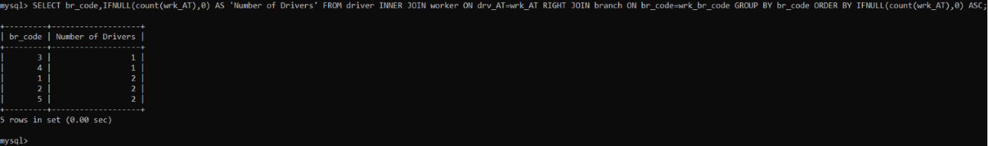

CALL insert_driver('AX10322100','Giorgos','Kapakis','1500.32','C','LOCAL',4);

Έπειτα καλούμε την **insert_driver**.

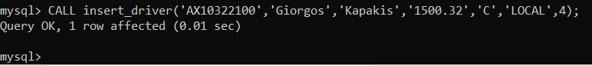

Και ξαναεκτελούμε το **select** που είχαμε αναφέρει.

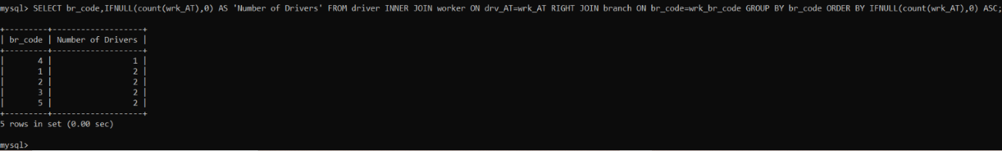

Βλέπουμε ότι ο οδηγός προστέθηκε στο branch με br_code=3, γιατί ήταν ένα από τα branches με τους λιγότερους οδηγούς. Αν κάποια branches έχουν ίσο σε αριθμό οδηγούς και είναι αυτά με τους λιγότερους οδηγούς σε σχέση με τα άλλα τότε ο νέος οδηγός προστίθεται στο branch με το μικρότερο id.

**3.1.3.2**

DROP PROCEDURE IF EXISTS search_trip;

DELIMITER $

CREATE PROCEDURE search_trip(IN code INT,IN start_date datetime,IN end_date datetime)

BEGIN

DECLARE trip_id INT;

DECLARE dep DATETIME;

DECLARE ret DATETIME;

DECLARE maxseats TINYINT;

DECLARE cost FLOAT(7,2);

DECLARE br_code INT;

DECLARE guide_AT CHAR(10);

DECLARE driver_AT CHAR(10);

DECLARE finishedFlag INT;

DECLARE no_of_reservations INT;

DECLARE driver_name VARCHAR(20);

DECLARE driver_lname VARCHAR(20);

DECLARE guide_name VARCHAR(20);

DECLARE guide_lname VARCHAR(20);

DECLARE empty_seats INT;

DECLARE tripCurs CURSOR FOR SELECT * FROM trip WHERE tr_departure>=start_date AND tr_departure<=end_date AND tr_br_code = code;

DECLARE CONTINUE HANDLER FOR NOT FOUND SET finishedFlag=1;

OPEN tripCurs;

SET finishedFlag=0;

FETCH tripCurs INTO trip_id,dep,ret,maxseats,cost,br_code,guide_AT,driver_AT;

WHILE(finishedFlag=0)

DO

SELECT COUNT(*) INTO no_of_reservations FROM reservation INNER JOIN trip ON res_tr_id=trip_id WHERE tr_departure>=start_date AND tr_departure<=end_date AND tr_br_code=code AND res_tr_id=tr_id;

SELECT wrk_name,wrk_lname INTO driver_name,driver_lname FROM trip INNER JOIN worker ON tr_drv_AT=wrk_AT WHERE tr_id=trip_id;

SELECT wrk_name,wrk_lname INTO guide_name,guide_lname FROM trip INNER JOIN worker ON tr_gui_AT=wrk_AT WHERE tr_id=trip_id;

SET empty_seats=maxseats-no_of_reservations;

SELECT trip_id AS 'Trip Id',cost AS 'Cost',maxseats AS 'Maxseats',no_of_reservations AS 'Number of Reservations',empty_seats AS 'Empty Seats',driver_lname AS 'Driver Lastname',driver_name AS 'Driver Name',guide_lname AS 'Guide Lastname',guide_name AS 'Guide Name',dep AS 'Departure',ret AS 'Return';

FETCH tripCurs INTO trip_id,dep,ret,maxseats,cost,br_code,guide_AT,driver_AT;

END WHILE;

CLOSE tripCurs;

END$

DELIMITER ;

Στο **procedure** αυτό δίνονται ως ορίσματα ο κωδικός ενός υποκαταστήματος και δύο ημερομηνίες. Για τα ταξίδια (trip) που διοργανώνονται από το υποκατάστημα του οποίου δόθηκε ο κωδικός, και των οποίων η ημερομηνία αναχώρησης είναι μέσα στο διάστημα που δόθηκε, επιστρέφονται το κόστος ταξιδιού (tr_cost ), οι μέγιστες θέσεις(maxseat), το σύνολο κρατήσεων (reservations), οι κενές θέσεις (maxseat – σύνολο κρατήσεων), το επώνυμο και το όνομα του οδηγού και του ξεναγού και τέλος η ημερομηνία αναχώρησης και επιστροφής. Δημιουργούμε έναν **cursor** με τον οποίο διατρέχουμε τον πίνακα **trip** και αποθηκεύουμε τις ζητούμενες πληροφορίες στις τοπικές μεταβλητές που δηλώσαμε και στο τέλος τις εκτυπώνουμε.

CALL search_trip(3,'2022-01-05 00:00:00','2022-08-15 23:59:59');

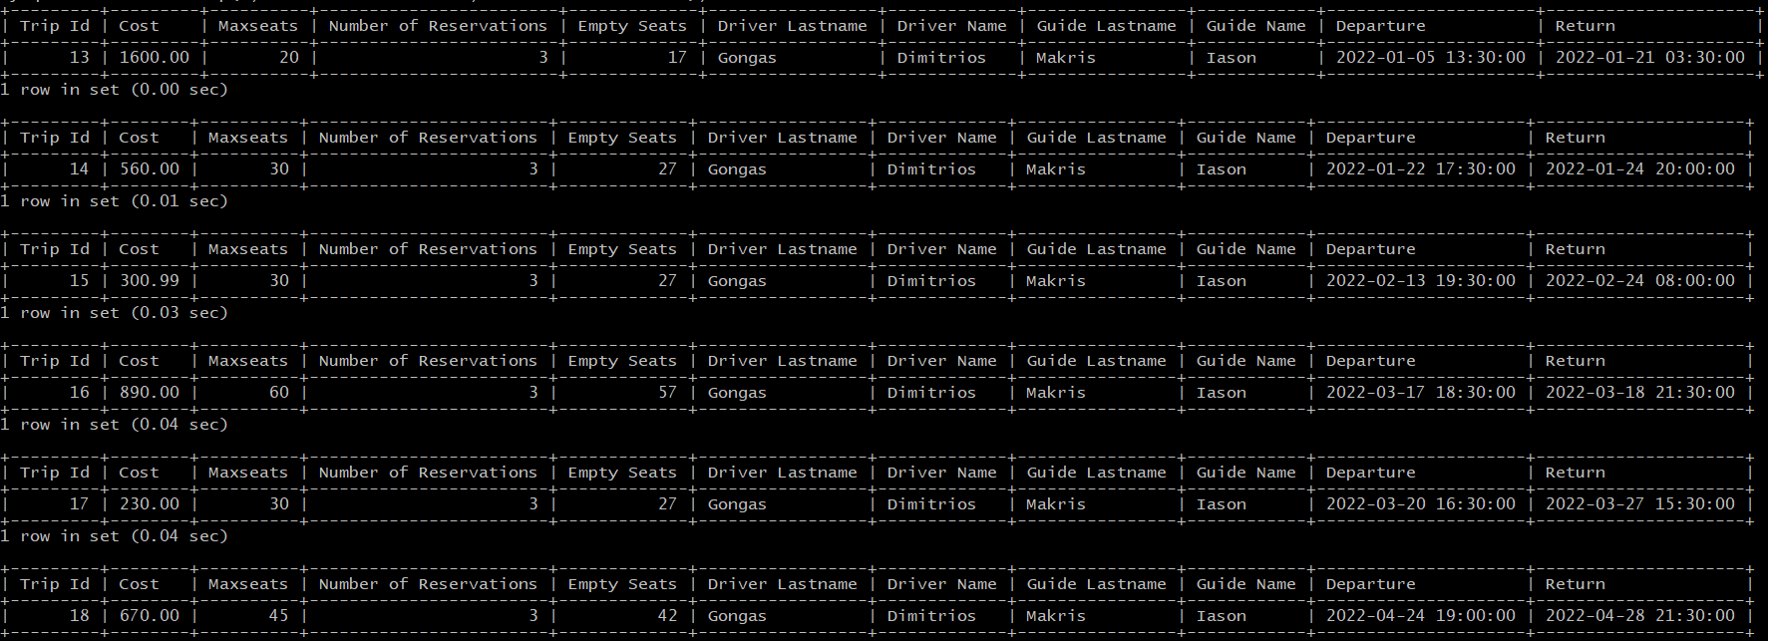

Καλούμε την συνάρτηση  **search_trip**.

SELECT * FROM trip WHERE '2022-01-05 00:00:00'<=tr_departure AND '2022-08-15 23:59:59'>=tr_departure AND tr_br_code=3;

SELECT * FROM reservation;

Μετά εκτελούμε τα παραπάνω **select** για να ελέγξουμε αν λειτουργεί σωστά το **procedure**.

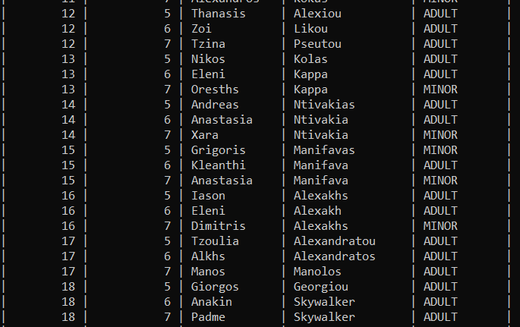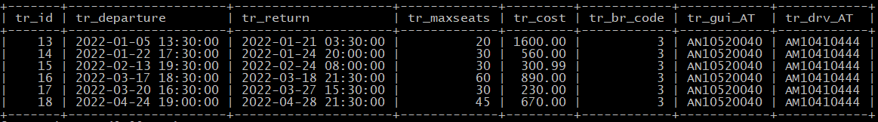

Βλέπουμε ότι επιλέγει τα σωστά **trips** και ο αριθμός των κρατήσεων για κάθε **trip** είναι σωστός.

**3.1.3.3**

DROP PROCEDURE IF EXISTS delete_worker;

DELIMITER $

CREATE PROCEDURE delete_worker(IN name varchar(20),IN lname varchar(20))

BEGIN

IF exists(SELECT * FROM worker INNER JOIN admin ON wrk_AT=adm_AT WHERE wrk_lname=lname AND wrk_name=name AND adm_type="ADMINISTRATIVE")

THEN

SELECT "This person is an admin in a branch therefore the deletion is restricted!" AS Error;

ELSEIF exists(SELECT * FROM worker WHERE wrk_lname=lname AND wrk_name=name)

THEN

DELETE FROM worker WHERE wrk_lname=lname AND wrk_name=name;

ELSE

SELECT "This person isn't a worker in any branch!" AS Error;

END IF;

END$

DELIMITER ;

Το **procedure** αυτό παίρνει ως όρισμα το όνομα και το επώνυμο ενός υπαλλήλου. Αν είναι διοικητικός τον διαγράφει. Αν ο υπάλληλος είναι διευθυντής υποκαταστήματος τότε εμφανίζεται μήνυμα ότι είναι διευθυντής του υποκαταστήματος και δεν επιτρέπει τη διαγραφή. Με ένα if ελέγχουμε αν ένας υπάλληλος είναι διευθυντής και αν ισχύει τότε εκτυπώνουμε ένα error message. Αν δεν είναι τότε μεταβαίνουμε στο επόμενο if και ελέγχουμε αν υπάρχει κάποιος υπάλληλος με το ονοματεπώνυμο που δόθηκε. Τέλος, αν δεν υπάρχει υπάλληλος, εκτυπώνουμε το αντίστοιχο error.

SELECT * FROM worker;

Εκτελούμε το παραπάνω **select**, για να δούμε τους workers.

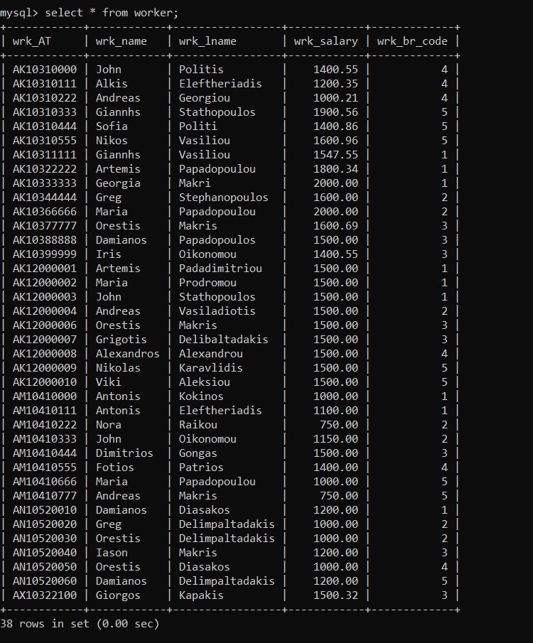

SELECT * FROM admin;

Εκτελούμε το παραπάνω select, για να δούμε τους admins.

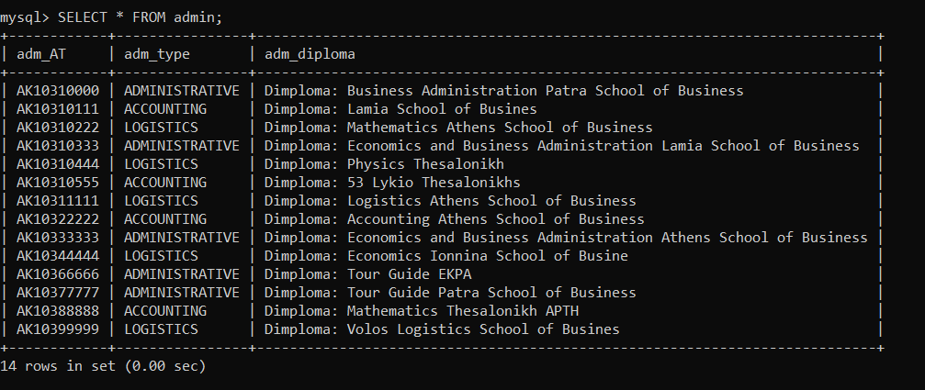

Έτσι μπορούμε να δούμε τους workers από τους οποίους θα επιλέξουμε να κάνουμε **delete_worker**.

CALL delete_worker('Orestis','Diasakos');

Εκτελούμε το παραπάνω **call**.

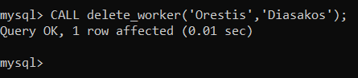

CALL delete_worker('Maria','Papadopoulou');

Κάνουμε πάλι κλήση της **delete_worker** αλλά με το παραπάνω **call**.

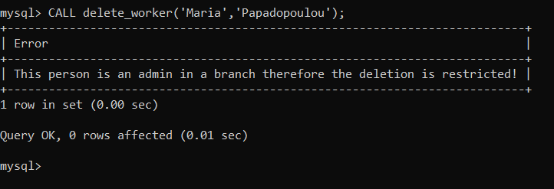

Εκτελούμε ξανά τα δύο προηγούμενα **select** με την ίδια σειρά.

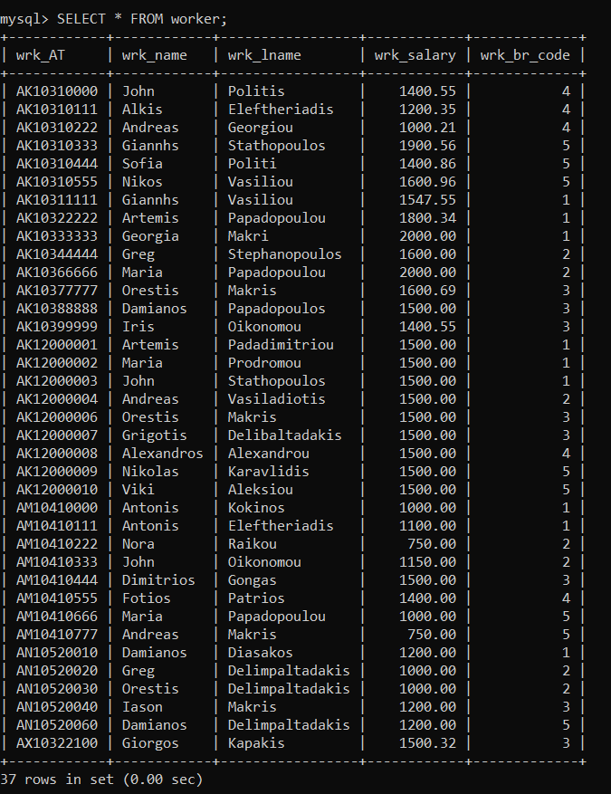

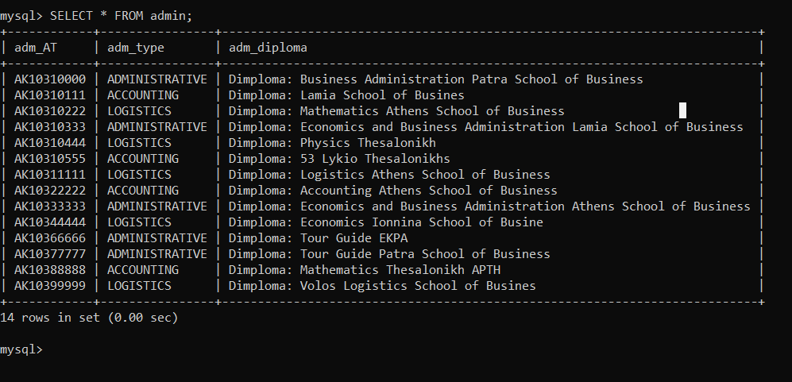

Βλέπουμε ότι ο Orestis Diasakos που διαγράψαμε στην αρχή, διαγράφηκε με επιτυχία ενώ η Maria Papadopoulou δεν διαγράφηκε επειδή είναι διευθύντρια του υποκαταστήματος με branch_id = 2.

**3.1.3.4**

DROP INDEX res_ind ON reservation_offers;

CREATE INDEX res_ind ON reservation_offers(deposit_amount, rsv_lastname, rsv_offer_id);

Πρώτα από όλα λόγω του μεγάλου πλήθους εγγραφών, δημιουργούμε ένα ευρετήριο στον πίνακα reservation_offers ώστε το πρόγραμμα να αναζητεί πιο αποδοτικά τις εγγραφές του πίνακα. Κάνουμε πρώτα **drop** σε περίπτωση που ήδη υπάρχει και το δημιουργούμε για τα πεδία **rsv_lastname** ,**deposit_amount** και **rsv_offer_id**. Δημιουργούμε το index για την στήλη **deposit_amount,** επειδή χρησιμοποιούμε αυτό το πεδίο μέσα σε **WHERE** **condition** για το **procedure** του υποερωτήματος **α)** και για τις **rsv_lastname, rsv_offer_id,** αντίστοιχα επειδή τα χρησιμοποιούμε σε πολλά **conditions** του **procedure** του υποερωτήματος **β)**.

**α)**

DROP PROCEDURE IF EXISTS res_range;

DELIMITER $

CREATE PROCEDURE res_range(IN r1 INT, IN r2 INT)

BEGIN

    SELECT rsv_name AS 'Firstname', rsv_lastname AS 'Lastname'

    FROM reservation_offers

    WHERE deposit_amount >= r1 AND deposit_amount<=r2;

END$

DELIMITER ;

Το **procedure** αυτό παίρνει ως παραμέτρους εισόδου δύο τιμές (π.χ. 50, 200) και τυπώνει τους πελάτες (επώνυμο, όνομα) που έκαναν κρατήσεις σε προσφορές ταξιδιών και πλήρωσαν για προκαταβολή κάποιο ποσό ανάμεσα στις δύο τιμές.

*Έλεγχος*

Έχουμε τον πίνακα reservation_offers, ο οποίος έχει 75000 εγγραφές.

**Εικόνα που περιέχει κείμενο

Περιγραφή που δημιουργήθηκε αυτόματα**

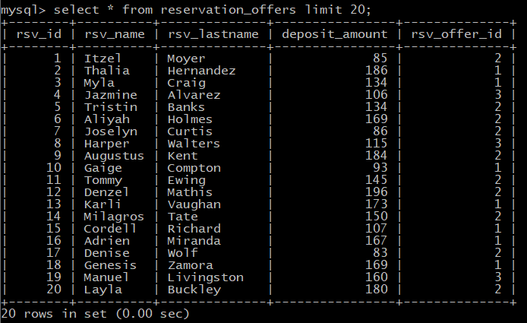

Έστω ότι καλούμε την procedure res_range για το εύρος προκαταβολών [80,95].

Χωρίς το ευρετήριο:



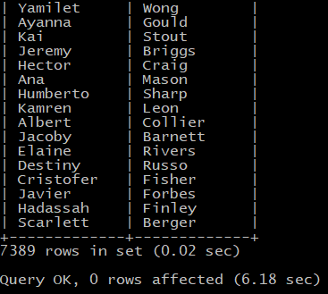

Βλέπουμε ότι το procedure εκτελέστηκε σε 0.02 s.

Με το ευρετήριο:

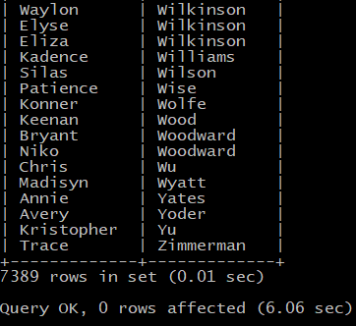

Το procedure εκτελείται σε 0.01 s.

**β)**

DROP PROCEDURE IF EXISTS res_names;

DELIMITER $

CREATE PROCEDURE res_names(IN lname VARCHAR(20))

BEGIN

    DECLARE flag INT;

    DECLARE offer_id INT;

    DECLARE no_of_res INT;

    DECLARE finishedFlag INT;

    DECLARE multResCurs CURSOR FOR

    SELECT rsv_offer_id, COUNT(rsv_offer_id)

    FROM reservation_offers

    WHERE rsv_lastname=lname

    GROUP BY rsv_offer_id

    HAVING COUNT(rsv_offer_id)>1

    ORDER BY rsv_offer_id;

    DECLARE singleResCurs CURSOR FOR

    SELECT rsv_offer_id, COUNT(rsv_offer_id)

    FROM reservation_offers

    WHERE rsv_lastname=lname

    GROUP BY rsv_offer_id

    HAVING COUNT(rsv_offer_id)=1

    ORDER BY rsv_offer_id;

    DECLARE CONTINUE HANDLER FOR NOT FOUND SET finishedFlag=1;

    OPEN multResCurs;

    SET finishedFlag=0;

    FETCH multResCurs INTO offer_id, no_of_res;

    SET flag = 0;

    WHILE(finishedFlag=0) DO

        IF(flag = 0) THEN

            SELECT 'Reserved offers for last name' AS '', lname AS '';

        END IF;

        SELECT offer_id AS 'Offer Id', no_of_res AS 'Number of reserved offers';

        FETCH multResCurs INTO offer_id,no_of_res;

        SET flag =  1;

    END WHILE;

    CLOSE multResCurs;

    OPEN singleResCurs;

    SET finishedFlag=0;

    SET flag = 0;

    FETCH singleResCurs INTO offer_id, no_of_res;

    WHILE(finishedFlag=0) DO

        IF(flag = 0) THEN

            SELECT 'Reserved offers with one reservation per offer' AS '';

        END IF;

        SELECT rsv_name, rsv_lastname, rsv_offer_id

        FROM reservation_offers

        WHERE rsv_offer_id = offer_id AND rsv_lastname = lname;

        SET flag = 1;

        FETCH singleResCurs INTO offer_id,no_of_res;

    END WHILE;

END$

DELIMITER ;

Στο **procedure** αυτό δίνεται ως παράμετρος εισόδου το επώνυμο ενός πελάτη και εκτυπώνει τα ονοματεπώνυμα των πελατών με το επώνυμο αυτό και την προσφορά ταξιδιού στην οποία έχουν κάνει κράτηση. Σε περίπτωση που υπάρχουν πάνω από ένας επιστρέφει το πλήθος των πελατών με το επώνυμο αυτό, ανά προσφορά ταξιδιού.

Η υλοποίηση έγινε με χρήση δύο cursors, **DECLARE multResCurs CURSOR** και **DECLARE singleResCurs CURSOR** τα οποία διατρέχουν το πίνακα reservation_offers και εντοπίζουν και εκτυπώνουν πολλαπλές και μονές κρατήσεις αντίστοιχα.

***Έλεγχος:***

Χωρίς ευρετήριο:

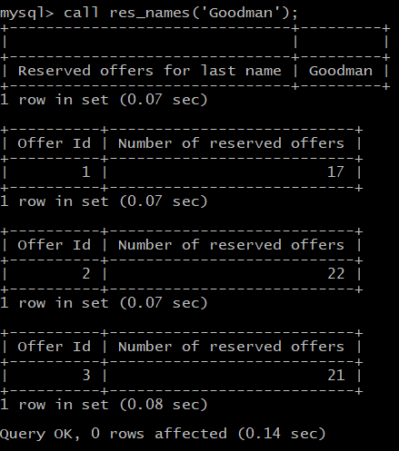

Με ευρετήριο:

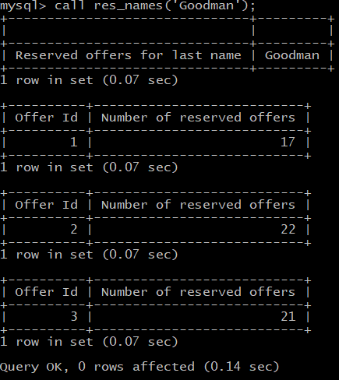

Με την χρήση ευρετηρίου η εκτέλεση είναι κατά 0.01 s πιο γρήγορη.

Ο πίνακας reservation_offers δημιουργήθηκε με την χρήση του δοθέντος αρχείου names.txt που περιέχει 10000 ονόματα, με τα οποία εκτελέσαμε τα INSERT για την εισαγωγή 75000 εγγραφών. Έτσι κάθε επώνυμο έχει κάνει πολλαπλές κρατήσεις σε κάθε προσφορά και για αυτό παραπάνω εκτυπώνεται ένας πίνακας με πολλαπλές κρατήσεις ανά offer.

Για να γίνει σωστός έλεγχος του procedure λοιπόν, εισάγουμε μερικές επιπλέον κρατήσεις:

INSERT INTO reservation_offers VALUES(null,'Greg','Deli',50,1);

INSERT INTO reservation_offers VALUES(null,'Maria','Deli',50,1);

INSERT INTO reservation_offers VALUES(null,'Greg','Deli',50,2);

INSERT INTO reservation_offers VALUES(null,'Greg','Deli',50,3);

Δηλαδή εισάγουμε 3 κρατήσεις για τον πελάτη Greg Deli, μία σε κάθε offer και μία κράτηση για την Maria Deli στο offer me id=1.

Αποτελέσματα:

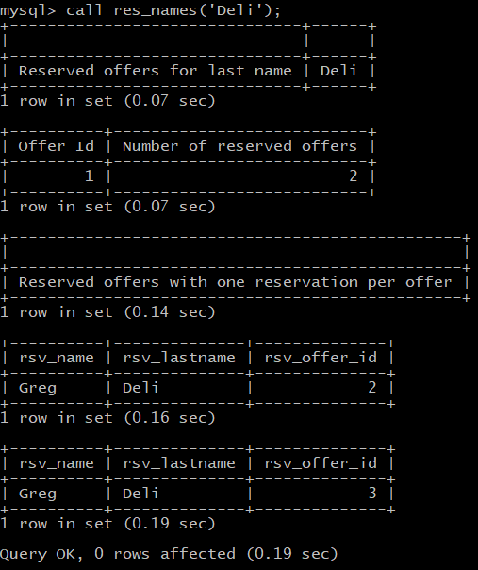

Βλέπουμε λοιπόν ότι για το επώνυμο Deli έχουμε δύο κρατήσεις για την προσφορά 1 (μία από τον Greg και μία από την Maria) και από μία κράτηση στις άλλες δυο προσφορές από τον Greg.

**Επιπλέον Procedures**

1. **create_user()** και **create_select_user()**

Πέρα από τα stored procedures που ζητούνταν προσθέσαμε δυο επιπλέον τα οποία δημιουργούν ένα user για την βάση με όλα τα privileges ή μόνο με select privileges.

/*Procedure pou dhmioyrgei enan neo user gia tin vasi travel_agency. Prepei na tin kalesoume afou kanoume insert enan it_admin*/

DROP PROCEDURE IF EXISTS create_user;

DELIMITER $

CREATE PROCEDURE create_user(IN it_username VARCHAR(20),IN it_password CHAR(10))

BEGIN

    /*prepei na xrisimopoiisw tin CONCAT() giati den mas epitrepei na ektelesoume tin CREATE USER me metavlites*/

    SET @cr_user = CONCAT

    ('

    CREATE USER "',it_username,'"@"localhost" IDENTIFIED BY "',it_password,'" '

    );

    PREPARE cr FROM @cr_user;

    EXECUTE cr;

    DEALLOCATE PREPARE cr;

    /*omoiws gia to GRANT PRIVILEGES*/

    SET @gr_user = CONCAT

    ('

    GRANT ALL ON travel_agency.* TO "',it_username,'"@"localhost" '

    );

    PREPARE gr FROM @gr_user;

    EXECUTE gr;

    DEALLOCATE PREPARE gr;

    /*gia na mporei na kanei select kai delete to user ston pinaka mysql.db*/

    SET @gr_user = CONCAT

    ('

    GRANT SELECT,DELETE ON mysql.db TO "',it_username,'"@"localhost" '

    );

    PREPARE gr FROM @gr_user;

    EXECUTE gr;

    DEALLOCATE PREPARE gr;

    /*gia na mporei na kanei create user*/

    SET @gr_cr_user = CONCAT

    ('

    GRANT CREATE USER ON *.* TO "',it_username,'"@"localhost" '

    );

    PREPARE gr_cr FROM @gr_cr_user;

    EXECUTE gr_cr;

    DEALLOCATE PREPARE gr_cr;

    SET @flush = "FLUSH PRIVILEGES";

    PREPARE stmt FROM @flush;

    EXECUTE stmt;

    DEALLOCATE PREPARE stmt;

END$

DELIMITER ;

/*user mono me select privilages*/

DROP PROCEDURE IF EXISTS create_select_user;

DELIMITER $

CREATE PROCEDURE create_select_user(IN it_username VARCHAR(20),IN it_password CHAR(10))

BEGIN

    #prepei na xrisimopoiisw tin CONCAT() giati den mas epitrepei na ektelesoume tin CREATE USER me metavlites

    SET @cr_user = CONCAT

    ('

    CREATE USER "',it_username,'"@"localhost" IDENTIFIED BY "',it_password,'" '

    );

    PREPARE cr FROM @cr_user;

    EXECUTE cr;

    DEALLOCATE PREPARE cr;

    /*PRIVILEGES SELECT kai EXECUTE gia na mporei na kalei procedures*/

    SET @gr_user = CONCAT

    ('

    GRANT EXECUTE, SELECT ON travel_agency.* TO "',it_username,'"@"localhost" '

    );

    PREPARE gr FROM @gr_user;

    EXECUTE gr;

    DEALLOCATE PREPARE gr;

    /*gia na mporei na kanei select kai delete to user ston pinaka mysql.db*/

    SET @gr_user = CONCAT

    ('

    GRANT SELECT ON mysql.db TO "',it_username,'"@"localhost" '

    );

    PREPARE gr FROM @gr_user;

    EXECUTE gr;

    DEALLOCATE PREPARE gr;

    SET @flush = "FLUSH PRIVILEGES";

    PREPARE stmt FROM @flush;

    EXECUTE stmt;

    DEALLOCATE PREPARE stmt;

END$

DELIMITER ;

Το ιδανικό θα ήταν να μπορούσαμε να δημιουργήσουμε τον user μέσα σε ένα trigger για τον πίνακα it_admin κάθε φορά που κάνουμε insert σε αυτόν. Όμως η mySQL δεν επιτρέπει την εκτέλεση της εντολής CREATE USER ούτε την κλήση procedure μέσα σε trigger.

Tα procedures παίρνουν ως ορίσματα ένα username και password και εκτελούνε τα queries:

* CREATE USER <username> IDENTIFIED BY <password>, για την δημιουργία του user.
* GRANT ALL ON travel_agency.* TO <username>, για να έχει όλα τα δικαιώματα στην βάση μας
* GRANT EXECUTE, SELECT ON travel_agency.* TO <username>, στην περίπτωση που δημιουργούμε έναν χρήστη με δικαιώματα select και execute μόνο.
* GRANT SELECT,DELETE ON mysql.db TO <username> και GRANT CREATE USER ON *.* TO <username>, για να μπορεί να δημιουργεί και να διαγράφει χρήστες.

***Έλεγχος:***

Κλήση του procedure:



Έλεγχος του πίνακα mysql.user και mysql.db:

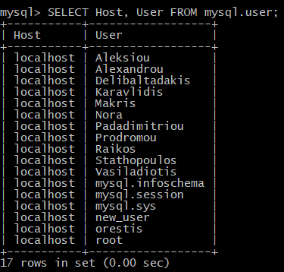

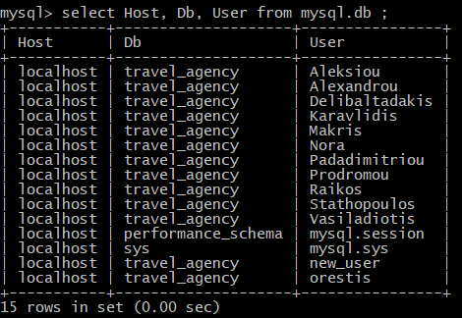

Βλέπουμε ότι ο new_user προστέθηκε και στους δύο.

Είσοδος στην βάση ως τον καινούριος user:

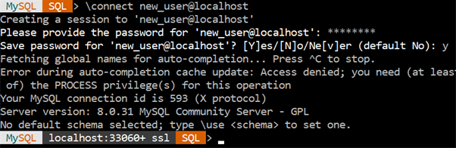

Εκτέλεση ενός query:

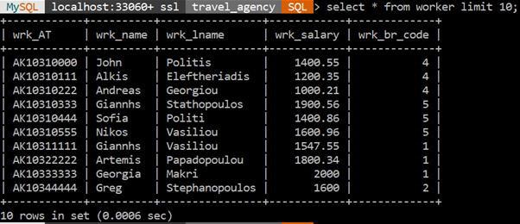

Συνδεθήκαμε και εκτελέσαμε με επιτυχία ένα querry στην βάση μας.

1. **branch_info()**

Αυτό το stored procedure εμφανίζει για κάθε υποκατάστημα τα στοιχεία του, το ονοματεπώνυμο του διευθυντή του, το σύνολο κρατήσεων και το σύνολο εσόδων (κρατήσεις επί κόστος ταξιδιού). Δημιουργήθηκε για να διευκολύνει την εμφάνιση των ζητουμένων πληροφοριών των υποκαταστημάτων στο GUI.

DROP PROCEDURE IF EXISTS branch_info;

DELIMITER $

CREATE PROCEDURE branch_info()

BEGIN

DECLARE branch_code INT(11);

DECLARE branch_street VARCHAR(30);

DECLARE branch_num INT(4);

DECLARE branch_city VARCHAR(30);

DECLARE finishedFlag INT;

DECLARE admin_name VARCHAR(20);

DECLARE admin_lname VARCHAR(20);

DECLARE total_of_reservations INT;

DECLARE income FLOAT;

DECLARE branchCurs CURSOR FOR SELECT * FROM branch;

DECLARE CONTINUE HANDLER FOR NOT FOUND SET finishedFlag=1;

OPEN branchCurs;

SET finishedFlag=0;

FETCH branchCurs INTO branch_code,branch_street,branch_num,branch_city;

WHILE(finishedFlag=0)

DO

SELECT COUNT(*) INTO total_of_reservations FROM reservation INNER JOIN trip ON res_tr_id=tr_id WHERE tr_br_code=branch_code;

SELECT wrk_name,wrk_lname INTO admin_name,admin_lname FROM admin INNER JOIN worker ON adm_AT=wrk_AT WHERE wrk_br_code=branch_code AND adm_type='ADMINISTRATIVE';

SET income=(SELECT SUM(tr_cost*res_count) FROM trip JOIN (SELECT res_tr_id, COUNT(*) as res_count FROM reservation GROUP BY res_tr_id) as res_counts ON trip.tr_id = res_counts.res_tr_id WHERE tr_br_code = branch_code);

SELECT branch_code AS 'Branch code',branch_street AS 'Street',branch_num AS 'Number',branch_city AS 'City',admin_name AS 'Admin name',admin_lname AS 'Admin last name',total_of_reservations AS 'Total of Reservations',income AS 'Income';

FETCH branchCurs INTO branch_code,branch_street,branch_num,branch_city;

END WHILE;

CLOSE branchCurs;

END$

DELIMITER ;

Το **procedure** αυτό δεν παίρνει κάποιο όρισμα. Δημιουργούμε έναν **cursor** με τον οποίο διατρέχουμε τον πίνακα **branch** και αποθηκεύουμε τις ζητούμενες πληροφορίες στις τοπικές μεταβλητές που δηλώσαμε και στο τέλος τις εκτυπώνουμε.

CALL branch_info();

Καλούμε τον branch_info με την παραπάνω εντολή.

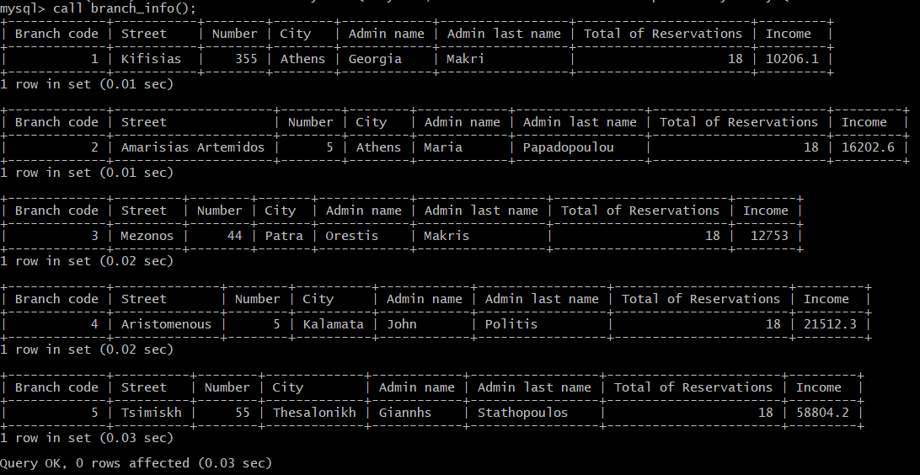

***Έλεγχος:***

Κάνουμε τα παρακάτω τρία **select** για να ελέγξουμε ότι λειτουργεί σωστά το procedure.

SELECT branch.*,wrk_name,wrk_lname FROM admin INNER JOIN worker ON adm_AT=wrk_AT INNER JOIN branch ON wrk_br_code=br_code WHERE adm_type='ADMINISTRATIVE';

SELECT * FROM trip;

SELECT br_code,COUNT(*) AS total_of_reservations FROM reservation INNER JOIN trip ON res_tr_id=tr_id INNER JOIN branch ON tr_br_code=br_code GROUP BY br_code;

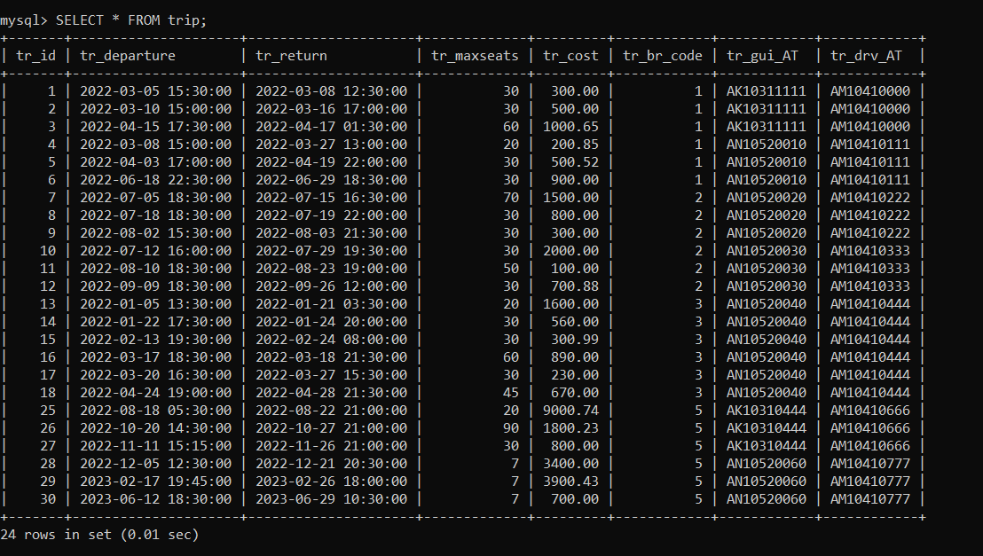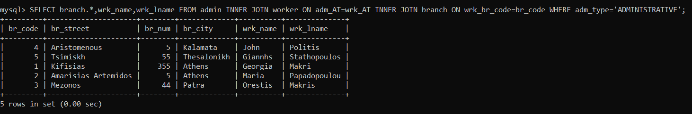

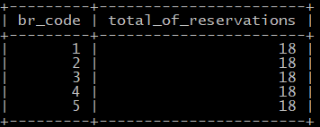

Όπως φαίνεται το procedure λειτουργεί σωστά. Μιας και το δεύτερο select φανερώνει πως κάθε branch έχει 18 κρατήσεις.

# 

# **Κεφάλαιο 3 - Triggers**

## **3.1.4.1**

Δημιουργήσαμε triggers για την καταγραφή **εισαγωγής**, **ενημέρωσης** ή **διαγραφής** σε έναν από τους πίνακες **trip**, **reservation**, **event**, **travel_to**, **destination**. Για κάθε πίνακα από αυτούς δημιουργούμε τρία triggers για όλες τις πιθανές δράσεις και μέσα σε αυτά εισάγουμε μια νέα εγγραφή στην οποία αποτυπώνεται η αλλαγή που κάναμε καθώς επίσης και ο χρήστης που την εκτέλεσε μαζί με την ώρα και ημερομηνία που την εκτέλεσε.

/*triggers gia ton log_trip*/

DROP TRIGGER IF EXISTS log_trip_insert;

DELIMITER $

CREATE TRIGGER log_trip_insert AFTER INSERT ON trip

FOR EACH ROW

BEGIN

    INSERT INTO log_trip VALUES

    ('INSERT',CURRENT_USER(),NOW(),NEW.tr_id,NEW.tr_departure,NEW.tr_return,

    NEW.tr_maxseats,NEW.tr_cost,NEW.tr_br_code,NEW.tr_gui_AT,NEW.tr_drv_AT);

END$

DELIMITER ;

DROP TRIGGER IF EXISTS log_trip_update;

DELIMITER $

CREATE TRIGGER log_trip_update AFTER UPDATE ON trip

FOR EACH ROW

BEGIN

    INSERT INTO log_trip VALUES

    ('UPDATE',CURRENT_USER(),NOW(),OLD.tr_id,OLD.tr_departure,OLD.tr_return,

    OLD.tr_maxseats,OLD.tr_cost,OLD.tr_br_code,OLD.tr_gui_AT,OLD.tr_drv_AT);

END$

DELIMITER ;

DROP TRIGGER IF EXISTS log_trip_delete;

DELIMITER $

CREATE TRIGGER log_trip_delete AFTER DELETE ON trip

FOR EACH ROW

BEGIN

    INSERT INTO log_trip VALUES

    ('DELETE',CURRENT_USER(),NOW(),OLD.tr_id,OLD.tr_departure,OLD.tr_return,

    OLD.tr_maxseats,OLD.tr_cost,OLD.tr_br_code,OLD.tr_gui_AT,OLD.tr_drv_AT);

END$

DELIMITER ;

UPDATE trip SET tr_departure = '2069-03-05 15:30:06'

WHERE tr_id = 33;

DELETE FROM trip where tr_id = 33;

/*triggers gia ton log_reservation*/

DROP TRIGGER IF EXISTS log_reservation_insert;

DELIMITER $

CREATE TRIGGER log_reservation_insert AFTER INSERT ON reservation

FOR EACH ROW

BEGIN

    INSERT INTO log_reservation VALUES

    ('INSERT',CURRENT_USER(),NOW(),NEW.res_tr_id,NEW.res_seatnum,

    NEW.res_name,NEW.res_lname,NEW.res_isadult);

END$

DELIMITER ;

DROP TRIGGER IF EXISTS log_reservation_update;

DELIMITER $

CREATE TRIGGER log_reservation_update AFTER UPDATE ON reservation

FOR EACH ROW

BEGIN

    INSERT INTO log_reservation VALUES

    ('UPDATE',CURRENT_USER(),NOW(),OLD.res_tr_id,OLD.res_seatnum,

    OLD.res_name,OLD.res_lname,OLD.res_isadult);

END$

DELIMITER ;

DROP TRIGGER IF EXISTS log_reservation_delete;

DELIMITER $

CREATE TRIGGER log_reservation_delete AFTER DELETE ON reservation

FOR EACH ROW

BEGIN

    INSERT INTO log_reservation VALUES

    ('DELETE',CURRENT_USER(),NOW(),OLD.res_tr_id,OLD.res_seatnum,

    OLD.res_name,OLD.res_lname,OLD.res_isadult);

END$

DELIMITER ;

/*triggers gia ton log_event*/

DROP TRIGGER IF EXISTS log_event_insert;

DELIMITER $

CREATE TRIGGER log_event_insert AFTER INSERT ON event

FOR EACH ROW

BEGIN

    INSERT INTO log_event VALUES

    ('INSERT',CURRENT_USER(),NOW(),NEW.ev_tr_id,NEW.ev_start,

    NEW.ev_end,NEW.ev_descr);

END$

DELIMITER ;

DROP TRIGGER IF EXISTS log_event_update;

DELIMITER $

CREATE TRIGGER log_event_update AFTER UPDATE ON event

FOR EACH ROW

BEGIN

    INSERT INTO log_event VALUES

    ('UPDATE',CURRENT_USER(),NOW(),OLD.ev_tr_id,OLD.ev_start,

    OLD.ev_end,OLD.ev_descr);

END$

DELIMITER ;

DROP TRIGGER IF EXISTS log_event_delete;

DELIMITER $

CREATE TRIGGER log_event_delete AFTER DELETE ON event

FOR EACH ROW

BEGIN

    INSERT INTO log_event VALUES

    ('DELETE',CURRENT_USER(),NOW(),OLD.ev_tr_id,OLD.ev_start,

    OLD.ev_end,OLD.ev_descr);

END$

DELIMITER ;

/*triggers gia ton log_travel_to*/

DROP TRIGGER IF EXISTS log_travel_to_insert;

DELIMITER $

CREATE TRIGGER log_travel_to_insert AFTER INSERT ON travel_to

FOR EACH ROW

BEGIN

    INSERT INTO log_travel_to VALUES

    ('INSERT',CURRENT_USER(),NOW(),NEW.to_tr_id,NEW.to_dst_id,

    NEW.to_arrival,NEW.to_departure);

END$

DELIMITER ;

DROP TRIGGER IF EXISTS log_travel_to_update;

DELIMITER $

CREATE TRIGGER log_travel_to_update AFTER UPDATE ON travel_to

FOR EACH ROW

BEGIN

    INSERT INTO log_travel_to VALUES

    ('UPDATE',CURRENT_USER(),NOW(),OLD.to_tr_id,OLD.to_dst_id,

    OLD.to_arrival,OLD.to_departure);

END$

DELIMITER ;

DROP TRIGGER IF EXISTS log_travel_to_delete;

DELIMITER $

CREATE TRIGGER log_travel_to_delete AFTER DELETE ON travel_to

FOR EACH ROW

BEGIN

    INSERT INTO log_travel_to VALUES

    ('DELETE',CURRENT_USER(),NOW(),OLD.to_tr_id,OLD.to_dst_id,

    OLD.to_arrival,OLD.to_departure);

END$

DELIMITER ;

/*triggers gia ton log_destination*/

DROP TRIGGER IF EXISTS log_destination_insert;

DELIMITER $

CREATE TRIGGER log_destination_insert AFTER INSERT ON destination

FOR EACH ROW

BEGIN

    INSERT INTO log_destination VALUES

    ('INSERT',CURRENT_USER(),NOW(),NEW.dst_id,NEW.dst_name,NEW.dst_dscr,

    NEW.dst_rtype,NEW.dst_language,NEW.dst_location);

END$

DELIMITER ;

DROP TRIGGER IF EXISTS log_destination_update;

DELIMITER $

CREATE TRIGGER log_destination_update AFTER UPDATE ON destination

FOR EACH ROW

BEGIN

    INSERT INTO log_destination VALUES

    ('UPDATE',CURRENT_USER(),NOW(),OLD.dst_id,OLD.dst_name,OLD.dst_dscr,

    OLD.dst_rtype,OLD.dst_language,OLD.dst_location);

END$

DELIMITER ;

DROP TRIGGER IF EXISTS log_destination_delete;

DELIMITER $

CREATE TRIGGER log_destination_delete AFTER DELETE ON destination

FOR EACH ROW

BEGIN

    INSERT INTO log_destination VALUES

    ('DELETE',CURRENT_USER(),NOW(),OLD.dst_id,OLD.dst_name,OLD.dst_dscr,

    OLD.dst_rtype,OLD.dst_language,OLD.dst_location);

END$

DELIMITER ;

**Έλεγχος**

Θα ελέγξουμε την λειτουργία των triggers εκτελώντας ένα insert, update και delete στον πίνακα trip.

1. **Αρχικά εισάγουμε ένα νέο trip**

Ο πίνακας trip πριν την εισαγωγή:

Εικόνα που περιέχει κείμενο

Περιγραφή που δημιουργήθηκε αυτόματα

Μετά την εισαγωγή:

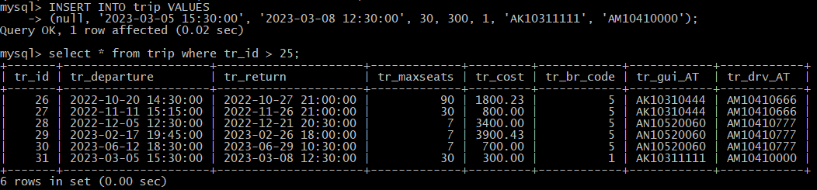

Έλεγχος του πίνακα log_trip:



Βλέπουμε πως στον πίνακα log_trip αποθηκεύτηκε μια εγγραφή στην οποία καταγράφονται το είδος της ενέργειας (INSERT), το username του χρήστη που την εκτέλεσε (root) και τα στοιχεία της εγγραφής που εισάχθηκε στον πίνακα trip.

1. **Στην συνέχεια ενημερώνουμε ένα trip**

Έστω ότι αλλάζουμε την ημερομηνία αναχώρησης του καινούριου trip.

Εικόνα που περιέχει κείμενο, πορτοκαλί

Περιγραφή που δημιουργήθηκε αυτόματα

Εικόνα που περιέχει κείμενο

Περιγραφή που δημιουργήθηκε αυτόματα

Βλέπουμε στην τελευταία γραμμή την ενημερωμένη ημερομηνία.

Έλεγχος του πίνακα log_trip:

Βλέπουμε πως εκτελέστηκε ένα UPDATE και αποθηκεύτηκε η ημερομηνία αναχώρησης που είχε το ταξίδι πριν την ενημέρωση.

1. **Τέλος διαγράφουμε ένα trip**



**Εικόνα που περιέχει κείμενο, ηλεκτρονικές συσκευές, υπολογιστής, πίνακας αποτελεσμάτων

Περιγραφή που δημιουργήθηκε αυτόματα**

Διαγράψαμε το trip με id = 31.

Έλεγχος του πίνακα log_trip:

Βλέπουμε πως εκτελέστηκε ένα DELETE και αποθηκεύτηκαν τα πεδία του ταξιδιού που διαγράφηκε.

Με αντίστοιχο τρόπο δουλεύουν και τα triggers των υπολοίπων πινάκων.

## **3.1.4.2**

DROP TRIGGER IF EXISTS check_reservations;

DELIMITER $

CREATE TRIGGER check_reservations BEFORE UPDATE ON trip

FOR EACH ROW

BEGIN

IF exists(SELECT * FROM reservation WHERE res_tr_id=OLD.tr_id)

THEN

SIGNAL SQLSTATE '45000' SET MESSAGE_TEXT='This trip already has reservations therefore updates are restricted!';

END IF;

END$

DELIMITER ;

Το **trigger** αυτό αποτρέπει την αλλαγή της ημερομηνίας αναχώρησης, της ημερομηνίας επιστροφής και του κόστους του ταξιδιού, αν έχουν ήδη γίνει κρατήσεις για αυτό. Ο έλεγχος γίνεται με ένα **if** που αν ισχύει τότε εκτυπώνεται κατάλληλο error.

SELECT * FROM reservation;

SELECT * FROM trip;

Εκτελούμε τα δύο παραπάνω **select** για να δούμε ποια **trips** έχουν κρατήσεις και ποια όχι.

UPDATE trip SET tr_cost=452.18 WHERE tr_id=30;

Στη συνέχεια Εκτελούμε το παραπάνω **update**.

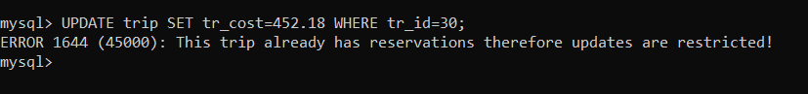

Εκτελούμε το **select** για το **trip** και βλέπουμε αν έχει γίνει αλλαγή.

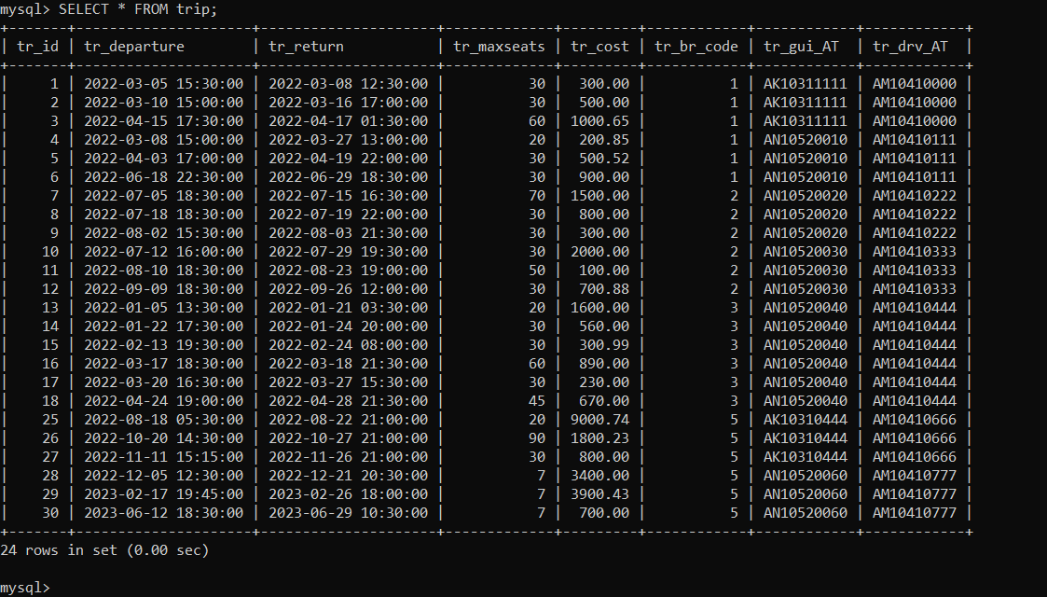

Όπως το περιμέναμε δεν έγινε κάποια αλλαγή.

## **3.1.4.3**

DROP TRIGGER IF EXISTS check_salary;

DELIMITER $

CREATE TRIGGER check_salary BEFORE UPDATE ON worker

FOR EACH ROW

BEGIN

IF OLD.wrk_salary>=NEW.wrk_salary

THEN

SIGNAL SQLSTATE '45000' SET MESSAGE_TEXT='The new salary must be greater than the older!';

END IF;

END$

DELIMITER ;

Το **trigger** αυτό δεν επιτρέπει τη μείωση του μισθού ενός υπαλλήλου. Με ένα if ελέγχουμε αν ο παλιός μισθός είναι μεγαλύτερος ή ίσος από τον καινούριο και αν είναι τότε εκτυπώνεται ένα error.

SELECT * FROM worker;

Εκτελούμε πρώτα αυτό το **select** για να διαλέξουμε τον worker του οποίου θα προσπαθήσουμε να αλλάξουμε τον μισθό.

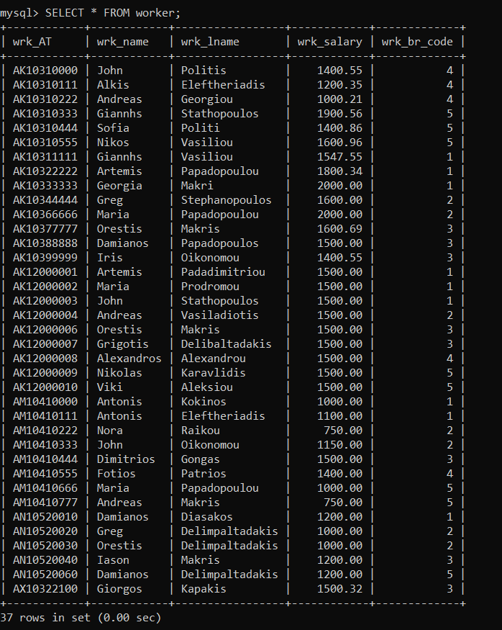

UPDATE worker SET wrk_salary=500 WHERE wrk_AT="AK10333333";

Εκτελούμε το παραπάνω **update**.

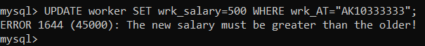

Εκτελούμε πάλι το **select** με το worker για να δούμε αν έχει γίνει αλλαγή.

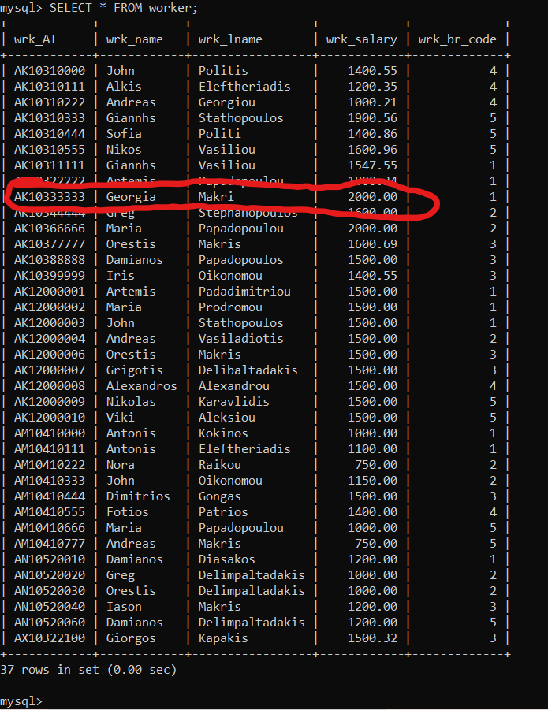

Απ’ ότι φαίνεται δεν έχει γίνει αλλαγή.

# **Μέρος Β: GUI**

# **Κεφάλαιο 4 – Java**

To GUI υλοποιήθηκε με απόλυτη επιτυχία με την χρήση του IDE NetBeans και της βιβλιοθήκης JDK 15 για την αλληλεπίδραση με την βάση δεδομένων σε mySQL. Αποτελείται από τις ακόλουθες κλάσης οποίες θα επεξηγούν αναλυτικά :

**AdminWorker**

**Branches**

**BranchInfo**

**Destination**

**DriverWorker**

**Events**

**GuideWorker**

**ItAdmin**

**Log_Destination**

**Log_Events**

**Log_Reservation**

**Log_Travel_To**

**Log_Trip**

**Login**

**Main**

**Menu**

**Offers**

**ProcedureResults**

**ReservationOffers**

**Reservations**

**Travel_To**

**TripEvent**

**Κλάση Main:**

Αποτελεί την κλάση εκκίνησης του application μας η οποία με την σειρά της καλεί την Login ώστε να πραγματοποίηση την είσοδο στην βάση δεδομένων ο χρήστης.

**Κλάση Login:**

Αποτελεί την κλάση εισόδου του User με Username: το Last Name του και έχει την ακόλουθη οπτική μορφή:

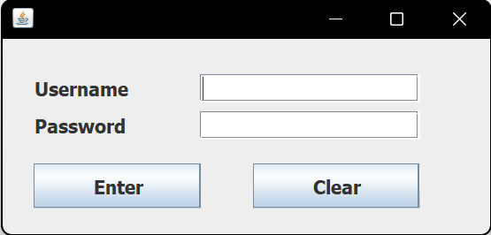

Αποτελείται από τον Constructor Login, την μέθοδο insert , την μέθοδο connect, την μέθοδο enterButtonActionPerformed και την μέθοδο resetButtonActionPerformed.

O Constructor Login με την χρήση του key Listener επιτρέπει στον χρήστη με το πάτημα του πλήκτρο enter να μεταβεί από το text field username στο text field password και από εκεί στο να πατήσει το Enter.

Η μέθοδος connect δέχεται σαν ορίσματα το username και το password και τα αξιοποιεί για να πραγματοποιήσει την σύνδεση με την βάση δεδομένων με την χρήση του jdbc.

Η μέθοδος insert σε πρώτη φάση διαβάζει τα ονόματα και τα επίθετα που βρίσκονται στο αρχείο names.txt (τοποθεσία στο folder classes του project) και τα αποθηκεύει σε δυο arrays. Εν συνεχεία με την χρήση της συνάρτησης random της java περνούμε τυχαία indexes για τα παραπάνω arrays αλλά και τυχαίες τιμές μεταξύ 70-200 για την προκαταβολή του πελάτη η τυχαία επιλογή αυτών των τιμών επαναλαμβάνατε 25.000 φορές για την εισαγωγή των τιμών στο πίνακα reservation_offers με την χρήση ενός for loop. Εκτελούμε την παραπάνω διαδικασία 3 φορές (σύνολο εγγραφών 75.000) για id offers από 1 έως 3 με την χρήση ενός εξωτερικού for loop. Με αυτήν την συνάρτηση επιτυγχάνουμε την αυτόματη εισαγωγή 75.000 εγγράφων στον πίνακα reservation_offers της βάσης.

Η μέθοδος enterButtonActionPerformed εκτελείτε όταν πατήσουμε το κουμπί enter στη διεπαφή και καλεί την συνάρτηση connect στην οποία περνάει το username και to password που διάβασε από τα αντίστοιχα πεδία της διεπαφης για να πραγματοποιήσει το connection του χρήστη με τα κατάλληλα δικαιώματα που έχει στην βάση και στην περίπτωση λανθασμένου username ή password ή μη υπάρχοντος χρήστη καθαρίζει τα πεδία και εκτυπώνει το παρακάτω μήνυμα σε ένα νέο παράθυρο με την χρήση της μεθόδου JOptionPane από την βιβλιοθήκη swing. Στην συνέχεια με την επιτυχή εκτέλεση του connection ελέγχουμε αν ο πίνακας reservation offers είναι empty, στην περίπτωση που είναι απλά εκτελείτε η συνάρτηση insert για να εισαχθούν οι 75.000 εγγραφές.

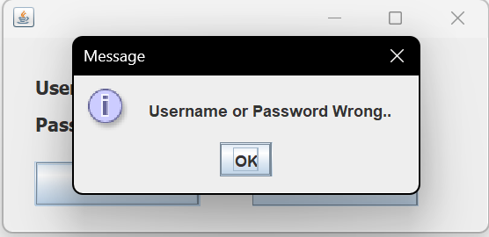

**Σε περίπτωση που πρέπει να πραγματοποιηθούν εγγραφές υπάρχει αναμονή που κινείτε μεταξύ 1 με 3 λεπτά.**

Το log in εξυπηρετεί και χρήστες με διαφορετικά δικαιώματα πχ admins με δικαίωμα view μόνο.

**Χρήστες για Log In :**

|  |  |
| --- | --- |
| **Last Name** | **Password** |
| Padadimitriou | password |
| Prodromou | password |
| Stathopoulos | John |
| Vasiladiotis | password |
| Raikos | 1234 |
| Makris | 1444 |
| Delibaltadakis | ff |
| Alexandrou | AlexAlex |
| Karavlidis | Nik |
| Aleksiou | password |

**Κλάση Menu:**

Είναι η κλάση που υλοποιεί το menu της εφαρμογής. Κάθε κουμπί αποτελεί μια ξεχωριστή μέθοδο της κλάσης αυτής και περιέχει κώδικα ο οποίος ανοίγει τα κατάλληλα παράθυρα. Σχετικά με την δομή του menu :

**Manipulate Tables:**

Περιέχει τα κουμπιά τα οποία οδηγούν σε παράθυρα που αφορούν τις λειτουργίες insert delete update and search για τους ακολούθους πίνακες Branches (Πίνακες Branches & Phones), Destinations, Trips/Events (Πινακες Trip & Events ), Reservations , Offers , Reservation_Offers και Travel_To.

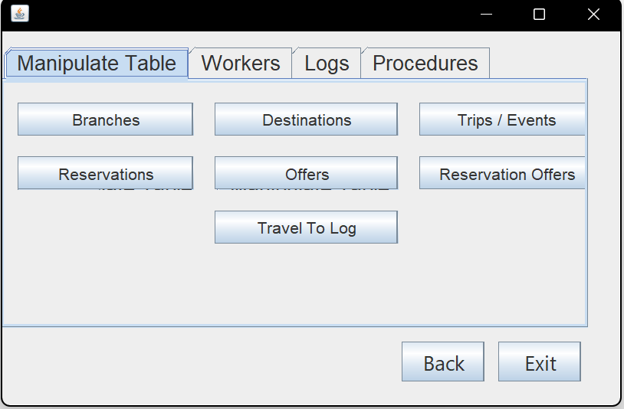

**Workers:**

Περιέχει τα κουμπιά τα οποία οδηγούν σε παράθυρα που αφορούν το της λειτουργίες insert delete update and search για τους ακολούθους πίνακες Guides (Πίνακες guide , worker & languages), IT Admins (Πίνακες it_admin & worker) , Drivers (worker & driver) and Admins (worker, manages & admin).

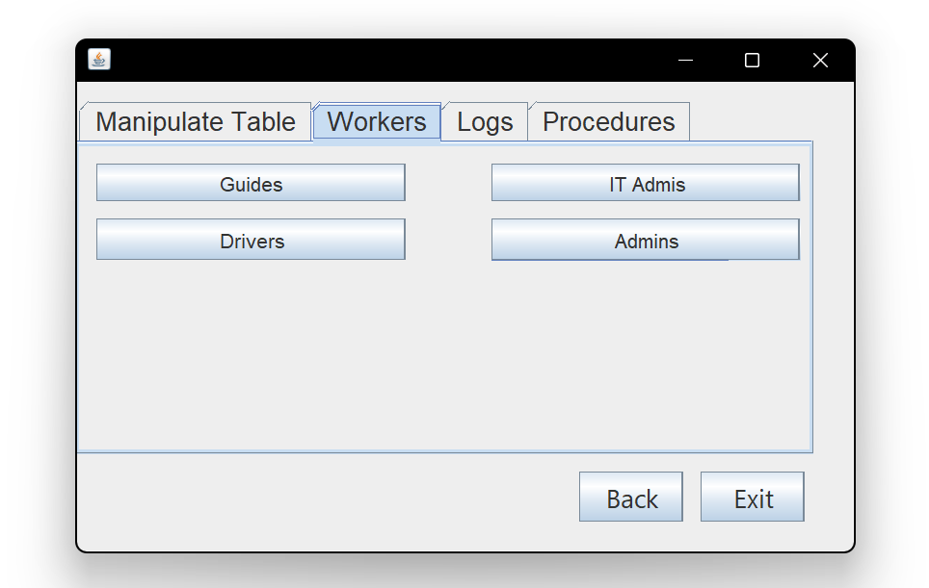

**Logs:**

Περιέχει τα κουμπιά τα οποία οδηγούν σε παράθυρα που παρουσιάζουν το περιεχόμενο των ακόλουθων πινάκων log_destination , log_event , log_event , log_reservation , log_travel_to , log_trip .

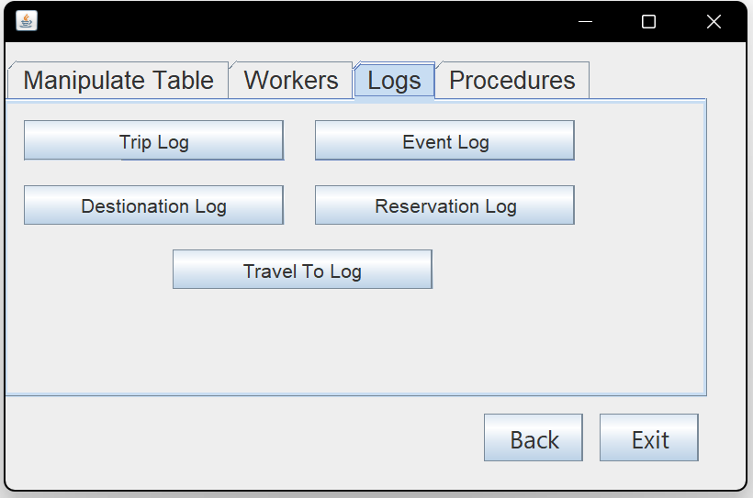

**Procedures:**

Περιέχει τα κουμπιά τα οποία οδηγούν σε παράθυρα που παρουσιάζουν τα αποτελέσματα εκτέλεσης των stored procedures search_trip(), reservation_offers() και branch_info().

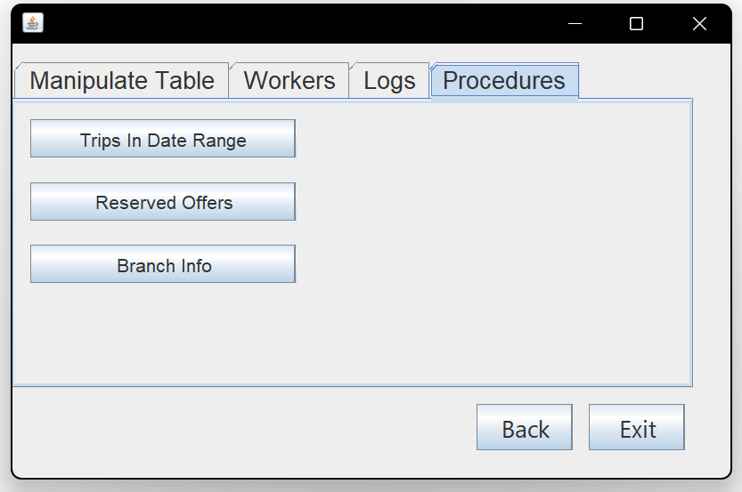

**Κλάση AdminWorker:**

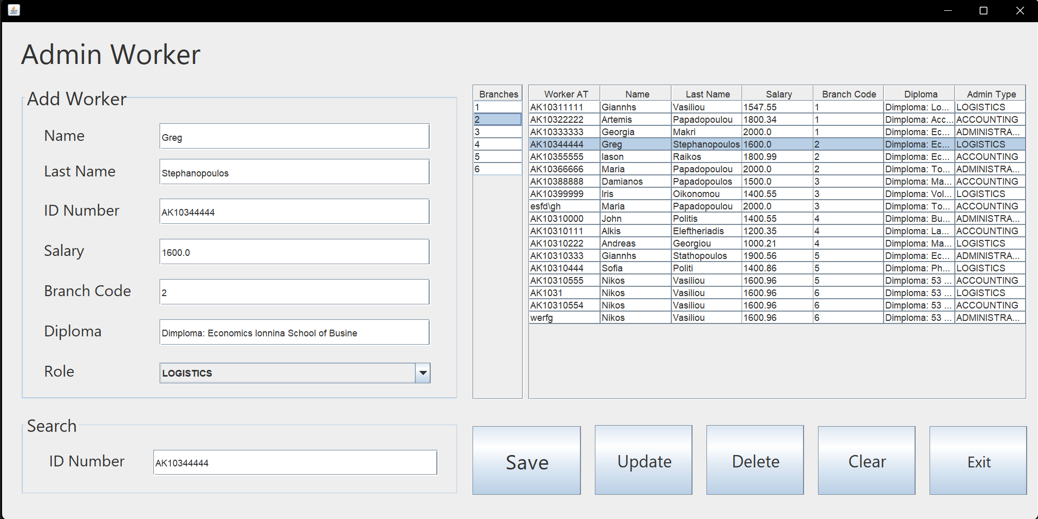

Αφορά τις λειτουργίες insert delete update and search για ένα admin worker και επηρεάζει τους πίνακες admin worker and manages. Αποτελείται από τις ακόλουθες μεθόδους table_load() , table_load_Branches(), SaveButtonActionPerformed() , ExitButtonActionPerformed() , ClearButtonActionPerformed() , jTable2MouseClicked() , UpdateButton2ActionPerformed() , jTable4MouseClicked() , SearchFieldKeyReleased() , DeleteButtonActionPerformed().

**table_load() :** Πραγματοποιεί ένα inner join select στους πίνακες admin, worker, manages και περνάει τα αποτελέσματα της απάντησης του σε έναν Jtable.

**table_load_Branches():** Πραγματοποιεί ένα select στον πίνακα Branches και περνάει τα αποτελέσματα της απάντησης του σε έναν Jtable ώστε όταν πάμε να κάνουμε insert ή update έναν admin ο χρηστής να έχει γνώση τον υπάρχοντων branches ώστε να επιλέξει ένα.

**SaveButtonActionPerformed():** διαβάζει τα περιεχόμενα των πεδίων Name , Last Name , ID Number, Salary, Branch Code, Diploma και του drop bar Role (enum var) και πραγματοποιεί το insert στους πίνακες Admin worker and manages. Σε περίπτωση error με την χρήση του sql exception το πιάνουμε και τυπώνομε το μήνυμα error στον χρήστη με μορφή ενός νέου παραθύρου.

**ExitButtonActionPerformed() :** exit από το application.

**ClearButtonActionPerformed():** Καθαρίζει όλα τα πεδία του παραθύρου.

**jTable2MouseClicked() :** Διασφαλίζειότι όταν επιλέγουμε ένα row από τον table admin περνάει το περιεχόμενο της κάθε στήλης του στα κατάλληλα text πεδία, drop fields και στο search πεδίο.

**jTable4MouseClicked():** Διασφαλίζειότι όταν επιλέγουμε ένα row από τον table branch περνάει το id του branch που περιέχει στο πεδίο Branch Code ώστε όταν πάμε να κάνουμε insert ή update έναν admin ο χρήστης να έχει γνώση τον υπάρχοντων branches ώστε να επιλέξει ένα.

**DeleteButtonActionPerformed() :** Διαβάζει το κλειδί του worker που είναι προς διαγραφή από το πεδίο ID Number στο search και τον διαγράφει με χρήση του stored procedure delete_worker(). Αν ο admin που διαγράφουμε είναι τύπου ADMINISTRATIVE δεν διαγράφεται.

**SearchFieldKeyReleased():** Διαβάζει το κλειδί (ID) του worker που θέλουμε να βρούμε από το πεδίο ID Number στο search και μόλις τον βρει μεταφέρει τα στοιχεία του από τους πίνακες admin worker και manages στα κατάλληλα πεδία. Η λειτουργία search υπάρχει για ευκολία του user στα operations Delete and Update .

**UpdateButton2ActionPerformed():** Αξιοποιεί την συνάρτηση SearchFieldKeyReleased ώστε να προσφέρει στον χρήστη την τρέχουσα κατάσταση των στοιχείων του admin ώστε να αλλάξει αυτά που επιθυμεί και αξιοποιώντας το τωρινό id (key) από το πεδίο ID Number στο search και πραγματοποιεί το update. Σε περίπτωση που μειώσει το μισθό του υπαλλήλου καλείται το κατάλληλο trigger που εμποδίζει το update τυπώνουμε το κατάλληλο μήνυμα error στον χρήστη με μορφή ενός νέου παραθύρου.

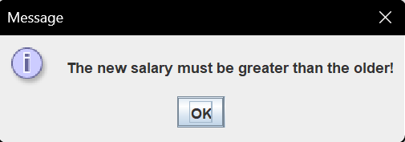

**Κλάση DriverWorker:**

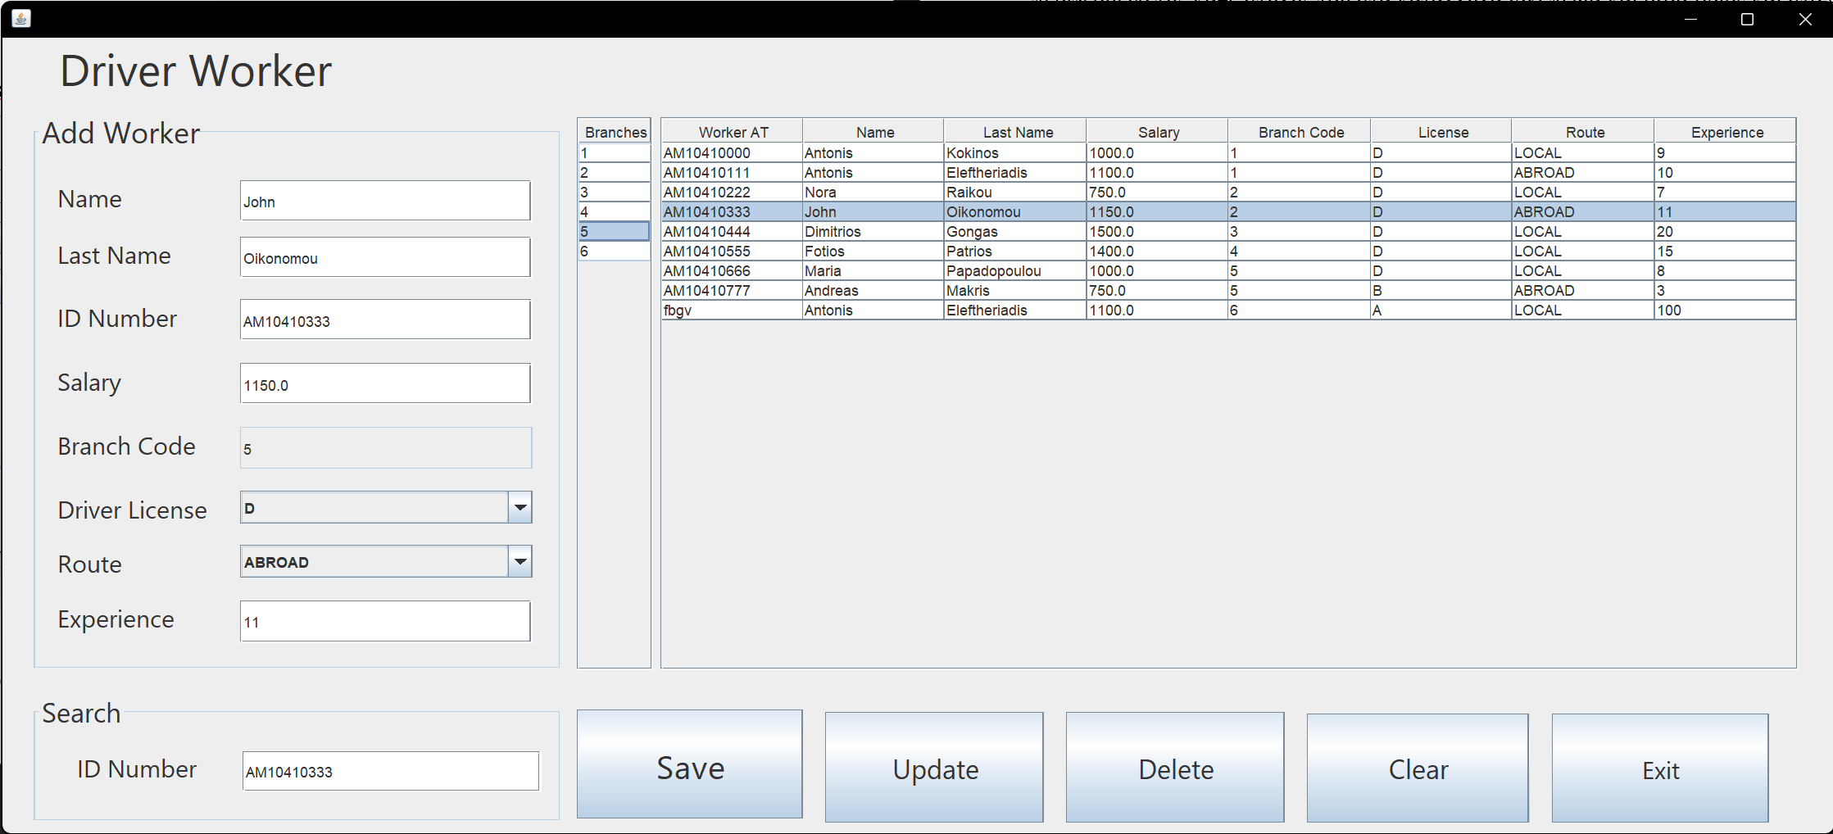

Αφορά τις λειτουργίες insert delete update and search για ένα Driver worker και επηρεάζει τους πίνακες worker and driver. Αποτελείται από τις ακόλουθες μεθόδους που αξιοποιούνται table_load() , table_load_Branches(), SaveButtonActionPerformed() , ExitButtonActionPerformed() , ClearButtonActionPerformed() , jTable2MouseClicked() , UpdateButton2ActionPerformed() , jTable4MouseClicked() , SearchFieldKeyReleased() , DeleteButtonActionPerformed().

**table_load() :** Πραγματοποιεί ένα inner join select στους πίνακες driver και worker και περνάει τα αποτελέσματα της απάντησης του σε έναν Jtable.

**table_load_Branches():** Πραγματοποιεί ένα select στον πίνακα Branches και περνάει τα αποτελέσματα της απάντησης του σε έναν Jtable ώστε όταν πάμε να κάνουμε insert ή update έναν driver, ο χρηστής να έχει γνώση τον υπάρχοντων branches ώστε να επιλέξει ένα.

**SaveButtonActionPerformed():** διαβάζει τα περιεχόμενα των πεδίων Name , Last Name , ID Number , Salary, Branch Code , Driver License , Route και Experience και πραγματοποιεί το insert στους πίνακες driver, worker Για την εισαγωγή ενός driver με την χρήσει του procedure insert_driver. Σε περίπτωση error με την χρήση του sql exception το πιάνουμε και τυπώνουμε το μήνυμα error με μορφή ενός νέου παραθύρου.

**ExitButtonActionPerformed() :** exit από το application.

**ClearButtonActionPerformed():** Καθαρίζει όλα τα πεδία του παραθύρου.

**jTable2MouseClicked() :** Διασφαλίζειότι όταν επιλέγουμε ένα row από τον table driver περνάει το περιεχόμενο της κάθε στήλης του στα κατάλληλα text πεδία, drop fields και στο search πεδίο.

**jTable4MouseClicked():** Διασφαλίζειότι όταν επιλέγουμε ένα row από τον table branch περνάει το id του branch που περιέχει στο πεδίο Branch Code ώστε όταν πάμε να κάνουμε insert ή update έναν admin ο χρηστής να έχει γνώση τον υπάρχοντων branches ώστε να επιλέξει ένα.

**DeleteButtonActionPerformed() :** Διαβάζει το κλειδί του worker που είναι προς διαγραφή από το πεδίο ID Number στο search και τον διαγράφει.

**SearchFieldKeyReleased():** Διαβάζει το κλειδί (ID) του worker που θέλουμε να βρούμε από το πεδίο ID Number στο search και μόλις τον βρει μεταφέρει τα στοιχεία του από τους πίνακες driver and worker στα κατάλληλα πεδία. Η λειτουργία search υπάρχει για ευκολία του user στα operations Delete και Update .

**UpdateButton2ActionPerformed():** Αξιοποιεί την συνάρτηση SearchFieldKeyReleased ώστε να προσφέρει στον χρήστη την τρέχουσα κατάσταση των στοιχείων του driver ώστε να αλλάξει αυτά που επιθυμεί και αξιοποιώντας το τωρινό id (key) από το πεδίο ID Number στο search και πραγματοποιεί το update. Σε περίπτωση που μειώσει το μισθό του υπαλλήλου διεγείρεται το κατάλληλο trigger που εμποδίζει το update τυπώνουμε το κατάλληλο μήνυμα error στον χρηστεί με μορφή ενός νέου παραθύρου.



**Κλάση GuideWorker:**

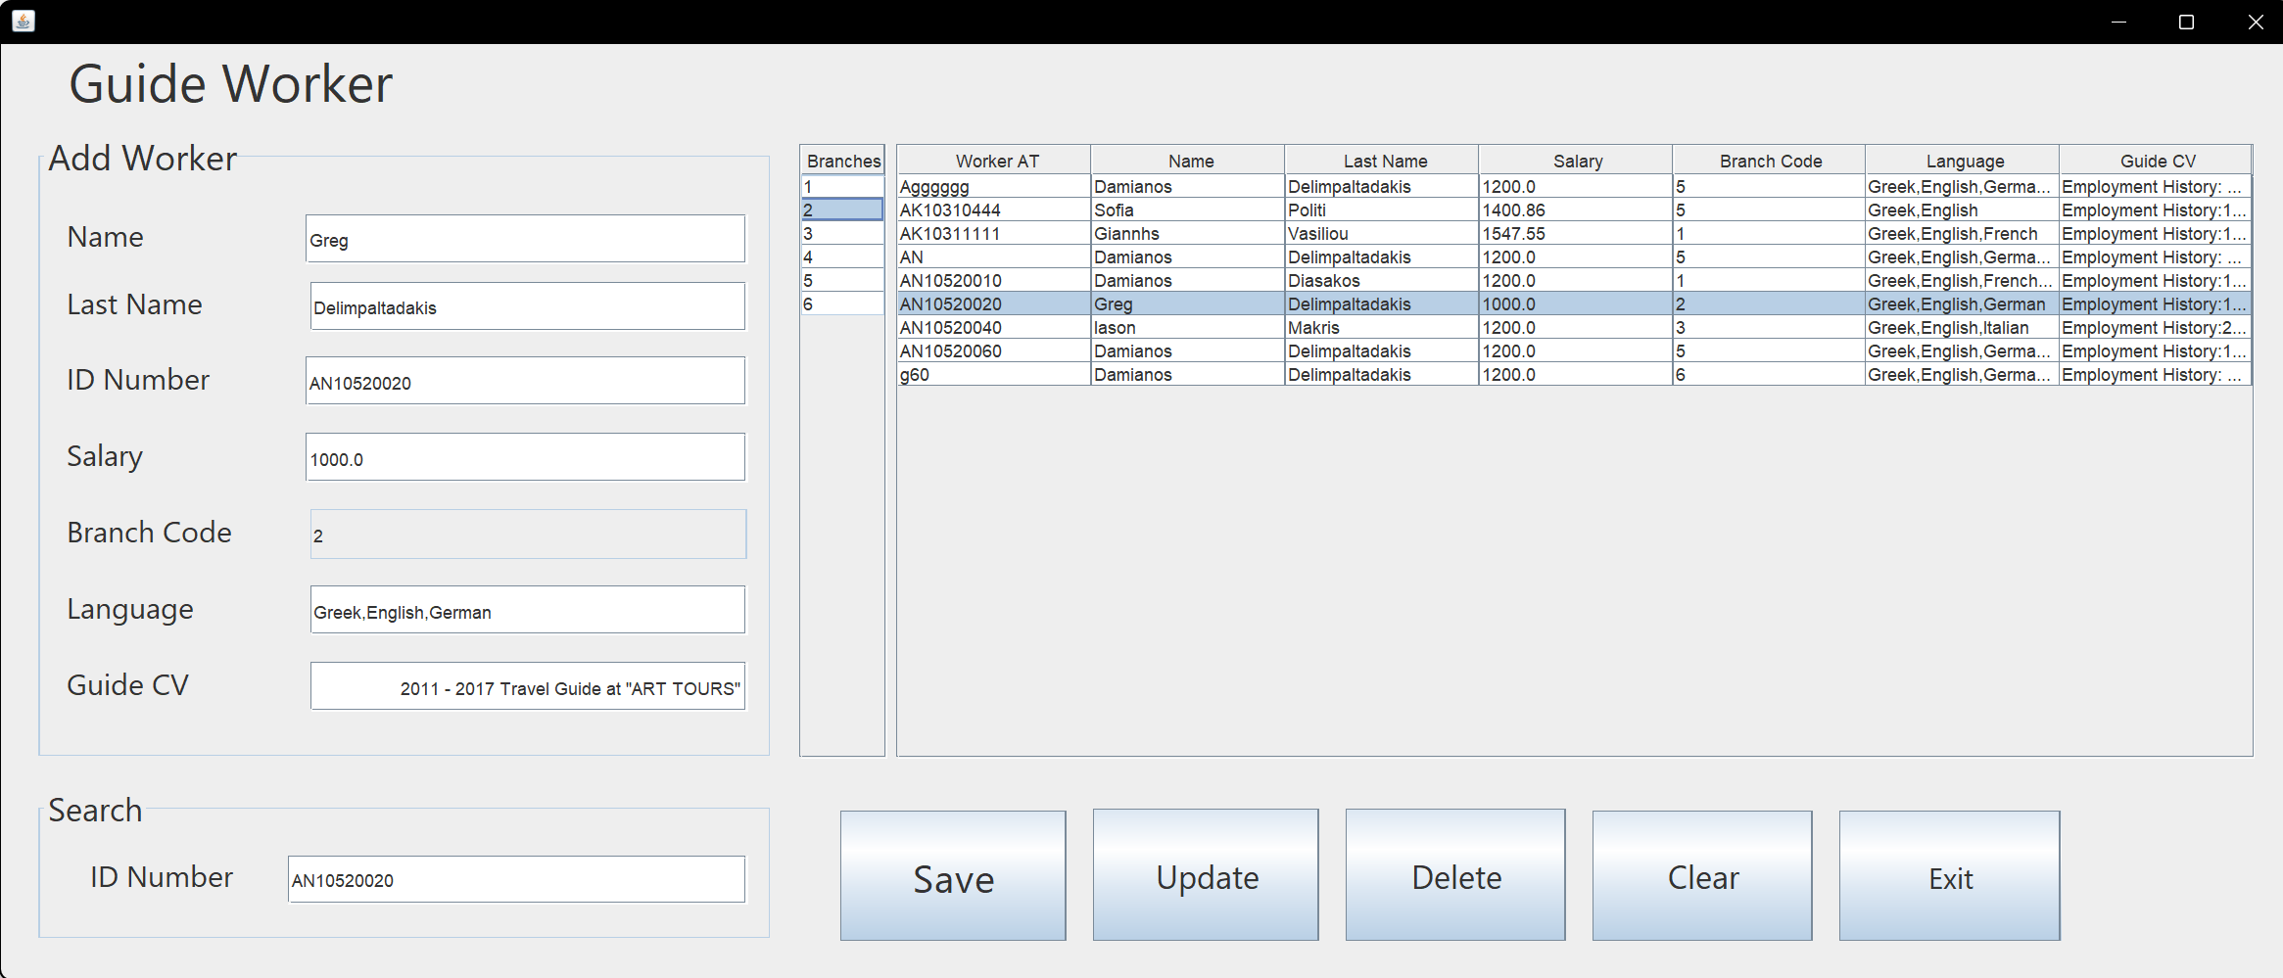

Αφορά τις λειτουργίες insert delete update and search για ένα Guide worker και επηρεάζει τους πίνακες guide worker και language . Αποτελείται από τις ακόλουθες μεθόδους table_load() , table_load_Branches(), SaveButtonActionPerformed() , ExitButtonActionPerformed() , ClearButtonActionPerformed() , jTable2MouseClicked() , UpdateButton2ActionPerformed() , jTable4MouseClicked() , SearchFieldKeyReleased() , DeleteButtonActionPerformed().

**table_load() :** Πραγματοποιεί ένα inner join select στους πίνακες guide, worker και language και περνάει τα αποτελέσματα της απάντησης του σε έναν Jtable.

**table_load_Branches():** Πραγματοποιεί ένα select στον πίνακα Branches και περνάει τα αποτελέσματα της απάντησης του σε έναν Jtable ώστε όταν πάμε να κάνουμε insert ή update έναν admin ο χρηστής να έχει γνώση τον υπάρχοντων branches ώστε να επιλέξει ένα.

**SaveButtonActionPerformed():** Διαβάζει τα περιεχόμενα των πεδίων Name , Last Name , ID Number , Salary, Branch Code , Language και Guide CV και πραγματοποιεί το insert στους πίνακες guide worker and language για την εισαγωγή ενός guide. Σε περίπτωση error με την χρήση του sql exception το πιάνουμε και τυπώνουμε το μήνυμα error στον χρήστη με μορφή ενός νέου παραθύρου.

**ExitButtonActionPerformed() :** Exit από το application.

**ClearButtonActionPerformed():** Καθαρίζει όλα τα πεδία του παραθύρου.

**jTable2MouseClicked() :** Διασφαλίζειότι όταν επιλέγουμε ένα row από τον table guide περνάει το περιεχόμενο της κάθε στήλης του στα κατάλληλα text πεδία και drop fields και στο search πεδίο.

**jTable4MouseClicked():** Διασφαλίζειότι όταν επιλέγουμε ένα row από τον table branch περνάει το id του branch που περιέχει στο πεδίο Branch Code ώστε όταν πάμε να κάνουμε insert ή update έναν admin ο χρηστής να έχει γνώση τον υπάρχοντων branches ώστε να επιλέξει ένα.

**DeleteButtonActionPerformed() :** Διαβάζει το κλειδί του worker που είναι προς διαγραφή από το πεδίο ID Number στο search και τον διαγράφει.

**SearchFieldKeyReleased():** Διαβάζει το κλειδί (ID) του worker που θέλουμε να βρούμε από το πεδίο ID Number στο search και μόλις τον βρει μεταφέρει τα στοιχεία του από τους πίνακες guide worker and language στα κατάλληλα πεδία η λειτουργία search υπάρχει για ευκολία του user στα operations Delete and Update .

**UpdateButton2ActionPerformed():** Αξιοποιεί την συνάρτηση SearchFieldKeyReleased ώστε να προσφέρει στον χρήστη την τρέχουσα κατάσταση των στοιχείων του guide ώστε να αλλάξει αυτά που επιθυμεί και αξιοποιώντας το τωρινό id (key) από το πεδίο ID Number στο search και πραγματοποιεί το update. Σε περίπτωση που μειώσει το μισθό του υπαλλήλου διεγείρεται το κατάλληλο trigger που εμποδίζει το update τυπώνουμε το κατάλληλο μήνυμα error με μορφή ενός νέου παραθύρου.



**Κλάση Branches:**

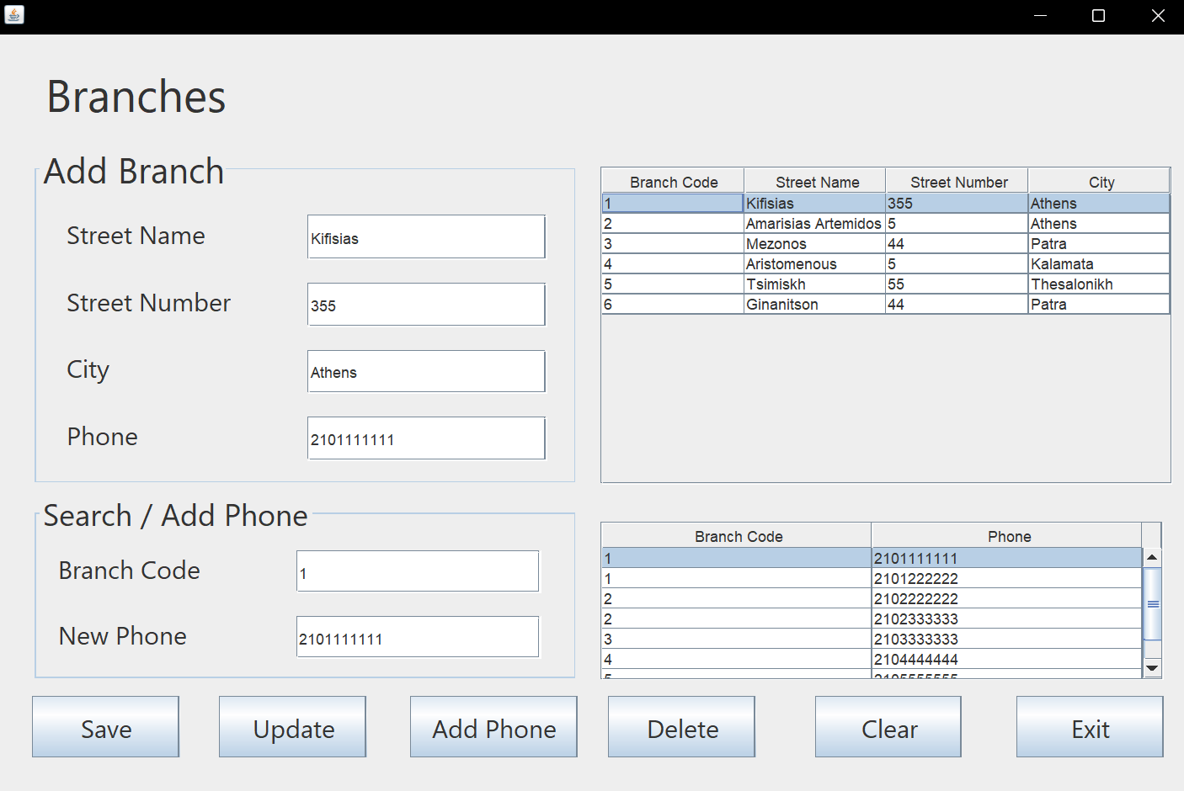

Αφορά τις λειτουργίες insert delete update and search για ένα branch και αλληλοεπιδρά με τον πίνακα branch. Αποτελείται από τις ακόλουθες μεθόδους που αξιοποιούνται table_load(), table_load2(), SaveButtonActionPerformed() , ExitButtonActionPerformed(), ClearButtonActionPerformed() , jTable1MouseClicked() , UpdateButtonActionPerformed() , jTable2MouseClicked() , SearchFieldKeyReleased() , DeleteButtonActionPerformed() , AddPhoneButtonActionPerformed().

**table_load() :** Πραγματοποιεί ένα select στον πίνακα branche και περνάει τα αποτελέσματα από το query σε έναν Jtable.

**table_load2() :** Πραγματοποιεί ένα select για τις στήλες ph_br_code _id και ph_number του πίνακα phones και περνάει τα αποτελέσματα από το query σε έναν Jtable , ώστε ο χρήστης να έχει μια καλύτερη εικόνα για τους διαθέσιμους προορισμός που μπορεί να επιλέξει για το πεδίο phone για τα operations insert delete update ενός τηλεφώνου του branch.

**SearchFieldKeyReleased():** Διαβάζει το κλειδί (ID) του branch και το τηλέφωνο που θέλουμε να βρούμε από το πεδίο Branch Code και New Phone στο search και μόλις το βρει μεταφέρει τα στοιχεία του destination από τον πίνακα destination στo κατάλληλa πεδία. Η λειτουργία search υπάρχει για ευκολία του user στα operations Delete and Update.

**ExitButtonActionPerformed() :** Exit από το application.

**ClearButtonActionPerformed():** Καθαρίζει όλα τα πεδία του παραθύρου.

**jTable1MouseClicked() :** Διασφαλίζειότι όταν επιλέγουμε ένα row από τον jtable branch και περνάει το περιεχόμενο της κάθε στήλης του στα κατάλληλα text πεδία και drop fields και στο search πεδίο.

**jTable2MouseClicked() :** Διασφαλίζειότι όταν επιλέγουμε ένα row από τον πίνακα phone jtable περνάει το περιεχόμενο του τηλεφώνου , στο PhoneField και στο NewPhoneField πεδίο.

**DeleteButtonActionPerformed() :** Διαβάζει το κλειδί του branch που είναι προς διαγραφή από το πεδίο Branch code στο search και το διαγράφει.

**UpdateButtonActionPerformed():** Αξιοποιεί την συνάρτηση SearchFieldKeyReleased ώστε να προσφέρει στον χρήστη την τρέχουσα κατάσταση των στοιχείων του destination ώστε να τροποποιήσει αυτά που επιθυμεί και αξιοποιώντας το τωρινό Branch Code (key) από το πεδίο Branch Code και το New Phone για το τηλέφωνο που είναι προς αλλαγή στο search και πραγματοποιεί το update.

**SaveButtonActionPerformed():** Διαβάζει τα περιεχόμενα των πεδίων Street Name , Street Number , City , Phone και πραγματοποίει το insert στον πίνακα branch για την εισαγωγή ενός νέου υποκαταστήματος . Σε περίπτωση error με την χρήση του sql exception το πιάνουμε και τυπώνουμε το μήνυμα error στον χρήστη με μορφή ενός νέου παραθύρου.

**AddPhoneButtonActionPerformed():** Διαβάζει τα περιεχόμενα των πεδίων Branch code and New Phone και πραγματοποίει το insert στον πίνακα phones για ένα νέο τηλέφωνο . Σε περίπτωση error με την χρήση του sql exception το πιάνουμε και τυπώνουμε το μήνυμα error στον χρήστη με μορφή ενός νέου παραθύρου.

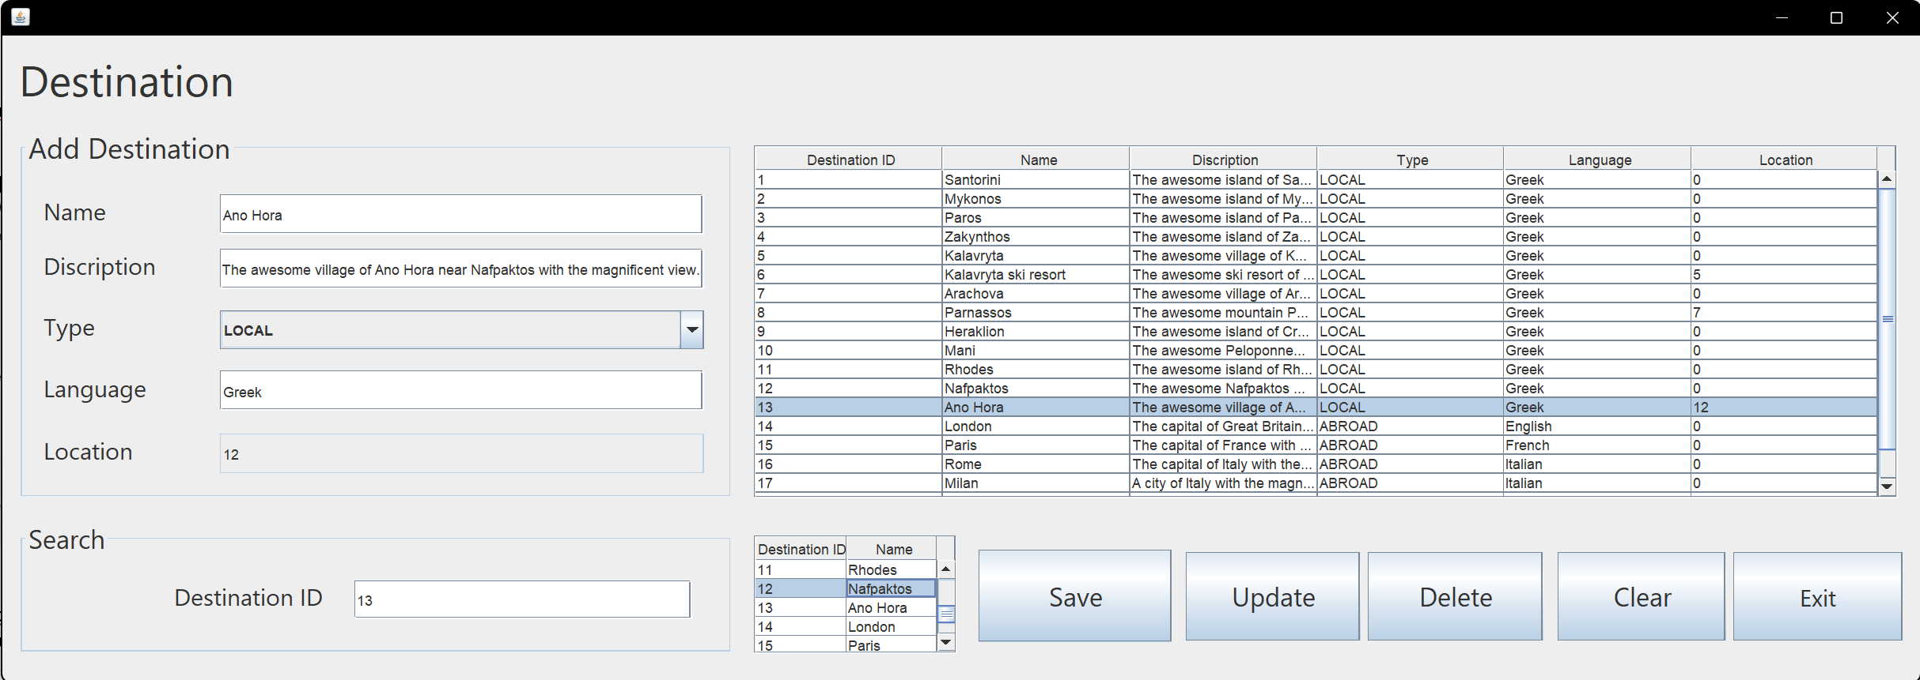**Κλάση Destination:**

Αφορά τις λειτουργίες insert delete update and search για ένα destination και αλληλοεπιδρά με τον πίνακα destination. Αποτελείται από τις ακόλουθες μεθόδους που αξιοποιούνται table_load(), table_load2(), SaveButtonActionPerformed() , ExitButtonActionPerformed(), ClearButtonActionPerformed() , jTable1MouseClicked() , UpdateButton2ActionPerformed() , jTable2MouseClicked() , SearchFieldKeyReleased() , DeleteButton1ActionPerformed().

**table_load() :** Πραγματοποιεί ένα select στον πίνακα destination και περνάει τα αποτελέσματα από το query σε έναν Jtable.

**table_load2() :** Πραγματοποιεί ένα select για τις στήλες dst_id και dst_name του πίνακα destination και περνάει τα αποτελέσματα από το query σε έναν Jtable , ώστε ο χρήστης να έχει μια καλύτερη εικόνα για τους διαθέσιμους προορισμός που μπορεί να επιλέξει για το πεδίο location αυτό αναφορά.

**SearchFieldKeyReleased():** Διαβάζει το κλειδί (ID) του destination που θέλουμε να βρούμε από το πεδίο Destination ID στο search και μόλις το βρει μεταφέρει τα στοιχεία του destination από τον πίνακα destination στo κατάλληλo πεδίo. Η λειτουργία search υπάρχει για ευκολία του user στα operations Delete and Update.

**ExitButtonActionPerformed() :** Exit από το application.

**ClearButtonActionPerformed():** Καθαρίζει όλα τα πεδία του παραθύρου.

**jTable1MouseClicked() :** Διασφαλίζειότι όταν επιλέγουμε ένα row από τον table destination περνάει το περιεχόμενο της κάθε στήλης του στα κατάλληλα text πεδία και drop fields και search πεδίο.

**jTable2MouseClicked() :** Διασφαλίζειότι όταν επιλέγουμε ένα row από τον αυτό αναφορικό destination selector jtable περνάει το περιεχόμενο της κάθε στήλης του, στο Location Text πεδίο.

**DeleteButtonActionPerformed() :** Διαβάζει το κλειδί του destination που είναι προς διαγραφή από το πεδίο Destination ID στο search και το διαγράφει.

**UpdateButton2ActionPerformed():** Αξιοποιεί την συνάρτηση SearchFieldKeyReleased ώστε να προσφέρει στον χρήστη την τρέχουσα κατάσταση των στοιχείων του destination ώστε να τροποποιήσει αυτά που επιθυμεί και αξιοποιώντας το τωρινό id (key) από το πεδίο Destination ID στο search και πραγματοποιεί το update. Το update εκτελείτε σε δυο περίπτωσης αν το location είναι zero (null) τότε ο προορισμός δεν περιέχει sub location άρα στο update query προς την sql δεν τροποποιεί η στήλη dst_location ενώ στην περίπτωση non zero στο update queries τροποποιούμε κατά βούληση το dst_location.

**SaveButtonActionPerformed():** Διαβάζει τα περιεχόμενα των πεδίων Name , Description , Type , Salary, Language και Location και πραγματοποίει το insert στον πίνακα destiantion για την εισαγωγή ενός προορισμού. Το insert εκτελείτε σε δυο περίπτωσης αν το location είναι zero (null) τότε ο προορισμός δεν περιέχει sub location άρα στο insert query προς την sql η στήλη dst_location πενει default τιμή (null) ενώ στην περίπτωση non zero στο insert query τοποθετούμε κατά βούληση στο dst_location. Σε περίπτωση error με την χρήση του sql exception το πιάνουμε και τυπώνουμε το μήνυμα error στον χρήστη με μορφή ενός νέου παραθύρου.

**Κλάση TripEvent**

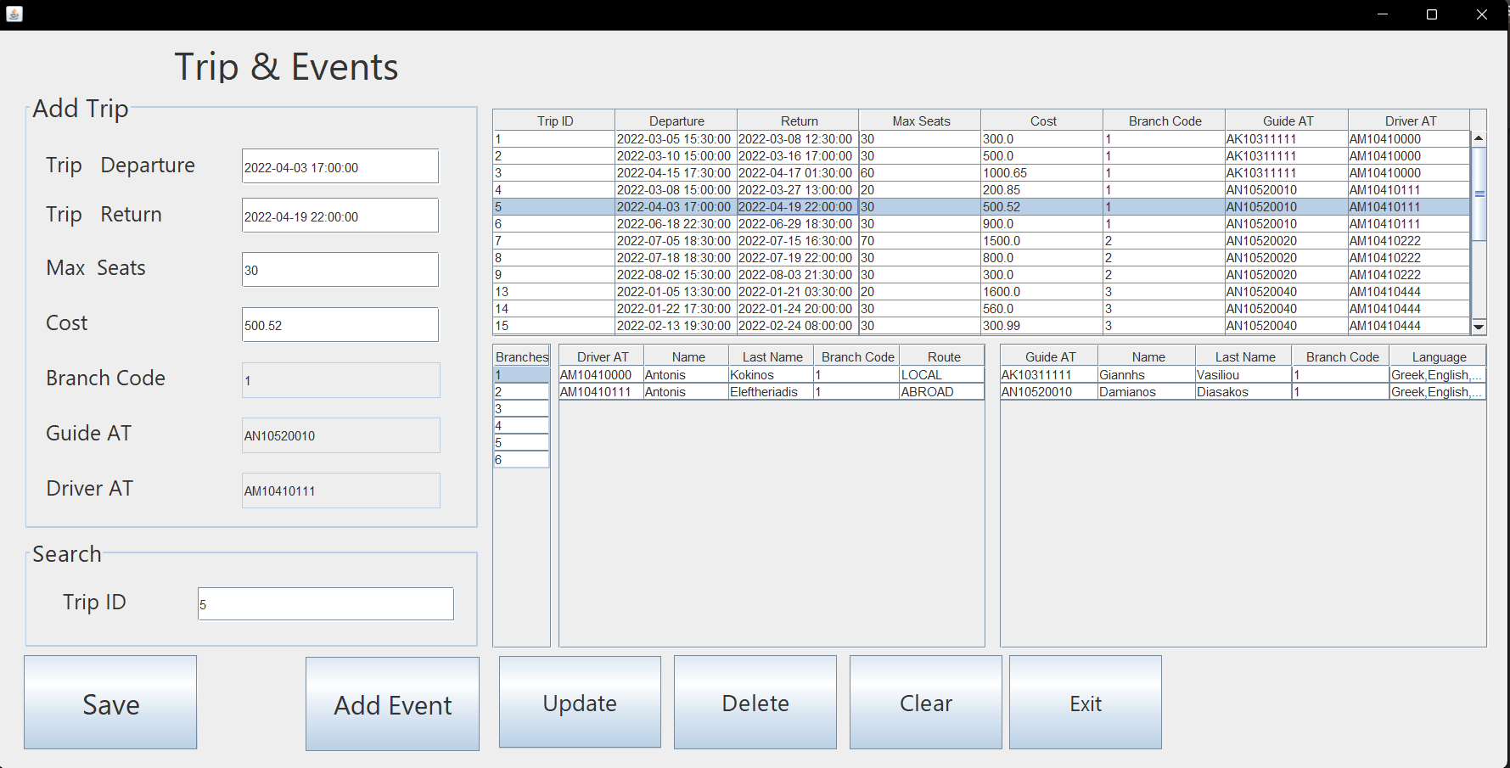

Αφορά τις της λειτουργίες insert delete update and search για ένα Trip & Event και αλληλοεπιδρά σε πρώτη φάση με τον πίνακα Trip και σε δεύτερη με τον πίνακα Events (νέο παράθυρο) . Αποτελείται από τις ακόλουθες μεθόδους που αξιοποιούνται table_load(), table_loadDriver(), table_loadGuide() , table_load_Branches() ,SaveButtonActionPerformed() , ExitButtonActionPerformed(), ClearButtonActionPerformed() , jTable4MouseClicked() , UpdateButton2ActionPerformed() , jTable2MouseClicked() , SearchFieldKeyReleased() , DeleteButtonActionPerformed(), jTabledriverMouseClicked() , jTableguideMouseClicked() , AdddEventButtonActionPerformed().

**table_load() :** Πραγματοποιεί ένα select στον πίνακα Trip της βάσης και περνάει τα αποτελέσματα από το query σε έναν Jtable.

**table_load_Branches():** Πραγματοποιεί ένα select στον πίνακα Branches και περνάει τα αποτελέσματα της απάντησης του σε έναν Jtable ώστε όταν πάει να κάνει insert ή update ένα trip ο χρηστής, να έχει γνώση τον υπάρχοντων branches ώστε, να επιλέξει ένα.

**table_loadDriver (String bf) :** Δέχεται σαν όρισμα τον branch code που έχουμε επιλέξει μέχρι τώρα από το πεδίο Branch Code και πραγματοποιεί ένα inner join select στους πίνακες worker και driver, για βρεί τους διαθέσιμους drivers του επιλεγμένου branch. Περνάει τα αποτελέσματα της απάντησης του σε έναν Jtable ώστε όταν πάει να κάνει insert ή update ένα trip ο χρηστής να έχει γνώση των διαθέσιμων drivers και των στοιχείων τους ώστε να επιλέξει ένα.

**table_loadGuide (String bf) :** Δέχεται σαν όρισμα τον branch code που έχουμε επιλέξει μέχρι τώρα από το πεδίο Branch Code και πραγματοποιεί ένα inner join select στους πίνακες worker , guide και languages , για βρει τους διαθέσιμους guides του επιλεγμένου branch. Περνάει τα αποτελέσματα της απάντησης του σε έναν Jtable ώστε όταν πάει να κάνει insert ή update ένα trip ο χρηστής να έχει γνώση των διαθέσιμων guides και των στοιχείων τους ώστε να επιλέξει ένα.

**jTable4MouseClicked():** Διασφαλίζειότι όταν επιλέγουμε ένα row από τον table branch περνάει το id του branch που περιέχει στο πεδίο Branch Code ώστε όταν πάμε να κάνουμε insert ή update ένα trip ο χρηστής να έχει γνώση τον υπάρχοντων branches ώστε να επιλέξει ένα.

**jTable2MouseClicked() :** Διασφαλίζειότι όταν επιλέγουμε ένα row από τον table trip περνάει το περιεχόμενο της κάθε στήλης του στα κατάλληλα text πεδία και drop fields και στο search πεδίο.

**UpdateButton2ActionPerformed():** Αξιοποιεί την συνάρτηση SearchFieldKeyReleased ώστε να προσφέρει στον χρήστη την τρέχουσα κατάσταση των στοιχείων του trip, ώστε να τροποποιήσει αυτά που επιθυμεί και αξιοποιώντας το τωρινό id (key) από το πεδίο Trip ID στο search πραγματοποιεί το update στην εγγραφή.

**DeleteButtonActionPerformed() :** Διαβάζει το κλειδί του trip που είναι προς διαγραφή από το πεδίο Trip ID στο search και το διαγράφει.

**SearchFieldKeyReleased():** Διαβάζει το κλειδί (ID) του trip που θέλουμε να βρούμε από το πεδίο Trip ID στο search και μόλις το βρει μεταφέρει τα στοιχεία του από τον πίνακα trip στα κατάλληλα πεδία η λειτουργία search υπάρχει για ευκολία του user στα operations Delete and Update.

**ExitButtonActionPerformed() :** Εxit από το application.

**ClearButtonActionPerformed():** Καθαρίζει όλα τα πεδία του παραθύρου

**SaveButtonActionPerformed():** Διαβάζει τα περιεχόμενα των πεδίων Trip Departure , Trip Return , Max seats ,Cost , Branch Code , Guide AT , Driver AT και πραγματοποιεί το insert στον πίνακα trip για την εισαγωγή ενός νέου trip. Σε περίπτωση error με την χρήση του sql exception το πιάνουμε και τυπώνουμε το μήνυμα error στον χρήστη με μορφή ενός νέου παραθύρου.

**jTabledriverMouseClicked():** Διασφαλίζειότι όταν επιλέγουμε ένα row από τον jtable driver περνάει το id του driver που περιέχει στο πεδίο Driver AΤ ώστε όταν πάμε να κάνουμε insert ή update ένα trip ο χρηστής να έχει γνώση τον υπάρχοντων Drivers ώστε να επιλέξει ένα.

**jTableguideMouseClicked():** Διασφαλίζειότι όταν επιλέγουμε ένα row από τον jtable guide περνάει το id του guide που περιέχει στο πεδίο Guide AI ώστε όταν πάμε να κάνουμε insert ή update ένα trip ο χρηστής να έχει γνώση τον υπάρχοντων guides ώστε να επιλέξει ένα.

**AddEventButtonActionPerformed() :** αποτελεί το κουμπί που οδηγεί τον χρήστη σε ένα νέο γραφικό παράθυρο που αφορά τα operations για τον πίνακα Event.

**Κλάση Events**

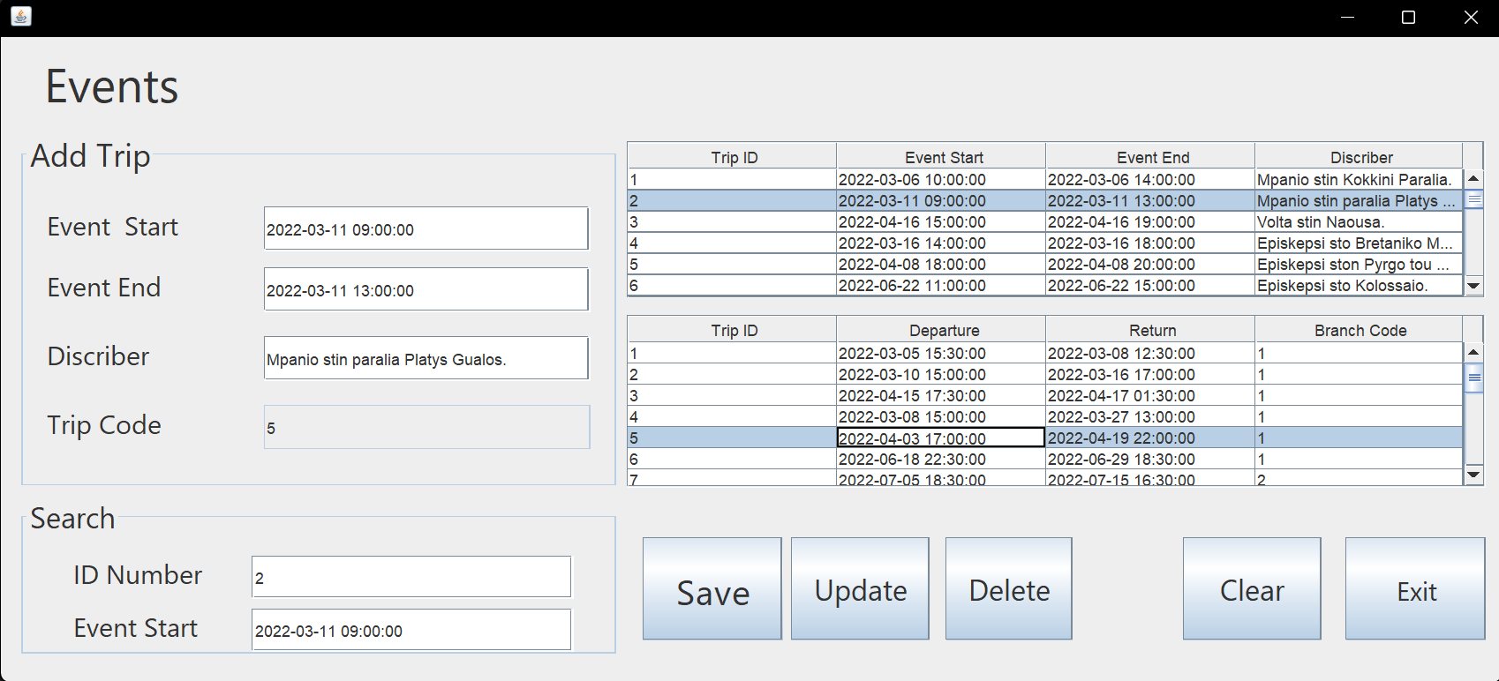

Αφορά τις λειτουργίες insert delete update and search για ένα event και αλληλοεπιδρά με τον πίνακα event. Η πρόσβαση σε αυτό το παράθυρο του gui πραγματοποιείται μέσα από το παράθυρο trip για λογούς συνέχειας, διότι τα γεγονότα συσχετίζονται άμεσα με το ένα ταξίδι . Αποτελείται από τις ακόλουθες μεθόδους που αξιοποιούνται table_load(), table_load2(), SaveButtonActionPerformed() , ExitButtonActionPerformed(), ClearButtonActionPerformed() , jTable1MouseClicked() , UpdateButton2ActionPerformed() , jTable2MouseClicked() , SearchField2KeyReleased() , DeleteButton1ActionPerformed().

**table_load() :** Πραγματοποιεί ένα select στον πίνακα Events και περνάει τα αποτελέσματα από το query σε έναν Jtable.

**table_load2() :** Πραγματοποιεί ένα select για τις στήλες tr_id , tr_departure , tr_return και tr_br_code του πίνακα trip και περνάει τα αποτελέσματα από το query σε έναν Jtable . Για να έχει ο χρήστης μια καλύτερη εικόνα για τους διαθέσιμα ταξίδια που μπορεί να επιλέξει για το πεδίο Trip Code του event το οποί συνδέει ένα event με το ταξίδι στο οποίο ανήκει .

**ExitButtonActionPerformed() :** Εxit από το application.

**ClearButtonActionPerformed():** Καθαρίζει όλα τα πεδία του παραθύρου.

**DeleteButtonActionPerformed() :** Διαβάζει τα δυο κλειδιά του event που είναι προς διαγραφή από τα πεδία ID Number and Event Start στο σύνολο πεδίων search και διαγράφει το event που επιθυμούμε.

**SaveButtonActionPerformed():** Διαβάζει τα περιεχόμενα των πεδίων Event Start , Event End , Describer , Trip Code και πραγματοποιεί το insert στον πίνακα event για την εισαγωγή ενός event. Σε περίπτωση error με την χρήση του sql exception το πιάνουμε και τυπώνουμε το μήνυμα error στον χρήστη με μορφή ενός νέου παραθύρου.

**UpdateButton2ActionPerformed():** Αξιοποιεί την συνάρτηση SearchFieldKeyReleased ώστε να προσφέρει στον χρήστη την τρέχουσα κατάσταση των στοιχείων του guide, για να τροποποιήσει αυτά που επιθυμεί. Αξιοποιώντας τα τωρινά κλειδιά του event από τα πεδία ID Number and Event Start στο σύνολο πεδίων search, πραγματοποιεί το update.

**SearchFieldKeyReleased():** Διαβάζει τα κλειδιά του event που θέλουμε να βρούμε από τα πεδία ID Number and Event Start στο σύνολο πεδίων και μόλις το βρει μεταφέρει τα στοιχεία του event από τον πίνακα event στα κατάλληλα πεδία, η λειτουργία search υπάρχει για ευκολία του user στα operations Delete and Update.

**jTable1MouseClicked() :** Διασφαλίζειότι όταν επιλέγουμε ένα row από τον table trip περνάει το περιεχόμενο της στήλης id του στο text πεδίο Trip Code.

**jTable2MouseClicked() :** Διασφαλίζειότι όταν επιλέγουμε ένα row από τον jtable event περνάει το περιεχόμενο της κάθε στήλης του στα κατάλληλα text πεδία και drop fields και search πεδία.

**Κλάση Offers :**

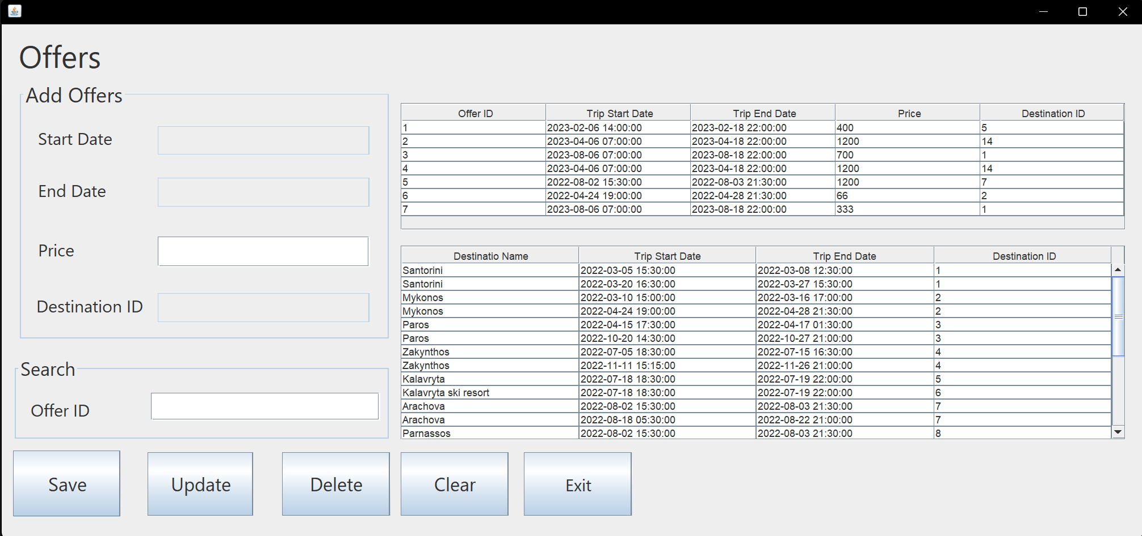

Αφορά τις λειτουργίες insert delete update and search για ένα offer και αλληλοεπιδρά τον πίνακα doffers. Αποτελείται από τις ακόλουθες μεθόδους που αξιοποιούνται table_load(), table_load2(), SaveButtonActionPerformed(), ExitButtonActionPerformed(), ClearButtonActionPerformed() , jTable1MouseClicked() , UpdateButton2ActionPerformed() , jTable2MouseClicked() , SearchFieldKeyReleased() , DeleteButton1ActionPerformed().

**table_load() :** Πραγματοποιεί ένα select στον πίνακα offers και περνάει τα αποτελέσματα από το query σε έναν Jtable.

**table_load2() :** Πραγματοποιεί ένα select για τις στήλες dst_id ,dst_name, tr_departure και tr_return του πίνακα trip και περνάει τα αποτελέσματα από το query σε έναν Jtable , ώστε ο χρήστης να έχει μια καλύτερη εικόνα για τa διαθέσιμους προορισμούς μπορεί να επιλέξει έναν για το offer (πεδίο Destination id).

**SearchFieldKeyReleased():** Διαβάζει το κλειδί (ID) του offer που θέλουμε να βρούμε από το πεδίο Offer ID στο search και μόλις το βρει μεταφέρει τα στοιχεία του offer από τον πίνακα offers στα κατάλληλα πεδία η λειτουργία search υπάρχει για ευκολία του user στα operations Delete and Update.

**ExitButtonActionPerformed() :** Εxit από το application.

**ClearButtonActionPerformed():** Καθαρίζει όλα τα πεδία του παραθύρου.

**jTable1MouseClicked() :** Διασφαλίζειότι όταν επιλέγουμε ένα row από τον jtable offers περνάει το περιεχόμενο της κάθε στήλης του στα κατάλληλα text πεδία και drop fields και στο search πεδίο.

**jTable2MouseClicked() :** Διασφαλίζειότι όταν επιλέγουμε ένα row από destination s jtable περνάει το περιεχόμενο του της id στήλης του στο Destination ID Text πεδίο.

**DeleteButtonActionPerformed() :** Διαβάζει το κλειδί του offer που είναι προς διαγραφή από το πεδίο Destination ID στο search και το διαγράφει.

**UpdateButton2ActionPerformed():** Αξιοποιεί την συνάρτηση SearchFieldKeyReleased ώστε να προσφέρει στον χρήστη την τρέχουσα κατάσταση των στοιχείων του offer ώστε να τροποποιήσει αυτά που επιθυμεί και αξιοποιώντας το τωρινό id (key) από το πεδίο Offer ID στο search πραγματοποιεί το update.

**SaveButtonActionPerformed():** Διαβάζει τα περιεχόμενα των πεδίων Start Date , End Date , Price , Destiantion ID και πραγματοποιεί το insert στον πίνακα offers για την εισαγωγή ενός offer. Σε περίπτωση error με την χρήση του sql exception το πιάνουμε και τυπώνουμε το μήνυμα error στον χρήστη με μορφή ενός νέου παραθύρου.

**Κλάση ReservationOffers :**

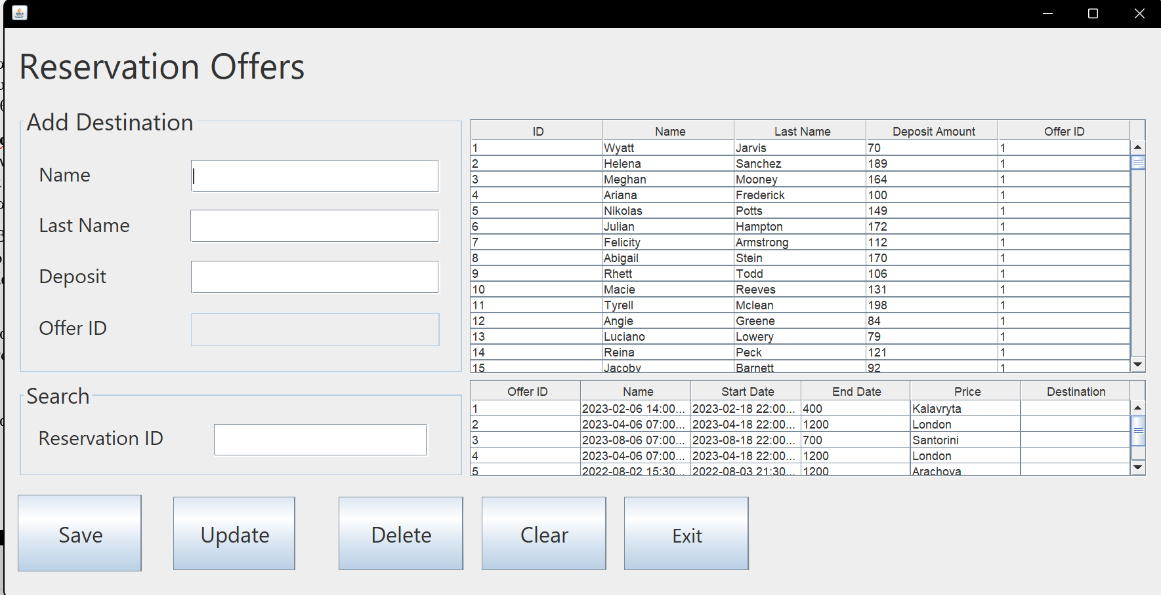

Αφορά τις λειτουργίες insert delete update and search για ένα offer και αλληλοεπιδρά τον πίνακα reservation_offers. Αποτελείται από τις ακόλουθες μεθόδους που αξιοποιούνται table_load(), table_load2(), SaveButtonActionPerformed() , ExitButtonActionPerformed(), ClearButtonActionPerformed() , jTable1MouseClicked() , UpdateButton2ActionPerformed() , jTable2MouseClicked() , SearchFieldKeyReleased() , DeleteButton1ActionPerformed().

**table_load() :** Πραγματοποιεί ένα select στον πίνακα reservation_offers και περνάει τα αποτελέσματα από το query σε έναν Jtable.

**table_load2() :** Πραγματοποιεί ένα inner join select για τις στήλες offer_id ,offer_trip_start_date , offer_trip_end_date ,Price_per_Person και dst_name των πινάκων offers και destination και περνάει τα αποτελέσματα από το query σε έναν Jtable , ώστε ο χρήστης να έχει μια καλύτερη εικόνα για τα διαθέσιμες προσφορές που μπορεί να επιλέξει έναν για το reservation offer (πεδίο Offer id ).

**SearchFieldKeyReleased():** Διαβάζει το κλειδί (ID) του reservation offer που θέλουμε να βρούμε από το πεδίο Reservation ID στο search και μόλις το βρει μεταφέρει τα στοιχεία του reservation offer από τον πίνακα reservation_offers στα κατάλληλα πεδία. H λειτουργία search υπάρχει για ευκολία του user στα operations Delete and Update.

**ExitButtonActionPerformed() :** Exit από το application.

**ClearButtonActionPerformed():** Καθαρίζει όλα τα πεδία του παραθύρου.

**jTable1MouseClicked() :** Διασφαλίζειότι όταν επιλέγουμε ένα row από τον jtable reservation_offers περνάει το περιεχόμενο της κάθε στήλης του στα κατάλληλα text πεδία και drop fields και στο search πεδίο.

**jTable2MouseClicked() :** Διασφαλίζειότι όταν επιλέγουμε ένα row από το offer jtable περνάει το περιεχόμενο του της id στήλης του στο Offer ID Text πεδίο.

**DeleteButtonActionPerformed() :** Διαβάζει το κλειδί του reservation offer που είναι προς διαγραφή από το πεδίο Destination ID στο search και το διαγράφει.

**UpdateButton2ActionPerformed():** Αξιοποιεί την συνάρτηση SearchFieldKeyReleased ώστε να προσφέρει στον χρήστη την τρέχουσα κατάσταση των στοιχείων του offer ώστε να τροποποιήσει αυτά που επιθυμεί και αξιοποιώντας το τωρινό id (key) από το πεδίο Reservation ID στο search πραγματοποιεί το update.

**SaveButtonActionPerformed():** Διαβάζει τα περιεχόμενα των πεδίων Name , Last Name , Deposit , Offer ID και πραγματοποιεί το insert στον πίνακα reservation_offers για την εισαγωγή ενός reservation offer. Σε περίπτωση error με την χρήση του sql exception το πιάνουμε και τυπώνουμε το μήνυμα error στον χρήστη με μορφή ενός νέου παραθύρου.

**Κλάση** **Reservations:**

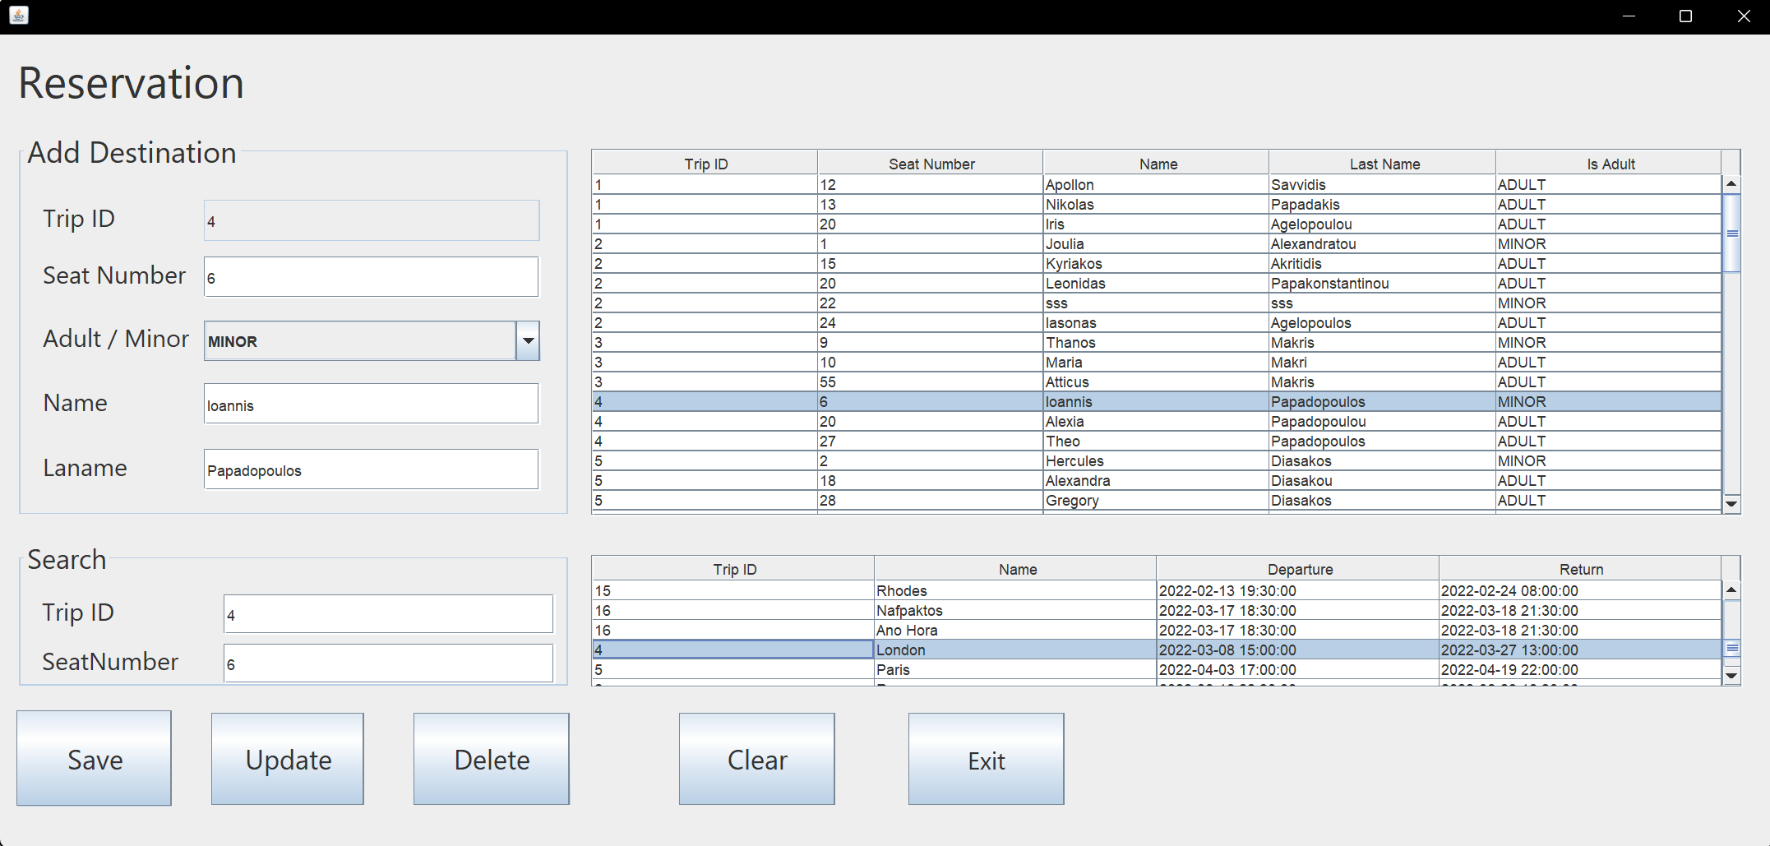

Αφορά τις λειτουργίες insert delete update and search για ένα Reservation και αλληλοεπιδρά με τον πίνακα reservation. Αποτελείται από τις ακόλουθες μεθόδους που αξιοποιούνται table_load(), table_load2(), SaveButtonActionPerformed() , ExitButtonActionPerformed(), ClearButtonActionPerformed() , jTable1MouseClicked() , UpdateButton2ActionPerformed() , jTable2MouseClicked() , SearchField2KeyReleased() , DeleteButton1ActionPerformed().

**table_load() :** Πραγματοποιεί ένα select στον πίνακα reservation και περνάει τα αποτελέσματα από το query σε έναν Jtable.

**table_load2() :** Πραγματοποιεί ένα inner join select για τις στήλες tr_id ,tr_departure, tr_return και dst_name τους πίνακες trip και destination περνάει τα αποτελέσματα από το query σε έναν Jtable, ώστε ο χρήστης να έχει μια καλύτερη εικόνα για τους διαθέσιμα ταξίδια που μπορεί να επιλέξει για το πεδίο Trip ID του reservation το οποίo συνδέει ένα reservation με το ταξίδι.

**ExitButtonActionPerformed() :** Exit από το application.

**ClearButtonActionPerformed():** Καθαρίζει όλα τα πεδία του παραθύρου.

**DeleteButtonActionPerformed() :** Διαβάζει τα δυο κλειδιά του reservation που είναι προς διαγραφή από τα πεδία Trip ID and SeatNumber στο σύνολο πεδίων search και διαγράφει το reservation που επιθυμούμε.

**SaveButtonActionPerformed():** Διαβάζει τα περιεχόμενα των πεδίων Trip ID , Seat Number , Adult / Minor, Name and Lname και πραγματοποιεί το insert στον πίνακα reservation για την εισαγωγή ενός reservation. Ωστόσο πριν πραγματοποίηση την εισαγωγή ελέγχει αν ο αριθμός της θέσεις που επέλεξε ο πελάτης για το ταξίδι είναι μικρότερος ή ίσος με τον μέγιστο αριθμού θέσεων του ταξιδιού που έκανε την κράτηση ο πελάτης . Στην περίπτωση που είναι τυπώνει το κατάλληλο μήνυμα σε ένα νέο παράθυρο. Ενώ για την ύπαρξη άλλου error με την χρήση του sql exception το πιάνουμε και τυπώνουμε το μήνυμα error στον χρήστη με μορφή ενός νέου παραθύρου.

**UpdateButton2ActionPerformed():** Αξιοποιεί την συνάρτηση SearchFieldKeyReleased ώστε να προσφέρει στον χρήστη την τρέχουσα κατάσταση των στοιχείων του reservation ώστε να τροποποιήσει αυτά που επιθυμεί και αξιοποιώντας τα τωρινά κλειδιά του reservation από τα πεδία Trip ID and Seat Start στο σύνολο πεδίων search και πραγματοποιεί το update. Ωστόσο πριν πραγματοποιήσει τo update ελέγχει αν ο αριθμός της θέσεις που επέλεξε για το ταξίδι είναι μικρότερος ή ίσος απο τον μέγιστο αριθμού θέσεων του ταξιδιού που έκανε την κράτηση ο πελάτης . Στην περίπτωση που είναι τυπώνει το κατάλληλο μήνυμα σε ένα νέο παράθυρο.

**SearchFieldKeyReleased():** Διαβάζει τα κλειδιά του reservation που θέλουμε να βρούμε από τα πεδία Trip ID and Seat Start στο σύνολο πεδίων και μόλις το βρει μεταφέρει τα στοιχεία του reservation από τον πίνακα event στα κατάλληλα πεδία. Η λειτουργία search υπάρχει για ευκολία του user στα operations Delete and Update.

**jTable1MouseClicked() :** Διασφαλίζειότι όταν επιλέγουμε ένα row από τον table reservation περνάει το περιεχόμενο της στήλης id του στο text πεδίο Trip Code.

**jTable2MouseClicked() :** Διασφαλίζειότι όταν επιλέγουμε ένα row από τον jtable destination περνάει το περιεχόμενο της κάθε στήλης του στα κατάλληλα text πεδία και drop fields και search πεδία.

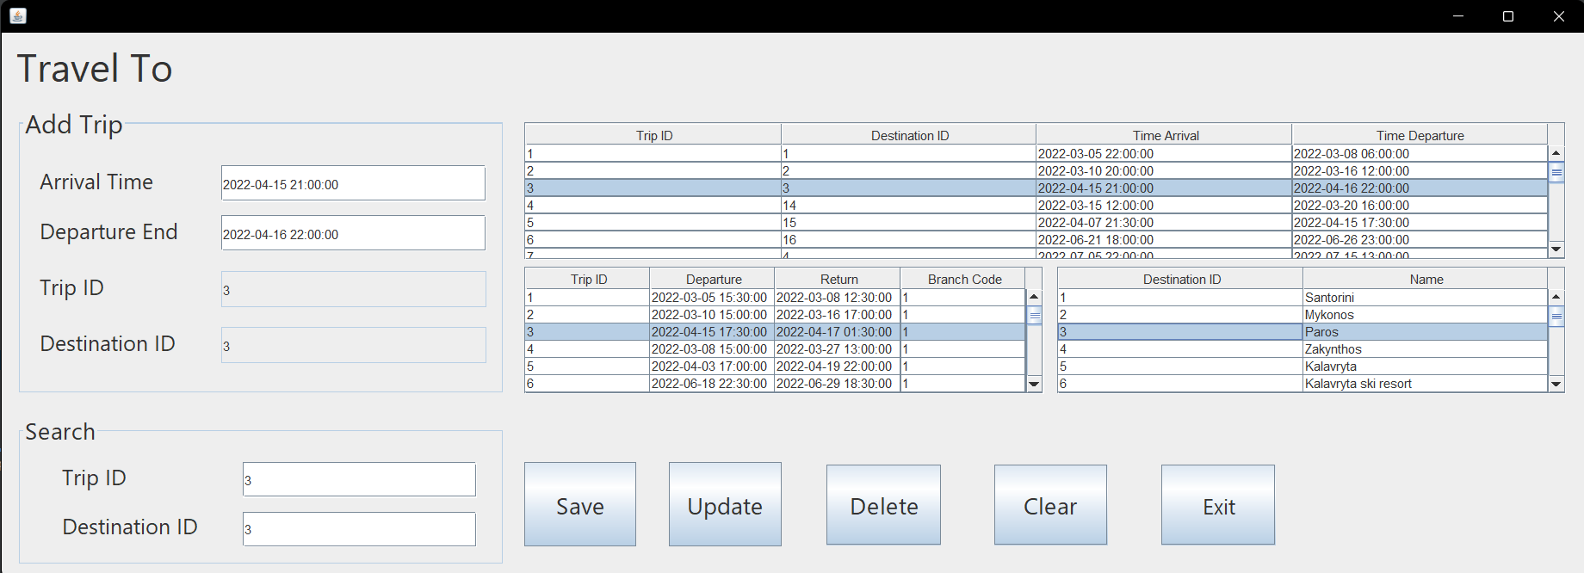**Κλάση Travel_To**

Αφορά τις λειτουργίες insert delete update and search για ένα Travel To και αλληλοεπιδρά με τον πίνακα travel_to. Αποτελείται από τις ακόλουθες μεθόδους που αξιοποιούνται table_load(), table_load2(), table_load3() , SaveButtonActionPerformed() , ExitButtonActionPerformed(), ClearButtonActionPerformed() , jTable1MouseClicked() , UpdateButton2ActionPerformed() , jTable2MouseClicked() , SearchField2KeyReleased() , DeleteButton1ActionPerformed().

**table_load() :** Πραγματοποιεί ένα select στον πίνακα Travel To και περνάει τα αποτελέσματα από το query σε έναν Jtable.

**table_load2() :** Πραγματοποιεί ένα inner join select για τις στήλες tr_id ,tr_departure, tr_return και dst_name τους πίνακες trip και destination περνάει τα αποτελέσματα από το query σε έναν Jtable, ώστε ο χρήστης να έχει μια καλύτερη εικόνα για τους διαθέσιμα ταξίδια που μπορεί να επιλέξει για το πεδίο Trip ID του reservation το οποίo συνδέει ένα reservation με το ταξίδι.

**table_load3() :** Πραγματοποιεί ένα inner join select για τις στήλες tr_id ,tr_departure, tr_return και dst_name τους πίνακες trip και destination περνάει τα αποτελέσματα από το query σε έναν Jtable , ώστε ο χρήστης να έχει μια καλύτερη εικόνα για τους διαθέσιμα ταξίδια που μπορεί να επιλέξει για το πεδίο Trip ID του reservation το οποί συνδέει ένα reservation με το ταξίδι.

**ExitButtonActionPerformed() :** Exit από το application.

**ClearButtonActionPerformed():** Καθαρίζει όλα τα πεδία του παραθύρου.

**DeleteButtonActionPerformed() :** Διαβάζει τα δυο κλειδιά του travel_to που είναι προς διαγραφή από τα πεδία Trip ID and Destionation Id στο σύνολο πεδίων search και διαγράφει το travel_to που επιθυμούμε.

**SaveButtonActionPerformed():** Διαβάζει τα περιεχόμενα των πεδίων Trip ID , Destination ID, Arrival Time Departure και πραγματοποιεί το insert στον πίνακα travel_to.

**UpdateButton2ActionPerformed():** Αξιοποιεί την συνάρτηση SearchFieldKeyReleased ώστε να προσφέρει στον χρήστη την τρέχουσα κατάσταση των στοιχείων του travel_to ώστε να τροποποιήσει αυτά που επιθυμεί και αξιοποιώντας τα τωρινά κλειδιά του travel_to από τα πεδία Trip ID and Destination ID στο σύνολο πεδίων search και πραγματοποιεί το update.

**SearchFieldKeyReleased():** Διαβάζει τα κλειδιά του travel_to που θέλουμε να βρούμε από τα πεδία Trip ID and Destination ID στο σύνολο πεδίων και μόλις το βρει μεταφέρει τα στοιχεία του travel_to από τον πίνακα travel_to στα κατάλληλα πεδία. H λειτουργία search υπάρχει για ευκολία του user στα operations Delete and Update.

**jTable1MouseClicked() :** Διασφαλίζειότι όταν επιλέγουμε ένα row από τον table trip περνάει το περιεχόμενο της στήλης id του στο text πεδίο Trip Code.

**jTable2MouseClicked() :** Διασφαλίζειότι όταν επιλέγουμε ένα row από τον jtable destination περνάει το περιεχόμενο της κάθε στήλης του στα κατάλληλα text πεδία και drop fields και search πεδία.

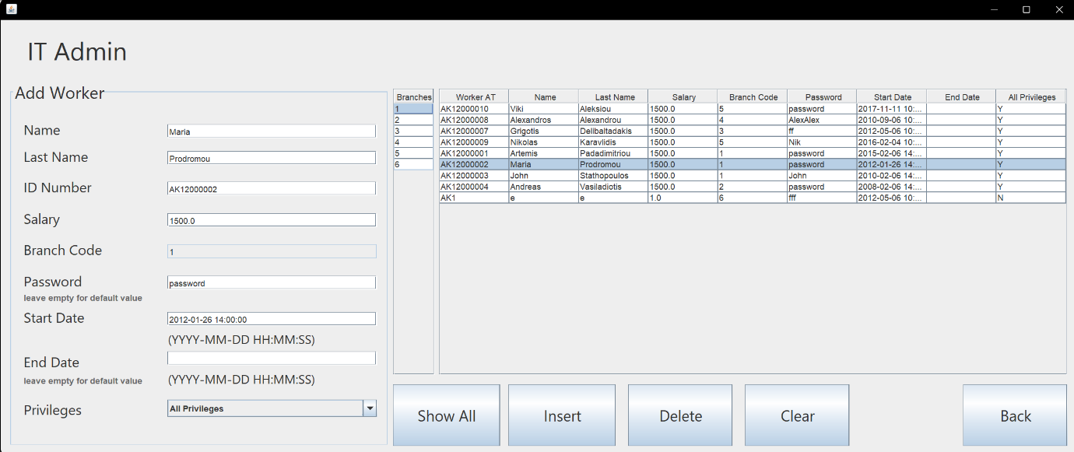**Κλάση ItAdmin**

Αφορά τις λειτουργίες insert, delete για ένα ItAdmin και αλληλοεπιδρά με τον πίνακα it_admin.

**Constructor:**

**public ItAdmin() {**

**initComponents();**

**tmodel = (DefaultTableModel) jTable.getModel();**

**branch_tmodel = (DefaultTableModel) jTable.getModel();**

**selectAll();**

**tableLoadBranches();**

**}**

Στον δημιουργό της κλάσης φορτώνουμε τα μοντέλα του βασικού πίνακα και του πίνακα των branches και γεμίζουμε τους πίνακες με τις κατάλληλες εγγραφές

**Εμφάνιση των διαχειριστών:**

H συμπλήρωση του βασικού πίνακα γίνεται με την χρήση της μεθόδου selectAll(). Σε αυτή την μέθοδο εκτελείται το ακόλουθο query:

ResultSet rs = stmt.executeQuery("SELECT wrk_AT,wrk_name,wrk_lname,wrk_salary,wrk_br_code, " +

"it_password,it_start_date,it_end_date,Insert_priv FROM worker " +

"INNER JOIN it_admin ON it_at = wrk_AT " +

"INNER JOIN mysql.db ON wrk_lname = User");

Έτσι μπορούμε να δούμε όλα τα γνωρίσματα ενός it_admin τα οποία λαμβάνουμε από τους πίνακες it_admin, worker και mysql.db (για τα δικαιώματα του χρήστη).

**Κουμπί Insert:**

Το πάτημα αυτού του κουμπιού καλεί την μέθοδο insertItAdmin().

**insertItAdmin() και insertItAdminDefPass():**

Σκοπός της μεθόδου είναι να προσθέσει έναν νέο διαχειριστή πληροφορική στην βάση. Αρχικά συμπληρώνουμε τα πεδία κειμένου του παραθύρου μας με τις ζητούμενες πληροφορίες και επιλέγουμε το branch στο οποίο θα εισαχθεί και το είδος των δικαιωμάτων που θα έχει. Έπειτα καλείται η μέθοδος createUser(), η οποία εκτελεί τις stored procedure create_user() ή create_select_user() ανάλογα με τα Privileges που επιλέξαμε. Αφού δημιουργηθεί ο χρήστης στην βάση με επιτυχία, εισάγουμε μία εγγραφή με τα στοιχεία του στον πίνακα worker και μετά ανάλογα με το αν έχουμε συμπληρώσει το πεδίο password ή όχι, τον εισάγουμε και στον πίνακα it_admin με τον κωδικό που δόθηκε ή με τον default κωδικό (χρήση της insertItAdminDefPass()). Εαν παρουσιαστεί SQLException στην εκτέλεση των insert, διαγράφουμε τον χρήστη από τον πίνακα mysql.db και κάνουμε drop user.

**Κουμπί Insert:**

Το πάτημα αυτού του κουμπιού καλεί την μέθοδο deleteItAdmin().

**deleteItAdmin():**

Με αυτή την μέθοδο διαγράφεται ένας it_admin. Αρχικά διαβάζουμε τις τιμές που χρειάζονται για την διαγραφή (Lastname, AT) από τα κατάλληλα πεδία. Για να γραφτούν σε αυτά τα πεδία οι τιμές πρέπει να πατήσουμε την εγγραφή που θέλουμε να διαγράψουμε στον πίνακα του παραθύρου. Η διαγραφή πραγματοποιείται με την εκτέλεση των παρακάτω queries:

PreparedStatement stmt= conn.prepareStatement("drop user <it_lname>@localhost");

stmt = conn.prepareStatement("delete from worker WHERE wrk_AT = <ti_at>");

stmt = conn.prepareStatement("delete from mysql.db WHERE User = ,<it_lname>");

Φυσικά κανένας user δεν μπορεί να διαγράψει τον εαυτό του και ένας χρήστης με select privileges δεν μπορεί να διαγράψει, ούτε να εισάγει κάποιον it_admin αλλα μόνο να τους δει.

**Κουμπί Clear:**

Αδειάζει όλα τα text fields.

**Κλάση BranchInfo:**

Έχει την ακόλουθη οπτική μορφή:

Εικόνα που περιέχει πίνακας

Περιγραφή που δημιουργήθηκε αυτόματα

Στο **BranchInfo** παράθυρο θέλουμε να βάλουμε τις πληροφορίες σε ένα **table** για κάθε υποκατάστημα τα στοιχεία του, το ονοματεπώνυμο του διευθυντή του, το σύνολο κρατήσεων και το σύνολο εσόδων (κράτηση επί κόστος ταξιδιού) και σε ένα άλλο **table** για κάθε υποκατάστημα το όνομα, επώνυμο και μισθό όλων των υπάλληλων του και το συνολικό ποσό μισθών που πληρώνει.

Επομένως φτιάχνουμε τα δύο **tables** με δύο **buttons** δίπλα από το καθένα.Και τα δύο **tables** έχουν ένα **button** **‘’Clear’’** που ‘’καθαρίζει’’ τους πίνακες και ένα **button** **‘’Get branch info’’** και **‘’Get branch employees’’** αντίστοιχα που βάζουνε τις αντίστοιχες πληροφορίες που εξηγήσαμε παραπάνω.

Η μέθοδος **branch_info()** εκτελεί στην βάση την εντολή **call branch_info()** την οποία έχουμε εξηγήσει στα **Επιπλέον Procedures** και παίρνει τα αποτελέσματα της βάσης και τα βάζει στο ένα **table**.

Η μέθοδος **branch_employees()** εκτελεί στην βάση την εντολή:

SELECT br_code,wrk_name,wrk_lname,wrk_salary,(SELECT SUM(wrk_salary) from worker WHERE wrk_br_code=br_code) AS 'Total salaries' FROM worker INNER JOIN branch ON br_code=wrk_br_code;

Η παραπάνω εντολή εμφανίζει τις πληροφορίες που έχουμε εξηγήσει παραπάνω. Έτσι, παίρνουμε τα αποτελέσματα της βάσης και τα βάζουμε στο άλλο table.

**Κλάση Log_Destination:**

Έχει την ακόλουθη οπτική μορφή:

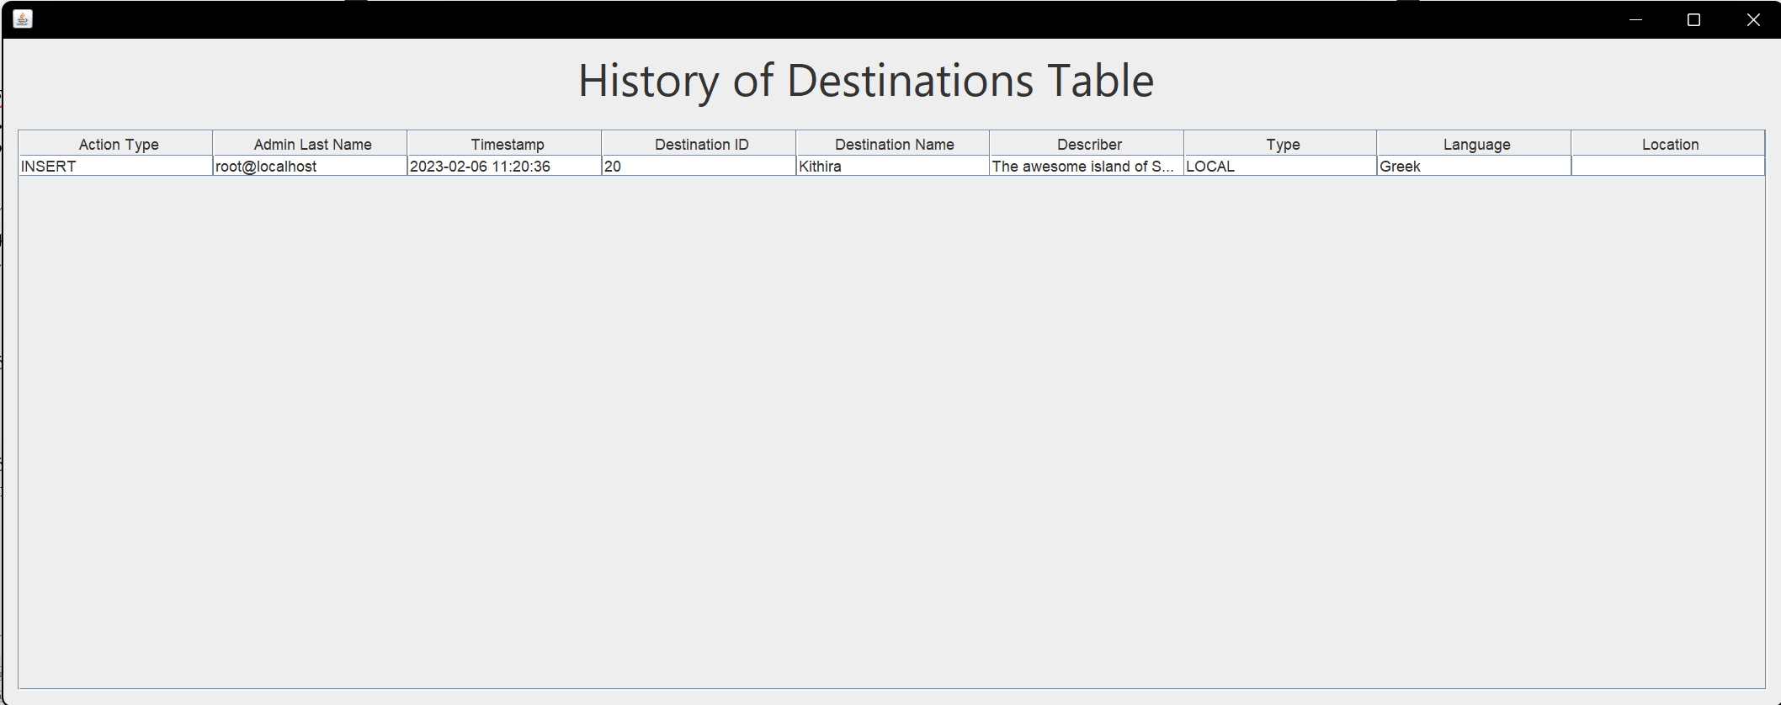

Στο Log_Destination παράθυρο θέλουμε να βλέπουμε όλες τις πληροφορίες που έχουν καταγραφεί στον πίνακα log_destination της βάσης μας, ο οποίος περιέχει το είδος της ενέργειας, το επώνυμο Υπευθύνου Πληροφορικής που έκανε την ενέργεια, το timestamp και τις πληροφορίες της παλιάς ή καινούργιας γραμμής του πίνακα destination ανάλογα αν έχουμε κάνει update ή delete και insert αντίστοιχα.

Η μέθοδος table_load() εκτελεί στην βάση την εντολή SELECT * FROM log_destination η οποία εμφανίζει όλες τις πληροφορίες του συγκεκριμένου πίνακα και τις βάζει σε ένα table του παραθύρου.

**Κλάση Log_Event:**

Έχει την ακόλουθη οπτική μορφή:

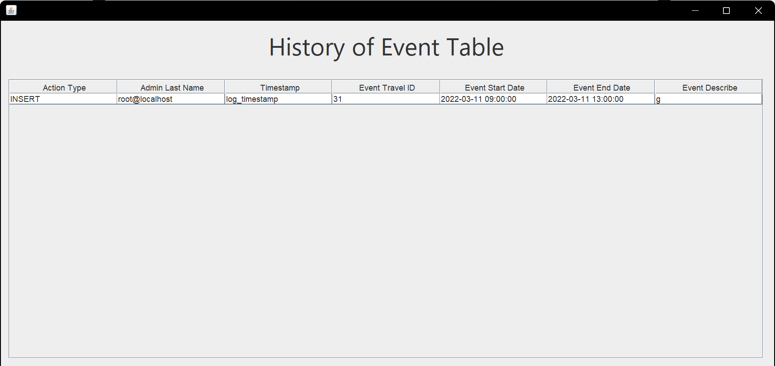

Στο Log_Event παράθυρο θέλουμε να βλέπουμε όλες τις πληροφορίες που έχουν καταγραφεί στον πίνακα log_event της βάσης μας, ο οποίος περιέχει το είδος της ενέργειας, το επώνυμο Υπευθύνου Πληροφορικής που έκανε την ενέργεια, το timestamp και τις πληροφορίες της παλιάς ή καινούργιας γραμμής του πίνακα event ανάλογα αν έχουμε κάνει update ή delete και insert αντίστοιχα.

Η μέθοδος table_load() εκτελεί στην βάση την εντολή SELECT * FROM log_event η οποία εμφανίζει όλες τις πληροφορίες του συγκεκριμένου πίνακα και τις βάζει σε ένα table του παραθύρου.

**Κλάση Log_Reservation:**

Έχει την ακόλουθη οπτική μορφή:

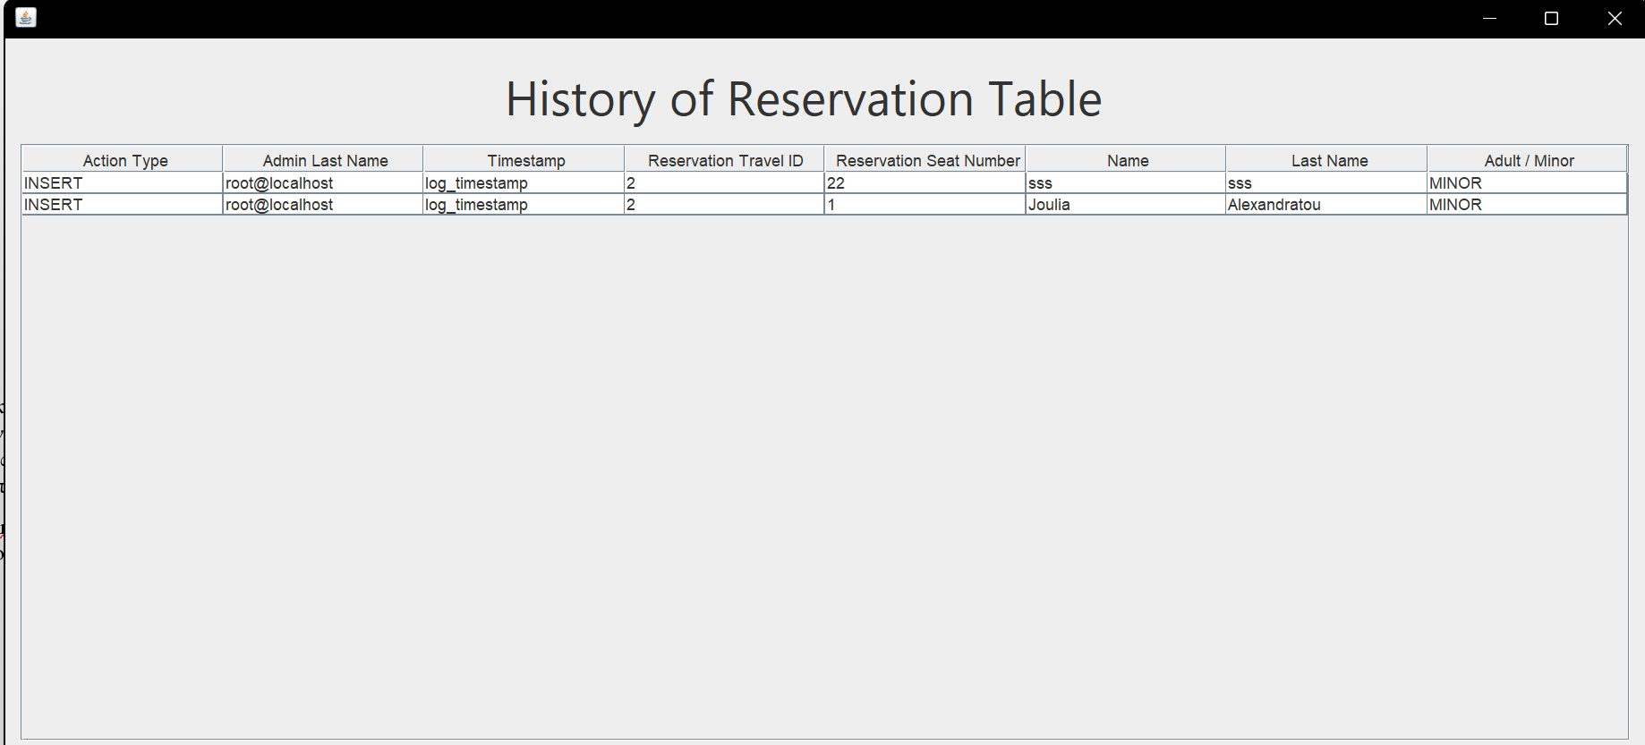

Στο Log_Reservation παράθυρο θέλουμε να βλέπουμε όλες τις πληροφορίες που έχουν καταγραφεί στον πίνακα log_reservation της βάσης μας, ο οποίος περιέχει το είδος της ενέργειας, το επώνυμο Υπευθύνου Πληροφορικής που έκανε την ενέργεια, το timestamp και τις πληροφορίες της παλιάς ή καινούργιας γραμμής του πίνακα reservation ανάλογα αν έχουμε κάνει update ή delete και insert αντίστοιχα.

Η μέθοδος table_load() εκτελεί στην βάση την εντολή SELECT * FROM log_reservation η οποία εμφανίζει όλες τις πληροφορίες του συγκεκριμένου πίνακα και τις βάζει σε ένα table του παραθύρου.

**Κλάση Log_Travel_To:**

Έχει την ακόλουθη οπτική μορφή:

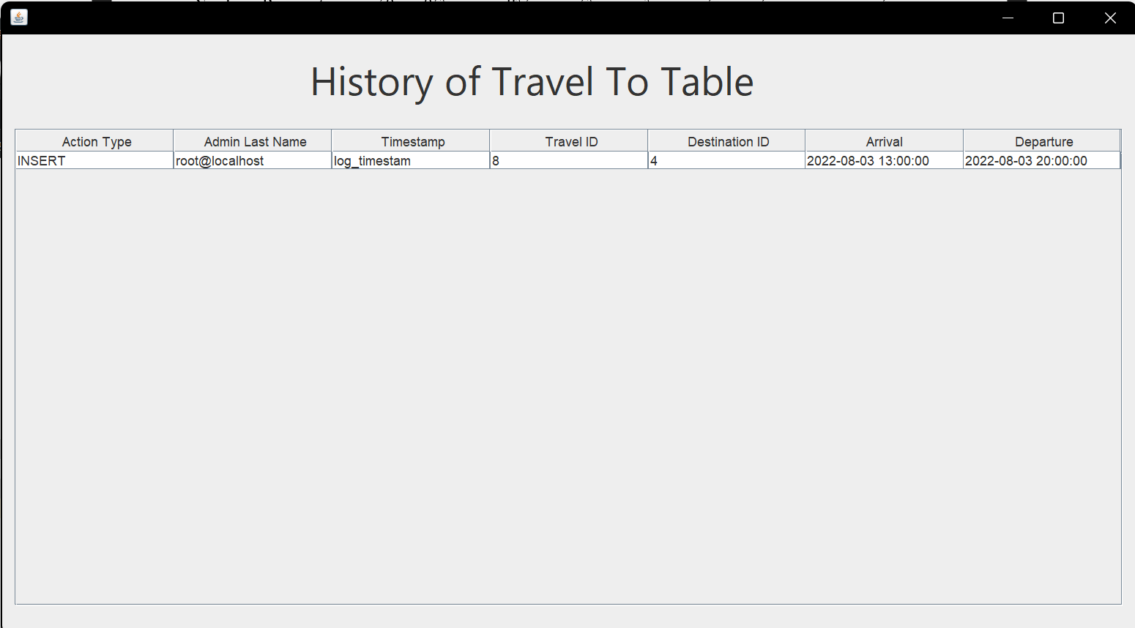

Στο Log_Travel_To παράθυρο θέλουμε να βλέπουμε όλες τις πληροφορίες που έχουν καταγραφεί στον πίνακα log_travel_to της βάσης μας, ο οποίος περιέχει το είδος της ενέργειας, το επώνυμο Υπευθύνου Πληροφορικής που έκανε την ενέργεια, το timestamp και τις πληροφορίες της παλιάς ή καινούργιας γραμμής του πίνακα travel_to ανάλογα αν έχουμε κάνει update ή delete και insert αντίστοιχα.

Η μέθοδος table_load() εκτελεί στην βάση την εντολή:

SELECT log_type , log_it_lname , log_timestamp  , log_to_tr_id ,log_to_dst_id,log_to_arrival,log_to_departure FROM log_travel_to

Η παραπάνω εντολή εμφανίζει όλες τις πληροφορίες του συγκεκριμένου πίνακα και τις βάζει σε ένα table του παραθύρου.

**Κλάση Log_Trip:**

Έχει την ακόλουθη οπτική μορφή:

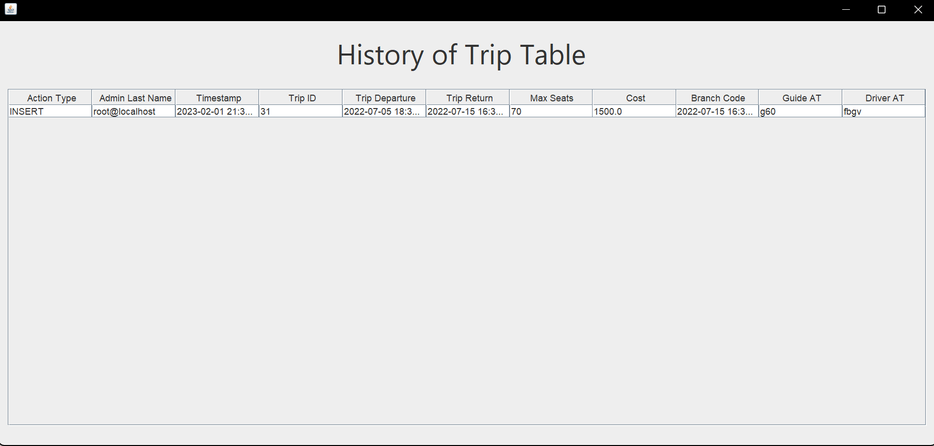

Στο Log_Trip παράθυρο θέλουμε να βλέπουμε όλες τις πληροφορίες που έχουν καταγραφεί στον πίνακα log_trip της βάσης μας, ο οποίος περιέχει το είδος της ενέργειας, το επώνυμο Υπευθύνου Πληροφορικής που έκανε την ενέργεια, το timestamp και τις πληροφορίες της παλιάς ή καινούργιας γραμμής του πίνακα trip ανάλογα αν έχουμε κάνει update ή delete και insert αντίστοιχα.

Η μέθοδος table_load() εκτελεί στην βάση την εντολή:

SELECT log_type , log_it_lname , log_timestamp  , log_tr_id ,log_tr_departure,log_tr_return,log_tr_maxseats,log_tr_cost,log_tr_br_code, log_tr_gui_AT ,log_tr_drv_AT FROM log_trip

Η παραπάνω εντολή εμφανίζει όλες τις πληροφορίες του συγκεκριμένου πίνακα και τις βάζει σε ένα table του παραθύρου.

**Κλάση ProcedureResults:**

Έχει την ακόλουθη οπτική μορφή:

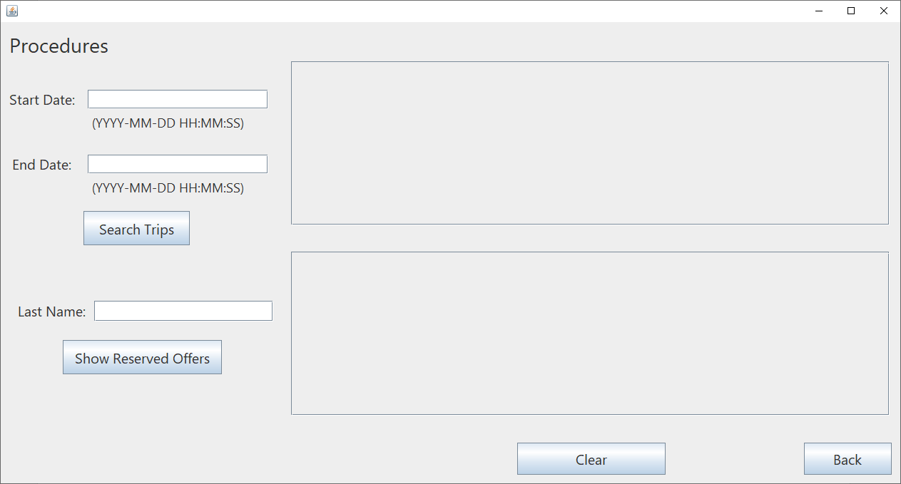

Στο ProcedureResults παράθυρο για κάθε υποκατάστημα και για ένα διάστημα που ορίζει ο Υπεύθυνος Πληροφορικής (ΙΤ), θέλουμε να βάλουμε το κόστος ταξιδιού, τις μέγιστες θέσεις ανά ταξίδι, το σύνολο κρατήσεων (reservation), τις διαθέσιμες κενές θέσεις, το επώνυμο και όνομα οδηγού και ξεναγού, την ημερομηνία αναχώρησης και επιστροφής σε ένα table και για ένα επώνυμο ενός πελάτη που ορίζει και πάλι ο ίδιος, θέλουμε να βάλουμε τα ονόματα και επώνυμα των πελατών με το επώνυμο αυτό και την προσφορά ταξιδιού στην οποία έχει γίνει εγγραφή σε ένα άλλο table. Σε περίπτωση που υπάρχουν πάνω από ένας επιστρέφει και το πλήθος των πελατών με το όνομα αυτό, ανά προσφορά ταξιδιού χρησιμοποιεί και τα δύο tables.

Η μέθοδος call_search_trip εκτελεί στην βάση την εντολή call search_trip() την οποία έχουμε εξηγήσει στο Κεφάλαιο 2 - Stored Procedures στο 3.1.3.2 και παίρνει τα αποτελέσματα της βάσης και τα βάζει στο ένα table.

Η μέθοδος res_names εκτελεί στην βάση την εντολή call res_names() την οποία έχουμε εξηγήσει στο Κεφάλαιο 2 - Stored Procedures στο 3.1.3.4 στο β) και παίρνει τα αποτελέσματα της βάσης και τα βάζει στο ένα table ή και στα δύο tables ανάλογα με την περίπτωση.

**Σενάριο Χρήσης**

1. Σύνδεση στην βάση ως τον root χρήστη.

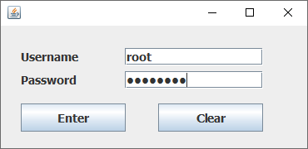

1. Υπομονή για ένα λεπτό, ώστε να εκτελεστούν τα insert στον πίνακα reservation_offers.
2. Μετά από ένα λεπτό περίπου ανοίγει το main menu του προγράμματός μας.

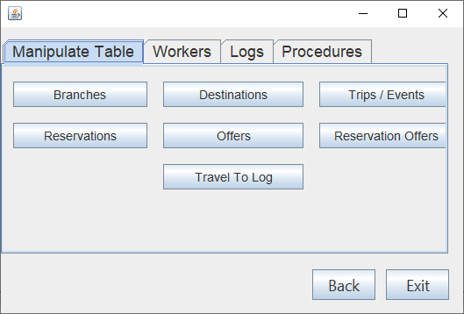

1. Εικόνα που περιέχει πίνακας

   Περιγραφή που δημιουργήθηκε αυτόματαΈστω ότι υπάρχει ένα πρόβλημα σε κάποιες κρατήσεις του ταξιδιού με id=3. Τα μέλη της οικογένειας Μακρή θέλουν να βρίσκονται σε διαδοχικές θέσεις. Πατάμε λοιπόν το κουμπί Reservations.

Βλέπουμε ότι η οικογένεια κάθεται σε διαφορετικές θέσεις.

Για να αλλάξουμε τους αριθμούς των θέσεων τους, πατάμε την κάθε εγγραφή που θέλουμε να αλλάξουμε, εισάγουμε στο πάνω πεδίο Seat Number τις καινούριες θέσεις και πατάμε το κουμπί Update.

Εικόνα που περιέχει πίνακας

Περιγραφή που δημιουργήθηκε αυτόματα

Εικόνα που περιέχει πίνακας

Περιγραφή που δημιουργήθηκε αυτόματαΕικόνα που περιέχει πίνακας

Περιγραφή που δημιουργήθηκε αυτόματα

Μετά από κάθε update εμφανίζεται το παρακάτω παράθυρο για επιβεβαίωση της αλλαγής.

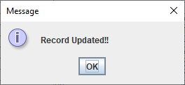

Τελικά μπορούμε να δούμε ότι οι θέσεις των κρατήσεων άλλαξαν.



1. Έστω ότι ανοίγει ένα καινούριο branch και πρέπει να προτεθεί στην βάση. Πατάμε το κουμπί “X” στο πάνω δεξιά μέρος του παραθύρου για να φύγουμε από το παράθυρο των κρατήσεων και επιστρέφουμε στο μενού.



1. Πατάμε το κουμπί Branches.
2. 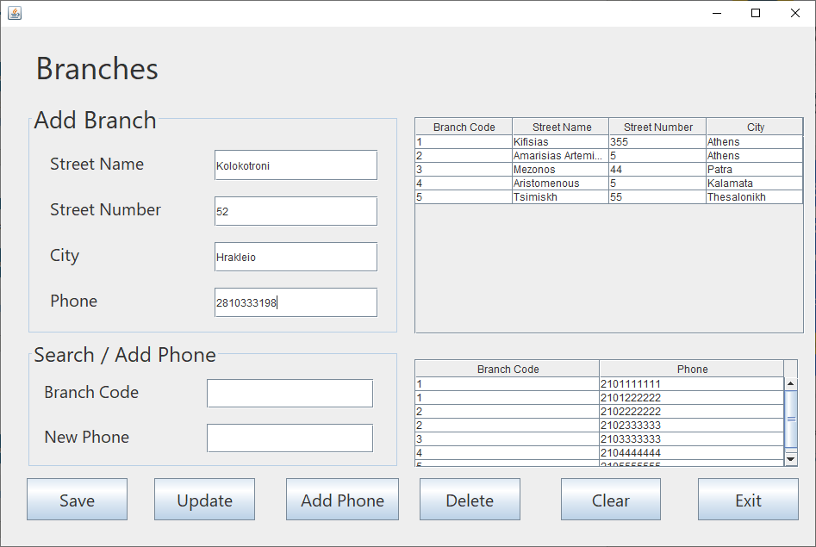Μπορούμε να δούμε όλα τα υπάρχοντα branches και τα τηλεφωνά τους. Εισάγουμε στα πεδία του Add Branch, τα στοιχείου του νέου branch, που θέλουμε να είναι στο Ηράκλειο και πατάμε Save.

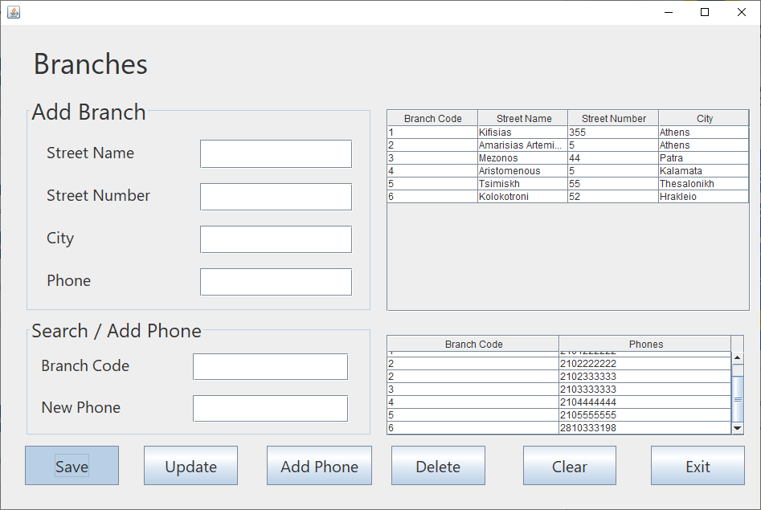

Βλέπουμε ότι προστέθηκε το νέο υποκατάστημα με branch code = 6.

1. Στην συνέχεια μπορούμε να δημιουργήσουμε ένα ταξίδι και να αναθέσουμε έναν οδηγό και ξεναγό σε αυτό. Πρώτα όμως πρέπει να προσθέσουμε έναν οδηγό κα έναν ξεναγό στο υποκατάστημα. Οπότε στο μενού πατάμε την σελίδα Workers.

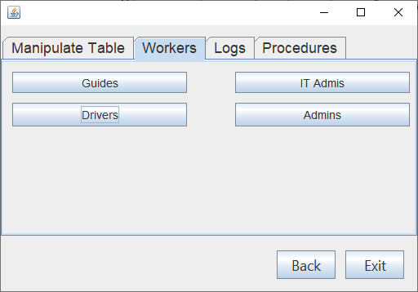

1. Πατάμε το κουμπί Drivers.

Εικόνα που περιέχει πίνακας

Περιγραφή που δημιουργήθηκε αυτόματα

1. Εικόνα που περιέχει πίνακας

   Περιγραφή που δημιουργήθηκε αυτόματαΕδώ μπορούμε να προσθέσουμε έναν νέο οδηγό εισάγοντας τα στοιχεία του, επιλέγοντας το υποκατάστημα στο οποίο θα εργάζεται και πατώντας το κουμπί Save.

Εικόνα που περιέχει πίνακας

Περιγραφή που δημιουργήθηκε αυτόματαΚάνουμε το ίδιο και για να προσθέσουμε έναν guide στο αντίστοιχο παράθυρο.

1. Τώρα λοιπόν πηγαίνουμε στο παράθυρο Trips/Events.

Εικόνα που περιέχει πίνακας

Περιγραφή που δημιουργήθηκε αυτόματα

Εικόνα που περιέχει πίνακας

Περιγραφή που δημιουργήθηκε αυτόματαΠατώντας το branch 6 εμφανίζονται οι εργαζόμενοι που μόλις προσθέσαμε. Εισάγουμε λοιπόν τα ζητούμενα στοιχεία, επιλέγοντας branch, driver και guide και πατάμε Save.

Εικόνα που περιέχει πίνακας

Περιγραφή που δημιουργήθηκε αυτόματαΒλέπουμε ότι το νέο ταξίδι με trip id = 31 προστέθηκε με επιθυμία.

1. Μπορούμε να δούμε την αλλαγή που έχουμε κάνει στον πίνακα Trip Log και Reservation στην σελίδα Logs του μενού μας.

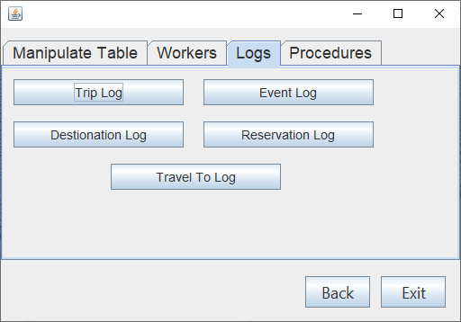

1. Εικόνα που περιέχει κείμενο

   Περιγραφή που δημιουργήθηκε αυτόματαΠατάμε το κουμπί Trip Log.

Βλέπουμε το καινούριο trip που κάναμε insert και το όνομα του χρήστη με το οποίο ήμαστε συνδεδεμένοι.

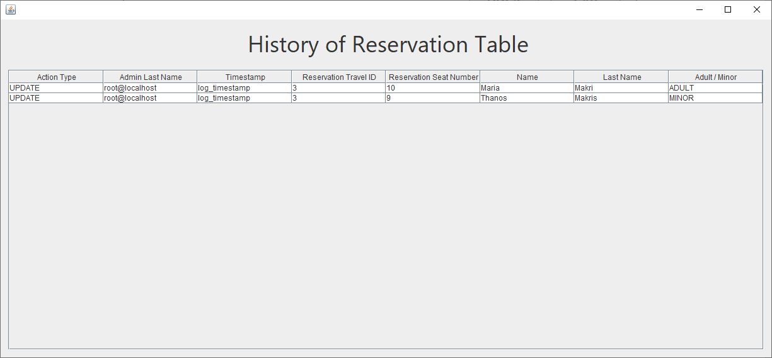Αν στην σελίδα Log πατήσουμε το κουμπί Reservation Log θα δούμε τις αλλαγές που κάναμε στις κρατήσεις στην αρχή.

1. Αν θέλαμε να δούμε τις βασικές πληροφορίες για όλα τα branches μπορούμε να μεταβούμε στην σελίδα Procedures του μενού.

Εικόνα που περιέχει κείμενο

Περιγραφή που δημιουργήθηκε αυτόματα

Εικόνα που περιέχει πίνακας

Περιγραφή που δημιουργήθηκε αυτόματαΠατάμε το κουμπί Branch Info και στο παράθυρο που ανοίγει πατάμε τα κουμπιά Get branch info και Get branch employees.

Έτσι μπορούμε να δούμε πληροφορίες και τα έσοδα του κάθε υποκαταστήματος και όλους τους εργαζόμενους των υποκαταστημάτων μαζί με τους μισθούς τους.

1. Για να δούμε το σύνολο των ταξιδιών σε ένα διάστημα ημερομηνιών και τις κρατήσεις προσφορών για τους πελάτες με το ίδιο επώνυμο μπορούμε να πατήσουμε τα κουμπιά Trips In Date Range ή Reserved Offers.

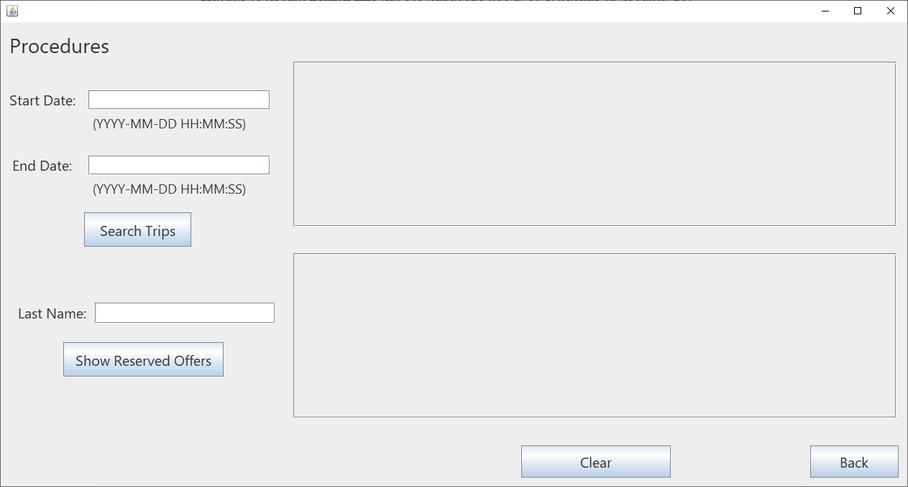

Εισάγουμε ένα διάστημα ημερομηνιών έστω από 2022-03-17 18:30:00 μέχρι 2022-10-08 16:30:00.Εικόνα που περιέχει πίνακας

Περιγραφή που δημιουργήθηκε αυτόματα

Βλέπουμε τα ταξίδια που θέλουμε στον πάνω πίνακα.

Εισάγουμε το επώνυμο ενός πελάτη στο πεδίο Last Name.

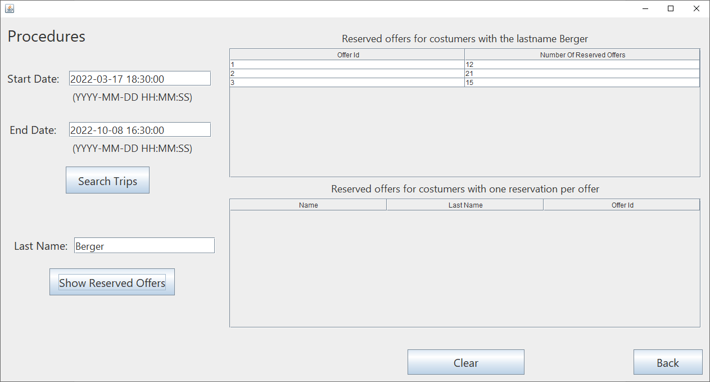

Βλέπουμε το σύνολο των κρατήσεων σε κάθε offer από άτομα με το επώνυμο που Berger, στον πάνω πίνακα. Ο κάτω πίνακας παραμένει άδειος επειδή δεν υπάρχουν offers με μόνο μία κράτηση από άτομο με αυτό το επώνυμο.

1. Εικόνα που περιέχει πίνακας

   Περιγραφή που δημιουργήθηκε αυτόματαΈστω ότι θέλουμε να δημιουργήσουμε έναν it_admin, με δικαιώματα προβολής μόνο. Πρέπει να μεταβούμε στην σελίδα Workers του μενού και να πατήσουμε το κουμπί It Admins.

Ανοίγει το παραπάνω παράθυρο στο οποίο μπορούμε να προσθέσουμε έναν it_admin και στο τέλος να επιλέξουμε select privileges και να πατήσουμε Insert.

Εικόνα που περιέχει πίνακας

Περιγραφή που δημιουργήθηκε αυτόματα

Βλέπουμε ότι ο εργαζόμενος προστέθηκε με επιτυχία.

1. Τώρα πατάμε Back για να μεταβούμε στο μενού και όταν βρισκόμαστε εκεί πατάμε πάλι Back για να ανοίξει το παράθυρο login. Εκεί εισάγουμε το useraname και password του νέου it_admin.

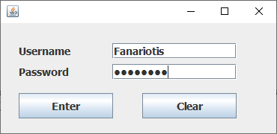

1. Ας προσπαθήσουμε να διαγράψουμε μια κράτηση στον πίνακα reservation.

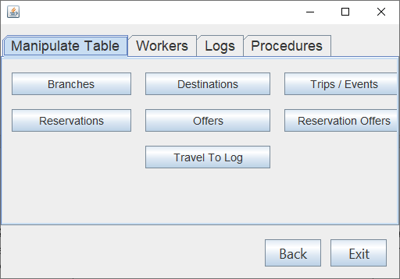

Πατάμε το κουμπί Reservations.

Εικόνα που περιέχει πίνακας

Περιγραφή που δημιουργήθηκε αυτόματαΒλέπουμε ότι ο πίνακας με της κρατήσεις φαίνεται κανονικά.

Εικόνα που περιέχει πίνακας

Περιγραφή που δημιουργήθηκε αυτόματαΑν επιλέξουμε όμως μία γραμμή και πατήσουμε Delete.

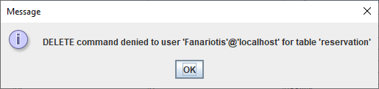

Η διαγραφή εμποδίζεται.

# **GUI Κώδικας**

**AdminWorker**

package classes;

import static classes.Login.conn;

import java.sql.*;

import java.util.logging.Level;

import java.util.logging.Logger;

import javax.swing.JOptionPane;

import javax.swing.table.DefaultTableModel;

public class AdminWorker extends javax.swing.JFrame {

public AdminWorker() throws SQLException {

initComponents();

table_load();

table_load_Branches();

}

PreparedStatement pst;

CallableStatement cs;

public void table_load() throws SQLException {

Statement st = conn.createStatement();

String table_sql = "SELECT wrk_AT , wrk_name,wrk_lname,wrk_salary,wrk_br_code,adm_type,adm_diploma FROM worker INNER JOIN manages ON mng_adm_AT = wrk_AT INNER JOIN admin ON adm_AT = wrk_AT";

ResultSet rs = st.executeQuery(table_sql);

while(rs.next()){

String at = rs.getString("wrk_AT");

String name = rs.getString("wrk_name");

String laname = rs.getString("wrk_lname");

String salary = String.valueOf(rs.getFloat("wrk_salary"));

String br_code = String.valueOf(rs.getInt("wrk_br_code"));

String type = rs.getString("adm_type");

String diploma = rs.getString("adm_diploma");

String tbData[] = {at , name, laname , salary , br_code , diploma , type };

DefaultTableModel tblModel = (DefaultTableModel)jTable2.getModel();

tblModel.addRow(tbData);

}

}

public void table_load_Branches() throws SQLException {

Statement st = conn.createStatement();

String table_sql = "SELECT br_code FROM branch";

ResultSet rs = st.executeQuery(table_sql);

while(rs.next()){

String br = rs.getString("br_code");

String tbData[] = {br};

DefaultTableModel tblModel = (DefaultTableModel)jTable4.getModel();

tblModel.addRow(tbData);

}

}

@SuppressWarnings("unchecked")

// <editor-fold defaultstate="collapsed" desc="Generated Code">//GEN-BEGIN:initComponents

private void initComponents() {

jLabel2 = new javax.swing.JLabel();

buttonGroup1 = new javax.swing.ButtonGroup();

jToggleButton1 = new javax.swing.JToggleButton();

jTable1 = new javax.swing.JTable();

jScrollPane2 = new javax.swing.JScrollPane();

jTable3 = new javax.swing.JTable();

jPanel2 = new javax.swing.JPanel();

jLabel1 = new javax.swing.JLabel();

jPanel3 = new javax.swing.JPanel();

jLabel4 = new javax.swing.JLabel();

jLabel5 = new javax.swing.JLabel();

jLabel6 = new javax.swing.JLabel();

jLabel7 = new javax.swing.JLabel();

LastNameField = new javax.swing.JTextField();

jLabel8 = new javax.swing.JLabel();

SalaryField = new javax.swing.JTextField();

NameField = new javax.swing.JTextField();

IdField = new javax.swing.JTextField();

BranchField = new javax.swing.JTextField();

jLabel9 = new javax.swing.JLabel();

jLabel11 = new javax.swing.JLabel();

RoleBox = new javax.swing.JComboBox<>();

DiplomaField = new javax.swing.JTextField();

SaveButton = new javax.swing.JButton();

ExitButton = new javax.swing.JButton();

ClearButton = new javax.swing.JButton();

jPanel1 = new javax.swing.JPanel();

jLabel10 = new javax.swing.JLabel();

SearchField = new javax.swing.JTextField();

DeleteButton = new javax.swing.JButton();

UpdateButton2 = new javax.swing.JButton();

jScrollPane1 = new javax.swing.JScrollPane();

jTable2 = new javax.swing.JTable();

jScrollPane3 = new javax.swing.JScrollPane();

jTable4 = new javax.swing.JTable();

jLabel2.setText("jLabel2");

jToggleButton1.setText("jToggleButton1");

jTable1.setModel(new javax.swing.table.DefaultTableModel(

new Object [][] {

{null, null, null, null},

{null, null, null, null},

{null, null, null, null},

{null, null, null, null}

},

new String [] {

"Title 1", "Title 2", "Title 3", "Title 4"

}

));

jTable3.setModel(new javax.swing.table.DefaultTableModel(

new Object [][] {

{null, null, null, null},

{null, null, null, null},

{null, null, null, null},

{null, null, null, null}

},

new String [] {

"Title 1", "Title 2", "Title 3", "Title 4"

}

));

jScrollPane2.setViewportView(jTable3);

setDefaultCloseOperation(javax.swing.WindowConstants.DISPOSE_ON_CLOSE);

jLabel1.setFont(new java.awt.Font("Segoe UI", 0, 36)); // NOI18N

jLabel1.setText("Admin Worker");

jPanel3.setBorder(javax.swing.BorderFactory.createTitledBorder(null, "Add Worker", javax.swing.border.TitledBorder.DEFAULT_JUSTIFICATION, javax.swing.border.TitledBorder.DEFAULT_POSITION, new java.awt.Font("Segoe UI", 0, 24))); // NOI18N

jLabel4.setFont(new java.awt.Font("Segoe UI", 0, 20)); // NOI18N

jLabel4.setText("Name");

jLabel5.setFont(new java.awt.Font("Segoe UI", 0, 20)); // NOI18N

jLabel5.setText("Last Name");

jLabel6.setFont(new java.awt.Font("Segoe UI", 0, 20)); // NOI18N

jLabel6.setText("ID Number");

jLabel7.setFont(new java.awt.Font("Segoe UI", 0, 20)); // NOI18N

jLabel7.setText("Salary");

LastNameField.addActionListener(new java.awt.event.ActionListener() {

public void actionPerformed(java.awt.event.ActionEvent evt) {

LastNameFieldActionPerformed(evt);

}

});

jLabel8.setFont(new java.awt.Font("Segoe UI", 0, 20)); // NOI18N

jLabel8.setText("Branch Code");

SalaryField.addActionListener(new java.awt.event.ActionListener() {

public void actionPerformed(java.awt.event.ActionEvent evt) {

SalaryFieldActionPerformed(evt);

}

});

IdField.addActionListener(new java.awt.event.ActionListener() {

public void actionPerformed(java.awt.event.ActionEvent evt) {

IdFieldActionPerformed(evt);

}

});

BranchField.addActionListener(new java.awt.event.ActionListener() {

public void actionPerformed(java.awt.event.ActionEvent evt) {

BranchFieldActionPerformed(evt);

}

});

jLabel9.setFont(new java.awt.Font("Segoe UI", 0, 20)); // NOI18N

jLabel9.setText("Diploma");

jLabel11.setFont(new java.awt.Font("Segoe UI", 0, 20)); // NOI18N

jLabel11.setText("Role");

RoleBox.setModel(new javax.swing.DefaultComboBoxModel<>(new String[] { "LOGISTICS", "ADMINISTRATIVE", "ACCOUNTING" }));

RoleBox.setSelectedItem(jTable2);

RoleBox.addActionListener(new java.awt.event.ActionListener() {

public void actionPerformed(java.awt.event.ActionEvent evt) {

RoleBoxActionPerformed(evt);

}

});

DiplomaField.addActionListener(new java.awt.event.ActionListener() {

public void actionPerformed(java.awt.event.ActionEvent evt) {

DiplomaFieldActionPerformed(evt);

}

});

javax.swing.GroupLayout jPanel3Layout = new javax.swing.GroupLayout(jPanel3);

jPanel3.setLayout(jPanel3Layout);

jPanel3Layout.setHorizontalGroup(

jPanel3Layout.createParallelGroup(javax.swing.GroupLayout.Alignment.LEADING)

.addGroup(jPanel3Layout.createSequentialGroup()

.addGap(25, 25, 25)

.addGroup(jPanel3Layout.createParallelGroup(javax.swing.GroupLayout.Alignment.LEADING)

.addGroup(jPanel3Layout.createParallelGroup(javax.swing.GroupLayout.Alignment.TRAILING, false)

.addComponent(jLabel11, javax.swing.GroupLayout.Alignment.LEADING, javax.swing.GroupLayout.DEFAULT_SIZE, javax.swing.GroupLayout.DEFAULT_SIZE, Short.MAX_VALUE)

.addComponent(jLabel5, javax.swing.GroupLayout.Alignment.LEADING)

.addComponent(jLabel9, javax.swing.GroupLayout.Alignment.LEADING)

.addComponent(jLabel8, javax.swing.GroupLayout.Alignment.LEADING, javax.swing.GroupLayout.DEFAULT_SIZE, javax.swing.GroupLayout.DEFAULT_SIZE, Short.MAX_VALUE))

.addComponent(jLabel7, javax.swing.GroupLayout.PREFERRED_SIZE, 106, javax.swing.GroupLayout.PREFERRED_SIZE)

.addComponent(jLabel4, javax.swing.GroupLayout.PREFERRED_SIZE, 75, javax.swing.GroupLayout.PREFERRED_SIZE)

.addComponent(jLabel6, javax.swing.GroupLayout.PREFERRED_SIZE, 106, javax.swing.GroupLayout.PREFERRED_SIZE))

.addPreferredGap(javax.swing.LayoutStyle.ComponentPlacement.RELATED, javax.swing.GroupLayout.DEFAULT_SIZE, Short.MAX_VALUE)

.addGroup(jPanel3Layout.createParallelGroup(javax.swing.GroupLayout.Alignment.LEADING, false)

.addComponent(NameField)

.addComponent(IdField)

.addComponent(SalaryField, javax.swing.GroupLayout.Alignment.TRAILING)

.addComponent(BranchField, javax.swing.GroupLayout.Alignment.TRAILING)

.addComponent(DiplomaField, javax.swing.GroupLayout.Alignment.TRAILING)

.addComponent(RoleBox, javax.swing.GroupLayout.Alignment.TRAILING, 0, 350, Short.MAX_VALUE)

.addComponent(LastNameField))

.addGap(31, 31, 31))

);

jPanel3Layout.setVerticalGroup(

jPanel3Layout.createParallelGroup(javax.swing.GroupLayout.Alignment.LEADING)

.addGroup(jPanel3Layout.createSequentialGroup()

.addGap(16, 16, 16)

.addGroup(jPanel3Layout.createParallelGroup(javax.swing.GroupLayout.Alignment.BASELINE)

.addComponent(jLabel4)

.addComponent(NameField, javax.swing.GroupLayout.DEFAULT_SIZE, 34, Short.MAX_VALUE))

.addPreferredGap(javax.swing.LayoutStyle.ComponentPlacement.UNRELATED)

.addGroup(jPanel3Layout.createParallelGroup(javax.swing.GroupLayout.Alignment.BASELINE)

.addComponent(jLabel5)

.addComponent(LastNameField, javax.swing.GroupLayout.DEFAULT_SIZE, 34, Short.MAX_VALUE))

.addGap(17, 17, 17)

.addGroup(jPanel3Layout.createParallelGroup(javax.swing.GroupLayout.Alignment.BASELINE)

.addComponent(jLabel6)

.addComponent(IdField, javax.swing.GroupLayout.DEFAULT_SIZE, 34, Short.MAX_VALUE))

.addGap(18, 18, 18)

.addGroup(jPanel3Layout.createParallelGroup(javax.swing.GroupLayout.Alignment.BASELINE)

.addComponent(jLabel7)

.addComponent(SalaryField, javax.swing.GroupLayout.DEFAULT_SIZE, 34, Short.MAX_VALUE))

.addGap(18, 18, 18)

.addGroup(jPanel3Layout.createParallelGroup(javax.swing.GroupLayout.Alignment.BASELINE)

.addComponent(jLabel8)

.addComponent(BranchField, javax.swing.GroupLayout.DEFAULT_SIZE, 34, Short.MAX_VALUE))

.addGap(18, 18, 18)

.addGroup(jPanel3Layout.createParallelGroup(javax.swing.GroupLayout.Alignment.BASELINE)

.addComponent(jLabel9)

.addComponent(DiplomaField, javax.swing.GroupLayout.DEFAULT_SIZE, 34, Short.MAX_VALUE))

.addGap(18, 18, 18)

.addGroup(jPanel3Layout.createParallelGroup(javax.swing.GroupLayout.Alignment.BASELINE)

.addComponent(RoleBox, javax.swing.GroupLayout.PREFERRED_SIZE, 27, javax.swing.GroupLayout.PREFERRED_SIZE)

.addComponent(jLabel11))

.addContainerGap(16, Short.MAX_VALUE))

);

SaveButton.setFont(new java.awt.Font("Segoe UI", 0, 27)); // NOI18N

SaveButton.setText("Save");

SaveButton.addActionListener(new java.awt.event.ActionListener() {

public void actionPerformed(java.awt.event.ActionEvent evt) {

SaveButtonActionPerformed(evt);

}

});

ExitButton.setFont(new java.awt.Font("Segoe UI", 0, 20)); // NOI18N

ExitButton.setText("Exit");

ExitButton.addActionListener(new java.awt.event.ActionListener() {

public void actionPerformed(java.awt.event.ActionEvent evt) {

ExitButtonActionPerformed(evt);

}

});

ClearButton.setFont(new java.awt.Font("Segoe UI", 0, 22)); // NOI18N

ClearButton.setText("Clear");

ClearButton.addActionListener(new java.awt.event.ActionListener() {

public void actionPerformed(java.awt.event.ActionEvent evt) {

ClearButtonActionPerformed(evt);

}

});

jPanel1.setBorder(javax.swing.BorderFactory.createTitledBorder(null, "Search", javax.swing.border.TitledBorder.DEFAULT_JUSTIFICATION, javax.swing.border.TitledBorder.DEFAULT_POSITION, new java.awt.Font("Segoe UI", 0, 22))); // NOI18N

jLabel10.setFont(new java.awt.Font("Segoe UI", 0, 20)); // NOI18N

jLabel10.setText("ID Number");

SearchField.addActionListener(new java.awt.event.ActionListener() {

public void actionPerformed(java.awt.event.ActionEvent evt) {

SearchFieldActionPerformed(evt);

}

});

SearchField.addKeyListener(new java.awt.event.KeyAdapter() {

public void keyReleased(java.awt.event.KeyEvent evt) {

SearchFieldKeyReleased(evt);

}

});

javax.swing.GroupLayout jPanel1Layout = new javax.swing.GroupLayout(jPanel1);

jPanel1.setLayout(jPanel1Layout);

jPanel1Layout.setHorizontalGroup(

jPanel1Layout.createParallelGroup(javax.swing.GroupLayout.Alignment.LEADING)

.addGroup(jPanel1Layout.createSequentialGroup()

.addGap(32, 32, 32)

.addComponent(jLabel10, javax.swing.GroupLayout.PREFERRED_SIZE, 109, javax.swing.GroupLayout.PREFERRED_SIZE)

.addGap(26, 26, 26)

.addComponent(SearchField, javax.swing.GroupLayout.PREFERRED_SIZE, 368, javax.swing.GroupLayout.PREFERRED_SIZE)

.addContainerGap(21, Short.MAX_VALUE))

);

jPanel1Layout.setVerticalGroup(

jPanel1Layout.createParallelGroup(javax.swing.GroupLayout.Alignment.LEADING)

.addGroup(jPanel1Layout.createSequentialGroup()

.addGap(15, 15, 15)

.addGroup(jPanel1Layout.createParallelGroup(javax.swing.GroupLayout.Alignment.BASELINE)

.addComponent(jLabel10)

.addComponent(SearchField, javax.swing.GroupLayout.PREFERRED_SIZE, 33, javax.swing.GroupLayout.PREFERRED_SIZE))

.addContainerGap(20, Short.MAX_VALUE))

);

DeleteButton.setFont(new java.awt.Font("Segoe UI", 0, 22)); // NOI18N

DeleteButton.setText("Delete");

DeleteButton.addActionListener(new java.awt.event.ActionListener() {

public void actionPerformed(java.awt.event.ActionEvent evt) {

DeleteButtonActionPerformed(evt);

}

});

UpdateButton2.setFont(new java.awt.Font("Segoe UI", 0, 22)); // NOI18N

UpdateButton2.setText("Update");

UpdateButton2.addActionListener(new java.awt.event.ActionListener() {

public void actionPerformed(java.awt.event.ActionEvent evt) {

UpdateButton2ActionPerformed(evt);

}

});

jTable2.setModel(new javax.swing.table.DefaultTableModel(

new Object [][] {

},

new String [] {

"Worker AT", "Name", "Last Name", "Salary", "Branch Code", "Diploma", "Admin Type"

}

) {

Class[] types = new Class [] {

java.lang.Object.class, java.lang.Object.class, java.lang.Object.class, java.lang.Object.class, java.lang.Object.class, java.lang.Object.class, java.lang.String.class

};

boolean[] canEdit = new boolean [] {

false, false, false, false, false, false, false

};

public Class getColumnClass(int columnIndex) {

return types [columnIndex];

}

public boolean isCellEditable(int rowIndex, int columnIndex) {

return canEdit [columnIndex];

}

});

jTable2.addMouseListener(new java.awt.event.MouseAdapter() {

public void mouseClicked(java.awt.event.MouseEvent evt) {

jTable2MouseClicked(evt);

}

});

jScrollPane1.setViewportView(jTable2);

jTable4.setBorder(javax.swing.BorderFactory.createTitledBorder(""));

jTable4.setModel(new javax.swing.table.DefaultTableModel(

new Object [][] {

},

new String [] {

"Branches"

}

) {

boolean[] canEdit = new boolean [] {

false

};

public boolean isCellEditable(int rowIndex, int columnIndex) {

return canEdit [columnIndex];

}

});

jTable4.addMouseListener(new java.awt.event.MouseAdapter() {

public void mouseClicked(java.awt.event.MouseEvent evt) {

jTable4MouseClicked(evt);

}

});

jScrollPane3.setViewportView(jTable4);

javax.swing.GroupLayout jPanel2Layout = new javax.swing.GroupLayout(jPanel2);

jPanel2.setLayout(jPanel2Layout);

jPanel2Layout.setHorizontalGroup(

jPanel2Layout.createParallelGroup(javax.swing.GroupLayout.Alignment.LEADING)

.addGroup(jPanel2Layout.createSequentialGroup()

.addContainerGap(javax.swing.GroupLayout.DEFAULT_SIZE, Short.MAX_VALUE)

.addGroup(jPanel2Layout.createParallelGroup(javax.swing.GroupLayout.Alignment.LEADING, false)

.addComponent(jPanel3, javax.swing.GroupLayout.DEFAULT_SIZE, javax.swing.GroupLayout.DEFAULT_SIZE, Short.MAX_VALUE)

.addComponent(jPanel1, javax.swing.GroupLayout.DEFAULT_SIZE, javax.swing.GroupLayout.DEFAULT_SIZE, Short.MAX_VALUE))

.addGap(18, 18, 18)

.addGroup(jPanel2Layout.createParallelGroup(javax.swing.GroupLayout.Alignment.LEADING, false)

.addGroup(jPanel2Layout.createSequentialGroup()

.addComponent(SaveButton, javax.swing.GroupLayout.PREFERRED_SIZE, 140, javax.swing.GroupLayout.PREFERRED_SIZE)

.addGap(18, 18, 18)

.addComponent(UpdateButton2, javax.swing.GroupLayout.PREFERRED_SIZE, 126, javax.swing.GroupLayout.PREFERRED_SIZE)

.addGap(18, 18, 18)

.addComponent(DeleteButton, javax.swing.GroupLayout.PREFERRED_SIZE, 126, javax.swing.GroupLayout.PREFERRED_SIZE)

.addGap(18, 18, 18)

.addComponent(ClearButton, javax.swing.GroupLayout.PREFERRED_SIZE, 126, javax.swing.GroupLayout.PREFERRED_SIZE)

.addGap(18, 18, 18)

.addComponent(ExitButton, javax.swing.GroupLayout.PREFERRED_SIZE, 126, javax.swing.GroupLayout.PREFERRED_SIZE))

.addGroup(jPanel2Layout.createSequentialGroup()

.addComponent(jScrollPane3, javax.swing.GroupLayout.PREFERRED_SIZE, 66, javax.swing.GroupLayout.PREFERRED_SIZE)

.addPreferredGap(javax.swing.LayoutStyle.ComponentPlacement.RELATED)

.addComponent(jScrollPane1)))

.addGap(26, 26, 26))

.addGroup(jPanel2Layout.createSequentialGroup()

.addContainerGap()

.addComponent(jLabel1, javax.swing.GroupLayout.PREFERRED_SIZE, 562, javax.swing.GroupLayout.PREFERRED_SIZE)

.addContainerGap(javax.swing.GroupLayout.DEFAULT_SIZE, Short.MAX_VALUE))

);

jPanel2Layout.setVerticalGroup(

jPanel2Layout.createParallelGroup(javax.swing.GroupLayout.Alignment.LEADING)

.addGroup(javax.swing.GroupLayout.Alignment.TRAILING, jPanel2Layout.createSequentialGroup()

.addContainerGap(15, Short.MAX_VALUE)

.addComponent(jLabel1)

.addGap(18, 18, 18)

.addGroup(jPanel2Layout.createParallelGroup(javax.swing.GroupLayout.Alignment.LEADING)

.addGroup(javax.swing.GroupLayout.Alignment.TRAILING, jPanel2Layout.createParallelGroup(javax.swing.GroupLayout.Alignment.TRAILING, false)

.addComponent(jScrollPane3, javax.swing.GroupLayout.DEFAULT_SIZE, 407, Short.MAX_VALUE)

.addComponent(jScrollPane1, javax.swing.GroupLayout.PREFERRED_SIZE, 0, Short.MAX_VALUE))

.addComponent(jPanel3, javax.swing.GroupLayout.Alignment.TRAILING, javax.swing.GroupLayout.PREFERRED_SIZE, javax.swing.GroupLayout.DEFAULT_SIZE, javax.swing.GroupLayout.PREFERRED_SIZE))

.addGroup(jPanel2Layout.createParallelGroup(javax.swing.GroupLayout.Alignment.LEADING)

.addGroup(jPanel2Layout.createSequentialGroup()

.addGap(33, 33, 33)

.addGroup(jPanel2Layout.createParallelGroup(javax.swing.GroupLayout.Alignment.BASELINE)

.addComponent(UpdateButton2, javax.swing.GroupLayout.PREFERRED_SIZE, 90, javax.swing.GroupLayout.PREFERRED_SIZE)

.addComponent(DeleteButton, javax.swing.GroupLayout.PREFERRED_SIZE, 90, javax.swing.GroupLayout.PREFERRED_SIZE)

.addComponent(ExitButton, javax.swing.GroupLayout.PREFERRED_SIZE, 89, javax.swing.GroupLayout.PREFERRED_SIZE)

.addComponent(ClearButton, javax.swing.GroupLayout.PREFERRED_SIZE, 89, javax.swing.GroupLayout.PREFERRED_SIZE)))

.addGroup(javax.swing.GroupLayout.Alignment.TRAILING, jPanel2Layout.createSequentialGroup()

.addPreferredGap(javax.swing.LayoutStyle.ComponentPlacement.RELATED)

.addGroup(jPanel2Layout.createParallelGroup(javax.swing.GroupLayout.Alignment.LEADING)

.addComponent(jPanel1, javax.swing.GroupLayout.Alignment.TRAILING, javax.swing.GroupLayout.PREFERRED_SIZE, javax.swing.GroupLayout.DEFAULT_SIZE, javax.swing.GroupLayout.PREFERRED_SIZE)

.addComponent(SaveButton, javax.swing.GroupLayout.Alignment.TRAILING, javax.swing.GroupLayout.PREFERRED_SIZE, 89, javax.swing.GroupLayout.PREFERRED_SIZE))))

.addGap(20, 20, 20))

);

javax.swing.GroupLayout layout = new javax.swing.GroupLayout(getContentPane());

getContentPane().setLayout(layout);

layout.setHorizontalGroup(

layout.createParallelGroup(javax.swing.GroupLayout.Alignment.LEADING)

.addGroup(javax.swing.GroupLayout.Alignment.TRAILING, layout.createSequentialGroup()

.addContainerGap(javax.swing.GroupLayout.DEFAULT_SIZE, Short.MAX_VALUE)

.addComponent(jPanel2, javax.swing.GroupLayout.PREFERRED_SIZE, 1314, javax.swing.GroupLayout.PREFERRED_SIZE)

.addContainerGap())

);

layout.setVerticalGroup(

layout.createParallelGroup(javax.swing.GroupLayout.Alignment.LEADING)

.addGroup(layout.createSequentialGroup()

.addComponent(jPanel2, javax.swing.GroupLayout.PREFERRED_SIZE, javax.swing.GroupLayout.DEFAULT_SIZE, javax.swing.GroupLayout.PREFERRED_SIZE)

.addContainerGap(javax.swing.GroupLayout.DEFAULT_SIZE, Short.MAX_VALUE))

);

pack();

}// </editor-fold>//GEN-END:initComponents

private void SaveButtonActionPerformed(java.awt.event.ActionEvent evt) {//GEN-FIRST:event_SaveButtonActionPerformed

String name , lname , id , salary , brcode ,diploma , role ;

name = NameField.getText();

lname =LastNameField.getText();

id = IdField.getText();

salary = SalaryField.getText();

brcode = BranchField.getText();

diploma = DiplomaField.getText();

role = RoleBox.getSelectedItem().toString();

try{

pst= conn.prepareStatement("insert into worker(wrk_AT,wrk_name,wrk_lname,wrk_salary,wrk_br_code)values(?,?,?,?,?)");

pst.setString(1,id);

pst.setString(2,name);

pst.setString(3,lname);

pst.setString(4,salary);

pst.setString(5,brcode);

pst.executeUpdate();

pst= conn.prepareStatement("insert into admin (adm_AT,adm_type,adm_diploma)values(?,?,?)");

pst.setString(1,id);

pst.setString(2,role);

pst.setString(3,diploma);

pst.executeUpdate();

pst= conn.prepareStatement("insert into manages (mng_adm_AT,mng_br_code)values(?,?)");

pst.setString(1,id);

pst.setString(2,brcode);

pst.executeUpdate();

JOptionPane.showMessageDialog(null , "Record Addedd!!");

jTable2.setModel(new DefaultTableModel(null , new String[]{"Worker AT", "Name","Last Name","Salary","Branch Code","Admin Type","Diploma"}));

table_load();

NameField.setText("");

LastNameField.setText("");

IdField.setText("");

SalaryField.setText("");

BranchField.setText("");

DiplomaField.setText("");

NameField.requestFocus();

}catch(SQLException e){

JOptionPane.showMessageDialog(null , e.getMessage());

}

}//GEN-LAST:event_SaveButtonActionPerformed

private void ExitButtonActionPerformed(java.awt.event.ActionEvent evt) {//GEN-FIRST:event_ExitButtonActionPerformed

System.exit(0);

}//GEN-LAST:event_ExitButtonActionPerformed

private void ClearButtonActionPerformed(java.awt.event.ActionEvent evt) {//GEN-FIRST:event_ClearButtonActionPerformed

NameField.setText("");

LastNameField.setText("");

IdField.setText("");

SalaryField.setText("");

BranchField.setText("");

DiplomaField.setText("");

}//GEN-LAST:event_ClearButtonActionPerformed

private void SearchFieldActionPerformed(java.awt.event.ActionEvent evt) {//GEN-FIRST:event_SearchFieldActionPerformed

// TODO add your handling code here:

}//GEN-LAST:event_SearchFieldActionPerformed

private void jTable2MouseClicked(java.awt.event.MouseEvent evt) {//GEN-FIRST:event_jTable2MouseClicked

DefaultTableModel model = (DefaultTableModel)jTable2.getModel();

int selectedRowIndex = jTable2.getSelectedRow();

IdField.setText(model.getValueAt(selectedRowIndex ,0 ).toString());

NameField.setText(model.getValueAt(selectedRowIndex ,1 ).toString());

LastNameField.setText(model.getValueAt(selectedRowIndex ,2 ).toString());

SalaryField.setText(model.getValueAt(selectedRowIndex ,3 ).toString());

BranchField.setText(model.getValueAt(selectedRowIndex ,4 ).toString());

DiplomaField.setText(model.getValueAt(selectedRowIndex ,5).toString());

String combosub = model.getValueAt(selectedRowIndex ,6).toString();

for (int i = 0 ; i < RoleBox.getItemCount(); i++){

if(RoleBox.getItemAt(i).toString().equalsIgnoreCase(combosub)){

RoleBox.setSelectedIndex(i);

}

}

SearchField.setText(model.getValueAt(selectedRowIndex ,0 ).toString());

}//GEN-LAST:event_jTable2MouseClicked

private void UpdateButton2ActionPerformed(java.awt.event.ActionEvent evt) {//GEN-FIRST:event_UpdateButton2ActionPerformed

String name , lname , id , salary , brcode ,srid ,diploma ,role;

name = NameField.getText();

lname =LastNameField.getText();

id = IdField.getText();

salary = SalaryField.getText();

brcode = BranchField.getText();

srid = SearchField.getText();

diploma = DiplomaField.getText();

role = RoleBox.getSelectedItem().toString();

try{

pst= conn.prepareStatement("update worker set wrk_AT=? ,wrk_name=? ,wrk_lname=? ,wrk_salary=?, wrk_br_code=? WHERE wrk_AT =?");

pst.setString(1,id);

pst.setString(2,name);

pst.setString(3,lname);

pst.setString(4,salary);

pst.setString(5,brcode);

pst.setString(6,srid);

pst.executeUpdate();

pst= conn.prepareStatement("update admin set adm_type =? ,adm_diploma = ? WHERE adm_AT =?");

pst.setString(1,role);

pst.setString(2,diploma);

pst.setString(3,srid);

pst.executeUpdate();

pst= conn.prepareStatement("update manages set mng_br_code = ? WHERE mng_adm_AT =?");

pst.setString(1,brcode);

pst.setString(2,srid);

pst.executeUpdate();

JOptionPane.showMessageDialog(null , "Record Update!!");

jTable2.setModel(new DefaultTableModel(null , new String[]{"Worker AT", "Name","Last Name","Salary","Branch Code","Admin Type","Diploma"}));

table_load();

NameField.setText("");

LastNameField.setText("");

IdField.setText("");

SalaryField.setText("");

BranchField.setText("");

DiplomaField.setText("");

NameField.requestFocus();

}catch(SQLException e){

JOptionPane.showMessageDialog(null , e.getMessage());

}

}//GEN-LAST:event_UpdateButton2ActionPerformed

private void jTable4MouseClicked(java.awt.event.MouseEvent evt) {//GEN-FIRST:event_jTable4MouseClicked

DefaultTableModel model = (DefaultTableModel)jTable4.getModel();

int selectedRowIndex = jTable4.getSelectedRow();

BranchField.setText(model.getValueAt(selectedRowIndex ,0 ).toString());

}//GEN-LAST:event_jTable4MouseClicked

private void SearchFieldKeyReleased(java.awt.event.KeyEvent evt) {//GEN-FIRST:event_SearchFieldKeyReleased

try{

String wrk_AT = SearchField.getText();

pst = conn.prepareStatement("SELECT wrk_AT , wrk_name,wrk_lname,wrk_salary,wrk_br_code,adm_type,adm_diploma FROM worker INNER JOIN manages ON mng_adm_AT = wrk_AT INNER JOIN admin ON adm_AT = wrk_AT WHERE wrk_AT = ?");

pst.setString(1 , wrk_AT);

ResultSet rs = pst.executeQuery();

if(rs.next() == true)

{

String AT = rs.getString(1);

String name = rs.getString(2);

String lname = rs.getString(3);

String salary = rs.getString(4);

String code = rs.getString(5);

String type = rs.getString(6);

String diploma = rs.getString(7);

NameField.setText(name);

LastNameField.setText(lname);

IdField.setText(AT);

SalaryField.setText(salary);

BranchField.setText(code);

DiplomaField.setText(diploma);

for (int i = 0 ; i < RoleBox.getItemCount(); i++){

if(RoleBox.getItemAt(i).toString().equalsIgnoreCase(type)){

RoleBox.setSelectedIndex(i);

}

}

}else{

NameField.setText("");

LastNameField.setText("");

IdField.setText("");

SalaryField.setText("");

BranchField.setText("");

DiplomaField.setText("");

}

}catch(SQLException e){

JOptionPane.showMessageDialog(null , e.getMessage());

}

}//GEN-LAST:event_SearchFieldKeyReleased

private void DeleteButtonActionPerformed(java.awt.event.ActionEvent evt) {//GEN-FIRST:event_DeleteButtonActionPerformed

String name , lname;

name = NameField.getText();

lname = LastNameField.getText();

try{

cs= conn.prepareCall("{ call delete_worker(?,?) }");

cs.setString(1,name);

cs.setString(2,lname);

cs.executeUpdate();

JOptionPane.showMessageDialog(null , "Record Deleted!!");

jTable2.setModel(new DefaultTableModel(null , new String[]{"Worker AT", "Name","Last Name","Salary","Branch Code","Admin Type","Diploma"}));

table_load();

NameField.setText("");

LastNameField.setText("");

IdField.setText("");

SalaryField.setText("");

BranchField.setText("");

DiplomaField.setText("");

SearchField.setText("");

NameField.requestFocus();

}catch(SQLException e){

JOptionPane.showMessageDialog(null , e.getMessage());

}

}//GEN-LAST:event_DeleteButtonActionPerformed

private void RoleBoxActionPerformed(java.awt.event.ActionEvent evt) {//GEN-FIRST:event_RoleBoxActionPerformed

// TODO add your handling code here:

}//GEN-LAST:event_RoleBoxActionPerformed

private void BranchFieldActionPerformed(java.awt.event.ActionEvent evt) {//GEN-FIRST:event_BranchFieldActionPerformed

// TODO add your handling code here:

}//GEN-LAST:event_BranchFieldActionPerformed

private void IdFieldActionPerformed(java.awt.event.ActionEvent evt) {//GEN-FIRST:event_IdFieldActionPerformed

// TODO add your handling code here:

}//GEN-LAST:event_IdFieldActionPerformed

private void SalaryFieldActionPerformed(java.awt.event.ActionEvent evt) {//GEN-FIRST:event_SalaryFieldActionPerformed

// TODO add your handling code here:

}//GEN-LAST:event_SalaryFieldActionPerformed

private void LastNameFieldActionPerformed(java.awt.event.ActionEvent evt) {//GEN-FIRST:event_LastNameFieldActionPerformed

// TODO add your handling code here:

}//GEN-LAST:event_LastNameFieldActionPerformed

private void DiplomaFieldActionPerformed(java.awt.event.ActionEvent evt) {//GEN-FIRST:event_DiplomaFieldActionPerformed

// TODO add your handling code here:

}//GEN-LAST:event_DiplomaFieldActionPerformed

/**

* @param args the command line arguments

*/

public static void main(String args[]) {

/* Set the Nimbus look and feel */

//<editor-fold defaultstate="collapsed" desc=" Look and feel setting code (optional) ">

/* If Nimbus (introduced in Java SE 6) is not available, stay with the default look and feel.

* For details see http://download.oracle.com/javase/tutorial/uiswing/lookandfeel/plaf.html

*/

try {

for (javax.swing.UIManager.LookAndFeelInfo info : javax.swing.UIManager.getInstalledLookAndFeels()) {

if ("Nimbus".equals(info.getName())) {

javax.swing.UIManager.setLookAndFeel(info.getClassName());

break;

}

}

} catch (ClassNotFoundException ex) {

java.util.logging.Logger.getLogger(AdminWorker.class.getName()).log(java.util.logging.Level.SEVERE, null, ex);

} catch (InstantiationException ex) {

java.util.logging.Logger.getLogger(AdminWorker.class.getName()).log(java.util.logging.Level.SEVERE, null, ex);

} catch (IllegalAccessException ex) {

java.util.logging.Logger.getLogger(AdminWorker.class.getName()).log(java.util.logging.Level.SEVERE, null, ex);

} catch (javax.swing.UnsupportedLookAndFeelException ex) {

java.util.logging.Logger.getLogger(AdminWorker.class.getName()).log(java.util.logging.Level.SEVERE, null, ex);

}

//</editor-fold>

//</editor-fold>

/* Create and display the form */

java.awt.EventQueue.invokeLater(new Runnable() {

public void run() {

try {

new AdminWorker().setVisible(true);

} catch (SQLException ex) {

Logger.getLogger(AdminWorker.class.getName()).log(Level.SEVERE, null, ex);

}

}

});

}

// Variables declaration - do not modify//GEN-BEGIN:variables

private javax.swing.JTextField BranchField;

private javax.swing.JButton ClearButton;

private javax.swing.JButton DeleteButton;

private javax.swing.JTextField DiplomaField;

private javax.swing.JButton ExitButton;

private javax.swing.JTextField IdField;

private javax.swing.JTextField LastNameField;

private javax.swing.JTextField NameField;

private javax.swing.JComboBox<String> RoleBox;

private javax.swing.JTextField SalaryField;

private javax.swing.JButton SaveButton;

private javax.swing.JTextField SearchField;

private javax.swing.JButton UpdateButton2;

private javax.swing.ButtonGroup buttonGroup1;

private javax.swing.JLabel jLabel1;

private javax.swing.JLabel jLabel10;

private javax.swing.JLabel jLabel11;

private javax.swing.JLabel jLabel2;

private javax.swing.JLabel jLabel4;

private javax.swing.JLabel jLabel5;

private javax.swing.JLabel jLabel6;

private javax.swing.JLabel jLabel7;

private javax.swing.JLabel jLabel8;

private javax.swing.JLabel jLabel9;

private javax.swing.JPanel jPanel1;

private javax.swing.JPanel jPanel2;

private javax.swing.JPanel jPanel3;

private javax.swing.JScrollPane jScrollPane1;

private javax.swing.JScrollPane jScrollPane2;

private javax.swing.JScrollPane jScrollPane3;

private javax.swing.JTable jTable1;

private javax.swing.JTable jTable2;

private javax.swing.JTable jTable3;

private javax.swing.JTable jTable4;

private javax.swing.JToggleButton jToggleButton1;

// End of variables declaration//GEN-END:variables

}

**Branches**

package classes;

import static classes.Login.conn;

import java.sql.*;

import java.util.logging.Level;

import java.util.logging.Logger;

import javax.swing.JOptionPane;

import javax.swing.table.DefaultTableModel;

public class Branches extends javax.swing.JFrame {

/**

* Creates new form Branches

*/

public Branches() throws SQLException {

initComponents();

table_load();

table_load2();

}

PreparedStatement pst;

public void table_load() throws SQLException {

Statement st = conn.createStatement();

String table_sql = "SELECT br_code , br_street , br_num , br_city FROM branch ";

ResultSet rs = st.executeQuery(table_sql);

while(rs.next()){

String br_code = String.valueOf(rs.getInt("br_code"));

String br_street= rs.getString("br_street");

String br_num = String.valueOf(rs.getInt("br_num"));

String br_city = rs.getString("br_city");

String tbData[] = {br_code , br_street, br_num , br_city };

DefaultTableModel tblModel = (DefaultTableModel)jTable1.getModel();

tblModel.addRow(tbData);

}

}

public void table_load2() throws SQLException {

Statement st = conn.createStatement();

String table_sql = "SELECT ph_br_code, ph_number FROM phones ";

ResultSet rs = st.executeQuery(table_sql);

while(rs.next()){

String br_code = String.valueOf(rs.getInt("ph_br_code"));

String ph_number = rs.getString("ph_number");

String tbData[] = {br_code ,ph_number};

DefaultTableModel tblModel = (DefaultTableModel)jTable2.getModel();

tblModel.addRow(tbData);

}

}

@SuppressWarnings("unchecked")

// <editor-fold defaultstate="collapsed" desc="Generated Code">//GEN-BEGIN:initComponents

private void initComponents() {

jPanel1 = new javax.swing.JPanel();

jLabel1 = new javax.swing.JLabel();

jPanel2 = new javax.swing.JPanel();

jLabel2 = new javax.swing.JLabel();

jLabel3 = new javax.swing.JLabel();

jLabel4 = new javax.swing.JLabel();

jLabel5 = new javax.swing.JLabel();

StreetField = new javax.swing.JTextField();

NumberField = new javax.swing.JTextField();

CityField = new javax.swing.JTextField();

PhoneField = new javax.swing.JTextField();

jPanel3 = new javax.swing.JPanel();

jLabel6 = new javax.swing.JLabel();

jLabel7 = new javax.swing.JLabel();

SearchField = new javax.swing.JTextField();

NewPhoneField = new javax.swing.JTextField();

jScrollPane1 = new javax.swing.JScrollPane();

jTable1 = new javax.swing.JTable();

jScrollPane2 = new javax.swing.JScrollPane();

jTable2 = new javax.swing.JTable();

ClearButton = new javax.swing.JToggleButton();

ExitButton = new javax.swing.JToggleButton();

DeleteButton = new javax.swing.JToggleButton();

SaveButton = new javax.swing.JToggleButton();

UpdateButton = new javax.swing.JToggleButton();

AddPhoneButton = new javax.swing.JToggleButton();

setDefaultCloseOperation(javax.swing.WindowConstants.DISPOSE_ON_CLOSE);

jLabel1.setFont(new java.awt.Font("Segoe UI", 0, 36)); // NOI18N

jLabel1.setText("Branches");

jPanel2.setBorder(javax.swing.BorderFactory.createTitledBorder(null, "Add Branch", javax.swing.border.TitledBorder.DEFAULT_JUSTIFICATION, javax.swing.border.TitledBorder.DEFAULT_POSITION, new java.awt.Font("Segoe UI", 0, 28))); // NOI18N

jLabel2.setFont(new java.awt.Font("Segoe UI", 0, 20)); // NOI18N

jLabel2.setText("Street Name");

jLabel3.setFont(new java.awt.Font("Segoe UI", 0, 20)); // NOI18N

jLabel3.setText("Phone");

jLabel4.setFont(new java.awt.Font("Segoe UI", 0, 20)); // NOI18N

jLabel4.setText("Street Number");

jLabel5.setFont(new java.awt.Font("Segoe UI", 0, 20)); // NOI18N

jLabel5.setText("City");

StreetField.setToolTipText("");

javax.swing.GroupLayout jPanel2Layout = new javax.swing.GroupLayout(jPanel2);

jPanel2.setLayout(jPanel2Layout);

jPanel2Layout.setHorizontalGroup(

jPanel2Layout.createParallelGroup(javax.swing.GroupLayout.Alignment.LEADING)

.addGroup(jPanel2Layout.createSequentialGroup()

.addGap(22, 22, 22)

.addGroup(jPanel2Layout.createParallelGroup(javax.swing.GroupLayout.Alignment.LEADING)

.addComponent(jLabel2)

.addComponent(jLabel5, javax.swing.GroupLayout.PREFERRED_SIZE, 47, javax.swing.GroupLayout.PREFERRED_SIZE)

.addComponent(jLabel4)

.addComponent(jLabel3, javax.swing.GroupLayout.PREFERRED_SIZE, 119, javax.swing.GroupLayout.PREFERRED_SIZE))

.addPreferredGap(javax.swing.LayoutStyle.ComponentPlacement.RELATED, javax.swing.GroupLayout.DEFAULT_SIZE, Short.MAX_VALUE)

.addGroup(jPanel2Layout.createParallelGroup(javax.swing.GroupLayout.Alignment.LEADING, false)

.addComponent(StreetField, javax.swing.GroupLayout.DEFAULT_SIZE, 190, Short.MAX_VALUE)

.addComponent(NumberField)

.addComponent(CityField)

.addComponent(PhoneField))

.addGap(19, 19, 19))

);

jPanel2Layout.setVerticalGroup(

jPanel2Layout.createParallelGroup(javax.swing.GroupLayout.Alignment.LEADING)

.addGroup(jPanel2Layout.createSequentialGroup()

.addContainerGap(16, Short.MAX_VALUE)

.addGroup(jPanel2Layout.createParallelGroup(javax.swing.GroupLayout.Alignment.BASELINE)

.addComponent(StreetField, javax.swing.GroupLayout.PREFERRED_SIZE, 36, javax.swing.GroupLayout.PREFERRED_SIZE)

.addComponent(jLabel2))

.addGap(18, 18, 18)

.addGroup(jPanel2Layout.createParallelGroup(javax.swing.GroupLayout.Alignment.BASELINE)

.addComponent(jLabel4)

.addComponent(NumberField, javax.swing.GroupLayout.PREFERRED_SIZE, 35, javax.swing.GroupLayout.PREFERRED_SIZE))

.addGap(18, 18, 18)

.addGroup(jPanel2Layout.createParallelGroup(javax.swing.GroupLayout.Alignment.BASELINE)

.addComponent(jLabel5)

.addComponent(CityField, javax.swing.GroupLayout.PREFERRED_SIZE, 35, javax.swing.GroupLayout.PREFERRED_SIZE))

.addGap(18, 18, 18)

.addGroup(jPanel2Layout.createParallelGroup(javax.swing.GroupLayout.Alignment.BASELINE)

.addComponent(jLabel3)

.addComponent(PhoneField, javax.swing.GroupLayout.PREFERRED_SIZE, 35, javax.swing.GroupLayout.PREFERRED_SIZE))

.addGap(14, 14, 14))

);

jPanel3.setBorder(javax.swing.BorderFactory.createTitledBorder(null, "Search / Add Phone", javax.swing.border.TitledBorder.DEFAULT_JUSTIFICATION, javax.swing.border.TitledBorder.DEFAULT_POSITION, new java.awt.Font("Segoe UI", 0, 24))); // NOI18N

jLabel6.setFont(new java.awt.Font("Segoe UI", 0, 20)); // NOI18N

jLabel6.setText("New Phone");

jLabel7.setFont(new java.awt.Font("Segoe UI", 0, 20)); // NOI18N

jLabel7.setText("Branch Code");

SearchField.addActionListener(new java.awt.event.ActionListener() {

public void actionPerformed(java.awt.event.ActionEvent evt) {

SearchFieldActionPerformed(evt);

}

});

SearchField.addKeyListener(new java.awt.event.KeyAdapter() {

public void keyReleased(java.awt.event.KeyEvent evt) {

SearchFieldKeyReleased(evt);

}

});

NewPhoneField.addActionListener(new java.awt.event.ActionListener() {

public void actionPerformed(java.awt.event.ActionEvent evt) {

NewPhoneFieldActionPerformed(evt);

}

});

javax.swing.GroupLayout jPanel3Layout = new javax.swing.GroupLayout(jPanel3);

jPanel3.setLayout(jPanel3Layout);

jPanel3Layout.setHorizontalGroup(

jPanel3Layout.createParallelGroup(javax.swing.GroupLayout.Alignment.LEADING)

.addGroup(jPanel3Layout.createSequentialGroup()

.addGap(15, 15, 15)

.addGroup(jPanel3Layout.createParallelGroup(javax.swing.GroupLayout.Alignment.LEADING, false)

.addGroup(jPanel3Layout.createSequentialGroup()

.addComponent(jLabel6, javax.swing.GroupLayout.PREFERRED_SIZE, 139, javax.swing.GroupLayout.PREFERRED_SIZE)

.addPreferredGap(javax.swing.LayoutStyle.ComponentPlacement.RELATED, javax.swing.GroupLayout.DEFAULT_SIZE, Short.MAX_VALUE)

.addComponent(NewPhoneField, javax.swing.GroupLayout.PREFERRED_SIZE, 194, javax.swing.GroupLayout.PREFERRED_SIZE))

.addGroup(jPanel3Layout.createSequentialGroup()

.addComponent(jLabel7, javax.swing.GroupLayout.PREFERRED_SIZE, 139, javax.swing.GroupLayout.PREFERRED_SIZE)

.addGap(50, 50, 50)

.addComponent(SearchField, javax.swing.GroupLayout.PREFERRED_SIZE, 194, javax.swing.GroupLayout.PREFERRED_SIZE)))

.addContainerGap(24, Short.MAX_VALUE))

);

jPanel3Layout.setVerticalGroup(

jPanel3Layout.createParallelGroup(javax.swing.GroupLayout.Alignment.LEADING)

.addGroup(javax.swing.GroupLayout.Alignment.TRAILING, jPanel3Layout.createSequentialGroup()

.addGap(12, 12, 12)

.addGroup(jPanel3Layout.createParallelGroup(javax.swing.GroupLayout.Alignment.BASELINE)

.addComponent(SearchField, javax.swing.GroupLayout.DEFAULT_SIZE, 34, Short.MAX_VALUE)

.addComponent(jLabel7))

.addGap(18, 18, 18)

.addGroup(jPanel3Layout.createParallelGroup(javax.swing.GroupLayout.Alignment.LEADING)

.addComponent(jLabel6)

.addComponent(NewPhoneField, javax.swing.GroupLayout.PREFERRED_SIZE, 34, javax.swing.GroupLayout.PREFERRED_SIZE))

.addContainerGap())

);

jTable1.setModel(new javax.swing.table.DefaultTableModel(

new Object [][] {

},

new String [] {

"Branch Code", "Street Name", "Street Number", "City"

}

) {

boolean[] canEdit = new boolean [] {

false, false, false, false

};

public boolean isCellEditable(int rowIndex, int columnIndex) {

return canEdit [columnIndex];

}

});

jTable1.addMouseListener(new java.awt.event.MouseAdapter() {

public void mouseClicked(java.awt.event.MouseEvent evt) {

jTable1MouseClicked(evt);

}

});

jScrollPane1.setViewportView(jTable1);

jTable2.setModel(new javax.swing.table.DefaultTableModel(

new Object [][] {

},

new String [] {

"Branch Code", "Phone"

}

) {

boolean[] canEdit = new boolean [] {

false, false

};

public boolean isCellEditable(int rowIndex, int columnIndex) {

return canEdit [columnIndex];

}

});

jTable2.addMouseListener(new java.awt.event.MouseAdapter() {

public void mouseClicked(java.awt.event.MouseEvent evt) {

jTable2MouseClicked(evt);

}

});

jScrollPane2.setViewportView(jTable2);

ClearButton.setFont(new java.awt.Font("Segoe UI", 0, 20)); // NOI18N

ClearButton.setText("Clear");

ClearButton.addActionListener(new java.awt.event.ActionListener() {

public void actionPerformed(java.awt.event.ActionEvent evt) {

ClearButtonActionPerformed(evt);

}

});

ExitButton.setFont(new java.awt.Font("Segoe UI", 0, 20)); // NOI18N

ExitButton.setText("Exit");

ExitButton.addActionListener(new java.awt.event.ActionListener() {

public void actionPerformed(java.awt.event.ActionEvent evt) {

ExitButtonActionPerformed(evt);

}

});

DeleteButton.setFont(new java.awt.Font("Segoe UI", 0, 20)); // NOI18N

DeleteButton.setText("Delete");

DeleteButton.addActionListener(new java.awt.event.ActionListener() {

public void actionPerformed(java.awt.event.ActionEvent evt) {

DeleteButtonActionPerformed(evt);

}

});

SaveButton.setFont(new java.awt.Font("Segoe UI", 0, 20)); // NOI18N

SaveButton.setText("Save");

SaveButton.addActionListener(new java.awt.event.ActionListener() {

public void actionPerformed(java.awt.event.ActionEvent evt) {

SaveButtonActionPerformed(evt);

}

});

UpdateButton.setFont(new java.awt.Font("Segoe UI", 0, 20)); // NOI18N

UpdateButton.setText("Update");

UpdateButton.addActionListener(new java.awt.event.ActionListener() {

public void actionPerformed(java.awt.event.ActionEvent evt) {

UpdateButtonActionPerformed(evt);

}

});

AddPhoneButton.setFont(new java.awt.Font("Segoe UI", 0, 20)); // NOI18N

AddPhoneButton.setText("Add Phone");

AddPhoneButton.addActionListener(new java.awt.event.ActionListener() {

public void actionPerformed(java.awt.event.ActionEvent evt) {

AddPhoneButtonActionPerformed(evt);

}

});

javax.swing.GroupLayout jPanel1Layout = new javax.swing.GroupLayout(jPanel1);

jPanel1.setLayout(jPanel1Layout);

jPanel1Layout.setHorizontalGroup(

jPanel1Layout.createParallelGroup(javax.swing.GroupLayout.Alignment.LEADING)

.addGroup(jPanel1Layout.createSequentialGroup()

.addGap(18, 18, 18)

.addGroup(jPanel1Layout.createParallelGroup(javax.swing.GroupLayout.Alignment.LEADING, false)

.addComponent(jPanel2, javax.swing.GroupLayout.DEFAULT_SIZE, javax.swing.GroupLayout.DEFAULT_SIZE, Short.MAX_VALUE)

.addComponent(jPanel3, javax.swing.GroupLayout.DEFAULT_SIZE, javax.swing.GroupLayout.DEFAULT_SIZE, Short.MAX_VALUE)

.addComponent(jLabel1, javax.swing.GroupLayout.Alignment.TRAILING, javax.swing.GroupLayout.PREFERRED_SIZE, 422, javax.swing.GroupLayout.PREFERRED_SIZE)

.addGroup(jPanel1Layout.createSequentialGroup()

.addComponent(SaveButton, javax.swing.GroupLayout.PREFERRED_SIZE, 117, javax.swing.GroupLayout.PREFERRED_SIZE)

.addGap(31, 31, 31)

.addComponent(UpdateButton, javax.swing.GroupLayout.PREFERRED_SIZE, 117, javax.swing.GroupLayout.PREFERRED_SIZE)

.addPreferredGap(javax.swing.LayoutStyle.ComponentPlacement.RELATED, javax.swing.GroupLayout.DEFAULT_SIZE, Short.MAX_VALUE)

.addComponent(AddPhoneButton)))

.addPreferredGap(javax.swing.LayoutStyle.ComponentPlacement.UNRELATED)

.addGroup(jPanel1Layout.createParallelGroup(javax.swing.GroupLayout.Alignment.LEADING, false)

.addComponent(jScrollPane1, javax.swing.GroupLayout.PREFERRED_SIZE, javax.swing.GroupLayout.DEFAULT_SIZE, javax.swing.GroupLayout.PREFERRED_SIZE)

.addComponent(jScrollPane2, javax.swing.GroupLayout.PREFERRED_SIZE, 446, javax.swing.GroupLayout.PREFERRED_SIZE)

.addGroup(javax.swing.GroupLayout.Alignment.TRAILING, jPanel1Layout.createSequentialGroup()

.addGap(6, 6, 6)

.addComponent(DeleteButton, javax.swing.GroupLayout.PREFERRED_SIZE, 117, javax.swing.GroupLayout.PREFERRED_SIZE)

.addPreferredGap(javax.swing.LayoutStyle.ComponentPlacement.RELATED, javax.swing.GroupLayout.DEFAULT_SIZE, Short.MAX_VALUE)

.addComponent(ClearButton, javax.swing.GroupLayout.PREFERRED_SIZE, 116, javax.swing.GroupLayout.PREFERRED_SIZE)

.addGap(43, 43, 43)

.addComponent(ExitButton, javax.swing.GroupLayout.PREFERRED_SIZE, 117, javax.swing.GroupLayout.PREFERRED_SIZE)

.addGap(7, 7, 7)))

.addContainerGap(12, Short.MAX_VALUE))

);

jPanel1Layout.setVerticalGroup(

jPanel1Layout.createParallelGroup(javax.swing.GroupLayout.Alignment.LEADING)

.addGroup(jPanel1Layout.createSequentialGroup()

.addComponent(jLabel1, javax.swing.GroupLayout.PREFERRED_SIZE, 69, javax.swing.GroupLayout.PREFERRED_SIZE)

.addPreferredGap(javax.swing.LayoutStyle.ComponentPlacement.RELATED)

.addGroup(jPanel1Layout.createParallelGroup(javax.swing.GroupLayout.Alignment.TRAILING)

.addComponent(jPanel2, javax.swing.GroupLayout.PREFERRED_SIZE, javax.swing.GroupLayout.DEFAULT_SIZE, javax.swing.GroupLayout.PREFERRED_SIZE)

.addComponent(jScrollPane1, javax.swing.GroupLayout.PREFERRED_SIZE, 252, javax.swing.GroupLayout.PREFERRED_SIZE))

.addPreferredGap(javax.swing.LayoutStyle.ComponentPlacement.RELATED)

.addGroup(jPanel1Layout.createParallelGroup(javax.swing.GroupLayout.Alignment.TRAILING)

.addComponent(jPanel3, javax.swing.GroupLayout.PREFERRED_SIZE, javax.swing.GroupLayout.DEFAULT_SIZE, javax.swing.GroupLayout.PREFERRED_SIZE)

.addComponent(jScrollPane2, javax.swing.GroupLayout.PREFERRED_SIZE, 126, javax.swing.GroupLayout.PREFERRED_SIZE))

.addPreferredGap(javax.swing.LayoutStyle.ComponentPlacement.UNRELATED)

.addGroup(jPanel1Layout.createParallelGroup(javax.swing.GroupLayout.Alignment.LEADING)

.addComponent(ExitButton, javax.swing.GroupLayout.PREFERRED_SIZE, 49, javax.swing.GroupLayout.PREFERRED_SIZE)

.addGroup(javax.swing.GroupLayout.Alignment.TRAILING, jPanel1Layout.createParallelGroup(javax.swing.GroupLayout.Alignment.BASELINE)

.addComponent(DeleteButton, javax.swing.GroupLayout.PREFERRED_SIZE, 49, javax.swing.GroupLayout.PREFERRED_SIZE)

.addComponent(SaveButton, javax.swing.GroupLayout.PREFERRED_SIZE, 49, javax.swing.GroupLayout.PREFERRED_SIZE)

.addComponent(UpdateButton, javax.swing.GroupLayout.PREFERRED_SIZE, 49, javax.swing.GroupLayout.PREFERRED_SIZE)

.addComponent(ClearButton, javax.swing.GroupLayout.PREFERRED_SIZE, 49, javax.swing.GroupLayout.PREFERRED_SIZE)

.addComponent(AddPhoneButton, javax.swing.GroupLayout.PREFERRED_SIZE, 49, javax.swing.GroupLayout.PREFERRED_SIZE)))

.addGap(12, 12, 12))

);

javax.swing.GroupLayout layout = new javax.swing.GroupLayout(getContentPane());

getContentPane().setLayout(layout);

layout.setHorizontalGroup(

layout.createParallelGroup(javax.swing.GroupLayout.Alignment.LEADING)

.addGroup(layout.createSequentialGroup()

.addContainerGap(javax.swing.GroupLayout.DEFAULT_SIZE, Short.MAX_VALUE)

.addComponent(jPanel1, javax.swing.GroupLayout.PREFERRED_SIZE, javax.swing.GroupLayout.DEFAULT_SIZE, javax.swing.GroupLayout.PREFERRED_SIZE))

);

layout.setVerticalGroup(

layout.createParallelGroup(javax.swing.GroupLayout.Alignment.LEADING)

.addGroup(layout.createSequentialGroup()

.addContainerGap()

.addComponent(jPanel1, javax.swing.GroupLayout.DEFAULT_SIZE, javax.swing.GroupLayout.DEFAULT_SIZE, Short.MAX_VALUE)

.addGap(18, 18, 18))

);

pack();

}// </editor-fold>//GEN-END:initComponents

private void NewPhoneFieldActionPerformed(java.awt.event.ActionEvent evt) {//GEN-FIRST:event_NewPhoneFieldActionPerformed

// TODO add your handling code here:

}//GEN-LAST:event_NewPhoneFieldActionPerformed

private void SearchFieldActionPerformed(java.awt.event.ActionEvent evt) {//GEN-FIRST:event_SearchFieldActionPerformed

// TODO add your handling code here:

}//GEN-LAST:event_SearchFieldActionPerformed

private void jTable1MouseClicked(java.awt.event.MouseEvent evt) {//GEN-FIRST:event_jTable1MouseClicked

DefaultTableModel model = (DefaultTableModel)jTable1.getModel();

int selectedRowIndex = jTable1.getSelectedRow();

SearchField.setText(model.getValueAt(selectedRowIndex ,0 ).toString());

StreetField.setText(model.getValueAt(selectedRowIndex ,1 ).toString());

NumberField.setText(model.getValueAt(selectedRowIndex ,2 ).toString());

CityField.setText(model.getValueAt(selectedRowIndex ,3 ).toString());

}//GEN-LAST:event_jTable1MouseClicked

private void jTable2MouseClicked(java.awt.event.MouseEvent evt) {//GEN-FIRST:event_jTable2MouseClicked

DefaultTableModel model = (DefaultTableModel)jTable2.getModel();

int selectedRowIndex = jTable2.getSelectedRow();

SearchField.setText(model.getValueAt(selectedRowIndex ,0 ).toString());

NewPhoneField.setText(model.getValueAt(selectedRowIndex ,1).toString());

PhoneField.setText(model.getValueAt(selectedRowIndex ,1).toString());

}//GEN-LAST:event_jTable2MouseClicked

private void ClearButtonActionPerformed(java.awt.event.ActionEvent evt) {//GEN-FIRST:event_ClearButtonActionPerformed

SearchField.setText("");

StreetField.setText("");

NumberField.setText("");

CityField.setText("");

NewPhoneField.setText("");

PhoneField.setText("");

}//GEN-LAST:event_ClearButtonActionPerformed

private void ExitButtonActionPerformed(java.awt.event.ActionEvent evt) {//GEN-FIRST:event_ExitButtonActionPerformed

System.exit(0);

}//GEN-LAST:event_ExitButtonActionPerformed

private void DeleteButtonActionPerformed(java.awt.event.ActionEvent evt) {//GEN-FIRST:event_DeleteButtonActionPerformed

String srid;

srid = SearchField.getText();

try{

pst= conn.prepareStatement("delete from branch WHERE br_code =?");

pst.setString(1,srid);

pst.executeUpdate();

JOptionPane.showMessageDialog(null , "Record Deleted!!");

jTable1.setModel(new DefaultTableModel(null , new String[]{"Branch Code", "Street Name","Street Number","City"}));

jTable2.setModel(new DefaultTableModel(null , new String[]{"Branch Code", "Phones"}));

table_load();

table_load2();

SearchField.setText("");

StreetField.setText("");

NumberField.setText("");

CityField.setText("");

NewPhoneField.setText("");

PhoneField.setText("");

}catch(SQLException e){

JOptionPane.showMessageDialog(null , e.getMessage());

}

}//GEN-LAST:event_DeleteButtonActionPerformed

private void SaveButtonActionPerformed(java.awt.event.ActionEvent evt) {//GEN-FIRST:event_SaveButtonActionPerformed

String br_street , br_num , br_city , ph_number;

br_street= StreetField.getText();

br_num = NumberField.getText();

br_city = CityField.getText();

ph_number = PhoneField.getText();

String br_code = null;

try{

pst= conn.prepareStatement("insert into branch(br_street,br_num,br_city)values(?,?,?)");

pst.setString(1, br_street);

pst.setString(2, br_num);

pst.setString(3,br_city);

pst.executeUpdate();

Statement st = conn.createStatement();

String table_sql = "SELECT br_code FROM branch ";

ResultSet rs = st.executeQuery(table_sql);

while(rs.next()){

br_code = String.valueOf(rs.getInt("br_code"));

}

pst= conn.prepareStatement("insert into phones (ph_br_code,ph_number)values(?,?)");

pst.setString(1,br_code);

pst.setString(2,ph_number);

pst.executeUpdate();

JOptionPane.showMessageDialog(null , "Record Addedd!!");

jTable1.setModel(new DefaultTableModel(null , new String[]{"Branch Code", "Street Name","Street Number","City"}));

jTable2.setModel(new DefaultTableModel(null , new String[]{"Branch Code", "Phones"}));

table_load();

table_load2();

SearchField.setText("");

StreetField.setText("");

NumberField.setText("");

CityField.setText("");

NewPhoneField.setText("");

PhoneField.setText("");

}catch(SQLException e){

JOptionPane.showMessageDialog(null , e.getMessage());

}

}//GEN-LAST:event_SaveButtonActionPerformed

private void UpdateButtonActionPerformed(java.awt.event.ActionEvent evt) {//GEN-FIRST:event_UpdateButtonActionPerformed

String br_street , br_num , br_city , ph_number ,sear , search_phone;

br_street= StreetField.getText();

br_num = NumberField.getText();

br_city = CityField.getText();

sear = SearchField.getText();

ph_number = PhoneField.getText();

search_phone = NewPhoneField.getText();

try{

pst= conn.prepareStatement("update branch set br_street = ? , br_num = ? , br_city = ? WHERE br_code =?");

pst.setString(1,br_street);

pst.setString(2,br_num);

pst.setString(3,br_city);

pst.setString(4,sear);

pst.executeUpdate();

pst= conn.prepareStatement("update phones set ph_number=? WHERE ph_br_code =? AND ph_number=?");

pst.setString(1,ph_number);

pst.setString(2,sear);

pst.setString(3,search_phone);

pst.executeUpdate();

JOptionPane.showMessageDialog(null , "Record Update!!");

jTable1.setModel(new DefaultTableModel(null , new String[]{"Branch Code", "Street Name","Street Number","City"}));

jTable2.setModel(new DefaultTableModel(null , new String[]{"Branch Code", "Phones"}));

table_load();

table_load2();

SearchField.setText("");

StreetField.setText("");

NumberField.setText("");

CityField.setText("");

NewPhoneField.setText("");

PhoneField.setText("");

}catch(SQLException e){

JOptionPane.showMessageDialog(null , e.getMessage());

}

}//GEN-LAST:event_UpdateButtonActionPerformed

private void SearchFieldKeyReleased(java.awt.event.KeyEvent evt) {//GEN-FIRST:event_SearchFieldKeyReleased

try{

String br_code = SearchField.getText();

pst = conn.prepareStatement("SELECT br_code , br_street , br_num , br_city ,ph_number FROM branch INNER JOIN phones ON br_code = ph_br_code WHERE br_code = ?");

pst.setString(1 , br_code);

ResultSet rs = pst.executeQuery();

pst = conn.prepareStatement("SELECT br_code , br_street , br_num , br_city FROM branch WHERE br_code = ?");

pst.setString(1 , br_code);

ResultSet rs1 = pst.executeQuery();

if(rs.next() == true )

{

String code = rs.getString(1);

String street = rs.getString(2);

String num = rs.getString(3);

String city = rs.getString(4);

String phone = rs.getString(5);

SearchField.setText(code);

StreetField.setText(street);

NumberField.setText(num);

CityField.setText(city);

PhoneField.setText(phone);

NewPhoneField.setText(phone);

}else if (rs1.next() == true){

String code = rs1.getString(1);

String street = rs1.getString(2);

String num = rs1.getString(3);

String city = rs1.getString(4);

SearchField.setText(code);

StreetField.setText(street);

NumberField.setText(num);

CityField.setText(city);

NewPhoneField.setText("");

PhoneField.setText("");

}else

{

SearchField.setText("");

StreetField.setText("");

NumberField.setText("");

CityField.setText("");

NewPhoneField.setText("");

PhoneField.setText("");

}

}catch(SQLException e){

JOptionPane.showMessageDialog(null , e.getMessage());

}

}//GEN-LAST:event_SearchFieldKeyReleased

private void AddPhoneButtonActionPerformed(java.awt.event.ActionEvent evt) {//GEN-FIRST:event_AddPhoneButtonActionPerformed

String br_code, ph_number;

ph_number = NewPhoneField.getText();

br_code = SearchField.getText();

try{

pst= conn.prepareStatement("insert into phones (ph_br_code,ph_number)values(?,?)");

pst.setString(1,br_code);

pst.setString(2,ph_number);

pst.executeUpdate();

JOptionPane.showMessageDialog(null , "Phone Addedd!!");

jTable1.setModel(new DefaultTableModel(null , new String[]{"Branch Code", "Street Name","Street Number","City"}));

jTable2.setModel(new DefaultTableModel(null , new String[]{"Branch Code", "Phones"}));

table_load();

table_load2();

SearchField.setText("");

StreetField.setText("");

NumberField.setText("");

CityField.setText("");

NewPhoneField.setText("");

PhoneField.setText("");

}catch(SQLException e){

JOptionPane.showMessageDialog(null , e.getMessage());

}

}//GEN-LAST:event_AddPhoneButtonActionPerformed

public static void main(String args[]) {

/* Set the Nimbus look and feel */

//<editor-fold defaultstate="collapsed" desc=" Look and feel setting code (optional) ">

/* If Nimbus (introduced in Java SE 6) is not available, stay with the default look and feel.

* For details see http://download.oracle.com/javase/tutorial/uiswing/lookandfeel/plaf.html

*/

try {

for (javax.swing.UIManager.LookAndFeelInfo info : javax.swing.UIManager.getInstalledLookAndFeels()) {

if ("Nimbus".equals(info.getName())) {

javax.swing.UIManager.setLookAndFeel(info.getClassName());

break;

}

}

} catch (ClassNotFoundException ex) {

java.util.logging.Logger.getLogger(Branches.class.getName()).log(java.util.logging.Level.SEVERE, null, ex);

} catch (InstantiationException ex) {

java.util.logging.Logger.getLogger(Branches.class.getName()).log(java.util.logging.Level.SEVERE, null, ex);

} catch (IllegalAccessException ex) {

java.util.logging.Logger.getLogger(Branches.class.getName()).log(java.util.logging.Level.SEVERE, null, ex);

} catch (javax.swing.UnsupportedLookAndFeelException ex) {

java.util.logging.Logger.getLogger(Branches.class.getName()).log(java.util.logging.Level.SEVERE, null, ex);

}

//</editor-fold>

//</editor-fold>

/* Create and display the form */

java.awt.EventQueue.invokeLater(new Runnable() {

public void run() {

try {

new Branches().setVisible(true);

} catch (SQLException ex) {

Logger.getLogger(Branches.class.getName()).log(Level.SEVERE, null, ex);

}

}

});

}

// Variables declaration - do not modify//GEN-BEGIN:variables

private javax.swing.JToggleButton AddPhoneButton;

private javax.swing.JTextField CityField;

private javax.swing.JToggleButton ClearButton;

private javax.swing.JToggleButton DeleteButton;

private javax.swing.JToggleButton ExitButton;

private javax.swing.JTextField NewPhoneField;

private javax.swing.JTextField NumberField;

private javax.swing.JTextField PhoneField;

private javax.swing.JToggleButton SaveButton;

private javax.swing.JTextField SearchField;

private javax.swing.JTextField StreetField;

private javax.swing.JToggleButton UpdateButton;

private javax.swing.JLabel jLabel1;

private javax.swing.JLabel jLabel2;

private javax.swing.JLabel jLabel3;

private javax.swing.JLabel jLabel4;

private javax.swing.JLabel jLabel5;

private javax.swing.JLabel jLabel6;

private javax.swing.JLabel jLabel7;

private javax.swing.JPanel jPanel1;

private javax.swing.JPanel jPanel2;

private javax.swing.JPanel jPanel3;

private javax.swing.JScrollPane jScrollPane1;

private javax.swing.JScrollPane jScrollPane2;

private javax.swing.JTable jTable1;

private javax.swing.JTable jTable2;

// End of variables declaration//GEN-END:variables

private boolean notNull(ResultSet rs1) {

throw new UnsupportedOperationException("Not supported yet."); // Generated from nbfs://nbhost/SystemFileSystem/Templates/Classes/Code/GeneratedMethodBody

}

}

**BranchInfo**

package classes;

import java.sql.*;

import javax.swing.table.DefaultTableModel;

import static classes.Login.*;

import static classes.Menu.menu;

public class BranchInfo extends javax.swing.JFrame {

private DefaultTableModel tmodel1;

private DefaultTableModel tmodel2;

public BranchInfo() {

initComponents();

}

private int branch_info()

{

try{

//create statement object

CallableStatement stmt = conn.prepareCall("{call branch_info()}");

//execute procedure

stmt.execute();

//process the results

ResultSet rs = stmt.getResultSet();

if(rs == null)

{

return -1;

}

ResultSetMetaData metaData = rs.getMetaData();

int columnCount = metaData.getColumnCount();

//prosthetw tis sthles tou sql pianaka sto TableModel mono gia tin prwti klisi tou procedure

if(tmodel1.getColumnCount() == 0)

{

tmodel1.addColumn("Branch code");

tmodel1.addColumn("Street");

tmodel1.addColumn("Number");

tmodel1.addColumn("City");

tmodel1.addColumn("Admin name");

tmodel1.addColumn("Admin last name");

tmodel1.addColumn("Total of reservations");

tmodel1.addColumn("Income");

}

//prosthetw tis grammes tou pinaka

Object[] row;

while (rs.next())

{

row = new Object[columnCount];

for (int i = 1; i <= columnCount; i++)

{

row[i - 1] = rs.getObject(i);

}

tmodel1.addRow(row);

}

while (stmt.getMoreResults())

{

rs = stmt.getResultSet();

while (rs.next())

{

row = new Object[columnCount];

for (int i = 1; i <= columnCount; i++)

{

row[i - 1] = rs.getObject(i);

}

tmodel1.addRow(row);

}

}

rs.close();

stmt.close();

return 0;

}

catch (SQLException e)

{

e.printStackTrace();

return 1;

}

}

private int branch_employees()

{

try{

Statement stmt = conn.createStatement();

ResultSet rs = stmt.executeQuery("SELECT br_code,wrk_name,wrk_lname,wrk_salary,(SELECT SUM(wrk_salary) from worker WHERE wrk_br_code=br_code) AS 'Total salaries' FROM worker INNER JOIN branch ON br_code=wrk_br_code;");

if(rs == null)

{

return -1;

}

ResultSetMetaData metaData = rs.getMetaData();

int columnCount = metaData.getColumnCount();

//prosthetw tis sthles tou sql pianaka sto TableModel mono gia tin prwti klisi tou procedure

if(tmodel2.getColumnCount() == 0)

{

tmodel2.addColumn("Branch code");

tmodel2.addColumn("Worker name");

tmodel2.addColumn("Worker last name");

tmodel2.addColumn("Worker salary");

tmodel2.addColumn("Total branch salaries");

}

//prosthetw tis grammes tou pinaka

Object[] row;

while (rs.next())

{

row = new Object[columnCount];

for (int i = 1; i <= columnCount; i++)

{

row[i - 1] = rs.getObject(i);

}

tmodel2.addRow(row);

}

//close the resources

rs.close();

stmt.close();

return 0; //an den yparxei exception return 0

}

catch (SQLException e)

{

e.printStackTrace();

return 1; //an yparxei exception return 1

}

}

@SuppressWarnings("unchecked")

// <editor-fold defaultstate="collapsed" desc="Generated Code">//GEN-BEGIN:initComponents

private void initComponents() {

jButton1 = new javax.swing.JButton();

jScrollPane1 = new javax.swing.JScrollPane();

jTable1 = new javax.swing.JTable();

jButton2 = new javax.swing.JButton();

jButton3 = new javax.swing.JButton();

jButton4 = new javax.swing.JButton();

jScrollPane2 = new javax.swing.JScrollPane();

jTable2 = new javax.swing.JTable();

backButton = new javax.swing.JButton();

setDefaultCloseOperation(javax.swing.WindowConstants.DISPOSE_ON_CLOSE);

jButton1.setFont(new java.awt.Font("Segoe UI", 1, 18)); // NOI18N

jButton1.setText("Get branch info");

jButton1.addActionListener(new java.awt.event.ActionListener() {

public void actionPerformed(java.awt.event.ActionEvent evt) {

jButton1ActionPerformed(evt);

}

});

jTable1.setModel(new javax.swing.table.DefaultTableModel(

new Object [][] {

{},

{},

{},

{}

},

new String [] {

}

));

jScrollPane1.setViewportView(jTable1);

jButton2.setFont(new java.awt.Font("Segoe UI", 1, 18)); // NOI18N

jButton2.setText("Get branch employees");

jButton2.addActionListener(new java.awt.event.ActionListener() {

public void actionPerformed(java.awt.event.ActionEvent evt) {

jButton2ActionPerformed(evt);

}

});

jButton3.setFont(new java.awt.Font("Segoe UI", 1, 18)); // NOI18N

jButton3.setText("Clear");

jButton3.addActionListener(new java.awt.event.ActionListener() {

public void actionPerformed(java.awt.event.ActionEvent evt) {

jButton3ActionPerformed(evt);

}

});

jButton4.setFont(new java.awt.Font("Segoe UI", 1, 18)); // NOI18N

jButton4.setText("Clear");

jButton4.addActionListener(new java.awt.event.ActionListener() {

public void actionPerformed(java.awt.event.ActionEvent evt) {

jButton4ActionPerformed(evt);

}

});

jTable2.setModel(new javax.swing.table.DefaultTableModel(

new Object [][] {

{},

{},

{},

{}

},

new String [] {

}

));

jScrollPane2.setViewportView(jTable2);

backButton.setFont(new java.awt.Font("Segoe UI", 0, 20)); // NOI18N

backButton.setText("Back");

backButton.addActionListener(new java.awt.event.ActionListener() {

public void actionPerformed(java.awt.event.ActionEvent evt) {

backButtonActionPerformed(evt);

}

});

javax.swing.GroupLayout layout = new javax.swing.GroupLayout(getContentPane());

getContentPane().setLayout(layout);

layout.setHorizontalGroup(

layout.createParallelGroup(javax.swing.GroupLayout.Alignment.LEADING)

.addGroup(layout.createSequentialGroup()

.addContainerGap()

.addGroup(layout.createParallelGroup(javax.swing.GroupLayout.Alignment.LEADING)

.addComponent(jButton2, javax.swing.GroupLayout.Alignment.TRAILING, javax.swing.GroupLayout.DEFAULT_SIZE, javax.swing.GroupLayout.DEFAULT_SIZE, Short.MAX_VALUE)

.addComponent(jButton3, javax.swing.GroupLayout.Alignment.TRAILING, javax.swing.GroupLayout.DEFAULT_SIZE, javax.swing.GroupLayout.DEFAULT_SIZE, Short.MAX_VALUE)

.addComponent(jButton1, javax.swing.GroupLayout.Alignment.TRAILING, javax.swing.GroupLayout.DEFAULT_SIZE, javax.swing.GroupLayout.DEFAULT_SIZE, Short.MAX_VALUE)

.addComponent(jButton4, javax.swing.GroupLayout.DEFAULT_SIZE, javax.swing.GroupLayout.DEFAULT_SIZE, Short.MAX_VALUE))

.addPreferredGap(javax.swing.LayoutStyle.ComponentPlacement.RELATED)

.addGroup(layout.createParallelGroup(javax.swing.GroupLayout.Alignment.LEADING)

.addComponent(jScrollPane2)

.addGroup(layout.createSequentialGroup()

.addGap(0, 0, Short.MAX_VALUE)

.addComponent(jScrollPane1, javax.swing.GroupLayout.PREFERRED_SIZE, 895, javax.swing.GroupLayout.PREFERRED_SIZE))))

.addGroup(javax.swing.GroupLayout.Alignment.TRAILING, layout.createSequentialGroup()

.addContainerGap(javax.swing.GroupLayout.DEFAULT_SIZE, Short.MAX_VALUE)

.addComponent(backButton, javax.swing.GroupLayout.PREFERRED_SIZE, 123, javax.swing.GroupLayout.PREFERRED_SIZE)

.addContainerGap())

);

layout.setVerticalGroup(

layout.createParallelGroup(javax.swing.GroupLayout.Alignment.LEADING)

.addGroup(layout.createSequentialGroup()

.addGroup(layout.createParallelGroup(javax.swing.GroupLayout.Alignment.TRAILING)

.addGroup(layout.createSequentialGroup()

.addGap(16, 16, 16)

.addComponent(jScrollPane1, javax.swing.GroupLayout.PREFERRED_SIZE, 309, javax.swing.GroupLayout.PREFERRED_SIZE))

.addGroup(javax.swing.GroupLayout.Alignment.LEADING, layout.createSequentialGroup()

.addGap(81, 81, 81)

.addComponent(jButton1, javax.swing.GroupLayout.PREFERRED_SIZE, 71, javax.swing.GroupLayout.PREFERRED_SIZE)

.addGap(39, 39, 39)

.addComponent(jButton3, javax.swing.GroupLayout.PREFERRED_SIZE, 71, javax.swing.GroupLayout.PREFERRED_SIZE)))

.addGap(63, 63, 63)

.addGroup(layout.createParallelGroup(javax.swing.GroupLayout.Alignment.LEADING)

.addGroup(layout.createSequentialGroup()

.addGap(81, 81, 81)

.addComponent(jButton2, javax.swing.GroupLayout.PREFERRED_SIZE, 71, javax.swing.GroupLayout.PREFERRED_SIZE)

.addGap(39, 39, 39)

.addComponent(jButton4, javax.swing.GroupLayout.PREFERRED_SIZE, 71, javax.swing.GroupLayout.PREFERRED_SIZE))

.addComponent(jScrollPane2, javax.swing.GroupLayout.PREFERRED_SIZE, 309, javax.swing.GroupLayout.PREFERRED_SIZE))

.addPreferredGap(javax.swing.LayoutStyle.ComponentPlacement.RELATED, 21, Short.MAX_VALUE)

.addComponent(backButton, javax.swing.GroupLayout.PREFERRED_SIZE, 45, javax.swing.GroupLayout.PREFERRED_SIZE)

.addContainerGap())

);

pack();

}// </editor-fold>//GEN-END:initComponents

private void jButton1ActionPerformed(java.awt.event.ActionEvent evt) {//GEN-FIRST:event_jButton1ActionPerformed

// TODO add your handling code here:

tmodel1 = new DefaultTableModel();

if(branch_info()==0)

{

jTable1.setModel(tmodel1);

}

}//GEN-LAST:event_jButton1ActionPerformed

private void jButton2ActionPerformed(java.awt.event.ActionEvent evt) {//GEN-FIRST:event_jButton2ActionPerformed

// TODO add your handling code here:

tmodel2 = new DefaultTableModel();

if(branch_employees()==0)

{

jTable2.setModel(tmodel2);

}

}//GEN-LAST:event_jButton2ActionPerformed

private void jButton3ActionPerformed(java.awt.event.ActionEvent evt) {//GEN-FIRST:event_jButton3ActionPerformed

// TODO add your handling code here:

DefaultTableModel model = new DefaultTableModel();

jTable1.setModel(model);

}//GEN-LAST:event_jButton3ActionPerformed

private void jButton4ActionPerformed(java.awt.event.ActionEvent evt) {//GEN-FIRST:event_jButton4ActionPerformed

// TODO add your handling code here:

DefaultTableModel model = new DefaultTableModel();

jTable2.setModel(model);

}//GEN-LAST:event_jButton4ActionPerformed

private void backButtonActionPerformed(java.awt.event.ActionEvent evt) {//GEN-FIRST:event_backButtonActionPerformed

// TODO add your handling code here:

this.dispose();

menu.requestFocus();

}//GEN-LAST:event_backButtonActionPerformed

/**

* @param args the command line arguments

*/

public static void main(String args[]) {

/* Set the Nimbus look and feel */

//<editor-fold defaultstate="collapsed" desc=" Look and feel setting code (optional) ">

/* If Nimbus (introduced in Java SE 6) is not available, stay with the default look and feel.

* For details see http://download.oracle.com/javase/tutorial/uiswing/lookandfeel/plaf.html

*/

try {

for (javax.swing.UIManager.LookAndFeelInfo info : javax.swing.UIManager.getInstalledLookAndFeels()) {

if ("Nimbus".equals(info.getName())) {

javax.swing.UIManager.setLookAndFeel(info.getClassName());

break;

}

}

} catch (ClassNotFoundException ex) {

java.util.logging.Logger.getLogger(BranchInfo.class.getName()).log(java.util.logging.Level.SEVERE, null, ex);

} catch (InstantiationException ex) {

java.util.logging.Logger.getLogger(BranchInfo.class.getName()).log(java.util.logging.Level.SEVERE, null, ex);

} catch (IllegalAccessException ex) {

java.util.logging.Logger.getLogger(BranchInfo.class.getName()).log(java.util.logging.Level.SEVERE, null, ex);

} catch (javax.swing.UnsupportedLookAndFeelException ex) {

java.util.logging.Logger.getLogger(BranchInfo.class.getName()).log(java.util.logging.Level.SEVERE, null, ex);

}

//</editor-fold>

/* Create and display the form */

java.awt.EventQueue.invokeLater(new Runnable() {

public void run() {

new BranchInfo().setVisible(true);

}

});

}

// Variables declaration - do not modify//GEN-BEGIN:variables

private javax.swing.JButton backButton;

private javax.swing.JButton jButton1;

private javax.swing.JButton jButton2;

private javax.swing.JButton jButton3;

private javax.swing.JButton jButton4;

private javax.swing.JScrollPane jScrollPane1;

private javax.swing.JScrollPane jScrollPane2;

private javax.swing.JTable jTable1;

private javax.swing.JTable jTable2;

// End of variables declaration//GEN-END:variables

}

**Destination**

package classes;

import static classes.Login.conn;

import java.sql.*;

import java.util.logging.Level;

import java.util.logging.Logger;

import javax.swing.JOptionPane;

import javax.swing.table.DefaultTableModel;

public class Destination extends javax.swing.JFrame {

public Destination() throws SQLException {

initComponents();

table_load();

table_load2();

}

PreparedStatement pst;

public void table_load() throws SQLException {

Statement st = conn.createStatement();

String table_sql = "SELECT dst_id , dst_name ,dst_dscr ,dst_rtype,dst_language,dst_location FROM destination";

ResultSet rs = st.executeQuery(table_sql);

while(rs.next()){

String dst_id = String.valueOf(rs.getInt("dst_id"));

String dst_name= rs.getString("dst_name");

String dst_dscr = rs.getString("dst_dscr");

String dst_rtype = rs.getString("dst_rtype");

String dst_language = rs.getString("dst_language");

String dst_location= String.valueOf(rs.getInt("dst_location"));

String tbData[] = {dst_id , dst_name, dst_dscr , dst_rtype ,dst_language,dst_location};

DefaultTableModel tblModel = (DefaultTableModel)jTable1.getModel();

tblModel.addRow(tbData);

}

}

public void table_load2() throws SQLException {

Statement st = conn.createStatement();

String table_sql = "SELECT dst_id , dst_name FROM destination";

ResultSet rs = st.executeQuery(table_sql);

while(rs.next()){

String dst_id= String.valueOf(rs.getInt("dst_id"));

String dst_name= rs.getString("dst_name");

String tbData[] = {dst_id , dst_name };

DefaultTableModel tblModel = (DefaultTableModel)jTable2.getModel();

tblModel.addRow(tbData);

}

}

@SuppressWarnings("unchecked")

// <editor-fold defaultstate="collapsed" desc="Generated Code">//GEN-BEGIN:initComponents

private void initComponents() {

jLabel1 = new javax.swing.JLabel();

jPanel3 = new javax.swing.JPanel();

jLabel4 = new javax.swing.JLabel();

jLabel5 = new javax.swing.JLabel();

jLabel6 = new javax.swing.JLabel();

jLabel7 = new javax.swing.JLabel();

DiscriptionField = new javax.swing.JTextField();

jLabel8 = new javax.swing.JLabel();

LanguageField = new javax.swing.JTextField();

NameField = new javax.swing.JTextField();

LocationField = new javax.swing.JTextField();

TypeBox = new javax.swing.JComboBox<>();

jPanel1 = new javax.swing.JPanel();

jLabel10 = new javax.swing.JLabel();

SearchField = new javax.swing.JTextField();

jScrollPane1 = new javax.swing.JScrollPane();

jTable1 = new javax.swing.JTable();

jScrollPane2 = new javax.swing.JScrollPane();

jTable2 = new javax.swing.JTable();

ExitButton = new javax.swing.JButton();

ClearButton = new javax.swing.JButton();

DeleteButton1 = new javax.swing.JButton();

UpdateButton2 = new javax.swing.JButton();

SaveButton = new javax.swing.JButton();

setDefaultCloseOperation(javax.swing.WindowConstants.DISPOSE_ON_CLOSE);

jLabel1.setFont(new java.awt.Font("Segoe UI", 0, 36)); // NOI18N

jLabel1.setText("Destination");

jPanel3.setBorder(javax.swing.BorderFactory.createTitledBorder(null, "Add Destination", javax.swing.border.TitledBorder.DEFAULT_JUSTIFICATION, javax.swing.border.TitledBorder.DEFAULT_POSITION, new java.awt.Font("Segoe UI", 0, 24))); // NOI18N

jLabel4.setFont(new java.awt.Font("Segoe UI", 0, 20)); // NOI18N

jLabel4.setText("Name");

jLabel5.setFont(new java.awt.Font("Segoe UI", 0, 20)); // NOI18N

jLabel5.setText("Discription");

jLabel6.setFont(new java.awt.Font("Segoe UI", 0, 20)); // NOI18N

jLabel6.setText("Type");

jLabel7.setFont(new java.awt.Font("Segoe UI", 0, 20)); // NOI18N

jLabel7.setText("Language");

DiscriptionField.addActionListener(new java.awt.event.ActionListener() {

public void actionPerformed(java.awt.event.ActionEvent evt) {

DiscriptionFieldActionPerformed(evt);

}

});

jLabel8.setFont(new java.awt.Font("Segoe UI", 0, 20)); // NOI18N

jLabel8.setText("Location");

LanguageField.addActionListener(new java.awt.event.ActionListener() {

public void actionPerformed(java.awt.event.ActionEvent evt) {

LanguageFieldActionPerformed(evt);

}

});

LocationField.setEditable(false);

LocationField.setText("0");

LocationField.addActionListener(new java.awt.event.ActionListener() {

public void actionPerformed(java.awt.event.ActionEvent evt) {

LocationFieldActionPerformed(evt);

}

});

TypeBox.setModel(new javax.swing.DefaultComboBoxModel<>(new String[] { "LOCAL", "ABROAD" }));

TypeBox.addActionListener(new java.awt.event.ActionListener() {

public void actionPerformed(java.awt.event.ActionEvent evt) {

TypeBoxActionPerformed(evt);

}

});

javax.swing.GroupLayout jPanel3Layout = new javax.swing.GroupLayout(jPanel3);

jPanel3.setLayout(jPanel3Layout);

jPanel3Layout.setHorizontalGroup(

jPanel3Layout.createParallelGroup(javax.swing.GroupLayout.Alignment.LEADING)

.addGroup(javax.swing.GroupLayout.Alignment.TRAILING, jPanel3Layout.createSequentialGroup()

.addGap(16, 16, 16)

.addGroup(jPanel3Layout.createParallelGroup(javax.swing.GroupLayout.Alignment.LEADING)

.addComponent(jLabel5, javax.swing.GroupLayout.PREFERRED_SIZE, 106, javax.swing.GroupLayout.PREFERRED_SIZE)

.addComponent(jLabel4, javax.swing.GroupLayout.PREFERRED_SIZE, 75, javax.swing.GroupLayout.PREFERRED_SIZE)

.addComponent(jLabel6, javax.swing.GroupLayout.PREFERRED_SIZE, 106, javax.swing.GroupLayout.PREFERRED_SIZE)

.addComponent(jLabel7, javax.swing.GroupLayout.PREFERRED_SIZE, 106, javax.swing.GroupLayout.PREFERRED_SIZE)

.addComponent(jLabel8, javax.swing.GroupLayout.PREFERRED_SIZE, 88, javax.swing.GroupLayout.PREFERRED_SIZE))

.addGap(43, 43, 43)

.addGroup(jPanel3Layout.createParallelGroup(javax.swing.GroupLayout.Alignment.TRAILING)

.addComponent(LocationField)

.addComponent(NameField)

.addComponent(DiscriptionField)

.addComponent(LanguageField)

.addComponent(TypeBox, 0, javax.swing.GroupLayout.DEFAULT_SIZE, Short.MAX_VALUE))

.addGap(19, 19, 19))

);

jPanel3Layout.setVerticalGroup(

jPanel3Layout.createParallelGroup(javax.swing.GroupLayout.Alignment.LEADING)

.addGroup(jPanel3Layout.createSequentialGroup()

.addGap(22, 22, 22)

.addGroup(jPanel3Layout.createParallelGroup(javax.swing.GroupLayout.Alignment.BASELINE)

.addComponent(jLabel4)

.addComponent(NameField, javax.swing.GroupLayout.DEFAULT_SIZE, 34, Short.MAX_VALUE))

.addPreferredGap(javax.swing.LayoutStyle.ComponentPlacement.UNRELATED)

.addGroup(jPanel3Layout.createParallelGroup(javax.swing.GroupLayout.Alignment.BASELINE)

.addComponent(jLabel5)

.addComponent(DiscriptionField, javax.swing.GroupLayout.DEFAULT_SIZE, 34, Short.MAX_VALUE))

.addGap(17, 17, 17)

.addGroup(jPanel3Layout.createParallelGroup(javax.swing.GroupLayout.Alignment.BASELINE)

.addComponent(jLabel6)

.addComponent(TypeBox, javax.swing.GroupLayout.DEFAULT_SIZE, 33, Short.MAX_VALUE))

.addGap(18, 18, 18)

.addGroup(jPanel3Layout.createParallelGroup(javax.swing.GroupLayout.Alignment.BASELINE)

.addComponent(jLabel7)

.addComponent(LanguageField, javax.swing.GroupLayout.DEFAULT_SIZE, 34, Short.MAX_VALUE))

.addGap(19, 19, 19)

.addGroup(jPanel3Layout.createParallelGroup(javax.swing.GroupLayout.Alignment.BASELINE)

.addComponent(jLabel8)

.addComponent(LocationField, javax.swing.GroupLayout.DEFAULT_SIZE, 34, Short.MAX_VALUE))

.addGap(16, 16, 16))

);

jPanel1.setBorder(javax.swing.BorderFactory.createTitledBorder(null, "Search", javax.swing.border.TitledBorder.DEFAULT_JUSTIFICATION, javax.swing.border.TitledBorder.DEFAULT_POSITION, new java.awt.Font("Segoe UI", 0, 22))); // NOI18N

jLabel10.setFont(new java.awt.Font("Segoe UI", 0, 20)); // NOI18N

jLabel10.setText("Destination ID");

SearchField.addActionListener(new java.awt.event.ActionListener() {

public void actionPerformed(java.awt.event.ActionEvent evt) {

SearchFieldActionPerformed(evt);

}

});

SearchField.addKeyListener(new java.awt.event.KeyAdapter() {

public void keyReleased(java.awt.event.KeyEvent evt) {

SearchFieldKeyReleased(evt);

}

});

javax.swing.GroupLayout jPanel1Layout = new javax.swing.GroupLayout(jPanel1);

jPanel1.setLayout(jPanel1Layout);

jPanel1Layout.setHorizontalGroup(

jPanel1Layout.createParallelGroup(javax.swing.GroupLayout.Alignment.LEADING)

.addGroup(javax.swing.GroupLayout.Alignment.TRAILING, jPanel1Layout.createSequentialGroup()

.addContainerGap(14, Short.MAX_VALUE)

.addComponent(jLabel10, javax.swing.GroupLayout.PREFERRED_SIZE, 134, javax.swing.GroupLayout.PREFERRED_SIZE)

.addGap(18, 18, 18)

.addComponent(SearchField, javax.swing.GroupLayout.PREFERRED_SIZE, 285, javax.swing.GroupLayout.PREFERRED_SIZE)

.addGap(29, 29, 29))

);

jPanel1Layout.setVerticalGroup(

jPanel1Layout.createParallelGroup(javax.swing.GroupLayout.Alignment.LEADING)

.addGroup(jPanel1Layout.createSequentialGroup()

.addGap(18, 18, 18)

.addGroup(jPanel1Layout.createParallelGroup(javax.swing.GroupLayout.Alignment.BASELINE)

.addComponent(SearchField, javax.swing.GroupLayout.PREFERRED_SIZE, 33, javax.swing.GroupLayout.PREFERRED_SIZE)

.addComponent(jLabel10))

.addContainerGap(24, Short.MAX_VALUE))

);

jTable1.setModel(new javax.swing.table.DefaultTableModel(

new Object [][] {

},

new String [] {

"Destination ID", "Name", "Discription", "Type", "Language", "Location"

}

) {

boolean[] canEdit = new boolean [] {

false, false, false, false, false, false

};

public boolean isCellEditable(int rowIndex, int columnIndex) {

return canEdit [columnIndex];

}

});

jTable1.addMouseListener(new java.awt.event.MouseAdapter() {

public void mouseClicked(java.awt.event.MouseEvent evt) {

jTable1MouseClicked(evt);

}

});

jScrollPane1.setViewportView(jTable1);

jTable2.setModel(new javax.swing.table.DefaultTableModel(

new Object [][] {

},

new String [] {

"Destination ID", "Name"

}

) {

boolean[] canEdit = new boolean [] {

false, false

};

public boolean isCellEditable(int rowIndex, int columnIndex) {

return canEdit [columnIndex];

}

});

jTable2.addMouseListener(new java.awt.event.MouseAdapter() {

public void mouseClicked(java.awt.event.MouseEvent evt) {

jTable2MouseClicked(evt);

}

});

jScrollPane2.setViewportView(jTable2);

ExitButton.setFont(new java.awt.Font("Segoe UI", 0, 20)); // NOI18N

ExitButton.setText("Exit");

ExitButton.addActionListener(new java.awt.event.ActionListener() {

public void actionPerformed(java.awt.event.ActionEvent evt) {

ExitButtonActionPerformed(evt);

}

});

ClearButton.setFont(new java.awt.Font("Segoe UI", 0, 22)); // NOI18N

ClearButton.setText("Clear");

ClearButton.addActionListener(new java.awt.event.ActionListener() {

public void actionPerformed(java.awt.event.ActionEvent evt) {

ClearButtonActionPerformed(evt);

}

});

DeleteButton1.setFont(new java.awt.Font("Segoe UI", 0, 22)); // NOI18N

DeleteButton1.setText("Delete");

DeleteButton1.addActionListener(new java.awt.event.ActionListener() {

public void actionPerformed(java.awt.event.ActionEvent evt) {

DeleteButton1ActionPerformed(evt);

}

});

UpdateButton2.setFont(new java.awt.Font("Segoe UI", 0, 22)); // NOI18N

UpdateButton2.setText("Update");

UpdateButton2.addActionListener(new java.awt.event.ActionListener() {

public void actionPerformed(java.awt.event.ActionEvent evt) {

UpdateButton2ActionPerformed(evt);

}

});

SaveButton.setFont(new java.awt.Font("Segoe UI", 0, 22)); // NOI18N

SaveButton.setText("Save");

SaveButton.addActionListener(new java.awt.event.ActionListener() {

public void actionPerformed(java.awt.event.ActionEvent evt) {

SaveButtonActionPerformed(evt);

}

});

javax.swing.GroupLayout layout = new javax.swing.GroupLayout(getContentPane());

getContentPane().setLayout(layout);

layout.setHorizontalGroup(

layout.createParallelGroup(javax.swing.GroupLayout.Alignment.LEADING)

.addGroup(layout.createSequentialGroup()

.addGap(14, 14, 14)

.addGroup(layout.createParallelGroup(javax.swing.GroupLayout.Alignment.LEADING, false)

.addComponent(jPanel1, javax.swing.GroupLayout.DEFAULT_SIZE, javax.swing.GroupLayout.DEFAULT_SIZE, Short.MAX_VALUE)

.addComponent(jLabel1, javax.swing.GroupLayout.PREFERRED_SIZE, 189, javax.swing.GroupLayout.PREFERRED_SIZE)

.addComponent(jPanel3, javax.swing.GroupLayout.DEFAULT_SIZE, javax.swing.GroupLayout.DEFAULT_SIZE, Short.MAX_VALUE))

.addGap(18, 18, 18)

.addGroup(layout.createParallelGroup(javax.swing.GroupLayout.Alignment.LEADING)

.addGroup(layout.createSequentialGroup()

.addComponent(jScrollPane1, javax.swing.GroupLayout.PREFERRED_SIZE, 964, javax.swing.GroupLayout.PREFERRED_SIZE)

.addContainerGap(12, Short.MAX_VALUE))

.addGroup(layout.createSequentialGroup()

.addComponent(jScrollPane2, javax.swing.GroupLayout.PREFERRED_SIZE, 171, javax.swing.GroupLayout.PREFERRED_SIZE)

.addGap(18, 18, 18)

.addComponent(SaveButton, javax.swing.GroupLayout.DEFAULT_SIZE, javax.swing.GroupLayout.DEFAULT_SIZE, Short.MAX_VALUE)

.addPreferredGap(javax.swing.LayoutStyle.ComponentPlacement.UNRELATED)

.addComponent(UpdateButton2, javax.swing.GroupLayout.PREFERRED_SIZE, 147, javax.swing.GroupLayout.PREFERRED_SIZE)

.addPreferredGap(javax.swing.LayoutStyle.ComponentPlacement.RELATED)

.addComponent(DeleteButton1, javax.swing.GroupLayout.PREFERRED_SIZE, 148, javax.swing.GroupLayout.PREFERRED_SIZE)

.addPreferredGap(javax.swing.LayoutStyle.ComponentPlacement.UNRELATED)

.addComponent(ClearButton, javax.swing.GroupLayout.PREFERRED_SIZE, 142, javax.swing.GroupLayout.PREFERRED_SIZE)

.addPreferredGap(javax.swing.LayoutStyle.ComponentPlacement.RELATED)

.addComponent(ExitButton, javax.swing.GroupLayout.PREFERRED_SIZE, 143, javax.swing.GroupLayout.PREFERRED_SIZE)

.addGap(20, 20, 20))))

);

layout.setVerticalGroup(

layout.createParallelGroup(javax.swing.GroupLayout.Alignment.LEADING)

.addGroup(layout.createSequentialGroup()

.addContainerGap()

.addComponent(jLabel1)

.addGroup(layout.createParallelGroup(javax.swing.GroupLayout.Alignment.LEADING)

.addGroup(layout.createSequentialGroup()

.addGap(18, 18, 18)

.addComponent(jPanel3, javax.swing.GroupLayout.PREFERRED_SIZE, javax.swing.GroupLayout.DEFAULT_SIZE, javax.swing.GroupLayout.PREFERRED_SIZE))

.addGroup(javax.swing.GroupLayout.Alignment.TRAILING, layout.createSequentialGroup()

.addGap(33, 33, 33)

.addComponent(jScrollPane1, javax.swing.GroupLayout.PREFERRED_SIZE, 298, javax.swing.GroupLayout.PREFERRED_SIZE)))

.addGroup(layout.createParallelGroup(javax.swing.GroupLayout.Alignment.LEADING)

.addGroup(layout.createParallelGroup(javax.swing.GroupLayout.Alignment.LEADING)

.addGroup(layout.createSequentialGroup()

.addGap(18, 18, 18)

.addComponent(jPanel1, javax.swing.GroupLayout.PREFERRED_SIZE, javax.swing.GroupLayout.DEFAULT_SIZE, javax.swing.GroupLayout.PREFERRED_SIZE))

.addGroup(javax.swing.GroupLayout.Alignment.TRAILING, layout.createSequentialGroup()

.addGap(31, 31, 31)

.addComponent(jScrollPane2, javax.swing.GroupLayout.PREFERRED_SIZE, 100, javax.swing.GroupLayout.PREFERRED_SIZE)))

.addGroup(layout.createSequentialGroup()

.addGap(43, 43, 43)

.addGroup(layout.createParallelGroup(javax.swing.GroupLayout.Alignment.BASELINE)

.addComponent(ClearButton, javax.swing.GroupLayout.PREFERRED_SIZE, 75, javax.swing.GroupLayout.PREFERRED_SIZE)

.addComponent(ExitButton, javax.swing.GroupLayout.PREFERRED_SIZE, 75, javax.swing.GroupLayout.PREFERRED_SIZE)

.addComponent(DeleteButton1, javax.swing.GroupLayout.PREFERRED_SIZE, 75, javax.swing.GroupLayout.PREFERRED_SIZE)

.addComponent(UpdateButton2, javax.swing.GroupLayout.PREFERRED_SIZE, 75, javax.swing.GroupLayout.PREFERRED_SIZE)

.addComponent(SaveButton, javax.swing.GroupLayout.PREFERRED_SIZE, 78, javax.swing.GroupLayout.PREFERRED_SIZE))))

.addContainerGap(24, Short.MAX_VALUE))

);

pack();

}// </editor-fold>//GEN-END:initComponents

private void DiscriptionFieldActionPerformed(java.awt.event.ActionEvent evt) {//GEN-FIRST:event_DiscriptionFieldActionPerformed

// TODO add your handling code here:

}//GEN-LAST:event_DiscriptionFieldActionPerformed

private void LanguageFieldActionPerformed(java.awt.event.ActionEvent evt) {//GEN-FIRST:event_LanguageFieldActionPerformed

// TODO add your handling code here:

}//GEN-LAST:event_LanguageFieldActionPerformed

private void LocationFieldActionPerformed(java.awt.event.ActionEvent evt) {//GEN-FIRST:event_LocationFieldActionPerformed

// TODO add your handling code here:

}//GEN-LAST:event_LocationFieldActionPerformed

private void TypeBoxActionPerformed(java.awt.event.ActionEvent evt) {//GEN-FIRST:event_TypeBoxActionPerformed

// TODO add your handling code here:

}//GEN-LAST:event_TypeBoxActionPerformed

private void SearchFieldActionPerformed(java.awt.event.ActionEvent evt) {//GEN-FIRST:event_SearchFieldActionPerformed

// TODO add your handling code here:

}//GEN-LAST:event_SearchFieldActionPerformed

private void SearchFieldKeyReleased(java.awt.event.KeyEvent evt) {//GEN-FIRST:event_SearchFieldKeyReleased

try{

String wrk_AT = SearchField.getText();

pst = conn.prepareStatement("Select dst_name ,dst_dscr ,dst_rtype,dst_language,dst_location FROM destination WHERE dst_id = ?");

pst.setString(1 , wrk_AT);

ResultSet rs = pst.executeQuery();

if(rs.next() == true)

{

String dst_name = rs.getString(1);

String dst_dscr = rs.getString(2);

String dst_rtype= rs.getString(3);

String dst_language = rs.getString(4);

String dst_location = rs.getString(5);

NameField.setText(dst_name);

DiscriptionField.setText( dst_dscr);

LanguageField.setText(dst_language);

LocationField.setText(dst_location);

for (int i = 0 ; i < TypeBox.getItemCount(); i++){

if(TypeBox.getItemAt(i).equalsIgnoreCase( dst_rtype)){

TypeBox.setSelectedIndex(i);

}

}

}else{

NameField.setText("");

DiscriptionField.setText("");

LanguageField.setText("");

LocationField.setText("0");

NameField.requestFocus();

}

}catch(SQLException e){

JOptionPane.showMessageDialog(null , e.getMessage());

}

}//GEN-LAST:event_SearchFieldKeyReleased

private void jTable2MouseClicked(java.awt.event.MouseEvent evt) {//GEN-FIRST:event_jTable2MouseClicked

DefaultTableModel model = (DefaultTableModel)jTable2.getModel();

int selectedRowIndex = jTable2.getSelectedRow();

LocationField.setText(model.getValueAt(selectedRowIndex ,0 ).toString());

}//GEN-LAST:event_jTable2MouseClicked

private void jTable1MouseClicked(java.awt.event.MouseEvent evt) {//GEN-FIRST:event_jTable1MouseClicked

DefaultTableModel model = (DefaultTableModel)jTable1.getModel();

int selectedRowIndex = jTable1.getSelectedRow();

SearchField.setText(model.getValueAt(selectedRowIndex ,0 ).toString());

NameField.setText(model.getValueAt(selectedRowIndex ,1 ).toString());

DiscriptionField.setText(model.getValueAt(selectedRowIndex ,2 ).toString());

String type = model.getValueAt(selectedRowIndex ,3 ).toString();

LanguageField.setText(model.getValueAt(selectedRowIndex ,4 ).toString());

String dst_location = model.getValueAt(selectedRowIndex ,5 ).toString();

if ("0".equals(dst_location) ){

LocationField.setText("0");

}else if (!"0".equals(dst_location)){

LocationField.setText(dst_location);

}

for (int i = 0 ; i < TypeBox.getItemCount(); i++){

if(TypeBox.getItemAt(i).toString().equalsIgnoreCase( type)){

TypeBox.setSelectedIndex(i);

}

}

}//GEN-LAST:event_jTable1MouseClicked

private void ExitButtonActionPerformed(java.awt.event.ActionEvent evt) {//GEN-FIRST:event_ExitButtonActionPerformed

System.exit(0);

}//GEN-LAST:event_ExitButtonActionPerformed

private void ClearButtonActionPerformed(java.awt.event.ActionEvent evt) {//GEN-FIRST:event_ClearButtonActionPerformed

NameField.setText("");

DiscriptionField.setText("");

LanguageField.setText("");

LocationField.setText("");

SearchField.setText("0");

}//GEN-LAST:event_ClearButtonActionPerformed

private void DeleteButton1ActionPerformed(java.awt.event.ActionEvent evt) {//GEN-FIRST:event_DeleteButton1ActionPerformed

String search1 ;

search1 = SearchField.getText();

try{

pst= conn.prepareStatement("delete from destination WHERE dst_id =? ");

pst.setString(1, search1);

pst.executeUpdate();

JOptionPane.showMessageDialog(null , "Record Deleted!!");

jTable1.setModel(new DefaultTableModel(null , new String[]{"Destination ID","Name","Discription","Type","Language","Location"}));

jTable2.setModel(new DefaultTableModel(null , new String[]{"Destination ID","Name"}));

table_load();

table_load2();

NameField.setText("");

DiscriptionField.setText("");

LanguageField.setText("");

LocationField.setText("0");

SearchField.setText("");

}catch(SQLException e){

JOptionPane.showMessageDialog(null , e.getMessage());

}

}//GEN-LAST:event_DeleteButton1ActionPerformed

private void UpdateButton2ActionPerformed(java.awt.event.ActionEvent evt) {//GEN-FIRST:event_UpdateButton2ActionPerformed

String dst_name ,dst_dscr ,dst_rtype ,dst_language,dst_location ,search1;

dst_name =NameField.getText();

dst_dscr = DiscriptionField.getText();

dst_rtype = TypeBox.getSelectedItem().toString();TypeBox.getSelectedItem().toString();

dst_language= LanguageField.getText();

dst_location = LocationField.getText();

search1 = SearchField.getText();

try{

if ("0".equals(dst_location) ){

pst= conn.prepareStatement("update destination set dst_name=? , dst_dscr =?, dst_rtype = ? , dst_language = ? WHERE dst_id =?");

pst.setString(1,dst_name);

pst.setString(2,dst_dscr);

pst.setString(3,dst_rtype);

pst.setString(4,dst_language);

pst.setString(5,search1);

pst.executeUpdate();

}else if (!"0".equals(dst_location)){

pst= conn.prepareStatement("update destination set dst_name=? , dst_dscr =?, dst_rtype = ? , dst_language = ? ,dst_location = ? WHERE dst_id =?");

pst.setString(1,dst_name);

pst.setString(2,dst_dscr);

pst.setString(3,dst_rtype);

pst.setString(4,dst_language);

pst.setString(5, dst_location);

pst.setString(6,search1);

pst.executeUpdate();

}

JOptionPane.showMessageDialog(null , "Record Updated!!");

jTable1.setModel(new DefaultTableModel(null , new String[]{"Destination ID","Name","Discription","Type","Language","Location"}));

jTable2.setModel(new DefaultTableModel(null , new String[]{"Destination ID","Name"}));

table_load();

table_load2();

NameField.setText("");

DiscriptionField.setText("");

LanguageField.setText("");

LocationField.setText("0");

SearchField.setText("");

}catch(SQLException e){

JOptionPane.showMessageDialog(null , e.getMessage());

}

}//GEN-LAST:event_UpdateButton2ActionPerformed

private void SaveButtonActionPerformed(java.awt.event.ActionEvent evt) {//GEN-FIRST:event_SaveButtonActionPerformed

String dst_name ,dst_dscr ,dst_rtype ,dst_language,dst_location ;

dst_name =NameField.getText();

dst_dscr = DiscriptionField.getText();

dst_rtype = TypeBox.getSelectedItem().toString();TypeBox.getSelectedItem().toString();

dst_language= LanguageField.getText();

dst_location = LocationField.getText();

try{

if ("0".equals(dst_location) ){

pst= conn.prepareCall("insert into destination (dst_name,dst_dscr,dst_rtype,dst_language )values(?,?,?,?)");

pst.setString(1,dst_name);

pst.setString(2,dst_dscr);

pst.setString(3,dst_rtype);

pst.setString(4,dst_language);

pst.executeUpdate();

}else if (!"0".equals(dst_location)){

pst= conn.prepareCall("insert into destination (dst_name,dst_dscr,dst_rtype,dst_language ,dst_location)values(?,?,?,?,?)");

pst.setString(1,dst_name);

pst.setString(2,dst_dscr);

pst.setString(3,dst_rtype);

pst.setString(4,dst_language);

pst.setString(5,dst_location);

pst.executeUpdate();

}

JOptionPane.showMessageDialog(null , "Record Addedd!!");

jTable1.setModel(new DefaultTableModel(null , new String[]{"Destination ID","Name","Discription","Type","Language","Location"}));

jTable2.setModel(new DefaultTableModel(null , new String[]{"Destination ID","Name"}));

table_load();

table_load2();

NameField.setText("");

DiscriptionField.setText("");

LanguageField.setText("");

LocationField.setText("0");

SearchField.setText("");

}catch(SQLException e){

JOptionPane.showMessageDialog(null , e.getMessage());

}

}//GEN-LAST:event_SaveButtonActionPerformed

/**

* @param args the command line arguments

*/

public static void main(String args[]) {

/* Set the Nimbus look and feel */

//<editor-fold defaultstate="collapsed" desc=" Look and feel setting code (optional) ">

/* If Nimbus (introduced in Java SE 6) is not available, stay with the default look and feel.

* For details see http://download.oracle.com/javase/tutorial/uiswing/lookandfeel/plaf.html

*/

try {

for (javax.swing.UIManager.LookAndFeelInfo info : javax.swing.UIManager.getInstalledLookAndFeels()) {

if ("Nimbus".equals(info.getName())) {

javax.swing.UIManager.setLookAndFeel(info.getClassName());

break;

}

}

} catch (ClassNotFoundException ex) {

java.util.logging.Logger.getLogger(Destination.class.getName()).log(java.util.logging.Level.SEVERE, null, ex);

} catch (InstantiationException ex) {

java.util.logging.Logger.getLogger(Destination.class.getName()).log(java.util.logging.Level.SEVERE, null, ex);

} catch (IllegalAccessException ex) {

java.util.logging.Logger.getLogger(Destination.class.getName()).log(java.util.logging.Level.SEVERE, null, ex);

} catch (javax.swing.UnsupportedLookAndFeelException ex) {

java.util.logging.Logger.getLogger(Destination.class.getName()).log(java.util.logging.Level.SEVERE, null, ex);

}

//</editor-fold>

//</editor-fold>

/* Create and display the form */

java.awt.EventQueue.invokeLater(new Runnable() {

public void run() {

try {

new Destination().setVisible(true);

} catch (SQLException ex) {

Logger.getLogger(Destination.class.getName()).log(Level.SEVERE, null, ex);

}

}

});

}

// Variables declaration - do not modify//GEN-BEGIN:variables

private javax.swing.JButton ClearButton;

private javax.swing.JButton DeleteButton1;

private javax.swing.JTextField DiscriptionField;

private javax.swing.JButton ExitButton;

private javax.swing.JTextField LanguageField;

private javax.swing.JTextField LocationField;

private javax.swing.JTextField NameField;

private javax.swing.JButton SaveButton;

private javax.swing.JTextField SearchField;

private javax.swing.JComboBox<String> TypeBox;

private javax.swing.JButton UpdateButton2;

private javax.swing.JLabel jLabel1;

private javax.swing.JLabel jLabel10;

private javax.swing.JLabel jLabel4;

private javax.swing.JLabel jLabel5;

private javax.swing.JLabel jLabel6;

private javax.swing.JLabel jLabel7;

private javax.swing.JLabel jLabel8;

private javax.swing.JPanel jPanel1;

private javax.swing.JPanel jPanel3;

private javax.swing.JScrollPane jScrollPane1;

private javax.swing.JScrollPane jScrollPane2;

private javax.swing.JTable jTable1;

private javax.swing.JTable jTable2;

// End of variables declaration//GEN-END:variables

}

**DriverWorker**

package classes;

import static classes.Login.*;

import java.sql.*;

import java.util.logging.Level;

import java.util.logging.Logger;

import javax.swing.JOptionPane;

import javax.swing.table.DefaultTableModel;

public class DriverWorker extends javax.swing.JFrame {

public DriverWorker() throws SQLException {

initComponents();

table_load();

table_load_Branches();

}

PreparedStatement pst;

CallableStatement cs;

public void table_load() throws SQLException {

Statement st = conn.createStatement();

String table_sql = "SELECT wrk_AT , wrk_name,wrk_lname,wrk_salary,wrk_br_code,drv_license, drv_route ,drv_experience FROM worker INNER JOIN driver ON drv_AT = wrk_AT ";

ResultSet rs = st.executeQuery(table_sql);

while(rs.next()){

String at = rs.getString("wrk_AT");

String name = rs.getString("wrk_name");

String laname = rs.getString("wrk_lname");

String salary = String.valueOf(rs.getFloat("wrk_salary"));

String br_code = String.valueOf(rs.getInt("wrk_br_code"));

String license = rs.getString("drv_license");

String route = rs.getString("drv_route");

String experience = String.valueOf(rs.getInt("drv_experience"));

String tbData[] = {at , name, laname , salary , br_code , license, route ,experience };

DefaultTableModel tblModel = (DefaultTableModel)jTable2.getModel();

tblModel.addRow(tbData);

}

}

public void table_load_Branches() throws SQLException {

Statement st = conn.createStatement();

String table_sql = "SELECT br_code FROM branch";

ResultSet rs = st.executeQuery(table_sql);

while(rs.next()){

String br = rs.getString("br_code");

String tbData[] = {br};

DefaultTableModel tblModel = (DefaultTableModel)jTable4.getModel();

tblModel.addRow(tbData);

}

}

@SuppressWarnings("unchecked")

// <editor-fold defaultstate="collapsed" desc="Generated Code">//GEN-BEGIN:initComponents

private void initComponents() {

jLabel2 = new javax.swing.JLabel();

buttonGroup1 = new javax.swing.ButtonGroup();

jToggleButton1 = new javax.swing.JToggleButton();

jTable1 = new javax.swing.JTable();

jScrollPane2 = new javax.swing.JScrollPane();

jTable3 = new javax.swing.JTable();

jScrollPane4 = new javax.swing.JScrollPane();

jTable5 = new javax.swing.JTable();

jScrollPane5 = new javax.swing.JScrollPane();

jTable6 = new javax.swing.JTable();

jScrollPane6 = new javax.swing.JScrollPane();

jTable7 = new javax.swing.JTable();

jScrollPane7 = new javax.swing.JScrollPane();

jTable8 = new javax.swing.JTable();

jPanel2 = new javax.swing.JPanel();

jLabel1 = new javax.swing.JLabel();

jPanel3 = new javax.swing.JPanel();

jLabel4 = new javax.swing.JLabel();

jLabel5 = new javax.swing.JLabel();

jLabel6 = new javax.swing.JLabel();

jLabel7 = new javax.swing.JLabel();

LastNameField = new javax.swing.JTextField();

jLabel8 = new javax.swing.JLabel();

SalaryField = new javax.swing.JTextField();

NameField = new javax.swing.JTextField();

IdField = new javax.swing.JTextField();

BranchField = new javax.swing.JTextField();

jLabel9 = new javax.swing.JLabel();

jLabel11 = new javax.swing.JLabel();

jLabel12 = new javax.swing.JLabel();

ExperienceField = new javax.swing.JTextField();

LicenseBox = new javax.swing.JComboBox<>();

RouteBox = new javax.swing.JComboBox<>();

SaveButton = new javax.swing.JButton();

ExitButton = new javax.swing.JButton();

ClearButton = new javax.swing.JButton();

jPanel1 = new javax.swing.JPanel();

jLabel10 = new javax.swing.JLabel();

SearchField = new javax.swing.JTextField();

DeleteButton = new javax.swing.JButton();

UpdateButton2 = new javax.swing.JButton();

jScrollPane1 = new javax.swing.JScrollPane();

jTable2 = new javax.swing.JTable();

jScrollPane3 = new javax.swing.JScrollPane();

jTable4 = new javax.swing.JTable();

jLabel2.setText("jLabel2");

jToggleButton1.setText("jToggleButton1");

jTable1.setModel(new javax.swing.table.DefaultTableModel(

new Object [][] {

{null, null, null, null},

{null, null, null, null},

{null, null, null, null},

{null, null, null, null}

},

new String [] {

"Title 1", "Title 2", "Title 3", "Title 4"

}

));

jTable3.setModel(new javax.swing.table.DefaultTableModel(

new Object [][] {

{null, null, null, null},

{null, null, null, null},

{null, null, null, null},

{null, null, null, null}

},

new String [] {

"Title 1", "Title 2", "Title 3", "Title 4"

}

));

jScrollPane2.setViewportView(jTable3);

jTable5.setModel(new javax.swing.table.DefaultTableModel(

new Object [][] {

{null, null, null, null},

{null, null, null, null},

{null, null, null, null},

{null, null, null, null}

},

new String [] {

"Title 1", "Title 2", "Title 3", "Title 4"

}

));

jScrollPane4.setViewportView(jTable5);

jTable6.setModel(new javax.swing.table.DefaultTableModel(

new Object [][] {

{null, null, null, null},

{null, null, null, null},

{null, null, null, null},

{null, null, null, null}

},

new String [] {

"Title 1", "Title 2", "Title 3", "Title 4"

}

));

jScrollPane5.setViewportView(jTable6);

jTable7.setModel(new javax.swing.table.DefaultTableModel(

new Object [][] {

{null, null, null, null},

{null, null, null, null},

{null, null, null, null},

{null, null, null, null}

},

new String [] {

"Title 1", "Title 2", "Title 3", "Title 4"

}

));

jScrollPane6.setViewportView(jTable7);

jTable8.setModel(new javax.swing.table.DefaultTableModel(

new Object [][] {

{null, null, null, null},

{null, null, null, null},

{null, null, null, null},

{null, null, null, null}

},

new String [] {

"Title 1", "Title 2", "Title 3", "Title 4"

}

));

jScrollPane7.setViewportView(jTable8);

setDefaultCloseOperation(javax.swing.WindowConstants.DISPOSE_ON_CLOSE);

jLabel1.setFont(new java.awt.Font("Segoe UI", 0, 36)); // NOI18N

jLabel1.setText("Driver Worker");

jPanel3.setBorder(javax.swing.BorderFactory.createTitledBorder(null, "Add Worker", javax.swing.border.TitledBorder.DEFAULT_JUSTIFICATION, javax.swing.border.TitledBorder.DEFAULT_POSITION, new java.awt.Font("Segoe UI", 0, 24))); // NOI18N

jLabel4.setFont(new java.awt.Font("Segoe UI", 0, 20)); // NOI18N

jLabel4.setText("Name");

jLabel5.setFont(new java.awt.Font("Segoe UI", 0, 20)); // NOI18N

jLabel5.setText("Last Name");

jLabel6.setFont(new java.awt.Font("Segoe UI", 0, 20)); // NOI18N

jLabel6.setText("ID Number");

jLabel7.setFont(new java.awt.Font("Segoe UI", 0, 20)); // NOI18N

jLabel7.setText("Salary");

LastNameField.addActionListener(new java.awt.event.ActionListener() {

public void actionPerformed(java.awt.event.ActionEvent evt) {

LastNameFieldActionPerformed(evt);

}

});

jLabel8.setFont(new java.awt.Font("Segoe UI", 0, 20)); // NOI18N

jLabel8.setText("Branch Code");

SalaryField.addActionListener(new java.awt.event.ActionListener() {

public void actionPerformed(java.awt.event.ActionEvent evt) {

SalaryFieldActionPerformed(evt);

}

});

IdField.addActionListener(new java.awt.event.ActionListener() {

public void actionPerformed(java.awt.event.ActionEvent evt) {

IdFieldActionPerformed(evt);

}

});

BranchField.setEditable(false);

BranchField.addActionListener(new java.awt.event.ActionListener() {

public void actionPerformed(java.awt.event.ActionEvent evt) {

BranchFieldActionPerformed(evt);

}

});

jLabel9.setFont(new java.awt.Font("Segoe UI", 0, 20)); // NOI18N

jLabel9.setText("Driver License");

jLabel11.setFont(new java.awt.Font("Segoe UI", 0, 20)); // NOI18N

jLabel11.setText("Route");

jLabel12.setFont(new java.awt.Font("Segoe UI", 0, 20)); // NOI18N

jLabel12.setText("Experience");

ExperienceField.addActionListener(new java.awt.event.ActionListener() {

public void actionPerformed(java.awt.event.ActionEvent evt) {

ExperienceFieldActionPerformed(evt);

}

});

LicenseBox.setModel(new javax.swing.DefaultComboBoxModel<>(new String[] { "A", "B", "C", "D" }));

LicenseBox.addActionListener(new java.awt.event.ActionListener() {

public void actionPerformed(java.awt.event.ActionEvent evt) {

LicenseBoxActionPerformed(evt);

}

});

RouteBox.setModel(new javax.swing.DefaultComboBoxModel<>(new String[] { "LOCAL", "ABROAD" }));

RouteBox.addActionListener(new java.awt.event.ActionListener() {

public void actionPerformed(java.awt.event.ActionEvent evt) {

RouteBoxActionPerformed(evt);

}

});

javax.swing.GroupLayout jPanel3Layout = new javax.swing.GroupLayout(jPanel3);

jPanel3.setLayout(jPanel3Layout);

jPanel3Layout.setHorizontalGroup(

jPanel3Layout.createParallelGroup(javax.swing.GroupLayout.Alignment.LEADING)

.addGroup(jPanel3Layout.createSequentialGroup()

.addGap(16, 16, 16)

.addGroup(jPanel3Layout.createParallelGroup(javax.swing.GroupLayout.Alignment.LEADING)

.addGroup(jPanel3Layout.createSequentialGroup()

.addGroup(jPanel3Layout.createParallelGroup(javax.swing.GroupLayout.Alignment.TRAILING, false)

.addComponent(jLabel11, javax.swing.GroupLayout.Alignment.LEADING, javax.swing.GroupLayout.DEFAULT_SIZE, javax.swing.GroupLayout.DEFAULT_SIZE, Short.MAX_VALUE)

.addComponent(jLabel5, javax.swing.GroupLayout.Alignment.LEADING)

.addComponent(jLabel9, javax.swing.GroupLayout.Alignment.LEADING)

.addComponent(jLabel8, javax.swing.GroupLayout.Alignment.LEADING)

.addComponent(jLabel12, javax.swing.GroupLayout.Alignment.LEADING, javax.swing.GroupLayout.DEFAULT_SIZE, javax.swing.GroupLayout.DEFAULT_SIZE, Short.MAX_VALUE))

.addGap(27, 27, 27)

.addGroup(jPanel3Layout.createParallelGroup(javax.swing.GroupLayout.Alignment.TRAILING)

.addComponent(NameField)

.addComponent(LastNameField)

.addComponent(IdField)

.addComponent(SalaryField)

.addComponent(BranchField)

.addComponent(LicenseBox, 0, javax.swing.GroupLayout.DEFAULT_SIZE, Short.MAX_VALUE)

.addComponent(RouteBox, javax.swing.GroupLayout.Alignment.LEADING, 0, javax.swing.GroupLayout.DEFAULT_SIZE, Short.MAX_VALUE)

.addComponent(ExperienceField))

.addGap(19, 19, 19))

.addGroup(jPanel3Layout.createSequentialGroup()

.addGroup(jPanel3Layout.createParallelGroup(javax.swing.GroupLayout.Alignment.LEADING)

.addComponent(jLabel4, javax.swing.GroupLayout.PREFERRED_SIZE, 75, javax.swing.GroupLayout.PREFERRED_SIZE)

.addComponent(jLabel6, javax.swing.GroupLayout.PREFERRED_SIZE, 106, javax.swing.GroupLayout.PREFERRED_SIZE)

.addComponent(jLabel7, javax.swing.GroupLayout.PREFERRED_SIZE, 106, javax.swing.GroupLayout.PREFERRED_SIZE))

.addContainerGap(javax.swing.GroupLayout.DEFAULT_SIZE, Short.MAX_VALUE))))

);

jPanel3Layout.setVerticalGroup(

jPanel3Layout.createParallelGroup(javax.swing.GroupLayout.Alignment.LEADING)

.addGroup(jPanel3Layout.createSequentialGroup()

.addGap(22, 22, 22)

.addGroup(jPanel3Layout.createParallelGroup(javax.swing.GroupLayout.Alignment.BASELINE)

.addComponent(jLabel4)

.addComponent(NameField, javax.swing.GroupLayout.DEFAULT_SIZE, 34, Short.MAX_VALUE))

.addPreferredGap(javax.swing.LayoutStyle.ComponentPlacement.UNRELATED)

.addGroup(jPanel3Layout.createParallelGroup(javax.swing.GroupLayout.Alignment.BASELINE)

.addComponent(jLabel5)

.addComponent(LastNameField, javax.swing.GroupLayout.DEFAULT_SIZE, 34, Short.MAX_VALUE))

.addGap(17, 17, 17)

.addGroup(jPanel3Layout.createParallelGroup(javax.swing.GroupLayout.Alignment.BASELINE)

.addComponent(jLabel6)

.addComponent(IdField, javax.swing.GroupLayout.DEFAULT_SIZE, 34, Short.MAX_VALUE))

.addGap(18, 18, 18)

.addGroup(jPanel3Layout.createParallelGroup(javax.swing.GroupLayout.Alignment.BASELINE)

.addComponent(jLabel7)

.addComponent(SalaryField, javax.swing.GroupLayout.DEFAULT_SIZE, 34, Short.MAX_VALUE))

.addGap(18, 18, 18)

.addGroup(jPanel3Layout.createParallelGroup(javax.swing.GroupLayout.Alignment.BASELINE)

.addComponent(jLabel8)

.addComponent(BranchField, javax.swing.GroupLayout.DEFAULT_SIZE, 34, Short.MAX_VALUE))

.addGap(18, 18, 18)

.addGroup(jPanel3Layout.createParallelGroup(javax.swing.GroupLayout.Alignment.LEADING, false)

.addComponent(jLabel9, javax.swing.GroupLayout.DEFAULT_SIZE, javax.swing.GroupLayout.DEFAULT_SIZE, Short.MAX_VALUE)

.addComponent(LicenseBox))

.addPreferredGap(javax.swing.LayoutStyle.ComponentPlacement.RELATED, 17, Short.MAX_VALUE)

.addGroup(jPanel3Layout.createParallelGroup(javax.swing.GroupLayout.Alignment.LEADING)

.addComponent(RouteBox, javax.swing.GroupLayout.Alignment.TRAILING, javax.swing.GroupLayout.PREFERRED_SIZE, 27, javax.swing.GroupLayout.PREFERRED_SIZE)

.addComponent(jLabel11, javax.swing.GroupLayout.Alignment.TRAILING))

.addGap(18, 18, 18)

.addGroup(jPanel3Layout.createParallelGroup(javax.swing.GroupLayout.Alignment.BASELINE)

.addComponent(ExperienceField, javax.swing.GroupLayout.PREFERRED_SIZE, 35, javax.swing.GroupLayout.PREFERRED_SIZE)

.addComponent(jLabel12))

.addContainerGap(17, Short.MAX_VALUE))

);

SaveButton.setFont(new java.awt.Font("Segoe UI", 0, 27)); // NOI18N

SaveButton.setText("Save");

SaveButton.addActionListener(new java.awt.event.ActionListener() {

public void actionPerformed(java.awt.event.ActionEvent evt) {

SaveButtonActionPerformed(evt);

}

});

ExitButton.setFont(new java.awt.Font("Segoe UI", 0, 20)); // NOI18N

ExitButton.setText("Exit");

ExitButton.addActionListener(new java.awt.event.ActionListener() {

public void actionPerformed(java.awt.event.ActionEvent evt) {

ExitButtonActionPerformed(evt);

}

});

ClearButton.setFont(new java.awt.Font("Segoe UI", 0, 22)); // NOI18N

ClearButton.setText("Clear");

ClearButton.addActionListener(new java.awt.event.ActionListener() {

public void actionPerformed(java.awt.event.ActionEvent evt) {

ClearButtonActionPerformed(evt);

}

});

jPanel1.setBorder(javax.swing.BorderFactory.createTitledBorder(null, "Search", javax.swing.border.TitledBorder.DEFAULT_JUSTIFICATION, javax.swing.border.TitledBorder.DEFAULT_POSITION, new java.awt.Font("Segoe UI", 0, 22))); // NOI18N

jLabel10.setFont(new java.awt.Font("Segoe UI", 0, 20)); // NOI18N

jLabel10.setText("ID Number");

SearchField.addActionListener(new java.awt.event.ActionListener() {

public void actionPerformed(java.awt.event.ActionEvent evt) {

SearchFieldActionPerformed(evt);

}

});

SearchField.addKeyListener(new java.awt.event.KeyAdapter() {

public void keyReleased(java.awt.event.KeyEvent evt) {

SearchFieldKeyReleased(evt);

}

});

javax.swing.GroupLayout jPanel1Layout = new javax.swing.GroupLayout(jPanel1);

jPanel1.setLayout(jPanel1Layout);

jPanel1Layout.setHorizontalGroup(

jPanel1Layout.createParallelGroup(javax.swing.GroupLayout.Alignment.LEADING)

.addGroup(jPanel1Layout.createSequentialGroup()

.addGap(32, 32, 32)

.addComponent(jLabel10, javax.swing.GroupLayout.PREFERRED_SIZE, 109, javax.swing.GroupLayout.PREFERRED_SIZE)

.addGap(26, 26, 26)

.addComponent(SearchField, javax.swing.GroupLayout.PREFERRED_SIZE, 243, javax.swing.GroupLayout.PREFERRED_SIZE)

.addContainerGap(javax.swing.GroupLayout.DEFAULT_SIZE, Short.MAX_VALUE))

);

jPanel1Layout.setVerticalGroup(

jPanel1Layout.createParallelGroup(javax.swing.GroupLayout.Alignment.LEADING)

.addGroup(jPanel1Layout.createSequentialGroup()

.addGap(15, 15, 15)

.addGroup(jPanel1Layout.createParallelGroup(javax.swing.GroupLayout.Alignment.BASELINE)

.addComponent(jLabel10)

.addComponent(SearchField, javax.swing.GroupLayout.PREFERRED_SIZE, 33, javax.swing.GroupLayout.PREFERRED_SIZE))

.addContainerGap(20, Short.MAX_VALUE))

);

DeleteButton.setFont(new java.awt.Font("Segoe UI", 0, 22)); // NOI18N

DeleteButton.setText("Delete");

DeleteButton.addActionListener(new java.awt.event.ActionListener() {

public void actionPerformed(java.awt.event.ActionEvent evt) {

DeleteButtonActionPerformed(evt);

}

});

UpdateButton2.setFont(new java.awt.Font("Segoe UI", 0, 22)); // NOI18N

UpdateButton2.setText("Update");

UpdateButton2.addActionListener(new java.awt.event.ActionListener() {

public void actionPerformed(java.awt.event.ActionEvent evt) {

UpdateButton2ActionPerformed(evt);

}

});

jTable2.setModel(new javax.swing.table.DefaultTableModel(

new Object [][] {

},

new String [] {

"Worker AT", "Name", "Last Name", "Salary", "Branch Code", "License", "Route", "Experience"

}

) {

boolean[] canEdit = new boolean [] {

false, false, false, false, false, false, false, false

};

public boolean isCellEditable(int rowIndex, int columnIndex) {

return canEdit [columnIndex];

}

});

jTable2.addMouseListener(new java.awt.event.MouseAdapter() {

public void mouseClicked(java.awt.event.MouseEvent evt) {

jTable2MouseClicked(evt);

}

});

jScrollPane1.setViewportView(jTable2);

jTable4.setBorder(javax.swing.BorderFactory.createTitledBorder(""));

jTable4.setModel(new javax.swing.table.DefaultTableModel(

new Object [][] {

},

new String [] {

"Branches"

}

) {

boolean[] canEdit = new boolean [] {

false

};

public boolean isCellEditable(int rowIndex, int columnIndex) {

return canEdit [columnIndex];

}

});

jTable4.addMouseListener(new java.awt.event.MouseAdapter() {

public void mouseClicked(java.awt.event.MouseEvent evt) {

jTable4MouseClicked(evt);

}

});

jScrollPane3.setViewportView(jTable4);

javax.swing.GroupLayout jPanel2Layout = new javax.swing.GroupLayout(jPanel2);

jPanel2.setLayout(jPanel2Layout);

jPanel2Layout.setHorizontalGroup(

jPanel2Layout.createParallelGroup(javax.swing.GroupLayout.Alignment.LEADING)

.addGroup(jPanel2Layout.createSequentialGroup()

.addGroup(jPanel2Layout.createParallelGroup(javax.swing.GroupLayout.Alignment.LEADING)

.addGroup(jPanel2Layout.createSequentialGroup()

.addGap(34, 34, 34)

.addComponent(jLabel1, javax.swing.GroupLayout.PREFERRED_SIZE, 562, javax.swing.GroupLayout.PREFERRED_SIZE))

.addGroup(jPanel2Layout.createSequentialGroup()

.addContainerGap()

.addGroup(jPanel2Layout.createParallelGroup(javax.swing.GroupLayout.Alignment.LEADING, false)

.addComponent(jPanel3, javax.swing.GroupLayout.DEFAULT_SIZE, javax.swing.GroupLayout.DEFAULT_SIZE, Short.MAX_VALUE)

.addComponent(jPanel1, javax.swing.GroupLayout.DEFAULT_SIZE, javax.swing.GroupLayout.DEFAULT_SIZE, Short.MAX_VALUE))

.addPreferredGap(javax.swing.LayoutStyle.ComponentPlacement.UNRELATED)

.addGroup(jPanel2Layout.createParallelGroup(javax.swing.GroupLayout.Alignment.LEADING)

.addGroup(jPanel2Layout.createSequentialGroup()

.addComponent(SaveButton, javax.swing.GroupLayout.PREFERRED_SIZE, 184, javax.swing.GroupLayout.PREFERRED_SIZE)

.addGap(18, 18, 18)

.addComponent(UpdateButton2, javax.swing.GroupLayout.PREFERRED_SIZE, 178, javax.swing.GroupLayout.PREFERRED_SIZE)

.addGap(18, 18, 18)

.addComponent(DeleteButton, javax.swing.GroupLayout.PREFERRED_SIZE, 178, javax.swing.GroupLayout.PREFERRED_SIZE)

.addGap(18, 18, 18)

.addComponent(ClearButton, javax.swing.GroupLayout.PREFERRED_SIZE, 181, javax.swing.GroupLayout.PREFERRED_SIZE)

.addGap(18, 18, 18)

.addComponent(ExitButton, javax.swing.GroupLayout.PREFERRED_SIZE, 177, javax.swing.GroupLayout.PREFERRED_SIZE))

.addGroup(jPanel2Layout.createSequentialGroup()

.addComponent(jScrollPane3, javax.swing.GroupLayout.PREFERRED_SIZE, 62, javax.swing.GroupLayout.PREFERRED_SIZE)

.addPreferredGap(javax.swing.LayoutStyle.ComponentPlacement.RELATED)

.addComponent(jScrollPane1, javax.swing.GroupLayout.PREFERRED_SIZE, 926, javax.swing.GroupLayout.PREFERRED_SIZE)))))

.addContainerGap(17, Short.MAX_VALUE))

);

jPanel2Layout.setVerticalGroup(

jPanel2Layout.createParallelGroup(javax.swing.GroupLayout.Alignment.LEADING)

.addGroup(javax.swing.GroupLayout.Alignment.TRAILING, jPanel2Layout.createSequentialGroup()

.addComponent(jLabel1, javax.swing.GroupLayout.DEFAULT_SIZE, javax.swing.GroupLayout.DEFAULT_SIZE, Short.MAX_VALUE)

.addPreferredGap(javax.swing.LayoutStyle.ComponentPlacement.UNRELATED)

.addGroup(jPanel2Layout.createParallelGroup(javax.swing.GroupLayout.Alignment.LEADING)

.addComponent(jScrollPane3, javax.swing.GroupLayout.Alignment.TRAILING, javax.swing.GroupLayout.PREFERRED_SIZE, 450, javax.swing.GroupLayout.PREFERRED_SIZE)

.addComponent(jScrollPane1, javax.swing.GroupLayout.Alignment.TRAILING, javax.swing.GroupLayout.PREFERRED_SIZE, 450, javax.swing.GroupLayout.PREFERRED_SIZE)

.addComponent(jPanel3, javax.swing.GroupLayout.PREFERRED_SIZE, javax.swing.GroupLayout.DEFAULT_SIZE, javax.swing.GroupLayout.PREFERRED_SIZE))

.addGap(18, 18, 18)

.addGroup(jPanel2Layout.createParallelGroup(javax.swing.GroupLayout.Alignment.TRAILING)

.addComponent(jPanel1, javax.swing.GroupLayout.PREFERRED_SIZE, javax.swing.GroupLayout.DEFAULT_SIZE, javax.swing.GroupLayout.PREFERRED_SIZE)

.addGroup(jPanel2Layout.createParallelGroup(javax.swing.GroupLayout.Alignment.BASELINE)

.addComponent(UpdateButton2, javax.swing.GroupLayout.PREFERRED_SIZE, 90, javax.swing.GroupLayout.PREFERRED_SIZE)

.addComponent(DeleteButton, javax.swing.GroupLayout.PREFERRED_SIZE, 90, javax.swing.GroupLayout.PREFERRED_SIZE)

.addComponent(ClearButton, javax.swing.GroupLayout.PREFERRED_SIZE, 89, javax.swing.GroupLayout.PREFERRED_SIZE)

.addComponent(ExitButton, javax.swing.GroupLayout.PREFERRED_SIZE, 89, javax.swing.GroupLayout.PREFERRED_SIZE)

.addComponent(SaveButton, javax.swing.GroupLayout.PREFERRED_SIZE, 89, javax.swing.GroupLayout.PREFERRED_SIZE)))

.addGap(9, 9, 9))

);

javax.swing.GroupLayout layout = new javax.swing.GroupLayout(getContentPane());

getContentPane().setLayout(layout);

layout.setHorizontalGroup(

layout.createParallelGroup(javax.swing.GroupLayout.Alignment.LEADING)

.addGroup(javax.swing.GroupLayout.Alignment.TRAILING, layout.createSequentialGroup()

.addContainerGap()

.addComponent(jPanel2, javax.swing.GroupLayout.DEFAULT_SIZE, javax.swing.GroupLayout.DEFAULT_SIZE, Short.MAX_VALUE)

.addContainerGap())

);

layout.setVerticalGroup(

layout.createParallelGroup(javax.swing.GroupLayout.Alignment.LEADING)

.addComponent(jPanel2, javax.swing.GroupLayout.PREFERRED_SIZE, javax.swing.GroupLayout.DEFAULT_SIZE, javax.swing.GroupLayout.PREFERRED_SIZE)

);

pack();

}// </editor-fold>//GEN-END:initComponents

private void jTable4MouseClicked(java.awt.event.MouseEvent evt) {//GEN-FIRST:event_jTable4MouseClicked

DefaultTableModel model = (DefaultTableModel)jTable4.getModel();

int selectedRowIndex = jTable4.getSelectedRow();

BranchField.setText(model.getValueAt(selectedRowIndex ,0 ).toString());

}//GEN-LAST:event_jTable4MouseClicked

private void jTable2MouseClicked(java.awt.event.MouseEvent evt) {//GEN-FIRST:event_jTable2MouseClicked

DefaultTableModel model = (DefaultTableModel)jTable2.getModel();

int selectedRowIndex = jTable2.getSelectedRow();

IdField.setText(model.getValueAt(selectedRowIndex ,0 ).toString());

NameField.setText(model.getValueAt(selectedRowIndex ,1 ).toString());

LastNameField.setText(model.getValueAt(selectedRowIndex ,2 ).toString());

SalaryField.setText(model.getValueAt(selectedRowIndex ,3 ).toString());

BranchField.setText(model.getValueAt(selectedRowIndex ,4 ).toString());

String Licen= model.getValueAt(selectedRowIndex ,5).toString();

String Route= model.getValueAt(selectedRowIndex ,6).toString();

ExperienceField.setText(model.getValueAt(selectedRowIndex ,7).toString());

SearchField.setText(model.getValueAt(selectedRowIndex ,0 ).toString());

for (int i = 0 ; i < LicenseBox.getItemCount(); i++){

if(LicenseBox.getItemAt(i).toString().equalsIgnoreCase(Licen)){

LicenseBox.setSelectedIndex(i);

}

}

for (int i = 0 ; i < RouteBox.getItemCount(); i++){

if(RouteBox.getItemAt(i).toString().equalsIgnoreCase(Route)){

RouteBox.setSelectedIndex(i);

}

}

}//GEN-LAST:event_jTable2MouseClicked

private void UpdateButton2ActionPerformed(java.awt.event.ActionEvent evt) {//GEN-FIRST:event_UpdateButton2ActionPerformed

String name , lname , id , salary , brcode ,srid ,license,route, experience;

name = NameField.getText();

lname =LastNameField.getText();

id = IdField.getText();

salary = SalaryField.getText();

brcode = BranchField.getText();

srid = SearchField.getText();

license = LicenseBox.getSelectedItem().toString();

route = RouteBox.getSelectedItem().toString();

experience = ExperienceField.getText();

try{

pst= conn.prepareStatement("update worker set wrk_AT=? ,wrk_name=? ,wrk_lname=? ,wrk_salary=?, wrk_br_code=? WHERE wrk_AT =?");

SQLWarning warning = pst.getWarnings();

pst.setString(1,id);

pst.setString(2,name);

pst.setString(3,lname);

pst.setString(4,salary);

pst.setString(5,brcode);

pst.setString(6,srid);

pst.executeUpdate();

pst= conn.prepareStatement("update driver set drv_license =? , drv_route= ? ,drv_experience=? WHERE drv_AT =?");

pst.setString(1,license);

pst.setString(2,route);

pst.setString(3,experience);

pst.setString(4,srid);

pst.executeUpdate();

JOptionPane.showMessageDialog(null , "Record Update!!");

jTable2.setModel(new DefaultTableModel(null , new String[]{"Worker AT", "Name","Last Name","Salary","Branch Code","Licensee","Route" ,"Experience"}));

table_load();

NameField.setText("");

LastNameField.setText("");

IdField.setText("");

SalaryField.setText("");

BranchField.setText("");

ExperienceField.setText("");

NameField.requestFocus();

}catch(SQLException e){

JOptionPane.showMessageDialog(null , e.getMessage());

}

}//GEN-LAST:event_UpdateButton2ActionPerformed

private void DeleteButtonActionPerformed(java.awt.event.ActionEvent evt) {//GEN-FIRST:event_DeleteButtonActionPerformed

String name , lname;

name = NameField.getText();

lname = LastNameField.getText();

try{

cs= conn.prepareCall("{ call delete_worker(?,?) }");

cs.setString(1,name);

cs.setString(2,lname);

cs.executeUpdate();

JOptionPane.showMessageDialog(null , "Record Deleted!!");

jTable2.setModel(new DefaultTableModel(null , new String[]{"Worker AT", "Name","Last Name","Salary","Branch Code","Licensee","Route" ,"Experience"}));

table_load();

NameField.setText("");

LastNameField.setText("");

IdField.setText("");

SalaryField.setText("");

BranchField.setText("");

ExperienceField.setText("");

NameField.requestFocus();

}catch(SQLException e){

JOptionPane.showMessageDialog(null , e.getMessage());

}

}//GEN-LAST:event_DeleteButtonActionPerformed

private void SearchFieldKeyReleased(java.awt.event.KeyEvent evt) {//GEN-FIRST:event_SearchFieldKeyReleased

try{

String wrk_AT = SearchField.getText();

pst = conn.prepareStatement("SELECT wrk_AT , wrk_name,wrk_lname,wrk_salary,wrk_br_code,drv_license, drv_route ,drv_experience FROM worker INNER JOIN driver ON drv_AT = wrk_AT WHERE wrk_AT = ?");

pst.setString(1 , wrk_AT);

ResultSet rs = pst.executeQuery();

if(rs.next() == true)

{

String AT = rs.getString(1);

String name = rs.getString(2);

String lname = rs.getString(3);

String salary = rs.getString(4);

String code = rs.getString(5);

String license = rs.getString(6);

String route = rs.getString(7);

String experience = rs.getString(8);

NameField.setText(name);

LastNameField.setText(lname);

IdField.setText(AT);

SalaryField.setText(salary);

BranchField.setText(code);

ExperienceField.setText(experience);

for (int i = 0 ; i < LicenseBox.getItemCount(); i++){

if(LicenseBox.getItemAt(i).toString().equalsIgnoreCase( license)){

LicenseBox.setSelectedIndex(i);

}

}

for (int i = 0 ; i < RouteBox.getItemCount(); i++){

if(RouteBox.getItemAt(i).toString().equalsIgnoreCase(route)){

RouteBox.setSelectedIndex(i);

}

}

}else{

NameField.setText("");

LastNameField.setText("");

IdField.setText("");

SalaryField.setText("");

BranchField.setText("");

ExperienceField.setText("");

NameField.requestFocus();

}

}catch(SQLException e){

JOptionPane.showMessageDialog(null , e.getMessage());

}

}//GEN-LAST:event_SearchFieldKeyReleased

private void SearchFieldActionPerformed(java.awt.event.ActionEvent evt) {//GEN-FIRST:event_SearchFieldActionPerformed

// TODO add your handling code here:

}//GEN-LAST:event_SearchFieldActionPerformed

private void ClearButtonActionPerformed(java.awt.event.ActionEvent evt) {//GEN-FIRST:event_ClearButtonActionPerformed

NameField.setText("");

LastNameField.setText("");

IdField.setText("");

SalaryField.setText("");

BranchField.setText("");

ExperienceField.setText("");

}//GEN-LAST:event_ClearButtonActionPerformed

private void ExitButtonActionPerformed(java.awt.event.ActionEvent evt) {//GEN-FIRST:event_ExitButtonActionPerformed

System.exit(0);

}//GEN-LAST:event_ExitButtonActionPerformed

private void SaveButtonActionPerformed(java.awt.event.ActionEvent evt) {//GEN-FIRST:event_SaveButtonActionPerformed

String name , lname , id , salary , brcode ,srid ,license,route, experience;

name = NameField.getText();

lname =LastNameField.getText();

id = IdField.getText();

salary = SalaryField.getText();

license = LicenseBox.getSelectedItem().toString();

route = RouteBox.getSelectedItem().toString();

experience = ExperienceField.getText();

try{

cs= conn.prepareCall("{ call insert_driver(?,?,?,?,?,?,?)}");

cs.setString(1,id);

cs.setString(2,name);

cs.setString(3,lname);

cs.setString(4,salary);

cs.setString(5,license);

cs.setString(6,route);

cs.setString(7,experience);

cs.executeUpdate();

JOptionPane.showMessageDialog(null , "Record Addedd!!");

jTable2.setModel(new DefaultTableModel(null , new String[]{"Worker AT", "Name","Last Name","Salary","Branch Code","Licensee","Route" ,"Experience"}));

table_load();

NameField.setText("");

LastNameField.setText("");

IdField.setText("");

SalaryField.setText("");

BranchField.setText("");

ExperienceField.setText("");

NameField.requestFocus();

}catch(SQLException e){

JOptionPane.showMessageDialog(null , e.getMessage());

}

}//GEN-LAST:event_SaveButtonActionPerformed

private void BranchFieldActionPerformed(java.awt.event.ActionEvent evt) {//GEN-FIRST:event_BranchFieldActionPerformed

// TODO add your handling code here:

}//GEN-LAST:event_BranchFieldActionPerformed

private void IdFieldActionPerformed(java.awt.event.ActionEvent evt) {//GEN-FIRST:event_IdFieldActionPerformed

// TODO add your handling code here:

}//GEN-LAST:event_IdFieldActionPerformed

private void SalaryFieldActionPerformed(java.awt.event.ActionEvent evt) {//GEN-FIRST:event_SalaryFieldActionPerformed

// TODO add your handling code here:

}//GEN-LAST:event_SalaryFieldActionPerformed

private void LastNameFieldActionPerformed(java.awt.event.ActionEvent evt) {//GEN-FIRST:event_LastNameFieldActionPerformed

// TODO add your handling code here:

}//GEN-LAST:event_LastNameFieldActionPerformed

private void ExperienceFieldActionPerformed(java.awt.event.ActionEvent evt) {//GEN-FIRST:event_ExperienceFieldActionPerformed

// TODO add your handling code here:

}//GEN-LAST:event_ExperienceFieldActionPerformed

private void LicenseBoxActionPerformed(java.awt.event.ActionEvent evt) {//GEN-FIRST:event_LicenseBoxActionPerformed

// TODO add your handling code here:

}//GEN-LAST:event_LicenseBoxActionPerformed

private void RouteBoxActionPerformed(java.awt.event.ActionEvent evt) {//GEN-FIRST:event_RouteBoxActionPerformed

// TODO add your handling code here:

}//GEN-LAST:event_RouteBoxActionPerformed

/**

* @param args the command line arguments

*/

public static void main(String args[]) {

/* Set the Nimbus look and feel */

//<editor-fold defaultstate="collapsed" desc=" Look and feel setting code (optional) ">

/* If Nimbus (introduced in Java SE 6) is not available, stay with the default look and feel.

* For details see http://download.oracle.com/javase/tutorial/uiswing/lookandfeel/plaf.html

*/

try {

for (javax.swing.UIManager.LookAndFeelInfo info : javax.swing.UIManager.getInstalledLookAndFeels()) {

if ("Nimbus".equals(info.getName())) {

javax.swing.UIManager.setLookAndFeel(info.getClassName());

break;

}

}

} catch (ClassNotFoundException ex) {

java.util.logging.Logger.getLogger(DriverWorker.class.getName()).log(java.util.logging.Level.SEVERE, null, ex);

} catch (InstantiationException ex) {

java.util.logging.Logger.getLogger(DriverWorker.class.getName()).log(java.util.logging.Level.SEVERE, null, ex);

} catch (IllegalAccessException ex) {

java.util.logging.Logger.getLogger(DriverWorker.class.getName()).log(java.util.logging.Level.SEVERE, null, ex);

} catch (javax.swing.UnsupportedLookAndFeelException ex) {

java.util.logging.Logger.getLogger(DriverWorker.class.getName()).log(java.util.logging.Level.SEVERE, null, ex);

}

//</editor-fold>

/* Create and display the form */

java.awt.EventQueue.invokeLater(new Runnable() {

public void run() {

try {

new DriverWorker().setVisible(true);

} catch (SQLException ex) {

Logger.getLogger(DriverWorker.class.getName()).log(Level.SEVERE, null, ex);

}

}

});

}

// Variables declaration - do not modify//GEN-BEGIN:variables

private javax.swing.JTextField BranchField;

private javax.swing.JButton ClearButton;

private javax.swing.JButton DeleteButton;

private javax.swing.JButton ExitButton;

private javax.swing.JTextField ExperienceField;

private javax.swing.JTextField IdField;

private javax.swing.JTextField LastNameField;

private javax.swing.JComboBox<String> LicenseBox;

private javax.swing.JTextField NameField;

private javax.swing.JComboBox<String> RouteBox;

private javax.swing.JTextField SalaryField;

private javax.swing.JButton SaveButton;

private javax.swing.JTextField SearchField;

private javax.swing.JButton UpdateButton2;

private javax.swing.ButtonGroup buttonGroup1;

private javax.swing.JLabel jLabel1;

private javax.swing.JLabel jLabel10;

private javax.swing.JLabel jLabel11;

private javax.swing.JLabel jLabel12;

private javax.swing.JLabel jLabel2;

private javax.swing.JLabel jLabel4;

private javax.swing.JLabel jLabel5;

private javax.swing.JLabel jLabel6;

private javax.swing.JLabel jLabel7;

private javax.swing.JLabel jLabel8;

private javax.swing.JLabel jLabel9;

private javax.swing.JPanel jPanel1;

private javax.swing.JPanel jPanel2;

private javax.swing.JPanel jPanel3;

private javax.swing.JScrollPane jScrollPane1;

private javax.swing.JScrollPane jScrollPane2;

private javax.swing.JScrollPane jScrollPane3;

private javax.swing.JScrollPane jScrollPane4;

private javax.swing.JScrollPane jScrollPane5;

private javax.swing.JScrollPane jScrollPane6;

private javax.swing.JScrollPane jScrollPane7;

private javax.swing.JTable jTable1;

private javax.swing.JTable jTable2;

private javax.swing.JTable jTable3;

private javax.swing.JTable jTable4;

private javax.swing.JTable jTable5;

private javax.swing.JTable jTable6;

private javax.swing.JTable jTable7;

private javax.swing.JTable jTable8;

private javax.swing.JToggleButton jToggleButton1;

// End of variables declaration//GEN-END:variables

}

**Events**

package classes;

import static classes.Login.conn;

import java.sql.*;

import java.util.logging.Level;

import java.util.logging.Logger;

import javax.swing.JOptionPane;

import javax.swing.table.DefaultTableModel;

public class Events extends javax.swing.JFrame {

public Events() throws SQLException {

initComponents();

table_load();

table_load2();

}

PreparedStatement pst;

CallableStatement cs;

public void table_load() throws SQLException {

Statement st = conn.createStatement();

String table_sql = "SELECT ev_tr_id , ev_start , ev_end ,ev_descr FROM event";

ResultSet rs = st.executeQuery(table_sql);

while(rs.next()){

String id = rs.getString("ev_tr_id");

String start = rs.getString("ev_start");

String end = rs.getString("ev_end");

String des = rs.getString("ev_descr");

String tbData[] = {id , start, end , des };

DefaultTableModel tblModel = (DefaultTableModel)jTable2.getModel();

tblModel.addRow(tbData);

}

}

public void table_load2() throws SQLException {

Statement st = conn.createStatement();

String table_sql = "SELECT tr_id, tr_departure , tr_return ,tr_br_code FROM trip";

ResultSet rs = st.executeQuery(table_sql);

while(rs.next()){

String tr_id = rs.getString("tr_id");

String tr_departure= rs.getString("tr_departure");

String tr_return = rs.getString("tr_return");

String tr_br_code = String.valueOf(rs.getInt("tr_br_code"));

String tbData[] = {tr_id, tr_departure, tr_return , tr_br_code };

DefaultTableModel tblModel = (DefaultTableModel)jTable1.getModel();

tblModel.addRow(tbData);

}

}

@SuppressWarnings("unchecked")

// <editor-fold defaultstate="collapsed" desc="Generated Code">//GEN-BEGIN:initComponents

private void initComponents() {

jLabel1 = new javax.swing.JLabel();

jPanel3 = new javax.swing.JPanel();

jLabel10 = new javax.swing.JLabel();

jLabel11 = new javax.swing.JLabel();

jLabel7 = new javax.swing.JLabel();

EndField = new javax.swing.JTextField();

jLabel8 = new javax.swing.JLabel();

DiscriberField = new javax.swing.JTextField();

StartField = new javax.swing.JTextField();

CodeField = new javax.swing.JTextField();

jScrollPane1 = new javax.swing.JScrollPane();

jTable1 = new javax.swing.JTable();

jScrollPane2 = new javax.swing.JScrollPane();

jTable2 = new javax.swing.JTable();

jPanel4 = new javax.swing.JPanel();

jLabel13 = new javax.swing.JLabel();

SearchField1 = new javax.swing.JTextField();

SearchField2 = new javax.swing.JTextField();

jLabel14 = new javax.swing.JLabel();

jPanel1 = new javax.swing.JPanel();

SaveButton = new javax.swing.JButton();

UpdateButton2 = new javax.swing.JButton();

DeleteButton = new javax.swing.JButton();

ClearButton = new javax.swing.JButton();

ExitButton = new javax.swing.JButton();

setDefaultCloseOperation(javax.swing.WindowConstants.DISPOSE_ON_CLOSE);

jLabel1.setFont(new java.awt.Font("Segoe UI", 0, 36)); // NOI18N

jLabel1.setText(" Events");

jPanel3.setBorder(javax.swing.BorderFactory.createTitledBorder(null, "Add Trip", javax.swing.border.TitledBorder.DEFAULT_JUSTIFICATION, javax.swing.border.TitledBorder.DEFAULT_POSITION, new java.awt.Font("Segoe UI", 0, 24))); // NOI18N

jLabel10.setFont(new java.awt.Font("Segoe UI", 0, 20)); // NOI18N

jLabel10.setText("Event Start");

jLabel11.setFont(new java.awt.Font("Segoe UI", 0, 20)); // NOI18N

jLabel11.setText("Event End");

jLabel7.setFont(new java.awt.Font("Segoe UI", 0, 20)); // NOI18N

jLabel7.setText("Discriber");

EndField.setText("YYY-MM-DD HH:MM:SS");

EndField.addActionListener(new java.awt.event.ActionListener() {

public void actionPerformed(java.awt.event.ActionEvent evt) {

EndFieldActionPerformed(evt);

}

});

jLabel8.setFont(new java.awt.Font("Segoe UI", 0, 20)); // NOI18N

jLabel8.setText("Trip Code");

DiscriberField.addActionListener(new java.awt.event.ActionListener() {

public void actionPerformed(java.awt.event.ActionEvent evt) {

DiscriberFieldActionPerformed(evt);

}

});

StartField.setText("YYY-MM-DD HH:MM:SS");

StartField.setToolTipText("");

StartField.addActionListener(new java.awt.event.ActionListener() {

public void actionPerformed(java.awt.event.ActionEvent evt) {

StartFieldActionPerformed(evt);

}

});

CodeField.setEditable(false);

CodeField.addActionListener(new java.awt.event.ActionListener() {

public void actionPerformed(java.awt.event.ActionEvent evt) {

CodeFieldActionPerformed(evt);

}

});

CodeField.addKeyListener(new java.awt.event.KeyAdapter() {

public void keyReleased(java.awt.event.KeyEvent evt) {

CodeFieldKeyReleased(evt);

}

});

javax.swing.GroupLayout jPanel3Layout = new javax.swing.GroupLayout(jPanel3);

jPanel3.setLayout(jPanel3Layout);

jPanel3Layout.setHorizontalGroup(

jPanel3Layout.createParallelGroup(javax.swing.GroupLayout.Alignment.LEADING)

.addGroup(jPanel3Layout.createSequentialGroup()

.addGap(16, 16, 16)

.addGroup(jPanel3Layout.createParallelGroup(javax.swing.GroupLayout.Alignment.LEADING)

.addComponent(jLabel11)

.addComponent(jLabel10, javax.swing.GroupLayout.PREFERRED_SIZE, 152, javax.swing.GroupLayout.PREFERRED_SIZE)

.addGroup(jPanel3Layout.createParallelGroup(javax.swing.GroupLayout.Alignment.TRAILING, false)

.addComponent(jLabel8, javax.swing.GroupLayout.Alignment.LEADING, javax.swing.GroupLayout.DEFAULT_SIZE, javax.swing.GroupLayout.DEFAULT_SIZE, Short.MAX_VALUE)

.addComponent(jLabel7, javax.swing.GroupLayout.Alignment.LEADING, javax.swing.GroupLayout.DEFAULT_SIZE, 106, Short.MAX_VALUE)))

.addPreferredGap(javax.swing.LayoutStyle.ComponentPlacement.RELATED)

.addGroup(jPanel3Layout.createParallelGroup(javax.swing.GroupLayout.Alignment.LEADING, false)

.addComponent(DiscriberField, javax.swing.GroupLayout.Alignment.TRAILING)

.addComponent(StartField, javax.swing.GroupLayout.DEFAULT_SIZE, 247, Short.MAX_VALUE)

.addComponent(EndField)

.addComponent(CodeField))

.addContainerGap(16, Short.MAX_VALUE))

);

jPanel3Layout.setVerticalGroup(

jPanel3Layout.createParallelGroup(javax.swing.GroupLayout.Alignment.LEADING)

.addGroup(jPanel3Layout.createSequentialGroup()

.addGap(22, 22, 22)

.addGroup(jPanel3Layout.createParallelGroup(javax.swing.GroupLayout.Alignment.BASELINE)

.addComponent(jLabel10)

.addComponent(StartField, javax.swing.GroupLayout.DEFAULT_SIZE, 34, Short.MAX_VALUE))

.addPreferredGap(javax.swing.LayoutStyle.ComponentPlacement.UNRELATED)

.addGroup(jPanel3Layout.createParallelGroup(javax.swing.GroupLayout.Alignment.BASELINE)

.addComponent(jLabel11)

.addComponent(EndField, javax.swing.GroupLayout.DEFAULT_SIZE, 34, Short.MAX_VALUE))

.addGap(18, 18, 18)

.addGroup(jPanel3Layout.createParallelGroup(javax.swing.GroupLayout.Alignment.BASELINE)

.addComponent(jLabel7)

.addComponent(DiscriberField, javax.swing.GroupLayout.DEFAULT_SIZE, 34, Short.MAX_VALUE))

.addGap(18, 18, 18)

.addGroup(jPanel3Layout.createParallelGroup(javax.swing.GroupLayout.Alignment.BASELINE)

.addComponent(jLabel8)

.addComponent(CodeField, javax.swing.GroupLayout.DEFAULT_SIZE, 34, Short.MAX_VALUE))

.addContainerGap(24, Short.MAX_VALUE))

);

jTable1.setModel(new javax.swing.table.DefaultTableModel(

new Object [][] {

},

new String [] {

"Trip ID", "Departure", "Return", "Branch Code"

}

));

jTable1.addMouseListener(new java.awt.event.MouseAdapter() {

public void mouseClicked(java.awt.event.MouseEvent evt) {

jTable1MouseClicked(evt);

}

});

jScrollPane1.setViewportView(jTable1);

jTable2.setModel(new javax.swing.table.DefaultTableModel(

new Object [][] {

},

new String [] {

"Trip ID", "Event Start", "Event End", "Discriber"

}

));

jTable2.addMouseListener(new java.awt.event.MouseAdapter() {

public void mouseClicked(java.awt.event.MouseEvent evt) {

jTable2MouseClicked(evt);

}

});

jScrollPane2.setViewportView(jTable2);

jPanel4.setBorder(javax.swing.BorderFactory.createTitledBorder(null, "Search", javax.swing.border.TitledBorder.DEFAULT_JUSTIFICATION, javax.swing.border.TitledBorder.DEFAULT_POSITION, new java.awt.Font("Segoe UI", 0, 22))); // NOI18N

jLabel13.setFont(new java.awt.Font("Segoe UI", 0, 20)); // NOI18N

jLabel13.setText("ID Number");

SearchField1.addActionListener(new java.awt.event.ActionListener() {

public void actionPerformed(java.awt.event.ActionEvent evt) {

SearchField1ActionPerformed(evt);

}

});

SearchField1.addKeyListener(new java.awt.event.KeyAdapter() {

public void keyReleased(java.awt.event.KeyEvent evt) {

SearchField1KeyReleased(evt);

}

});

SearchField2.addActionListener(new java.awt.event.ActionListener() {

public void actionPerformed(java.awt.event.ActionEvent evt) {

SearchField2ActionPerformed(evt);

}

});

SearchField2.addKeyListener(new java.awt.event.KeyAdapter() {

public void keyReleased(java.awt.event.KeyEvent evt) {

SearchField2KeyReleased(evt);

}

});

jLabel14.setFont(new java.awt.Font("Segoe UI", 0, 20)); // NOI18N

jLabel14.setText("Event Start");

javax.swing.GroupLayout jPanel4Layout = new javax.swing.GroupLayout(jPanel4);

jPanel4.setLayout(jPanel4Layout);

jPanel4Layout.setHorizontalGroup(

jPanel4Layout.createParallelGroup(javax.swing.GroupLayout.Alignment.LEADING)

.addGroup(javax.swing.GroupLayout.Alignment.TRAILING, jPanel4Layout.createSequentialGroup()

.addContainerGap(javax.swing.GroupLayout.DEFAULT_SIZE, Short.MAX_VALUE)

.addGroup(jPanel4Layout.createParallelGroup(javax.swing.GroupLayout.Alignment.LEADING)

.addComponent(jLabel13, javax.swing.GroupLayout.PREFERRED_SIZE, 109, javax.swing.GroupLayout.PREFERRED_SIZE)

.addComponent(jLabel14, javax.swing.GroupLayout.PREFERRED_SIZE, 109, javax.swing.GroupLayout.PREFERRED_SIZE))

.addGap(26, 26, 26)

.addGroup(jPanel4Layout.createParallelGroup(javax.swing.GroupLayout.Alignment.LEADING)

.addComponent(SearchField2, javax.swing.GroupLayout.PREFERRED_SIZE, 243, javax.swing.GroupLayout.PREFERRED_SIZE)

.addComponent(SearchField1, javax.swing.GroupLayout.PREFERRED_SIZE, 243, javax.swing.GroupLayout.PREFERRED_SIZE))

.addGap(29, 29, 29))

);

jPanel4Layout.setVerticalGroup(

jPanel4Layout.createParallelGroup(javax.swing.GroupLayout.Alignment.LEADING)

.addGroup(javax.swing.GroupLayout.Alignment.TRAILING, jPanel4Layout.createSequentialGroup()

.addContainerGap()

.addGroup(jPanel4Layout.createParallelGroup(javax.swing.GroupLayout.Alignment.BASELINE)

.addComponent(jLabel13)

.addComponent(SearchField1, javax.swing.GroupLayout.PREFERRED_SIZE, 33, javax.swing.GroupLayout.PREFERRED_SIZE))

.addPreferredGap(javax.swing.LayoutStyle.ComponentPlacement.RELATED, javax.swing.GroupLayout.DEFAULT_SIZE, Short.MAX_VALUE)

.addGroup(jPanel4Layout.createParallelGroup(javax.swing.GroupLayout.Alignment.BASELINE)

.addComponent(SearchField2, javax.swing.GroupLayout.PREFERRED_SIZE, 33, javax.swing.GroupLayout.PREFERRED_SIZE)

.addComponent(jLabel14))

.addContainerGap())

);

SaveButton.setFont(new java.awt.Font("Segoe UI", 0, 27)); // NOI18N

SaveButton.setText("Save");

SaveButton.addActionListener(new java.awt.event.ActionListener() {

public void actionPerformed(java.awt.event.ActionEvent evt) {

SaveButtonActionPerformed(evt);

}

});

UpdateButton2.setFont(new java.awt.Font("Segoe UI", 0, 22)); // NOI18N

UpdateButton2.setText("Update");

UpdateButton2.addActionListener(new java.awt.event.ActionListener() {

public void actionPerformed(java.awt.event.ActionEvent evt) {

UpdateButton2ActionPerformed(evt);

}

});

DeleteButton.setFont(new java.awt.Font("Segoe UI", 0, 22)); // NOI18N

DeleteButton.setText("Delete");

DeleteButton.addActionListener(new java.awt.event.ActionListener() {

public void actionPerformed(java.awt.event.ActionEvent evt) {

DeleteButtonActionPerformed(evt);

}

});

ClearButton.setFont(new java.awt.Font("Segoe UI", 0, 22)); // NOI18N

ClearButton.setText("Clear");

ClearButton.addActionListener(new java.awt.event.ActionListener() {

public void actionPerformed(java.awt.event.ActionEvent evt) {

ClearButtonActionPerformed(evt);

}

});

ExitButton.setFont(new java.awt.Font("Segoe UI", 0, 20)); // NOI18N

ExitButton.setText("Exit");

ExitButton.addActionListener(new java.awt.event.ActionListener() {

public void actionPerformed(java.awt.event.ActionEvent evt) {

ExitButtonActionPerformed(evt);

}

});

javax.swing.GroupLayout jPanel1Layout = new javax.swing.GroupLayout(jPanel1);

jPanel1.setLayout(jPanel1Layout);

jPanel1Layout.setHorizontalGroup(

jPanel1Layout.createParallelGroup(javax.swing.GroupLayout.Alignment.LEADING)

.addGroup(jPanel1Layout.createSequentialGroup()

.addContainerGap()

.addComponent(SaveButton, javax.swing.GroupLayout.PREFERRED_SIZE, 106, javax.swing.GroupLayout.PREFERRED_SIZE)

.addPreferredGap(javax.swing.LayoutStyle.ComponentPlacement.RELATED)

.addComponent(UpdateButton2)

.addPreferredGap(javax.swing.LayoutStyle.ComponentPlacement.UNRELATED)

.addComponent(DeleteButton)

.addPreferredGap(javax.swing.LayoutStyle.ComponentPlacement.RELATED, javax.swing.GroupLayout.DEFAULT_SIZE, Short.MAX_VALUE)

.addComponent(ClearButton, javax.swing.GroupLayout.PREFERRED_SIZE, 105, javax.swing.GroupLayout.PREFERRED_SIZE)

.addGap(18, 18, 18)

.addComponent(ExitButton, javax.swing.GroupLayout.PREFERRED_SIZE, 106, javax.swing.GroupLayout.PREFERRED_SIZE))

);

jPanel1Layout.setVerticalGroup(

jPanel1Layout.createParallelGroup(javax.swing.GroupLayout.Alignment.LEADING)

.addGroup(jPanel1Layout.createSequentialGroup()

.addContainerGap()

.addGroup(jPanel1Layout.createParallelGroup(javax.swing.GroupLayout.Alignment.LEADING, false)

.addComponent(SaveButton, javax.swing.GroupLayout.DEFAULT_SIZE, 78, Short.MAX_VALUE)

.addComponent(UpdateButton2, javax.swing.GroupLayout.DEFAULT_SIZE, javax.swing.GroupLayout.DEFAULT_SIZE, Short.MAX_VALUE)

.addComponent(DeleteButton, javax.swing.GroupLayout.DEFAULT_SIZE, javax.swing.GroupLayout.DEFAULT_SIZE, Short.MAX_VALUE)

.addComponent(ExitButton, javax.swing.GroupLayout.DEFAULT_SIZE, javax.swing.GroupLayout.DEFAULT_SIZE, Short.MAX_VALUE)

.addComponent(ClearButton, javax.swing.GroupLayout.DEFAULT_SIZE, javax.swing.GroupLayout.DEFAULT_SIZE, Short.MAX_VALUE))

.addContainerGap(javax.swing.GroupLayout.DEFAULT_SIZE, Short.MAX_VALUE))

);

javax.swing.GroupLayout layout = new javax.swing.GroupLayout(getContentPane());

getContentPane().setLayout(layout);

layout.setHorizontalGroup(

layout.createParallelGroup(javax.swing.GroupLayout.Alignment.LEADING)

.addGroup(layout.createSequentialGroup()

.addGap(14, 14, 14)

.addGroup(layout.createParallelGroup(javax.swing.GroupLayout.Alignment.LEADING)

.addGroup(layout.createSequentialGroup()

.addGap(9, 9, 9)

.addComponent(jLabel1, javax.swing.GroupLayout.PREFERRED_SIZE, 154, javax.swing.GroupLayout.PREFERRED_SIZE)

.addGap(0, 0, Short.MAX_VALUE))

.addGroup(layout.createSequentialGroup()

.addGroup(layout.createParallelGroup(javax.swing.GroupLayout.Alignment.LEADING, false)

.addComponent(jPanel3, javax.swing.GroupLayout.DEFAULT_SIZE, javax.swing.GroupLayout.DEFAULT_SIZE, Short.MAX_VALUE)

.addComponent(jPanel4, javax.swing.GroupLayout.DEFAULT_SIZE, javax.swing.GroupLayout.DEFAULT_SIZE, Short.MAX_VALUE))

.addPreferredGap(javax.swing.LayoutStyle.ComponentPlacement.RELATED)

.addGroup(layout.createParallelGroup(javax.swing.GroupLayout.Alignment.LEADING)

.addComponent(jScrollPane1, javax.swing.GroupLayout.Alignment.TRAILING)

.addComponent(jScrollPane2, javax.swing.GroupLayout.DEFAULT_SIZE, 649, Short.MAX_VALUE)

.addComponent(jPanel1, javax.swing.GroupLayout.DEFAULT_SIZE, javax.swing.GroupLayout.DEFAULT_SIZE, Short.MAX_VALUE))))

.addContainerGap())

);

layout.setVerticalGroup(

layout.createParallelGroup(javax.swing.GroupLayout.Alignment.LEADING)

.addGroup(layout.createSequentialGroup()

.addGap(15, 15, 15)

.addComponent(jLabel1, javax.swing.GroupLayout.PREFERRED_SIZE, 39, javax.swing.GroupLayout.PREFERRED_SIZE)

.addGap(18, 18, 18)

.addGroup(layout.createParallelGroup(javax.swing.GroupLayout.Alignment.TRAILING)

.addGroup(layout.createSequentialGroup()

.addComponent(jScrollPane2, javax.swing.GroupLayout.PREFERRED_SIZE, 119, javax.swing.GroupLayout.PREFERRED_SIZE)

.addGap(12, 12, 12)

.addComponent(jScrollPane1, javax.swing.GroupLayout.PREFERRED_SIZE, 131, javax.swing.GroupLayout.PREFERRED_SIZE))

.addComponent(jPanel3, javax.swing.GroupLayout.PREFERRED_SIZE, javax.swing.GroupLayout.DEFAULT_SIZE, javax.swing.GroupLayout.PREFERRED_SIZE))

.addPreferredGap(javax.swing.LayoutStyle.ComponentPlacement.RELATED)

.addGroup(layout.createParallelGroup(javax.swing.GroupLayout.Alignment.TRAILING)

.addComponent(jPanel4, javax.swing.GroupLayout.PREFERRED_SIZE, 121, javax.swing.GroupLayout.PREFERRED_SIZE)

.addComponent(jPanel1, javax.swing.GroupLayout.PREFERRED_SIZE, javax.swing.GroupLayout.DEFAULT_SIZE, javax.swing.GroupLayout.PREFERRED_SIZE))

.addContainerGap(20, Short.MAX_VALUE))

);

pack();

}// </editor-fold>//GEN-END:initComponents

private void EndFieldActionPerformed(java.awt.event.ActionEvent evt) {//GEN-FIRST:event_EndFieldActionPerformed

// TODO add your handling code here:

}//GEN-LAST:event_EndFieldActionPerformed

private void DiscriberFieldActionPerformed(java.awt.event.ActionEvent evt) {//GEN-FIRST:event_DiscriberFieldActionPerformed

// TODO add your handling code here:

}//GEN-LAST:event_DiscriberFieldActionPerformed

private void StartFieldActionPerformed(java.awt.event.ActionEvent evt) {//GEN-FIRST:event_StartFieldActionPerformed

// TODO add your handling code here:

}//GEN-LAST:event_StartFieldActionPerformed

private void CodeFieldActionPerformed(java.awt.event.ActionEvent evt) {//GEN-FIRST:event_CodeFieldActionPerformed

// TODO add your handling code here:

}//GEN-LAST:event_CodeFieldActionPerformed

private void CodeFieldKeyReleased(java.awt.event.KeyEvent evt) {//GEN-FIRST:event_CodeFieldKeyReleased

// TODO add your handling code here:

}//GEN-LAST:event_CodeFieldKeyReleased

private void SaveButtonActionPerformed(java.awt.event.ActionEvent evt) {//GEN-FIRST:event_SaveButtonActionPerformed

String ev_tr_id ,ev_start , ev_end ,ev_descr ;

ev_start = StartField.getText();

ev_end = EndField.getText();

ev_descr= DiscriberField.getText();

ev_tr_id = CodeField.getText();

try{

cs= conn.prepareCall("insert into event (ev_tr_id,ev_start,ev_end,ev_descr)values(?,?,?,?)");

cs.setString(1,ev_tr_id );

cs.setString(2,ev_start);

cs.setString(3,ev_end);

cs.setString(4,ev_descr);

cs.executeUpdate();

JOptionPane.showMessageDialog(null , "Record Addedd!!");

jTable2.setModel(new DefaultTableModel(null , new String[]{"Trip ID","Event Start","Event End","Discriber"}));

table_load();

StartField.setText("");

EndField.setText("");

DiscriberField.setText("");

CodeField.setText("");

}catch(SQLException e){

JOptionPane.showMessageDialog(null , e.getMessage());

}

}//GEN-LAST:event_SaveButtonActionPerformed

private void UpdateButton2ActionPerformed(java.awt.event.ActionEvent evt) {//GEN-FIRST:event_UpdateButton2ActionPerformed

String ev_tr_id ,ev_start , ev_end ,ev_descr ,search1 ,search2 ;

ev_start = StartField.getText();

ev_end = EndField.getText();

ev_descr= DiscriberField.getText();

ev_tr_id = CodeField.getText();

search1 = SearchField1.getText();

search2 = SearchField2.getText();

try{

pst= conn.prepareStatement("update event set ev_tr_id =? ,ev_start=? , ev_end=?, ev_descr=? WHERE ev_tr_id =? and ev_start =?");

pst.setString(1,ev_tr_id);

pst.setString(2,ev_start);

pst.setString(3,ev_end);

pst.setString(4,ev_descr);

pst.setString(5,search1);

pst.setString(6,search2);

pst.executeUpdate();

JOptionPane.showMessageDialog(null , "Record upadted!");

jTable2.setModel(new DefaultTableModel(null , new String[]{"Trip ID","Event Start","Event End","Discriber"}));

table_load();

StartField.setText("");

EndField.setText("");

DiscriberField.setText("");

CodeField.setText("");

}catch(SQLException e){

JOptionPane.showMessageDialog(null , e.getMessage());

}

}//GEN-LAST:event_UpdateButton2ActionPerformed

private void DeleteButtonActionPerformed(java.awt.event.ActionEvent evt) {//GEN-FIRST:event_DeleteButtonActionPerformed

String search1 , search2;

search1 = SearchField1.getText();

search2 = SearchField2.getText();

try{

pst= conn.prepareStatement("delete from event WHERE ev_tr_id =? and ev_start=? ");

pst.setString(1, search1);

pst.setString(2, search2);

pst.executeUpdate();

JOptionPane.showMessageDialog(null , "Record Deleted!!");

jTable2.setModel(new DefaultTableModel(null , new String[]{"Trip ID","Event Start","Event End","Discriber"}));

table_load();

StartField.setText("");

EndField.setText("");

DiscriberField.setText("");

CodeField.setText("");

SearchField1.setText("");

SearchField2.setText("");

}catch(SQLException e){

JOptionPane.showMessageDialog(null , e.getMessage());

}

}//GEN-LAST:event_DeleteButtonActionPerformed

private void ClearButtonActionPerformed(java.awt.event.ActionEvent evt) {//GEN-FIRST:event_ClearButtonActionPerformed

StartField.setText("");

EndField.setText("");

DiscriberField.setText("");

CodeField.setText("");

SearchField1.setText("");

SearchField2.setText("");

}//GEN-LAST:event_ClearButtonActionPerformed

private void ExitButtonActionPerformed(java.awt.event.ActionEvent evt) {//GEN-FIRST:event_ExitButtonActionPerformed

System.exit(0);

}//GEN-LAST:event_ExitButtonActionPerformed

private void SearchField1ActionPerformed(java.awt.event.ActionEvent evt) {//GEN-FIRST:event_SearchField1ActionPerformed

// TODO add your handling code here:

}//GEN-LAST:event_SearchField1ActionPerformed

private void SearchField1KeyReleased(java.awt.event.KeyEvent evt) {//GEN-FIRST:event_SearchField1KeyReleased

}//GEN-LAST:event_SearchField1KeyReleased

private void SearchField2ActionPerformed(java.awt.event.ActionEvent evt) {//GEN-FIRST:event_SearchField2ActionPerformed

// TODO add your handling code here:

}//GEN-LAST:event_SearchField2ActionPerformed

private void SearchField2KeyReleased(java.awt.event.KeyEvent evt) {//GEN-FIRST:event_SearchField2KeyReleased

try{

String sr1 = SearchField1.getText();

String sr2 = SearchField2.getText();

pst = conn.prepareStatement("SELECT ev_tr_id , ev_start, ev_end, ev_descr FROM event WHERE ev_tr_id =? and ev_start =?");

pst.setString(1 , sr1);

pst.setString(2 , sr2);

ResultSet rs = pst.executeQuery();

if(rs.next() == true)

{

String ev_tr_id = rs.getString(1);

String ev_start = rs.getString(2);

String ev_end = rs.getString(3);

String ev_descr = rs.getString(4);

StartField.setText(ev_tr_id);

EndField.setText(ev_start);

DiscriberField.setText(ev_end);

CodeField.setText( ev_descr);

}else{

StartField.setText("");

EndField.setText("");

DiscriberField.setText("");

CodeField.setText("");

SearchField1.setText("");

SearchField2.setText("");

}

}catch(SQLException e){

JOptionPane.showMessageDialog(null , e.getMessage());

}

}//GEN-LAST:event_SearchField2KeyReleased

private void jTable2MouseClicked(java.awt.event.MouseEvent evt) {//GEN-FIRST:event_jTable2MouseClicked

DefaultTableModel model = (DefaultTableModel)jTable2.getModel();

int selectedRowIndex = jTable2.getSelectedRow();

SearchField1.setText(model.getValueAt(selectedRowIndex ,0 ).toString());

StartField.setText(model.getValueAt(selectedRowIndex ,1 ).toString());

EndField.setText(model.getValueAt(selectedRowIndex ,2 ).toString());

DiscriberField.setText(model.getValueAt(selectedRowIndex ,3 ).toString());

SearchField2.setText(model.getValueAt(selectedRowIndex ,1 ).toString());

}//GEN-LAST:event_jTable2MouseClicked

private void jTable1MouseClicked(java.awt.event.MouseEvent evt) {//GEN-FIRST:event_jTable1MouseClicked

DefaultTableModel model = (DefaultTableModel)jTable1.getModel();

int selectedRowIndex = jTable1.getSelectedRow();

CodeField.setText(model.getValueAt(selectedRowIndex ,0 ).toString());

}//GEN-LAST:event_jTable1MouseClicked

/**

* @param args the command line arguments

*/

public static void main(String args[]) {

/* Set the Nimbus look and feel */

//<editor-fold defaultstate="collapsed" desc=" Look and feel setting code (optional) ">

/* If Nimbus (introduced in Java SE 6) is not available, stay with the default look and feel.

* For details see http://download.oracle.com/javase/tutorial/uiswing/lookandfeel/plaf.html

*/

try {

for (javax.swing.UIManager.LookAndFeelInfo info : javax.swing.UIManager.getInstalledLookAndFeels()) {

if ("Nimbus".equals(info.getName())) {

javax.swing.UIManager.setLookAndFeel(info.getClassName());

break;

}

}

} catch (ClassNotFoundException ex) {

java.util.logging.Logger.getLogger(Events.class.getName()).log(java.util.logging.Level.SEVERE, null, ex);

} catch (InstantiationException ex) {

java.util.logging.Logger.getLogger(Events.class.getName()).log(java.util.logging.Level.SEVERE, null, ex);

} catch (IllegalAccessException ex) {

java.util.logging.Logger.getLogger(Events.class.getName()).log(java.util.logging.Level.SEVERE, null, ex);

} catch (javax.swing.UnsupportedLookAndFeelException ex) {

java.util.logging.Logger.getLogger(Events.class.getName()).log(java.util.logging.Level.SEVERE, null, ex);

}

//</editor-fold>

//</editor-fold>

/* Create and display the form */

java.awt.EventQueue.invokeLater(new Runnable() {

public void run() {

try {

new Events().setVisible(true);

} catch (SQLException ex) {

Logger.getLogger(Events.class.getName()).log(Level.SEVERE, null, ex);

}

}

});

}

// Variables declaration - do not modify//GEN-BEGIN:variables

private javax.swing.JButton ClearButton;

private javax.swing.JTextField CodeField;

private javax.swing.JButton DeleteButton;

private javax.swing.JTextField DiscriberField;

private javax.swing.JTextField EndField;

private javax.swing.JButton ExitButton;

private javax.swing.JButton SaveButton;

private javax.swing.JTextField SearchField1;

private javax.swing.JTextField SearchField2;

private javax.swing.JTextField StartField;

private javax.swing.JButton UpdateButton2;

private javax.swing.JLabel jLabel1;

private javax.swing.JLabel jLabel10;

private javax.swing.JLabel jLabel11;

private javax.swing.JLabel jLabel13;

private javax.swing.JLabel jLabel14;

private javax.swing.JLabel jLabel7;

private javax.swing.JLabel jLabel8;

private javax.swing.JPanel jPanel1;

private javax.swing.JPanel jPanel3;

private javax.swing.JPanel jPanel4;

private javax.swing.JScrollPane jScrollPane1;

private javax.swing.JScrollPane jScrollPane2;

private javax.swing.JTable jTable1;

private javax.swing.JTable jTable2;

// End of variables declaration//GEN-END:variables

}

**GuideWorker**

package classes;

import static classes.Login.*;

import java.sql.*;

import java.util.logging.Level;

import java.util.logging.Logger;

import javax.swing.JOptionPane;

import javax.swing.table.DefaultTableModel;

public class GuideWorker extends javax.swing.JFrame {

public GuideWorker() throws SQLException {

initComponents();

table_load();

table_load_Branches();

}

PreparedStatement pst;

CallableStatement cs;

public void table_load() throws SQLException {

Statement st = conn.createStatement();

String table_sql = "SELECT wrk_AT , wrk_name,wrk_lname,wrk_salary,wrk_br_code,gui_cv, lng_language FROM worker INNER JOIN guide ON gui_AT = wrk_AT INNER JOIN languages ON lng_gui_AT = wrk_AT";

ResultSet rs = st.executeQuery(table_sql);

while(rs.next()){

String at = rs.getString("wrk_AT");

String name = rs.getString("wrk_name");

String laname = rs.getString("wrk_lname");

String salary = String.valueOf(rs.getFloat("wrk_salary"));

String br_code = String.valueOf(rs.getInt("wrk_br_code"));

String language = rs.getString("gui_cv");

String cv = rs.getString("lng_language");

String tbData[] = {at , name, laname , salary , br_code , cv, language };

DefaultTableModel tblModel = (DefaultTableModel)jTable2.getModel();

tblModel.addRow(tbData);

}

}

public void table_load_Branches() throws SQLException {

Statement st = conn.createStatement();

String table_sql = "SELECT br_code FROM branch";

ResultSet rs = st.executeQuery(table_sql);

while(rs.next()){

String br = rs.getString("br_code");

String tbData[] = {br};

DefaultTableModel tblModel = (DefaultTableModel)jTable4.getModel();

tblModel.addRow(tbData);

}

}

@SuppressWarnings("unchecked")

// <editor-fold defaultstate="collapsed" desc="Generated Code">//GEN-BEGIN:initComponents

private void initComponents() {

jLabel2 = new javax.swing.JLabel();

buttonGroup1 = new javax.swing.ButtonGroup();

jToggleButton1 = new javax.swing.JToggleButton();

jTable1 = new javax.swing.JTable();

jScrollPane2 = new javax.swing.JScrollPane();

jTable3 = new javax.swing.JTable();

jScrollPane4 = new javax.swing.JScrollPane();

jTable5 = new javax.swing.JTable();

jScrollPane5 = new javax.swing.JScrollPane();

jTable6 = new javax.swing.JTable();

jScrollPane6 = new javax.swing.JScrollPane();

jTable7 = new javax.swing.JTable();

jScrollPane7 = new javax.swing.JScrollPane();

jTable8 = new javax.swing.JTable();

jPanel2 = new javax.swing.JPanel();

jLabel1 = new javax.swing.JLabel();

jPanel3 = new javax.swing.JPanel();

jLabel4 = new javax.swing.JLabel();

jLabel5 = new javax.swing.JLabel();

jLabel6 = new javax.swing.JLabel();

jLabel7 = new javax.swing.JLabel();

LastNameField = new javax.swing.JTextField();

jLabel8 = new javax.swing.JLabel();

SalaryField = new javax.swing.JTextField();

NameField = new javax.swing.JTextField();

IdField = new javax.swing.JTextField();

BranchField = new javax.swing.JTextField();

jLabel9 = new javax.swing.JLabel();

jLabel11 = new javax.swing.JLabel();

LanguageField = new javax.swing.JTextField();

GuideCVField = new javax.swing.JTextField();

SaveButton = new javax.swing.JButton();

ExitButton = new javax.swing.JButton();

ClearButton = new javax.swing.JButton();

jPanel1 = new javax.swing.JPanel();

jLabel10 = new javax.swing.JLabel();

SearchField = new javax.swing.JTextField();

DeleteButton = new javax.swing.JButton();

UpdateButton2 = new javax.swing.JButton();

jScrollPane1 = new javax.swing.JScrollPane();

jTable2 = new javax.swing.JTable();

jScrollPane3 = new javax.swing.JScrollPane();

jTable4 = new javax.swing.JTable();

jLabel2.setText("jLabel2");

jToggleButton1.setText("jToggleButton1");

jTable1.setModel(new javax.swing.table.DefaultTableModel(

new Object [][] {

{null, null, null, null},

{null, null, null, null},

{null, null, null, null},

{null, null, null, null}

},

new String [] {

"Title 1", "Title 2", "Title 3", "Title 4"

}

));

jTable3.setModel(new javax.swing.table.DefaultTableModel(

new Object [][] {

{null, null, null, null},

{null, null, null, null},

{null, null, null, null},

{null, null, null, null}

},

new String [] {

"Title 1", "Title 2", "Title 3", "Title 4"

}

));

jScrollPane2.setViewportView(jTable3);

jTable5.setModel(new javax.swing.table.DefaultTableModel(

new Object [][] {

{null, null, null, null},

{null, null, null, null},

{null, null, null, null},

{null, null, null, null}

},

new String [] {

"Title 1", "Title 2", "Title 3", "Title 4"

}

));

jScrollPane4.setViewportView(jTable5);

jTable6.setModel(new javax.swing.table.DefaultTableModel(

new Object [][] {

{null, null, null, null},

{null, null, null, null},

{null, null, null, null},

{null, null, null, null}

},

new String [] {

"Title 1", "Title 2", "Title 3", "Title 4"

}

));

jScrollPane5.setViewportView(jTable6);

jTable7.setModel(new javax.swing.table.DefaultTableModel(

new Object [][] {

{null, null, null, null},

{null, null, null, null},

{null, null, null, null},

{null, null, null, null}

},

new String [] {

"Title 1", "Title 2", "Title 3", "Title 4"

}

));

jScrollPane6.setViewportView(jTable7);

jTable8.setModel(new javax.swing.table.DefaultTableModel(

new Object [][] {

{null, null, null, null},

{null, null, null, null},

{null, null, null, null},

{null, null, null, null}

},

new String [] {

"Title 1", "Title 2", "Title 3", "Title 4"

}

));

jScrollPane7.setViewportView(jTable8);

setDefaultCloseOperation(javax.swing.WindowConstants.DISPOSE_ON_CLOSE);

jLabel1.setFont(new java.awt.Font("Segoe UI", 0, 36)); // NOI18N

jLabel1.setText("Guide Worker");

jPanel3.setBorder(javax.swing.BorderFactory.createTitledBorder(null, "Add Worker", javax.swing.border.TitledBorder.DEFAULT_JUSTIFICATION, javax.swing.border.TitledBorder.DEFAULT_POSITION, new java.awt.Font("Segoe UI", 0, 24))); // NOI18N

jLabel4.setFont(new java.awt.Font("Segoe UI", 0, 20)); // NOI18N

jLabel4.setText("Name");

jLabel5.setFont(new java.awt.Font("Segoe UI", 0, 20)); // NOI18N

jLabel5.setText("Last Name");

jLabel6.setFont(new java.awt.Font("Segoe UI", 0, 20)); // NOI18N

jLabel6.setText("ID Number");

jLabel7.setFont(new java.awt.Font("Segoe UI", 0, 20)); // NOI18N

jLabel7.setText("Salary");

LastNameField.addActionListener(new java.awt.event.ActionListener() {

public void actionPerformed(java.awt.event.ActionEvent evt) {

LastNameFieldActionPerformed(evt);

}

});

jLabel8.setFont(new java.awt.Font("Segoe UI", 0, 20)); // NOI18N

jLabel8.setText("Branch Code");

SalaryField.addActionListener(new java.awt.event.ActionListener() {

public void actionPerformed(java.awt.event.ActionEvent evt) {

SalaryFieldActionPerformed(evt);

}

});

IdField.addActionListener(new java.awt.event.ActionListener() {

public void actionPerformed(java.awt.event.ActionEvent evt) {

IdFieldActionPerformed(evt);

}

});

BranchField.setEditable(false);

BranchField.addActionListener(new java.awt.event.ActionListener() {

public void actionPerformed(java.awt.event.ActionEvent evt) {

BranchFieldActionPerformed(evt);

}

});

jLabel9.setFont(new java.awt.Font("Segoe UI", 0, 20)); // NOI18N

jLabel9.setText("Language");

jLabel11.setFont(new java.awt.Font("Segoe UI", 0, 20)); // NOI18N

jLabel11.setText("Guide CV");

LanguageField.addActionListener(new java.awt.event.ActionListener() {

public void actionPerformed(java.awt.event.ActionEvent evt) {

LanguageFieldActionPerformed(evt);

}

});

GuideCVField.addActionListener(new java.awt.event.ActionListener() {

public void actionPerformed(java.awt.event.ActionEvent evt) {

GuideCVFieldActionPerformed(evt);

}

});

javax.swing.GroupLayout jPanel3Layout = new javax.swing.GroupLayout(jPanel3);

jPanel3.setLayout(jPanel3Layout);

jPanel3Layout.setHorizontalGroup(

jPanel3Layout.createParallelGroup(javax.swing.GroupLayout.Alignment.LEADING)

.addGroup(jPanel3Layout.createSequentialGroup()

.addGap(16, 16, 16)

.addGroup(jPanel3Layout.createParallelGroup(javax.swing.GroupLayout.Alignment.LEADING)

.addGroup(jPanel3Layout.createSequentialGroup()

.addGroup(jPanel3Layout.createParallelGroup(javax.swing.GroupLayout.Alignment.TRAILING, false)

.addComponent(jLabel11, javax.swing.GroupLayout.Alignment.LEADING, javax.swing.GroupLayout.DEFAULT_SIZE, javax.swing.GroupLayout.DEFAULT_SIZE, Short.MAX_VALUE)

.addComponent(jLabel5, javax.swing.GroupLayout.Alignment.LEADING)

.addComponent(jLabel9, javax.swing.GroupLayout.Alignment.LEADING)

.addComponent(jLabel8, javax.swing.GroupLayout.Alignment.LEADING))

.addGap(53, 53, 53)

.addGroup(jPanel3Layout.createParallelGroup(javax.swing.GroupLayout.Alignment.LEADING)

.addComponent(LastNameField, javax.swing.GroupLayout.Alignment.TRAILING)

.addComponent(BranchField, javax.swing.GroupLayout.Alignment.TRAILING)

.addComponent(LanguageField)

.addComponent(GuideCVField, javax.swing.GroupLayout.Alignment.TRAILING)))

.addGroup(javax.swing.GroupLayout.Alignment.TRAILING, jPanel3Layout.createSequentialGroup()

.addGap(0, 0, Short.MAX_VALUE)

.addGroup(jPanel3Layout.createParallelGroup(javax.swing.GroupLayout.Alignment.LEADING, false)

.addComponent(NameField, javax.swing.GroupLayout.Alignment.TRAILING)

.addComponent(IdField, javax.swing.GroupLayout.Alignment.TRAILING)

.addComponent(SalaryField, javax.swing.GroupLayout.Alignment.TRAILING, javax.swing.GroupLayout.PREFERRED_SIZE, 301, javax.swing.GroupLayout.PREFERRED_SIZE)))

.addComponent(jLabel7, javax.swing.GroupLayout.PREFERRED_SIZE, 106, javax.swing.GroupLayout.PREFERRED_SIZE)

.addComponent(jLabel4, javax.swing.GroupLayout.PREFERRED_SIZE, 75, javax.swing.GroupLayout.PREFERRED_SIZE)

.addComponent(jLabel6, javax.swing.GroupLayout.PREFERRED_SIZE, 106, javax.swing.GroupLayout.PREFERRED_SIZE))

.addContainerGap())

);

jPanel3Layout.setVerticalGroup(

jPanel3Layout.createParallelGroup(javax.swing.GroupLayout.Alignment.LEADING)

.addGroup(jPanel3Layout.createSequentialGroup()

.addGap(22, 22, 22)

.addGroup(jPanel3Layout.createParallelGroup(javax.swing.GroupLayout.Alignment.BASELINE)

.addComponent(jLabel4)

.addComponent(NameField, javax.swing.GroupLayout.DEFAULT_SIZE, 34, Short.MAX_VALUE))

.addPreferredGap(javax.swing.LayoutStyle.ComponentPlacement.UNRELATED)

.addGroup(jPanel3Layout.createParallelGroup(javax.swing.GroupLayout.Alignment.BASELINE)

.addComponent(jLabel5)

.addComponent(LastNameField, javax.swing.GroupLayout.DEFAULT_SIZE, 34, Short.MAX_VALUE))

.addGap(17, 17, 17)

.addGroup(jPanel3Layout.createParallelGroup(javax.swing.GroupLayout.Alignment.BASELINE)

.addComponent(jLabel6)

.addComponent(IdField, javax.swing.GroupLayout.DEFAULT_SIZE, 34, Short.MAX_VALUE))

.addGap(18, 18, 18)

.addGroup(jPanel3Layout.createParallelGroup(javax.swing.GroupLayout.Alignment.BASELINE)

.addComponent(jLabel7)

.addComponent(SalaryField, javax.swing.GroupLayout.DEFAULT_SIZE, 34, Short.MAX_VALUE))

.addGap(18, 18, 18)

.addGroup(jPanel3Layout.createParallelGroup(javax.swing.GroupLayout.Alignment.BASELINE)

.addComponent(jLabel8)

.addComponent(BranchField, javax.swing.GroupLayout.DEFAULT_SIZE, 34, Short.MAX_VALUE))

.addGap(18, 18, 18)

.addGroup(jPanel3Layout.createParallelGroup(javax.swing.GroupLayout.Alignment.BASELINE)

.addComponent(jLabel9)

.addComponent(LanguageField, javax.swing.GroupLayout.DEFAULT_SIZE, 34, Short.MAX_VALUE))

.addGap(18, 18, 18)

.addGroup(jPanel3Layout.createParallelGroup(javax.swing.GroupLayout.Alignment.BASELINE)

.addComponent(jLabel11)

.addComponent(GuideCVField, javax.swing.GroupLayout.DEFAULT_SIZE, 34, Short.MAX_VALUE))

.addGap(27, 27, 27))

);

SaveButton.setFont(new java.awt.Font("Segoe UI", 0, 27)); // NOI18N

SaveButton.setText("Save");

SaveButton.addActionListener(new java.awt.event.ActionListener() {

public void actionPerformed(java.awt.event.ActionEvent evt) {

SaveButtonActionPerformed(evt);

}

});

ExitButton.setFont(new java.awt.Font("Segoe UI", 0, 20)); // NOI18N

ExitButton.setText("Exit");

ExitButton.addActionListener(new java.awt.event.ActionListener() {

public void actionPerformed(java.awt.event.ActionEvent evt) {

ExitButtonActionPerformed(evt);

}

});

ClearButton.setFont(new java.awt.Font("Segoe UI", 0, 22)); // NOI18N

ClearButton.setText("Clear");

ClearButton.addActionListener(new java.awt.event.ActionListener() {

public void actionPerformed(java.awt.event.ActionEvent evt) {

ClearButtonActionPerformed(evt);

}

});

jPanel1.setBorder(javax.swing.BorderFactory.createTitledBorder(null, "Search", javax.swing.border.TitledBorder.DEFAULT_JUSTIFICATION, javax.swing.border.TitledBorder.DEFAULT_POSITION, new java.awt.Font("Segoe UI", 0, 22))); // NOI18N

jLabel10.setFont(new java.awt.Font("Segoe UI", 0, 20)); // NOI18N

jLabel10.setText("ID Number");

SearchField.addActionListener(new java.awt.event.ActionListener() {

public void actionPerformed(java.awt.event.ActionEvent evt) {

SearchFieldActionPerformed(evt);

}

});

SearchField.addKeyListener(new java.awt.event.KeyAdapter() {

public void keyReleased(java.awt.event.KeyEvent evt) {

SearchFieldKeyReleased(evt);

}

});

javax.swing.GroupLayout jPanel1Layout = new javax.swing.GroupLayout(jPanel1);

jPanel1.setLayout(jPanel1Layout);

jPanel1Layout.setHorizontalGroup(

jPanel1Layout.createParallelGroup(javax.swing.GroupLayout.Alignment.LEADING)

.addGroup(jPanel1Layout.createSequentialGroup()

.addGap(32, 32, 32)

.addComponent(jLabel10, javax.swing.GroupLayout.PREFERRED_SIZE, 109, javax.swing.GroupLayout.PREFERRED_SIZE)

.addGap(26, 26, 26)

.addComponent(SearchField, javax.swing.GroupLayout.PREFERRED_SIZE, 313, javax.swing.GroupLayout.PREFERRED_SIZE)

.addContainerGap(javax.swing.GroupLayout.DEFAULT_SIZE, Short.MAX_VALUE))

);

jPanel1Layout.setVerticalGroup(

jPanel1Layout.createParallelGroup(javax.swing.GroupLayout.Alignment.LEADING)

.addGroup(jPanel1Layout.createSequentialGroup()

.addGap(15, 15, 15)

.addGroup(jPanel1Layout.createParallelGroup(javax.swing.GroupLayout.Alignment.BASELINE)

.addComponent(jLabel10)

.addComponent(SearchField, javax.swing.GroupLayout.PREFERRED_SIZE, 33, javax.swing.GroupLayout.PREFERRED_SIZE))

.addContainerGap(20, Short.MAX_VALUE))

);

DeleteButton.setFont(new java.awt.Font("Segoe UI", 0, 22)); // NOI18N

DeleteButton.setText("Delete");

DeleteButton.addActionListener(new java.awt.event.ActionListener() {

public void actionPerformed(java.awt.event.ActionEvent evt) {

DeleteButtonActionPerformed(evt);

}

});

UpdateButton2.setFont(new java.awt.Font("Segoe UI", 0, 22)); // NOI18N

UpdateButton2.setText("Update");

UpdateButton2.addActionListener(new java.awt.event.ActionListener() {

public void actionPerformed(java.awt.event.ActionEvent evt) {

UpdateButton2ActionPerformed(evt);

}

});

jTable2.setModel(new javax.swing.table.DefaultTableModel(

new Object [][] {

},

new String [] {

"Worker AT", "Name", "Last Name", "Salary", "Branch Code", "Language", "Guide CV"

}

) {

boolean[] canEdit = new boolean [] {

false, false, false, false, false, false, false

};

public boolean isCellEditable(int rowIndex, int columnIndex) {

return canEdit [columnIndex];

}

});

jTable2.addMouseListener(new java.awt.event.MouseAdapter() {

public void mouseClicked(java.awt.event.MouseEvent evt) {

jTable2MouseClicked(evt);

}

});

jScrollPane1.setViewportView(jTable2);

jTable4.setBorder(javax.swing.BorderFactory.createTitledBorder(""));

jTable4.setModel(new javax.swing.table.DefaultTableModel(

new Object [][] {

},

new String [] {

"Branches"

}

) {

boolean[] canEdit = new boolean [] {

false

};

public boolean isCellEditable(int rowIndex, int columnIndex) {

return canEdit [columnIndex];

}

});

jTable4.addMouseListener(new java.awt.event.MouseAdapter() {

public void mouseClicked(java.awt.event.MouseEvent evt) {

jTable4MouseClicked(evt);

}

});

jScrollPane3.setViewportView(jTable4);

javax.swing.GroupLayout jPanel2Layout = new javax.swing.GroupLayout(jPanel2);

jPanel2.setLayout(jPanel2Layout);

jPanel2Layout.setHorizontalGroup(

jPanel2Layout.createParallelGroup(javax.swing.GroupLayout.Alignment.LEADING)

.addGroup(jPanel2Layout.createSequentialGroup()

.addGroup(jPanel2Layout.createParallelGroup(javax.swing.GroupLayout.Alignment.LEADING)

.addGroup(jPanel2Layout.createSequentialGroup()

.addContainerGap()

.addGroup(jPanel2Layout.createParallelGroup(javax.swing.GroupLayout.Alignment.LEADING, false)

.addComponent(jPanel3, javax.swing.GroupLayout.DEFAULT_SIZE, javax.swing.GroupLayout.DEFAULT_SIZE, Short.MAX_VALUE)

.addComponent(jPanel1, javax.swing.GroupLayout.DEFAULT_SIZE, javax.swing.GroupLayout.DEFAULT_SIZE, Short.MAX_VALUE))

.addGroup(jPanel2Layout.createParallelGroup(javax.swing.GroupLayout.Alignment.TRAILING)

.addGroup(javax.swing.GroupLayout.Alignment.LEADING, jPanel2Layout.createSequentialGroup()

.addGap(18, 18, 18)

.addComponent(jScrollPane3, javax.swing.GroupLayout.PREFERRED_SIZE, 60, javax.swing.GroupLayout.PREFERRED_SIZE)

.addPreferredGap(javax.swing.LayoutStyle.ComponentPlacement.RELATED)

.addComponent(jScrollPane1, javax.swing.GroupLayout.PREFERRED_SIZE, 925, javax.swing.GroupLayout.PREFERRED_SIZE))

.addGroup(javax.swing.GroupLayout.Alignment.LEADING, jPanel2Layout.createSequentialGroup()

.addGap(46, 46, 46)

.addComponent(SaveButton, javax.swing.GroupLayout.PREFERRED_SIZE, 154, javax.swing.GroupLayout.PREFERRED_SIZE)

.addGap(18, 18, 18)

.addComponent(UpdateButton2, javax.swing.GroupLayout.PREFERRED_SIZE, 154, javax.swing.GroupLayout.PREFERRED_SIZE)

.addGap(18, 18, 18)

.addComponent(DeleteButton, javax.swing.GroupLayout.PREFERRED_SIZE, 150, javax.swing.GroupLayout.PREFERRED_SIZE)

.addGap(18, 18, 18)

.addComponent(ClearButton, javax.swing.GroupLayout.PREFERRED_SIZE, 150, javax.swing.GroupLayout.PREFERRED_SIZE)

.addGap(18, 18, 18)

.addComponent(ExitButton, javax.swing.GroupLayout.PREFERRED_SIZE, 151, javax.swing.GroupLayout.PREFERRED_SIZE))))

.addGroup(jPanel2Layout.createSequentialGroup()

.addGap(34, 34, 34)

.addComponent(jLabel1, javax.swing.GroupLayout.PREFERRED_SIZE, 562, javax.swing.GroupLayout.PREFERRED_SIZE)))

.addContainerGap(javax.swing.GroupLayout.DEFAULT_SIZE, Short.MAX_VALUE))

);

jPanel2Layout.setVerticalGroup(

jPanel2Layout.createParallelGroup(javax.swing.GroupLayout.Alignment.LEADING)

.addGroup(javax.swing.GroupLayout.Alignment.TRAILING, jPanel2Layout.createSequentialGroup()

.addComponent(jLabel1, javax.swing.GroupLayout.DEFAULT_SIZE, javax.swing.GroupLayout.DEFAULT_SIZE, Short.MAX_VALUE)

.addGroup(jPanel2Layout.createParallelGroup(javax.swing.GroupLayout.Alignment.LEADING)

.addGroup(javax.swing.GroupLayout.Alignment.TRAILING, jPanel2Layout.createSequentialGroup()

.addGap(20, 20, 20)

.addComponent(jScrollPane1, javax.swing.GroupLayout.PREFERRED_SIZE, 419, javax.swing.GroupLayout.PREFERRED_SIZE))

.addGroup(jPanel2Layout.createSequentialGroup()

.addPreferredGap(javax.swing.LayoutStyle.ComponentPlacement.UNRELATED)

.addGroup(jPanel2Layout.createParallelGroup(javax.swing.GroupLayout.Alignment.LEADING)

.addComponent(jPanel3, javax.swing.GroupLayout.PREFERRED_SIZE, javax.swing.GroupLayout.DEFAULT_SIZE, javax.swing.GroupLayout.PREFERRED_SIZE)

.addComponent(jScrollPane3, javax.swing.GroupLayout.Alignment.TRAILING, javax.swing.GroupLayout.PREFERRED_SIZE, 419, javax.swing.GroupLayout.PREFERRED_SIZE))))

.addGap(18, 18, 18)

.addGroup(jPanel2Layout.createParallelGroup(javax.swing.GroupLayout.Alignment.TRAILING)

.addComponent(jPanel1, javax.swing.GroupLayout.PREFERRED_SIZE, javax.swing.GroupLayout.DEFAULT_SIZE, javax.swing.GroupLayout.PREFERRED_SIZE)

.addGroup(jPanel2Layout.createParallelGroup(javax.swing.GroupLayout.Alignment.BASELINE)

.addComponent(UpdateButton2, javax.swing.GroupLayout.PREFERRED_SIZE, 90, javax.swing.GroupLayout.PREFERRED_SIZE)

.addComponent(DeleteButton, javax.swing.GroupLayout.PREFERRED_SIZE, 90, javax.swing.GroupLayout.PREFERRED_SIZE)

.addComponent(ClearButton, javax.swing.GroupLayout.PREFERRED_SIZE, 89, javax.swing.GroupLayout.PREFERRED_SIZE)

.addComponent(ExitButton, javax.swing.GroupLayout.PREFERRED_SIZE, 89, javax.swing.GroupLayout.PREFERRED_SIZE))

.addComponent(SaveButton, javax.swing.GroupLayout.PREFERRED_SIZE, 89, javax.swing.GroupLayout.PREFERRED_SIZE))

.addGap(26, 26, 26))

);

javax.swing.GroupLayout layout = new javax.swing.GroupLayout(getContentPane());

getContentPane().setLayout(layout);

layout.setHorizontalGroup(

layout.createParallelGroup(javax.swing.GroupLayout.Alignment.LEADING)

.addGroup(javax.swing.GroupLayout.Alignment.TRAILING, layout.createSequentialGroup()

.addContainerGap(javax.swing.GroupLayout.DEFAULT_SIZE, Short.MAX_VALUE)

.addComponent(jPanel2, javax.swing.GroupLayout.PREFERRED_SIZE, javax.swing.GroupLayout.DEFAULT_SIZE, javax.swing.GroupLayout.PREFERRED_SIZE)

.addContainerGap())

);

layout.setVerticalGroup(

layout.createParallelGroup(javax.swing.GroupLayout.Alignment.LEADING)

.addComponent(jPanel2, javax.swing.GroupLayout.PREFERRED_SIZE, javax.swing.GroupLayout.DEFAULT_SIZE, javax.swing.GroupLayout.PREFERRED_SIZE)

);

pack();

}// </editor-fold>//GEN-END:initComponents

private void jTable4MouseClicked(java.awt.event.MouseEvent evt) {//GEN-FIRST:event_jTable4MouseClicked

DefaultTableModel model = (DefaultTableModel)jTable4.getModel();

int selectedRowIndex = jTable4.getSelectedRow();

BranchField.setText(model.getValueAt(selectedRowIndex ,0 ).toString());

}//GEN-LAST:event_jTable4MouseClicked

private void jTable2MouseClicked(java.awt.event.MouseEvent evt) {//GEN-FIRST:event_jTable2MouseClicked

DefaultTableModel model = (DefaultTableModel)jTable2.getModel();

int selectedRowIndex = jTable2.getSelectedRow();

IdField.setText(model.getValueAt(selectedRowIndex ,0 ).toString());

NameField.setText(model.getValueAt(selectedRowIndex ,1 ).toString());

LastNameField.setText(model.getValueAt(selectedRowIndex ,2 ).toString());

SalaryField.setText(model.getValueAt(selectedRowIndex ,3 ).toString());

BranchField.setText(model.getValueAt(selectedRowIndex ,4 ).toString());

LanguageField.setText(model.getValueAt(selectedRowIndex ,5).toString());

GuideCVField.setText(model.getValueAt(selectedRowIndex ,6).toString());

SearchField.setText(model.getValueAt(selectedRowIndex ,0 ).toString());

}//GEN-LAST:event_jTable2MouseClicked

private void UpdateButton2ActionPerformed(java.awt.event.ActionEvent evt) {//GEN-FIRST:event_UpdateButton2ActionPerformed

String name , lname , id , salary , brcode ,srid ,language,cv ;

name = NameField.getText();

lname =LastNameField.getText();

id = IdField.getText();

salary = SalaryField.getText();

brcode = BranchField.getText();

srid = SearchField.getText();

language = LanguageField.getText();

cv = GuideCVField.getText();

try{

pst= conn.prepareStatement("update worker set wrk_AT=? ,wrk_name=? ,wrk_lname=? ,wrk_salary=?, wrk_br_code=? WHERE wrk_AT =?");

SQLWarning warning = pst.getWarnings();

pst.setString(1,id);

pst.setString(2,name);

pst.setString(3,lname);

pst.setString(4,salary);

pst.setString(5,brcode);

pst.setString(6,srid);

pst.executeUpdate();

pst= conn.prepareStatement("update guide set gui_cv = ? WHERE gui_AT =?");

pst.setString(1,cv);

pst.setString(2,srid);

pst.executeUpdate();

pst= conn.prepareStatement("update languages set lng_language = ? WHERE lng_gui_AT =?");

pst.setString(1,language);

pst.setString(2,srid);

pst.executeUpdate();

JOptionPane.showMessageDialog(null , "Record Update!!");

jTable2.setModel(new DefaultTableModel(null , new String[]{"Worker AT", "Name","Last Name","Salary","Branch Code","Language","Guide CV"}));

table_load();

NameField.setText("");

LastNameField.setText("");

IdField.setText("");

SalaryField.setText("");

BranchField.setText("");

LanguageField.setText("");

GuideCVField.setText("");

NameField.requestFocus();

}catch(SQLException e){

JOptionPane.showMessageDialog(null , e.getMessage());

}

}//GEN-LAST:event_UpdateButton2ActionPerformed

private void DeleteButtonActionPerformed(java.awt.event.ActionEvent evt) {//GEN-FIRST:event_DeleteButtonActionPerformed

String name , lname;

name = NameField.getText();

lname = LastNameField.getText();

try{

cs= conn.prepareCall("{ call delete_worker(?,?) }");

cs.setString(1,name);

cs.setString(2,lname);

cs.executeUpdate();

JOptionPane.showMessageDialog(null , "Record Deleted!!");

jTable2.setModel(new DefaultTableModel(null , new String[]{"Worker AT", "Name","Last Name","Salary","Branch Code","Language","Guide CV"}));

table_load();

NameField.setText("");

LastNameField.setText("");

IdField.setText("");

SalaryField.setText("");

BranchField.setText("");

LanguageField.setText("");

GuideCVField.setText("");

NameField.requestFocus();

}catch(SQLException e){

JOptionPane.showMessageDialog(null , e.getMessage());

}

}//GEN-LAST:event_DeleteButtonActionPerformed

private void SearchFieldKeyReleased(java.awt.event.KeyEvent evt) {//GEN-FIRST:event_SearchFieldKeyReleased

try{

String wrk_AT = SearchField.getText();

pst = conn.prepareStatement("SELECT wrk_AT , wrk_name,wrk_lname,wrk_salary,wrk_br_code,gui_cv, lng_language FROM worker INNER JOIN guide ON gui_AT = wrk_AT INNER JOIN languages ON lng_gui_AT = wrk_AT WHERE wrk_AT = ?");

pst.setString(1 , wrk_AT);

ResultSet rs = pst.executeQuery();

if(rs.next() == true)

{

String AT = rs.getString(1);

String name = rs.getString(2);

String lname = rs.getString(3);

String salary = rs.getString(4);

String code = rs.getString(5);

String language = rs.getString(6);

String cv = rs.getString(7);

NameField.setText(name);

LastNameField.setText(lname);

IdField.setText(AT);

SalaryField.setText(salary);

BranchField.setText(code);

LanguageField.setText(language);

GuideCVField.setText(cv);

}else{

NameField.setText("");

LastNameField.setText("");

IdField.setText("");

SalaryField.setText("");

BranchField.setText("");

LanguageField.setText("");

GuideCVField.setText("");

}

}catch(SQLException e){

JOptionPane.showMessageDialog(null , e.getMessage());

}

}//GEN-LAST:event_SearchFieldKeyReleased

private void SearchFieldActionPerformed(java.awt.event.ActionEvent evt) {//GEN-FIRST:event_SearchFieldActionPerformed

// TODO add your handling code here:

}//GEN-LAST:event_SearchFieldActionPerformed

private void ClearButtonActionPerformed(java.awt.event.ActionEvent evt) {//GEN-FIRST:event_ClearButtonActionPerformed

NameField.setText("");

LastNameField.setText("");

IdField.setText("");

SalaryField.setText("");

BranchField.setText("");

LanguageField.setText("");

GuideCVField.setText("");

}//GEN-LAST:event_ClearButtonActionPerformed

private void ExitButtonActionPerformed(java.awt.event.ActionEvent evt) {//GEN-FIRST:event_ExitButtonActionPerformed

System.exit(0);

}//GEN-LAST:event_ExitButtonActionPerformed

private void SaveButtonActionPerformed(java.awt.event.ActionEvent evt) {//GEN-FIRST:event_SaveButtonActionPerformed

String name , lname , id , salary , brcode ,language,cv ;

name = NameField.getText();

lname =LastNameField.getText();

id = IdField.getText();

salary = SalaryField.getText();

brcode = BranchField.getText();

language = LanguageField.getText();

cv = GuideCVField.getText();

try{

pst= conn.prepareStatement("insert into worker(wrk_AT,wrk_name,wrk_lname,wrk_salary,wrk_br_code)values(?,?,?,?,?)");

pst.setString(1,id);

pst.setString(2,name);

pst.setString(3,lname);

pst.setString(4,salary);

pst.setString(5,brcode);

pst.executeUpdate();

pst= conn.prepareStatement("insert into guide (gui_AT,gui_cv)values(?,?)");

pst.setString(1,id);

pst.setString(2,cv);

pst.executeUpdate();

pst= conn.prepareStatement("insert into languages (lng_gui_AT,lng_language)values(?,?)");

pst.setString(1,id);

pst.setString(2,language);

pst.executeUpdate();

JOptionPane.showMessageDialog(null , "Record Addedd!!");

jTable2.setModel(new DefaultTableModel(null , new String[]{"Worker AT", "Name","Last Name","Salary","Branch Code","Language","Guide CV"}));

table_load();

NameField.setText("");

LastNameField.setText("");

IdField.setText("");

SalaryField.setText("");

BranchField.setText("");

LanguageField.setText("");

GuideCVField.setText("");

NameField.requestFocus();

}catch(SQLException e){

JOptionPane.showMessageDialog(null , e.getMessage());

}

}//GEN-LAST:event_SaveButtonActionPerformed

private void GuideCVFieldActionPerformed(java.awt.event.ActionEvent evt) {//GEN-FIRST:event_GuideCVFieldActionPerformed

// TODO add your handling code here:

}//GEN-LAST:event_GuideCVFieldActionPerformed

private void LanguageFieldActionPerformed(java.awt.event.ActionEvent evt) {//GEN-FIRST:event_LanguageFieldActionPerformed

// TODO add your handling code here:

}//GEN-LAST:event_LanguageFieldActionPerformed

private void BranchFieldActionPerformed(java.awt.event.ActionEvent evt) {//GEN-FIRST:event_BranchFieldActionPerformed

// TODO add your handling code here:

}//GEN-LAST:event_BranchFieldActionPerformed

private void IdFieldActionPerformed(java.awt.event.ActionEvent evt) {//GEN-FIRST:event_IdFieldActionPerformed

// TODO add your handling code here:

}//GEN-LAST:event_IdFieldActionPerformed

private void SalaryFieldActionPerformed(java.awt.event.ActionEvent evt) {//GEN-FIRST:event_SalaryFieldActionPerformed

// TODO add your handling code here:

}//GEN-LAST:event_SalaryFieldActionPerformed

private void LastNameFieldActionPerformed(java.awt.event.ActionEvent evt) {//GEN-FIRST:event_LastNameFieldActionPerformed

// TODO add your handling code here:

}//GEN-LAST:event_LastNameFieldActionPerformed

/**

* @param args the command line arguments

*/

public static void main(String args[]) {

/* Set the Nimbus look and feel */

//<editor-fold defaultstate="collapsed" desc=" Look and feel setting code (optional) ">

/* If Nimbus (introduced in Java SE 6) is not available, stay with the default look and feel.

* For details see http://download.oracle.com/javase/tutorial/uiswing/lookandfeel/plaf.html

*/

try {

for (javax.swing.UIManager.LookAndFeelInfo info : javax.swing.UIManager.getInstalledLookAndFeels()) {

if ("Nimbus".equals(info.getName())) {

javax.swing.UIManager.setLookAndFeel(info.getClassName());

break;

}

}

} catch (ClassNotFoundException ex) {

java.util.logging.Logger.getLogger(GuideWorker.class.getName()).log(java.util.logging.Level.SEVERE, null, ex);

} catch (InstantiationException ex) {

java.util.logging.Logger.getLogger(GuideWorker.class.getName()).log(java.util.logging.Level.SEVERE, null, ex);

} catch (IllegalAccessException ex) {

java.util.logging.Logger.getLogger(GuideWorker.class.getName()).log(java.util.logging.Level.SEVERE, null, ex);

} catch (javax.swing.UnsupportedLookAndFeelException ex) {

java.util.logging.Logger.getLogger(GuideWorker.class.getName()).log(java.util.logging.Level.SEVERE, null, ex);

}

//</editor-fold>

//</editor-fold>

//</editor-fold>

//</editor-fold>

//</editor-fold>

//</editor-fold>

//</editor-fold>

//</editor-fold>

//</editor-fold>

//</editor-fold>

//</editor-fold>

//</editor-fold>

//</editor-fold>

//</editor-fold>

//</editor-fold>

//</editor-fold>

//</editor-fold>

//</editor-fold>

//</editor-fold>

//</editor-fold>

//</editor-fold>

//</editor-fold>

//</editor-fold>

//</editor-fold>

//</editor-fold>

//</editor-fold>

//</editor-fold>

//</editor-fold>

//</editor-fold>

//</editor-fold>

//</editor-fold>

//</editor-fold>

/* Create and display the form */

java.awt.EventQueue.invokeLater(new Runnable() {

public void run() {

try {

new GuideWorker().setVisible(true);

} catch (SQLException ex) {

Logger.getLogger(GuideWorker.class.getName()).log(Level.SEVERE, null, ex);

}

}

});

}

// Variables declaration - do not modify//GEN-BEGIN:variables

private javax.swing.JTextField BranchField;

private javax.swing.JButton ClearButton;

private javax.swing.JButton DeleteButton;

private javax.swing.JButton ExitButton;

private javax.swing.JTextField GuideCVField;

private javax.swing.JTextField IdField;

private javax.swing.JTextField LanguageField;

private javax.swing.JTextField LastNameField;

private javax.swing.JTextField NameField;

private javax.swing.JTextField SalaryField;

private javax.swing.JButton SaveButton;

private javax.swing.JTextField SearchField;

private javax.swing.JButton UpdateButton2;

private javax.swing.ButtonGroup buttonGroup1;

private javax.swing.JLabel jLabel1;

private javax.swing.JLabel jLabel10;

private javax.swing.JLabel jLabel11;

private javax.swing.JLabel jLabel2;

private javax.swing.JLabel jLabel4;

private javax.swing.JLabel jLabel5;

private javax.swing.JLabel jLabel6;

private javax.swing.JLabel jLabel7;

private javax.swing.JLabel jLabel8;

private javax.swing.JLabel jLabel9;

private javax.swing.JPanel jPanel1;

private javax.swing.JPanel jPanel2;

private javax.swing.JPanel jPanel3;

private javax.swing.JScrollPane jScrollPane1;

private javax.swing.JScrollPane jScrollPane2;

private javax.swing.JScrollPane jScrollPane3;

private javax.swing.JScrollPane jScrollPane4;

private javax.swing.JScrollPane jScrollPane5;

private javax.swing.JScrollPane jScrollPane6;

private javax.swing.JScrollPane jScrollPane7;

private javax.swing.JTable jTable1;

private javax.swing.JTable jTable2;

private javax.swing.JTable jTable3;

private javax.swing.JTable jTable4;

private javax.swing.JTable jTable5;

private javax.swing.JTable jTable6;

private javax.swing.JTable jTable7;

private javax.swing.JTable jTable8;

private javax.swing.JToggleButton jToggleButton1;

// End of variables declaration//GEN-END:variables

}

**ItAdmin**

package classes;

import static classes.Login.conn;

import static classes.Login.login;

import static classes.Menu.menu;

import java.sql.*;

import java.util.logging.Level;

import java.util.logging.Logger;

import javax.swing.table.DefaultTableModel;

public class ItAdmin extends javax.swing.JFrame {

//private Connection conn;

private DefaultTableModel tmodel;

private DefaultTableModel branch_tmodel;

public ItAdmin() {

initComponents();

tmodel = (DefaultTableModel) jTable.getModel();

branch_tmodel = (DefaultTableModel) jTable.getModel();

selectAll();

tableLoadBranches();

}

private void selectAll(){

try {

Statement stmt = conn.createStatement();

ResultSet rs = stmt.executeQuery("SELECT wrk_AT,wrk_name,wrk_lname,wrk_salary,wrk_br_code, " +

"it_password,it_start_date,it_end_date,Insert_priv FROM worker " +

"INNER JOIN it_admin ON it_at = wrk_AT " +

"INNER JOIN mysql.db ON wrk_lname = User");

ResultSetMetaData metaData = rs.getMetaData();

int columnCount = metaData.getColumnCount();

Object[] row;

while (rs.next()) {

row = new Object[columnCount];

for (int i = 1; i <= columnCount; i++) {

row[i - 1] = rs.getString(i);

}

tmodel.addRow(row);

}

rs.close();

stmt.close();

}catch (SQLException e) {

e.printStackTrace();

}

}

public void tableLoadBranches(){

try {

Statement st = conn.createStatement();

String table_sql = "SELECT br_code FROM branch";

ResultSet rs = st.executeQuery(table_sql);

while(rs.next()){

String br = rs.getString("br_code");

String tbData[] = {br};

DefaultTableModel tblModel = (DefaultTableModel)jTable4.getModel();

tblModel.addRow(tbData);

}

} catch (SQLException e) {

e.printStackTrace();

}

}

private int insertItAdmin() throws SQLException{

try {

boolean userCreated = createUser();

if(userCreated==false){

return 1;

}

String sql = "INSERT INTO worker(wrk_AT,wrk_name,wrk_lname,wrk_salary,wrk_br_code)"

+ "VALUES(?,?,?,?,?)";

PreparedStatement stmt = conn.prepareStatement(sql);

stmt.setString(1,idField.getText());

stmt.setString(2,nameField.getText());

stmt.setString(3,lastNameField.getText());

float salaryValue = Float.parseFloat(salaryField.getText());

stmt.setFloat(4, salaryValue);

int brCodeValue = Integer.parseInt(branchField.getText());

stmt.setInt(5,brCodeValue);

stmt.executeUpdate();

//an exw keno to field password kalw synartisei pou kanei insert tin default timi password

String passwordValue = passwordField.getText();

if(passwordValue.isEmpty()){

insertItAdminDefPass();

return 0;

}

sql = "INSERT INTO it_admin(it_at,it_password,it_start_date,it_end_date)VALUES(?,?,?,?)";

stmt = conn.prepareStatement(sql);

String endDateValue = endDateField.getText();

stmt.setString(1, idField.getText());

stmt.setString(2, passwordValue);

stmt.setString(3, startDateField.getText());

if(endDateValue.isEmpty()){

stmt.setObject(4,null);

}

else{

stmt.setString(4, endDateValue);

}

stmt.executeUpdate();

stmt.close();

}catch(SQLException e) {

e.printStackTrace();

//mporei na dimiourgithei o user alla na yparxei provlima stin dimiourgia worker i it_admin opote

//diagrafw ton user pou eixe dimiourgithei

String username = lastNameField.getText();

PreparedStatement stmt= conn.prepareStatement("drop user ?@localhost");

stmt.setString(1,username);

stmt.execute();

stmt = conn.prepareStatement("delete from mysql.db WHERE User = ?");

stmt.setString(1, username);

stmt.executeUpdate();

return 1;

}

catch(NumberFormatException e){

e.printStackTrace();

return 1;

}

return 0;

}

private void insertItAdminDefPass() throws SQLException{

try {

String sql = "INSERT INTO it_admin(it_at,it_password,it_start_date,it_end_date)VALUES(?,DEFAULT,?,?)";

PreparedStatement stmt = conn.prepareStatement(sql);

stmt = conn.prepareStatement(sql);

String endDateValue = endDateField.getText();

stmt.setString(1, idField.getText());

stmt.setString(2, startDateField.getText());

if(endDateValue.isEmpty()){

stmt.setObject(3,null);

}

else{

stmt.setString(3, endDateValue);

}

stmt.executeUpdate();

stmt.close();

}catch(SQLException e) {

e.printStackTrace();

String username = lastNameField.getText();

PreparedStatement stmt= conn.prepareStatement("drop user ?@localhost");

stmt.setString(1,username);

stmt.execute();

stmt = conn.prepareStatement("delete from mysql.db WHERE User = ?");

stmt.setString(1, username);

stmt.executeUpdate();

}

}

private boolean createUser(){

try{

String priv = (String)privilegesBox.getSelectedItem();

CallableStatement stmt;

if(priv.equals("Select Privileges")){

stmt = conn.prepareCall("{call create_select_user(?, ?)}");

}

else{

stmt = conn.prepareCall("{call create_user(?, ?)}");

}

String username = lastNameField.getText();

String password = passwordField.getText();

if(password.isEmpty()){

password = "password";

}

//set procedure input args

stmt.setString(1, username);

stmt.setString(2, password);

//execute procedure

stmt.execute();

//close the resources

stmt.close();

}catch (SQLException e) {

e.printStackTrace();

return false;

}

return true;

}

private void clearTable(DefaultTableModel model){

while(model.getRowCount()>0) {

model.removeRow(0);

}

}

private int deleteItAdmin(){

try{

//den mporw na diagrapsw ton user me ton opoio exw syndethei

if(login.username.equals(lastNameField.getText())){

return 1;

}

String username = lastNameField.getText();

PreparedStatement stmt= conn.prepareStatement("drop user ?@localhost");

stmt.setString(1,username);

stmt.execute();

stmt = conn.prepareStatement("delete from worker WHERE wrk_AT = ?");

String at = idField.getText();

stmt.setString(1, at);

stmt.executeUpdate();

stmt = conn.prepareStatement("delete from mysql.db WHERE User = ?");

stmt.setString(1, username);

stmt.executeUpdate();

nameField.setText("");

lastNameField.setText("");

idField.setText("");

salaryField.setText("");

branchField.setText("");

passwordField.setText("");

startDateField.setText("");

endDateField.setText("");

}catch(SQLException e){

e.printStackTrace();

return 1;

}

return 0;

}

@SuppressWarnings("unchecked")

// <editor-fold defaultstate="collapsed" desc="Generated Code">//GEN-BEGIN:initComponents

private void initComponents() {

jLabel1 = new javax.swing.JLabel();

jPanel3 = new javax.swing.JPanel();

nameLabel = new javax.swing.JLabel();

lastNameLabel = new javax.swing.JLabel();

idLabel = new javax.swing.JLabel();

salaryLabel = new javax.swing.JLabel();

branchCodeLabel = new javax.swing.JLabel();

passwordLabel = new javax.swing.JLabel();

startDateLabel = new javax.swing.JLabel();

endDateLabel = new javax.swing.JLabel();

nameField = new javax.swing.JTextField();

lastNameField = new javax.swing.JTextField();

salaryField = new javax.swing.JTextField();

idField = new javax.swing.JTextField();

branchField = new javax.swing.JTextField();

passwordField = new javax.swing.JTextField();

startDateField = new javax.swing.JTextField();

endDateField = new javax.swing.JTextField();

jLabel5 = new javax.swing.JLabel();

jLabel6 = new javax.swing.JLabel();

jLabel7 = new javax.swing.JLabel();

jLabel9 = new javax.swing.JLabel();

privilegesLabel = new javax.swing.JLabel();

privilegesBox = new javax.swing.JComboBox<>();

jScrollPane1 = new javax.swing.JScrollPane();

jTable = new javax.swing.JTable();

selectAllButton = new javax.swing.JButton();

saveButton = new javax.swing.JButton();

clearButton = new javax.swing.JButton();

deleteButton = new javax.swing.JButton();

backButton = new javax.swing.JButton();

jScrollPane3 = new javax.swing.JScrollPane();

jTable4 = new javax.swing.JTable();

setDefaultCloseOperation(javax.swing.WindowConstants.DISPOSE_ON_CLOSE);

jLabel1.setFont(new java.awt.Font("Segoe UI", 0, 36)); // NOI18N

jLabel1.setText("IT Admin ");

jPanel3.setBorder(javax.swing.BorderFactory.createTitledBorder(null, "Add Worker", javax.swing.border.TitledBorder.DEFAULT_JUSTIFICATION, javax.swing.border.TitledBorder.DEFAULT_POSITION, new java.awt.Font("Segoe UI", 0, 24))); // NOI18N

nameLabel.setFont(new java.awt.Font("Segoe UI", 0, 20)); // NOI18N

nameLabel.setText("Name");

lastNameLabel.setFont(new java.awt.Font("Segoe UI", 0, 20)); // NOI18N

lastNameLabel.setText("Last Name");

idLabel.setFont(new java.awt.Font("Segoe UI", 0, 20)); // NOI18N

idLabel.setText("ID Number");

salaryLabel.setFont(new java.awt.Font("Segoe UI", 0, 20)); // NOI18N

salaryLabel.setText("Salary");

branchCodeLabel.setFont(new java.awt.Font("Segoe UI", 0, 20)); // NOI18N

branchCodeLabel.setText("Branch Code");

passwordLabel.setFont(new java.awt.Font("Segoe UI", 0, 20)); // NOI18N

passwordLabel.setText("Password");

startDateLabel.setFont(new java.awt.Font("Segoe UI", 0, 20)); // NOI18N

startDateLabel.setText("Start Date");

endDateLabel.setFont(new java.awt.Font("Segoe UI", 0, 20)); // NOI18N

endDateLabel.setText("End Date");

lastNameField.addActionListener(new java.awt.event.ActionListener() {

public void actionPerformed(java.awt.event.ActionEvent evt) {

lastNameFieldActionPerformed(evt);

}

});

salaryField.addActionListener(new java.awt.event.ActionListener() {

public void actionPerformed(java.awt.event.ActionEvent evt) {

salaryFieldActionPerformed(evt);

}

});

idField.addActionListener(new java.awt.event.ActionListener() {

public void actionPerformed(java.awt.event.ActionEvent evt) {

idFieldActionPerformed(evt);

}

});

branchField.setEditable(false);

branchField.addActionListener(new java.awt.event.ActionListener() {

public void actionPerformed(java.awt.event.ActionEvent evt) {

branchFieldActionPerformed(evt);

}

});

passwordField.addActionListener(new java.awt.event.ActionListener() {

public void actionPerformed(java.awt.event.ActionEvent evt) {

passwordFieldActionPerformed(evt);

}

});

startDateField.addActionListener(new java.awt.event.ActionListener() {

public void actionPerformed(java.awt.event.ActionEvent evt) {

startDateFieldActionPerformed(evt);

}

});

endDateField.addActionListener(new java.awt.event.ActionListener() {

public void actionPerformed(java.awt.event.ActionEvent evt) {

endDateFieldActionPerformed(evt);

}

});

jLabel5.setFont(new java.awt.Font("Segoe UI", 0, 18)); // NOI18N

jLabel5.setText("(YYYY-MM-DD HH:MM:SS)");

jLabel6.setFont(new java.awt.Font("Segoe UI", 0, 18)); // NOI18N

jLabel6.setText("(YYYY-MM-DD HH:MM:SS)");

jLabel7.setForeground(new java.awt.Color(102, 102, 102));

jLabel7.setText("leave empty for default value");

jLabel9.setForeground(new java.awt.Color(102, 102, 102));

jLabel9.setText("leave empty for default value");

privilegesLabel.setFont(new java.awt.Font("Segoe UI", 0, 20)); // NOI18N

privilegesLabel.setText("Privileges");

privilegesBox.setModel(new javax.swing.DefaultComboBoxModel<>(new String[] { "All Privileges", "Select Privileges" }));

javax.swing.GroupLayout jPanel3Layout = new javax.swing.GroupLayout(jPanel3);

jPanel3.setLayout(jPanel3Layout);

jPanel3Layout.setHorizontalGroup(

jPanel3Layout.createParallelGroup(javax.swing.GroupLayout.Alignment.LEADING)

.addGroup(jPanel3Layout.createSequentialGroup()

.addGap(16, 16, 16)

.addGroup(jPanel3Layout.createParallelGroup(javax.swing.GroupLayout.Alignment.LEADING)

.addGroup(javax.swing.GroupLayout.Alignment.TRAILING, jPanel3Layout.createSequentialGroup()

.addGap(0, 0, Short.MAX_VALUE)

.addGroup(jPanel3Layout.createParallelGroup(javax.swing.GroupLayout.Alignment.LEADING, false)

.addComponent(nameField, javax.swing.GroupLayout.Alignment.TRAILING)

.addComponent(idField, javax.swing.GroupLayout.Alignment.TRAILING)

.addComponent(salaryField, javax.swing.GroupLayout.Alignment.TRAILING, javax.swing.GroupLayout.PREFERRED_SIZE, 301, javax.swing.GroupLayout.PREFERRED_SIZE)))

.addGroup(jPanel3Layout.createSequentialGroup()

.addGroup(jPanel3Layout.createParallelGroup(javax.swing.GroupLayout.Alignment.LEADING)

.addGroup(jPanel3Layout.createParallelGroup(javax.swing.GroupLayout.Alignment.TRAILING, false)

.addComponent(startDateLabel, javax.swing.GroupLayout.Alignment.LEADING, javax.swing.GroupLayout.DEFAULT_SIZE, javax.swing.GroupLayout.DEFAULT_SIZE, Short.MAX_VALUE)

.addComponent(lastNameLabel, javax.swing.GroupLayout.Alignment.LEADING)

.addComponent(passwordLabel, javax.swing.GroupLayout.Alignment.LEADING)

.addComponent(branchCodeLabel, javax.swing.GroupLayout.Alignment.LEADING)

.addComponent(endDateLabel, javax.swing.GroupLayout.Alignment.LEADING, javax.swing.GroupLayout.DEFAULT_SIZE, javax.swing.GroupLayout.DEFAULT_SIZE, Short.MAX_VALUE))

.addComponent(jLabel9)

.addComponent(jLabel7)

.addComponent(salaryLabel, javax.swing.GroupLayout.PREFERRED_SIZE, 106, javax.swing.GroupLayout.PREFERRED_SIZE)

.addComponent(nameLabel, javax.swing.GroupLayout.PREFERRED_SIZE, 75, javax.swing.GroupLayout.PREFERRED_SIZE)

.addComponent(idLabel, javax.swing.GroupLayout.PREFERRED_SIZE, 106, javax.swing.GroupLayout.PREFERRED_SIZE)

.addComponent(privilegesLabel, javax.swing.GroupLayout.PREFERRED_SIZE, 93, javax.swing.GroupLayout.PREFERRED_SIZE))

.addGap(36, 36, 36)

.addGroup(jPanel3Layout.createParallelGroup(javax.swing.GroupLayout.Alignment.LEADING)

.addComponent(lastNameField, javax.swing.GroupLayout.Alignment.TRAILING)

.addComponent(branchField, javax.swing.GroupLayout.Alignment.TRAILING)

.addComponent(passwordField)

.addComponent(startDateField, javax.swing.GroupLayout.Alignment.TRAILING)

.addComponent(endDateField)

.addGroup(jPanel3Layout.createSequentialGroup()

.addGroup(jPanel3Layout.createParallelGroup(javax.swing.GroupLayout.Alignment.LEADING)

.addComponent(jLabel5)

.addComponent(jLabel6))

.addGap(0, 90, Short.MAX_VALUE))

.addComponent(privilegesBox, 0, javax.swing.GroupLayout.DEFAULT_SIZE, Short.MAX_VALUE))))

.addContainerGap())

);

jPanel3Layout.setVerticalGroup(

jPanel3Layout.createParallelGroup(javax.swing.GroupLayout.Alignment.LEADING)

.addGroup(jPanel3Layout.createSequentialGroup()

.addGap(22, 22, 22)

.addGroup(jPanel3Layout.createParallelGroup(javax.swing.GroupLayout.Alignment.BASELINE)

.addComponent(nameLabel)

.addComponent(nameField))

.addPreferredGap(javax.swing.LayoutStyle.ComponentPlacement.UNRELATED)

.addGroup(jPanel3Layout.createParallelGroup(javax.swing.GroupLayout.Alignment.BASELINE)

.addComponent(lastNameLabel)

.addComponent(lastNameField))

.addGap(17, 17, 17)

.addGroup(jPanel3Layout.createParallelGroup(javax.swing.GroupLayout.Alignment.BASELINE)

.addComponent(idLabel)

.addComponent(idField))

.addGap(18, 18, 18)

.addGroup(jPanel3Layout.createParallelGroup(javax.swing.GroupLayout.Alignment.BASELINE)

.addComponent(salaryLabel)

.addComponent(salaryField))

.addGap(18, 18, 18)

.addGroup(jPanel3Layout.createParallelGroup(javax.swing.GroupLayout.Alignment.BASELINE)

.addComponent(branchCodeLabel)

.addComponent(branchField))

.addGap(18, 18, 18)

.addGroup(jPanel3Layout.createParallelGroup(javax.swing.GroupLayout.Alignment.BASELINE)

.addComponent(passwordLabel)

.addComponent(passwordField))

.addGap(3, 3, 3)

.addComponent(jLabel7)

.addPreferredGap(javax.swing.LayoutStyle.ComponentPlacement.RELATED)

.addGroup(jPanel3Layout.createParallelGroup(javax.swing.GroupLayout.Alignment.BASELINE)

.addComponent(startDateLabel)

.addComponent(startDateField))

.addPreferredGap(javax.swing.LayoutStyle.ComponentPlacement.RELATED)

.addComponent(jLabel6)

.addPreferredGap(javax.swing.LayoutStyle.ComponentPlacement.RELATED)

.addGroup(jPanel3Layout.createParallelGroup(javax.swing.GroupLayout.Alignment.LEADING)

.addGroup(jPanel3Layout.createSequentialGroup()

.addComponent(endDateField, javax.swing.GroupLayout.PREFERRED_SIZE, javax.swing.GroupLayout.DEFAULT_SIZE, javax.swing.GroupLayout.PREFERRED_SIZE)

.addPreferredGap(javax.swing.LayoutStyle.ComponentPlacement.RELATED)

.addComponent(jLabel5))

.addGroup(jPanel3Layout.createSequentialGroup()

.addComponent(endDateLabel, javax.swing.GroupLayout.PREFERRED_SIZE, 27, javax.swing.GroupLayout.PREFERRED_SIZE)

.addPreferredGap(javax.swing.LayoutStyle.ComponentPlacement.RELATED)

.addComponent(jLabel9)))

.addGap(18, 18, 18)

.addGroup(jPanel3Layout.createParallelGroup(javax.swing.GroupLayout.Alignment.LEADING)

.addComponent(privilegesLabel, javax.swing.GroupLayout.PREFERRED_SIZE, 27, javax.swing.GroupLayout.PREFERRED_SIZE)

.addComponent(privilegesBox, javax.swing.GroupLayout.PREFERRED_SIZE, javax.swing.GroupLayout.DEFAULT_SIZE, javax.swing.GroupLayout.PREFERRED_SIZE))

.addGap(31, 31, 31))

);

jTable.setModel(new javax.swing.table.DefaultTableModel(

new Object [][] {

},

new String [] {

"Worker AT", "Name", "Last Name", "Salary", "Branch Code", "Password", "Start Date", "End Date", "All Privileges"

}

) {

boolean[] canEdit = new boolean [] {

false, false, false, false, false, false, false, false, false

};

public boolean isCellEditable(int rowIndex, int columnIndex) {

return canEdit [columnIndex];

}

});

jTable.addMouseListener(new java.awt.event.MouseAdapter() {

public void mouseClicked(java.awt.event.MouseEvent evt) {

jTableMouseClicked(evt);

}

});

jScrollPane1.setViewportView(jTable);

selectAllButton.setFont(new java.awt.Font("Segoe UI", 0, 22)); // NOI18N

selectAllButton.setText("Show All");

selectAllButton.addActionListener(new java.awt.event.ActionListener() {

public void actionPerformed(java.awt.event.ActionEvent evt) {

selectAllButtonActionPerformed(evt);

}

});

saveButton.setFont(new java.awt.Font("Segoe UI", 0, 22)); // NOI18N

saveButton.setText("Insert");

saveButton.addActionListener(new java.awt.event.ActionListener() {

public void actionPerformed(java.awt.event.ActionEvent evt) {

saveButtonActionPerformed(evt);

}

});

clearButton.setFont(new java.awt.Font("Segoe UI", 0, 22)); // NOI18N

clearButton.setText("Clear");

clearButton.addActionListener(new java.awt.event.ActionListener() {

public void actionPerformed(java.awt.event.ActionEvent evt) {

clearButtonActionPerformed(evt);

}

});

deleteButton.setFont(new java.awt.Font("Segoe UI", 0, 22)); // NOI18N

deleteButton.setText("Delete");

deleteButton.addActionListener(new java.awt.event.ActionListener() {

public void actionPerformed(java.awt.event.ActionEvent evt) {

deleteButtonActionPerformed(evt);

}

});

backButton.setFont(new java.awt.Font("Segoe UI", 0, 22)); // NOI18N

backButton.setText("Back");

backButton.addActionListener(new java.awt.event.ActionListener() {

public void actionPerformed(java.awt.event.ActionEvent evt) {

backButtonActionPerformed(evt);

}

});

jTable4.setBorder(javax.swing.BorderFactory.createTitledBorder(""));

jTable4.setModel(new javax.swing.table.DefaultTableModel(

new Object [][] {

},

new String [] {

"Branches"

}

) {

boolean[] canEdit = new boolean [] {

false

};

public boolean isCellEditable(int rowIndex, int columnIndex) {

return canEdit [columnIndex];

}

});

jTable4.addMouseListener(new java.awt.event.MouseAdapter() {

public void mouseClicked(java.awt.event.MouseEvent evt) {

jTable4MouseClicked(evt);

}

});

jScrollPane3.setViewportView(jTable4);

javax.swing.GroupLayout layout = new javax.swing.GroupLayout(getContentPane());

getContentPane().setLayout(layout);

layout.setHorizontalGroup(

layout.createParallelGroup(javax.swing.GroupLayout.Alignment.LEADING)

.addGroup(layout.createSequentialGroup()

.addContainerGap()

.addGroup(layout.createParallelGroup(javax.swing.GroupLayout.Alignment.LEADING)

.addGroup(javax.swing.GroupLayout.Alignment.TRAILING, layout.createSequentialGroup()

.addGap(0, 26, Short.MAX_VALUE)

.addComponent(jLabel1, javax.swing.GroupLayout.PREFERRED_SIZE, 562, javax.swing.GroupLayout.PREFERRED_SIZE)

.addGap(945, 945, 945))

.addGroup(layout.createSequentialGroup()

.addComponent(jPanel3, javax.swing.GroupLayout.PREFERRED_SIZE, javax.swing.GroupLayout.DEFAULT_SIZE, javax.swing.GroupLayout.PREFERRED_SIZE)

.addPreferredGap(javax.swing.LayoutStyle.ComponentPlacement.RELATED)

.addGroup(layout.createParallelGroup(javax.swing.GroupLayout.Alignment.LEADING)

.addGroup(layout.createSequentialGroup()

.addComponent(selectAllButton, javax.swing.GroupLayout.PREFERRED_SIZE, 154, javax.swing.GroupLayout.PREFERRED_SIZE)

.addPreferredGap(javax.swing.LayoutStyle.ComponentPlacement.UNRELATED)

.addComponent(saveButton, javax.swing.GroupLayout.PREFERRED_SIZE, 154, javax.swing.GroupLayout.PREFERRED_SIZE)

.addGap(18, 18, 18)

.addComponent(deleteButton, javax.swing.GroupLayout.PREFERRED_SIZE, 150, javax.swing.GroupLayout.PREFERRED_SIZE)

.addGap(18, 18, 18)

.addComponent(clearButton, javax.swing.GroupLayout.PREFERRED_SIZE, 150, javax.swing.GroupLayout.PREFERRED_SIZE)

.addPreferredGap(javax.swing.LayoutStyle.ComponentPlacement.RELATED, javax.swing.GroupLayout.DEFAULT_SIZE, Short.MAX_VALUE)

.addComponent(backButton, javax.swing.GroupLayout.PREFERRED_SIZE, 150, javax.swing.GroupLayout.PREFERRED_SIZE))

.addGroup(layout.createSequentialGroup()

.addComponent(jScrollPane3, javax.swing.GroupLayout.PREFERRED_SIZE, 60, javax.swing.GroupLayout.PREFERRED_SIZE)

.addPreferredGap(javax.swing.LayoutStyle.ComponentPlacement.RELATED)

.addComponent(jScrollPane1)))

.addGap(12, 12, 12))))

);

layout.setVerticalGroup(

layout.createParallelGroup(javax.swing.GroupLayout.Alignment.LEADING)

.addGroup(layout.createSequentialGroup()

.addContainerGap()

.addComponent(jLabel1, javax.swing.GroupLayout.PREFERRED_SIZE, 63, javax.swing.GroupLayout.PREFERRED_SIZE)

.addPreferredGap(javax.swing.LayoutStyle.ComponentPlacement.UNRELATED)

.addGroup(layout.createParallelGroup(javax.swing.GroupLayout.Alignment.LEADING)

.addComponent(jPanel3, javax.swing.GroupLayout.DEFAULT_SIZE, javax.swing.GroupLayout.DEFAULT_SIZE, Short.MAX_VALUE)

.addGroup(layout.createSequentialGroup()

.addGap(12, 12, 12)

.addGroup(layout.createParallelGroup(javax.swing.GroupLayout.Alignment.LEADING, false)

.addComponent(jScrollPane3, javax.swing.GroupLayout.DEFAULT_SIZE, 412, Short.MAX_VALUE)

.addComponent(jScrollPane1, javax.swing.GroupLayout.PREFERRED_SIZE, 0, Short.MAX_VALUE))

.addGroup(layout.createParallelGroup(javax.swing.GroupLayout.Alignment.LEADING)

.addGroup(layout.createSequentialGroup()

.addPreferredGap(javax.swing.LayoutStyle.ComponentPlacement.RELATED, javax.swing.GroupLayout.DEFAULT_SIZE, Short.MAX_VALUE)

.addComponent(backButton, javax.swing.GroupLayout.PREFERRED_SIZE, 89, javax.swing.GroupLayout.PREFERRED_SIZE))

.addGroup(layout.createSequentialGroup()

.addGap(13, 13, 13)

.addGroup(layout.createParallelGroup(javax.swing.GroupLayout.Alignment.BASELINE)

.addComponent(saveButton, javax.swing.GroupLayout.PREFERRED_SIZE, 89, javax.swing.GroupLayout.PREFERRED_SIZE)

.addComponent(selectAllButton, javax.swing.GroupLayout.PREFERRED_SIZE, 89, javax.swing.GroupLayout.PREFERRED_SIZE)

.addComponent(deleteButton, javax.swing.GroupLayout.PREFERRED_SIZE, 89, javax.swing.GroupLayout.PREFERRED_SIZE)

.addComponent(clearButton, javax.swing.GroupLayout.PREFERRED_SIZE, 89, javax.swing.GroupLayout.PREFERRED_SIZE))

.addGap(0, 0, Short.MAX_VALUE)))))

.addGap(12, 12, 12))

);

pack();

}// </editor-fold>//GEN-END:initComponents

private void lastNameFieldActionPerformed(java.awt.event.ActionEvent evt) {//GEN-FIRST:event_lastNameFieldActionPerformed

// TODO add your handling code here:

}//GEN-LAST:event_lastNameFieldActionPerformed

private void salaryFieldActionPerformed(java.awt.event.ActionEvent evt) {//GEN-FIRST:event_salaryFieldActionPerformed

// TODO add your handling code here:

}//GEN-LAST:event_salaryFieldActionPerformed

private void idFieldActionPerformed(java.awt.event.ActionEvent evt) {//GEN-FIRST:event_idFieldActionPerformed

// TODO add your handling code here:

}//GEN-LAST:event_idFieldActionPerformed

private void branchFieldActionPerformed(java.awt.event.ActionEvent evt) {//GEN-FIRST:event_branchFieldActionPerformed

// TODO add your handling code here:

}//GEN-LAST:event_branchFieldActionPerformed

private void passwordFieldActionPerformed(java.awt.event.ActionEvent evt) {//GEN-FIRST:event_passwordFieldActionPerformed

// TODO add your handling code here:

}//GEN-LAST:event_passwordFieldActionPerformed

private void startDateFieldActionPerformed(java.awt.event.ActionEvent evt) {//GEN-FIRST:event_startDateFieldActionPerformed

// TODO add your handling code here:

}//GEN-LAST:event_startDateFieldActionPerformed

private void endDateFieldActionPerformed(java.awt.event.ActionEvent evt) {//GEN-FIRST:event_endDateFieldActionPerformed

// TODO add your handling code here:

}//GEN-LAST:event_endDateFieldActionPerformed

private void jTableMouseClicked(java.awt.event.MouseEvent evt) {//GEN-FIRST:event_jTableMouseClicked

int selectedRowIndex = jTable.getSelectedRow();

idField.setText(tmodel.getValueAt(selectedRowIndex ,0 ).toString());

nameField.setText(tmodel.getValueAt(selectedRowIndex ,1 ).toString());

lastNameField.setText(tmodel.getValueAt(selectedRowIndex ,2 ).toString());

salaryField.setText(tmodel.getValueAt(selectedRowIndex ,3 ).toString());

branchField.setText(tmodel.getValueAt(selectedRowIndex ,4 ).toString());

passwordField.setText(tmodel.getValueAt(selectedRowIndex ,5).toString());

startDateField.setText(tmodel.getValueAt(selectedRowIndex ,6).toString());

try{

endDateField.setText(tmodel.getValueAt(selectedRowIndex ,7 ).toString());

}

catch(NullPointerException e){

endDateField.setText("");

}

if(tmodel.getValueAt(selectedRowIndex ,8).toString().equals("Y")){

privilegesBox.setSelectedItem("All Privileges");

}

else{

privilegesBox.setSelectedItem("Select Privileges");

}

}//GEN-LAST:event_jTableMouseClicked

private void saveButtonActionPerformed(java.awt.event.ActionEvent evt) {//GEN-FIRST:event_saveButtonActionPerformed

clearTable(tmodel);

try {

insertItAdmin();

} catch (SQLException e) {

e.printStackTrace();

}

selectAll();

}//GEN-LAST:event_saveButtonActionPerformed

private void clearButtonActionPerformed(java.awt.event.ActionEvent evt) {//GEN-FIRST:event_clearButtonActionPerformed

//clear text fields

nameField.setText("");

lastNameField.setText("");

idField.setText("");

salaryField.setText("");

branchField.setText("");

passwordField.setText("");

startDateField.setText("");

endDateField.setText("");

}//GEN-LAST:event_clearButtonActionPerformed

private void selectAllButtonActionPerformed(java.awt.event.ActionEvent evt) {//GEN-FIRST:event_selectAllButtonActionPerformed

clearTable(tmodel);

selectAll();

}//GEN-LAST:event_selectAllButtonActionPerformed

private void deleteButtonActionPerformed(java.awt.event.ActionEvent evt) {//GEN-FIRST:event_deleteButtonActionPerformed

// TODO add your handling code here:

clearTable(tmodel);

deleteItAdmin();

selectAll();

}//GEN-LAST:event_deleteButtonActionPerformed

private void backButtonActionPerformed(java.awt.event.ActionEvent evt) {//GEN-FIRST:event_backButtonActionPerformed

// TODO add your handling code here:

this.dispose();

menu.requestFocus();

}//GEN-LAST:event_backButtonActionPerformed

private void jTable4MouseClicked(java.awt.event.MouseEvent evt) {//GEN-FIRST:event_jTable4MouseClicked

DefaultTableModel model = (DefaultTableModel)jTable4.getModel();

int selectedRowIndex = jTable4.getSelectedRow();

branchField.setText(model.getValueAt(selectedRowIndex ,0 ).toString());

}//GEN-LAST:event_jTable4MouseClicked

/**

* @param args the command line arguments

*/

public static void main(String args[]) {

/* Set the Nimbus look and feel */

//<editor-fold defaultstate="collapsed" desc=" Look and feel setting code (optional) ">

/* If Nimbus (introduced in Java SE 6) is not available, stay with the default look and feel.

* For details see http://download.oracle.com/javase/tutorial/uiswing/lookandfeel/plaf.html

*/

try {

for (javax.swing.UIManager.LookAndFeelInfo info : javax.swing.UIManager.getInstalledLookAndFeels()) {

if ("Nimbus".equals(info.getName())) {

javax.swing.UIManager.setLookAndFeel(info.getClassName());

break;

}

}

} catch (ClassNotFoundException ex) {

java.util.logging.Logger.getLogger(ItAdmin.class.getName()).log(java.util.logging.Level.SEVERE, null, ex);

} catch (InstantiationException ex) {

java.util.logging.Logger.getLogger(ItAdmin.class.getName()).log(java.util.logging.Level.SEVERE, null, ex);

} catch (IllegalAccessException ex) {

java.util.logging.Logger.getLogger(ItAdmin.class.getName()).log(java.util.logging.Level.SEVERE, null, ex);

} catch (javax.swing.UnsupportedLookAndFeelException ex) {

java.util.logging.Logger.getLogger(ItAdmin.class.getName()).log(java.util.logging.Level.SEVERE, null, ex);

}

//</editor-fold>

//</editor-fold>

/* Create and display the form */

java.awt.EventQueue.invokeLater(new Runnable() {

public void run() {

new ItAdmin().setVisible(true);

}

});

}

// Variables declaration - do not modify//GEN-BEGIN:variables

private javax.swing.JButton backButton;

private javax.swing.JLabel branchCodeLabel;

private javax.swing.JTextField branchField;

private javax.swing.JButton clearButton;

private javax.swing.JButton deleteButton;

private javax.swing.JTextField endDateField;

private javax.swing.JLabel endDateLabel;

private javax.swing.JTextField idField;

private javax.swing.JLabel idLabel;

private javax.swing.JLabel jLabel1;

private javax.swing.JLabel jLabel5;

private javax.swing.JLabel jLabel6;

private javax.swing.JLabel jLabel7;

private javax.swing.JLabel jLabel9;

private javax.swing.JPanel jPanel3;

private javax.swing.JScrollPane jScrollPane1;

private javax.swing.JScrollPane jScrollPane3;

private javax.swing.JTable jTable;

private javax.swing.JTable jTable4;

private javax.swing.JTextField lastNameField;

private javax.swing.JLabel lastNameLabel;

private javax.swing.JTextField nameField;

private javax.swing.JLabel nameLabel;

private javax.swing.JTextField passwordField;

private javax.swing.JLabel passwordLabel;

private javax.swing.JComboBox<String> privilegesBox;

private javax.swing.JLabel privilegesLabel;

private javax.swing.JTextField salaryField;

private javax.swing.JLabel salaryLabel;

private javax.swing.JButton saveButton;

private javax.swing.JButton selectAllButton;

private javax.swing.JTextField startDateField;

private javax.swing.JLabel startDateLabel;

// End of variables declaration//GEN-END:variables

}

**Log_Destination**

package classes;

import static classes.Login.*;

import java.sql.*;

import javax.swing.table.DefaultTableModel;

import java.sql.PreparedStatement;

import java.sql.SQLException;

import java.util.logging.Level;

import java.util.logging.Logger;

public class Log_Destination extends javax.swing.JFrame {

public Log_Destination() throws SQLException {

initComponents();

table_load();

}

public void table_load() throws SQLException {

Statement st = conn.createStatement();

String table_sql = "SELECT * FROM log_destination ";

ResultSet rs = st.executeQuery(table_sql);

while(rs.next()){

String log_type = rs.getString("log_type");

String log_it_lname = rs.getString("log_it_lname");

String log_timestamp = rs.getString("log_timestamp");

String log_dst_id = String.valueOf(rs.getInt("log_dst_id"));

String log_dst_name = rs.getString("log_dst_name");

String log_dst_dscr = rs.getString("log_dst_dscr");

String log_dst_rtype = rs.getString("log_dst_rtype");

String log_dst_language = rs.getString("log_dst_language");

String log_dst_location = rs.getString("log_dst_location");

String tbData[] = {log_type,log_it_lname,log_timestamp ,log_dst_id ,log_dst_name,log_dst_dscr,log_dst_rtype,log_dst_language,log_dst_location };

DefaultTableModel tblModel = (DefaultTableModel)jTable1.getModel();

tblModel.addRow(tbData);

}

}

@SuppressWarnings("unchecked")

// <editor-fold defaultstate="collapsed" desc="Generated Code">//GEN-BEGIN:initComponents

private void initComponents() {

jLabel1 = new javax.swing.JLabel();

jScrollPane1 = new javax.swing.JScrollPane();

jTable1 = new javax.swing.JTable();

setDefaultCloseOperation(javax.swing.WindowConstants.DISPOSE_ON_CLOSE);

jLabel1.setFont(new java.awt.Font("Segoe UI", 0, 36)); // NOI18N

jLabel1.setText("History of Destinations Table");

jTable1.setModel(new javax.swing.table.DefaultTableModel(

new Object [][] {

},

new String [] {

"Action Type", "Admin Last Name", "Timestamp", "Destination ID", "Destination Name", "Describer", "Type", "Language", "Location"

}

) {

boolean[] canEdit = new boolean [] {

false, false, false, false, false, false, false, false, false

};

public boolean isCellEditable(int rowIndex, int columnIndex) {

return canEdit [columnIndex];

}

});

jScrollPane1.setViewportView(jTable1);

javax.swing.GroupLayout layout = new javax.swing.GroupLayout(getContentPane());

getContentPane().setLayout(layout);

layout.setHorizontalGroup(

layout.createParallelGroup(javax.swing.GroupLayout.Alignment.LEADING)

.addGroup(layout.createSequentialGroup()

.addContainerGap()

.addComponent(jScrollPane1)

.addContainerGap())

.addGroup(layout.createSequentialGroup()

.addGap(455, 455, 455)

.addComponent(jLabel1, javax.swing.GroupLayout.DEFAULT_SIZE, 467, Short.MAX_VALUE)

.addGap(488, 488, 488))

);

layout.setVerticalGroup(

layout.createParallelGroup(javax.swing.GroupLayout.Alignment.LEADING)

.addGroup(layout.createSequentialGroup()

.addComponent(jLabel1, javax.swing.GroupLayout.DEFAULT_SIZE, 60, Short.MAX_VALUE)

.addGap(12, 12, 12)

.addComponent(jScrollPane1, javax.swing.GroupLayout.DEFAULT_SIZE, 445, Short.MAX_VALUE)

.addContainerGap())

);

pack();

}// </editor-fold>//GEN-END:initComponents

public static void main(String args[]) {

/* Set the Nimbus look and feel */

//<editor-fold defaultstate="collapsed" desc=" Look and feel setting code (optional) ">

/* If Nimbus (introduced in Java SE 6) is not available, stay with the default look and feel.

* For details see http://download.oracle.com/javase/tutorial/uiswing/lookandfeel/plaf.html

*/

try {

for (javax.swing.UIManager.LookAndFeelInfo info : javax.swing.UIManager.getInstalledLookAndFeels()) {

if ("Nimbus".equals(info.getName())) {

javax.swing.UIManager.setLookAndFeel(info.getClassName());

break;

}

}

} catch (ClassNotFoundException ex) {

java.util.logging.Logger.getLogger(Log_Destination.class.getName()).log(java.util.logging.Level.SEVERE, null, ex);

} catch (InstantiationException ex) {

java.util.logging.Logger.getLogger(Log_Destination.class.getName()).log(java.util.logging.Level.SEVERE, null, ex);

} catch (IllegalAccessException ex) {

java.util.logging.Logger.getLogger(Log_Destination.class.getName()).log(java.util.logging.Level.SEVERE, null, ex);

} catch (javax.swing.UnsupportedLookAndFeelException ex) {

java.util.logging.Logger.getLogger(Log_Destination.class.getName()).log(java.util.logging.Level.SEVERE, null, ex);

}

//</editor-fold>

/* Create and display the form */

java.awt.EventQueue.invokeLater(new Runnable() {

public void run() {

try {

new Log_Destination().setVisible(true);

} catch (SQLException ex) {

Logger.getLogger(Log_Destination.class.getName()).log(Level.SEVERE, null, ex);

}

}

});

}

// Variables declaration - do not modify//GEN-BEGIN:variables

private javax.swing.JLabel jLabel1;

private javax.swing.JScrollPane jScrollPane1;

private javax.swing.JTable jTable1;

// End of variables declaration//GEN-END:variables

}

**Log_Events**

package classes;

import static classes.Login.*;

import java.sql.*;

import javax.swing.table.DefaultTableModel;

import java.sql.PreparedStatement;

import java.sql.SQLException;

import java.util.logging.Level;

import java.util.logging.Logger;

public class Log_Event extends javax.swing.JFrame {

public Log_Event() throws SQLException {

initComponents();

table_load();

}

PreparedStatement pst;

public void table_load() throws SQLException {

Statement st = conn.createStatement();

String table_sql = "SELECT * FROM log_event ";

ResultSet rs = st.executeQuery(table_sql);

while(rs.next()){

String log_type = rs.getString("log_type");

String log_it_lname = rs.getString("log_it_lname");

String log_timestamp = String.valueOf("log_timestamp ");

String log_ev_tr_id = String.valueOf(rs.getInt("log_ev_tr_id"));

String log_ev_start = rs.getString("log_ev_start");

String log_ev_end = rs.getString("log_ev_end");

String log_ev_descr = rs.getString("log_ev_descr");

String tbData[] = {log_type,log_it_lname,log_timestamp ,log_ev_tr_id ,log_ev_start,log_ev_end, log_ev_descr};

DefaultTableModel tblModel = (DefaultTableModel)jTable1.getModel();

tblModel.addRow(tbData);

}

}

@SuppressWarnings("unchecked")

// <editor-fold defaultstate="collapsed" desc="Generated Code">//GEN-BEGIN:initComponents

private void initComponents() {

jLabel1 = new javax.swing.JLabel();

jScrollPane1 = new javax.swing.JScrollPane();

jTable1 = new javax.swing.JTable();

setDefaultCloseOperation(javax.swing.WindowConstants.DISPOSE_ON_CLOSE);

jLabel1.setFont(new java.awt.Font("Segoe UI", 0, 36)); // NOI18N

jLabel1.setText("History of Event Table");

jTable1.setModel(new javax.swing.table.DefaultTableModel(

new Object [][] {

},

new String [] {

"Action Type", "Admin Last Name", "Timestamp", "Event Travel ID", "Event Start Date", "Event End Date", "Event Describe"

}

) {

boolean[] canEdit = new boolean [] {

false, false, false, false, false, false, false

};

public boolean isCellEditable(int rowIndex, int columnIndex) {

return canEdit [columnIndex];

}

});

jScrollPane1.setViewportView(jTable1);

javax.swing.GroupLayout layout = new javax.swing.GroupLayout(getContentPane());

getContentPane().setLayout(layout);

layout.setHorizontalGroup(

layout.createParallelGroup(javax.swing.GroupLayout.Alignment.LEADING)

.addGroup(layout.createSequentialGroup()

.addContainerGap()

.addComponent(jScrollPane1, javax.swing.GroupLayout.DEFAULT_SIZE, 1113, Short.MAX_VALUE)

.addGap(16, 16, 16))

.addGroup(javax.swing.GroupLayout.Alignment.TRAILING, layout.createSequentialGroup()

.addGap(395, 395, 395)

.addComponent(jLabel1, javax.swing.GroupLayout.PREFERRED_SIZE, 0, Short.MAX_VALUE)

.addGap(386, 386, 386))

);

layout.setVerticalGroup(

layout.createParallelGroup(javax.swing.GroupLayout.Alignment.LEADING)

.addGroup(layout.createSequentialGroup()

.addContainerGap()

.addComponent(jLabel1, javax.swing.GroupLayout.DEFAULT_SIZE, javax.swing.GroupLayout.DEFAULT_SIZE, Short.MAX_VALUE)

.addGap(27, 27, 27)

.addComponent(jScrollPane1, javax.swing.GroupLayout.DEFAULT_SIZE, 413, Short.MAX_VALUE)

.addGap(17, 17, 17))

);

pack();

}// </editor-fold>//GEN-END:initComponents

/**

* @param args the command line arguments

*/

public static void main(String args[]) {

/* Set the Nimbus look and feel */

//<editor-fold defaultstate="collapsed" desc=" Look and feel setting code (optional) ">

/* If Nimbus (introduced in Java SE 6) is not available, stay with the default look and feel.

* For details see http://download.oracle.com/javase/tutorial/uiswing/lookandfeel/plaf.html

*/

try {

for (javax.swing.UIManager.LookAndFeelInfo info : javax.swing.UIManager.getInstalledLookAndFeels()) {

if ("Nimbus".equals(info.getName())) {

javax.swing.UIManager.setLookAndFeel(info.getClassName());

break;

}

}

} catch (ClassNotFoundException ex) {

java.util.logging.Logger.getLogger(Log_Event.class.getName()).log(java.util.logging.Level.SEVERE, null, ex);

} catch (InstantiationException ex) {

java.util.logging.Logger.getLogger(Log_Event.class.getName()).log(java.util.logging.Level.SEVERE, null, ex);

} catch (IllegalAccessException ex) {

java.util.logging.Logger.getLogger(Log_Event.class.getName()).log(java.util.logging.Level.SEVERE, null, ex);

} catch (javax.swing.UnsupportedLookAndFeelException ex) {

java.util.logging.Logger.getLogger(Log_Event.class.getName()).log(java.util.logging.Level.SEVERE, null, ex);

}

//</editor-fold>

//</editor-fold>

//</editor-fold>

//</editor-fold>

/* Create and display the form */

java.awt.EventQueue.invokeLater(new Runnable() {

public void run() {

try {

new Log_Event().setVisible(true);

} catch (SQLException ex) {

Logger.getLogger(Log_Event.class.getName()).log(Level.SEVERE, null, ex);

}

}

});

}

// Variables declaration - do not modify//GEN-BEGIN:variables

private javax.swing.JLabel jLabel1;

private javax.swing.JScrollPane jScrollPane1;

private javax.swing.JTable jTable1;

// End of variables declaration//GEN-END:variables

}

**Log_Reservation**

package classes;

import static classes.Login.conn;

import java.sql.*;

import javax.swing.table.DefaultTableModel;

import java.sql.Connection;

import java.sql.DriverManager;

import java.sql.PreparedStatement;

import java.sql.SQLException;

import java.util.logging.Level;

import java.util.logging.Logger;

public class Log_Reservation extends javax.swing.JFrame {

public Log_Reservation() throws SQLException {

initComponents();

table_load();

}

PreparedStatement pst;

public void table_load() throws SQLException {

Statement st = conn.createStatement();

String table_sql = "SELECT * FROM log_reservation ";

ResultSet rs = st.executeQuery(table_sql);

while(rs.next()){

String log_type = rs.getString("log_type");

String log_it_lname = rs.getString("log_it_lname");

String log_timestamp = String.valueOf("log_timestamp ");

String log_res_tr_id = String.valueOf(rs.getInt("log_res_tr_id"));

String log_res_seatnum = rs.getString("log_res_seatnum");

String log_res_name = rs.getString("log_res_name");

String log_res_lname = rs.getString("log_res_lname");

String log_res_isadult = rs.getString("log_res_isadult");

String tbData[] = {log_type,log_it_lname,log_timestamp ,log_res_tr_id ,log_res_seatnum,log_res_name, log_res_lname ,log_res_isadult };

DefaultTableModel tblModel = (DefaultTableModel)jTable1.getModel();

tblModel.addRow(tbData);

}

}

@SuppressWarnings("unchecked")

// <editor-fold defaultstate="collapsed" desc="Generated Code">//GEN-BEGIN:initComponents

private void initComponents() {

jLabel1 = new javax.swing.JLabel();

jScrollPane1 = new javax.swing.JScrollPane();

jTable1 = new javax.swing.JTable();

setDefaultCloseOperation(javax.swing.WindowConstants.DISPOSE_ON_CLOSE);

jLabel1.setFont(new java.awt.Font("Segoe UI", 0, 36)); // NOI18N

jLabel1.setText("History of Reservation Table");

jTable1.setModel(new javax.swing.table.DefaultTableModel(

new Object [][] {

},

new String [] {

"Action Type", "Admin Last Name", "Timestamp", "Reservation Travel ID", "Reservation Seat Number", "Name", "Last Name", "Adult / Minor"

}

) {

boolean[] canEdit = new boolean [] {

false, false, false, false, false, false, false, false

};

public boolean isCellEditable(int rowIndex, int columnIndex) {

return canEdit [columnIndex];

}

});

jScrollPane1.setViewportView(jTable1);

javax.swing.GroupLayout layout = new javax.swing.GroupLayout(getContentPane());

getContentPane().setLayout(layout);

layout.setHorizontalGroup(

layout.createParallelGroup(javax.swing.GroupLayout.Alignment.LEADING)

.addGroup(layout.createSequentialGroup()

.addContainerGap()

.addComponent(jScrollPane1, javax.swing.GroupLayout.DEFAULT_SIZE, 1199, Short.MAX_VALUE)

.addContainerGap())

.addGroup(layout.createSequentialGroup()

.addGap(372, 372, 372)

.addComponent(jLabel1, javax.swing.GroupLayout.PREFERRED_SIZE, 459, javax.swing.GroupLayout.PREFERRED_SIZE)

.addContainerGap(javax.swing.GroupLayout.DEFAULT_SIZE, Short.MAX_VALUE))

);

layout.setVerticalGroup(

layout.createParallelGroup(javax.swing.GroupLayout.Alignment.LEADING)

.addGroup(layout.createSequentialGroup()

.addContainerGap()

.addComponent(jLabel1, javax.swing.GroupLayout.DEFAULT_SIZE, 61, Short.MAX_VALUE)

.addPreferredGap(javax.swing.LayoutStyle.ComponentPlacement.RELATED)

.addComponent(jScrollPane1, javax.swing.GroupLayout.DEFAULT_SIZE, 445, Short.MAX_VALUE)

.addContainerGap())

);

pack();

}// </editor-fold>//GEN-END:initComponents

/**

* @param args the command line arguments

*/

public static void main(String args[]) {

/* Set the Nimbus look and feel */

//<editor-fold defaultstate="collapsed" desc=" Look and feel setting code (optional) ">

/* If Nimbus (introduced in Java SE 6) is not available, stay with the default look and feel.

* For details see http://download.oracle.com/javase/tutorial/uiswing/lookandfeel/plaf.html

*/

try {

for (javax.swing.UIManager.LookAndFeelInfo info : javax.swing.UIManager.getInstalledLookAndFeels()) {

if ("Nimbus".equals(info.getName())) {

javax.swing.UIManager.setLookAndFeel(info.getClassName());

break;

}

}

} catch (ClassNotFoundException ex) {

java.util.logging.Logger.getLogger(Log_Reservation.class.getName()).log(java.util.logging.Level.SEVERE, null, ex);

} catch (InstantiationException ex) {

java.util.logging.Logger.getLogger(Log_Reservation.class.getName()).log(java.util.logging.Level.SEVERE, null, ex);

} catch (IllegalAccessException ex) {

java.util.logging.Logger.getLogger(Log_Reservation.class.getName()).log(java.util.logging.Level.SEVERE, null, ex);

} catch (javax.swing.UnsupportedLookAndFeelException ex) {

java.util.logging.Logger.getLogger(Log_Reservation.class.getName()).log(java.util.logging.Level.SEVERE, null, ex);

}

//</editor-fold>

//</editor-fold>

/* Create and display the form */

java.awt.EventQueue.invokeLater(new Runnable() {

public void run() {

try {

new Log_Reservation().setVisible(true);

} catch (SQLException ex) {

Logger.getLogger(Log_Reservation.class.getName()).log(Level.SEVERE, null, ex);

}

}

});

}

// Variables declaration - do not modify//GEN-BEGIN:variables

private javax.swing.JLabel jLabel1;

private javax.swing.JScrollPane jScrollPane1;

private javax.swing.JTable jTable1;

// End of variables declaration//GEN-END:variables

}

**Log_Travel_To**

package classes;

import static classes.Login.conn;

import java.sql.*;

import javax.swing.table.DefaultTableModel;

import java.sql.Connection;

import java.sql.DriverManager;

import java.sql.PreparedStatement;

import java.sql.SQLException;

import java.util.logging.Level;

import java.util.logging.Logger;

public class Log_Travel_To extends javax.swing.JFrame {

PreparedStatement pst;

public void table_load() throws SQLException {

Statement st = conn.createStatement();

String table_sql = "SELECT log_type , log_it_lname , log_timestamp , log_to_tr_id ,log_to_dst_id,log_to_arrival,log_to_departure FROM log_travel_to ";

ResultSet rs = st.executeQuery(table_sql);

while(rs.next()){

String log_type = rs.getString("log_type");

String log_it_lname = rs.getString("log_it_lname");

String log_timestamp = String.valueOf("log_timestam");

String log_to_tr_id = String.valueOf(rs.getInt("log_to_tr_id"));

String log_to_dst_id = String.valueOf(rs.getInt("log_to_dst_id"));

String log_to_arrival = rs.getString("log_to_arrival");

String log_to_departure =rs.getString("log_to_departure");

String tbData[] = {log_type,log_it_lname,log_timestamp ,log_to_tr_id ,log_to_dst_id,log_to_arrival,log_to_departure};

DefaultTableModel tblModel = (DefaultTableModel)jTable1.getModel();

tblModel.addRow(tbData);

}

}

public Log_Travel_To() throws SQLException {

initComponents();

table_load();

}

@SuppressWarnings("unchecked")

// <editor-fold defaultstate="collapsed" desc="Generated Code">//GEN-BEGIN:initComponents

private void initComponents() {

jLabel1 = new javax.swing.JLabel();

jScrollPane1 = new javax.swing.JScrollPane();

jTable1 = new javax.swing.JTable();

setDefaultCloseOperation(javax.swing.WindowConstants.DISPOSE_ON_CLOSE);

jLabel1.setFont(new java.awt.Font("Segoe UI", 0, 36)); // NOI18N

jLabel1.setText("History of Travel To Table");

jTable1.setModel(new javax.swing.table.DefaultTableModel(

new Object [][] {

},

new String [] {

"Action Type", "Admin Last Name", "Timestamp", "Travel ID", "Destination ID", "Arrival ", "Departure"

}

) {

boolean[] canEdit = new boolean [] {

false, false, false, false, false, false, false

};

public boolean isCellEditable(int rowIndex, int columnIndex) {

return canEdit [columnIndex];

}

});

jScrollPane1.setViewportView(jTable1);

javax.swing.GroupLayout layout = new javax.swing.GroupLayout(getContentPane());

getContentPane().setLayout(layout);

layout.setHorizontalGroup(

layout.createParallelGroup(javax.swing.GroupLayout.Alignment.LEADING)

.addGroup(layout.createSequentialGroup()

.addGap(280, 280, 280)

.addComponent(jLabel1, javax.swing.GroupLayout.DEFAULT_SIZE, 417, Short.MAX_VALUE)

.addGap(336, 336, 336))

.addGroup(layout.createSequentialGroup()

.addContainerGap()

.addComponent(jScrollPane1)

.addContainerGap())

);

layout.setVerticalGroup(

layout.createParallelGroup(javax.swing.GroupLayout.Alignment.LEADING)

.addGroup(layout.createSequentialGroup()

.addContainerGap()

.addComponent(jLabel1, javax.swing.GroupLayout.DEFAULT_SIZE, 56, Short.MAX_VALUE)

.addGap(18, 18, 18)

.addComponent(jScrollPane1, javax.swing.GroupLayout.DEFAULT_SIZE, 435, Short.MAX_VALUE)

.addGap(25, 25, 25))

);

pack();

}// </editor-fold>//GEN-END:initComponents

public static void main(String args[]) {

/* Set the Nimbus look and feel */

//<editor-fold defaultstate="collapsed" desc=" Look and feel setting code (optional) ">

/* If Nimbus (introduced in Java SE 6) is not available, stay with the default look and feel.

* For details see http://download.oracle.com/javase/tutorial/uiswing/lookandfeel/plaf.html

*/

try {

for (javax.swing.UIManager.LookAndFeelInfo info : javax.swing.UIManager.getInstalledLookAndFeels()) {

if ("Nimbus".equals(info.getName())) {

javax.swing.UIManager.setLookAndFeel(info.getClassName());

break;

}

}

} catch (ClassNotFoundException ex) {

java.util.logging.Logger.getLogger(Log_Travel_To.class.getName()).log(java.util.logging.Level.SEVERE, null, ex);

} catch (InstantiationException ex) {

java.util.logging.Logger.getLogger(Log_Travel_To.class.getName()).log(java.util.logging.Level.SEVERE, null, ex);

} catch (IllegalAccessException ex) {

java.util.logging.Logger.getLogger(Log_Travel_To.class.getName()).log(java.util.logging.Level.SEVERE, null, ex);

} catch (javax.swing.UnsupportedLookAndFeelException ex) {

java.util.logging.Logger.getLogger(Log_Travel_To.class.getName()).log(java.util.logging.Level.SEVERE, null, ex);

}

//</editor-fold>

//</editor-fold>

/* Create and display the form */

java.awt.EventQueue.invokeLater(new Runnable() {

public void run() {

try {

new Log_Travel_To().setVisible(true);

} catch (SQLException ex) {

Logger.getLogger(Log_Travel_To.class.getName()).log(Level.SEVERE, null, ex);

}

}

});

}

// Variables declaration - do not modify//GEN-BEGIN:variables

private javax.swing.JLabel jLabel1;

private javax.swing.JScrollPane jScrollPane1;

private javax.swing.JTable jTable1;

// End of variables declaration//GEN-END:variables

}

**Log_Trip**

package classes;

import static classes.Login.conn;

import java.sql.*;

import javax.swing.table.DefaultTableModel;

import java.sql.Connection;

import java.sql.DriverManager;

import java.sql.PreparedStatement;

import java.sql.SQLException;

import java.util.logging.Level;

import java.util.logging.Logger;

public class Log_Trip extends javax.swing.JFrame {

public void table_load() throws SQLException {

Statement st = conn.createStatement();

String table_sql = "SELECT log_type , log_it_lname , log_timestamp , log_tr_id ,log_tr_departure,log_tr_return,log_tr_maxseats,log_tr_cost,"

+ "log_tr_br_code, log_tr_gui_AT ,log_tr_drv_AT FROM log_trip ";

ResultSet rs = st.executeQuery(table_sql);

while(rs.next()){

String log_type = rs.getString("log_type");

String log_it_lname = rs.getString("log_it_lname");

String log_timestamp = rs.getString("log_timestamp");

String log_tr_id = String.valueOf(rs.getInt("log_tr_id"));

String log_tr_departure = rs.getString("log_tr_departure");

String log_tr_return = rs.getString("log_tr_return");

String log_tr_maxseats =rs.getString("log_tr_maxseats");

String log_tr_cost = rs.getString("log_tr_cost");

String log_tr_br_code = rs.getString(rs.getInt("log_tr_br_code"));

String log_tr_gui_AT = rs.getString("log_tr_gui_AT");

String log_tr_drv_AT = rs.getString("log_tr_drv_AT");

String tbData[] = {log_type,log_it_lname,log_timestamp ,log_tr_id,log_tr_departure , log_tr_return,log_tr_maxseats,log_tr_cost,log_tr_br_code,log_tr_gui_AT,log_tr_drv_AT};

DefaultTableModel tblModel = (DefaultTableModel)jTable1.getModel();

tblModel.addRow(tbData);

}

}

public Log_Trip() throws SQLException {

initComponents();

table_load();

}

@SuppressWarnings("unchecked")

// <editor-fold defaultstate="collapsed" desc="Generated Code">//GEN-BEGIN:initComponents

private void initComponents() {

jLabel1 = new javax.swing.JLabel();

jScrollPane1 = new javax.swing.JScrollPane();

jTable1 = new javax.swing.JTable();

setDefaultCloseOperation(javax.swing.WindowConstants.DISPOSE_ON_CLOSE);

jLabel1.setFont(new java.awt.Font("Segoe UI", 0, 36)); // NOI18N

jLabel1.setText("History of Trip Table");

jTable1.setModel(new javax.swing.table.DefaultTableModel(

new Object [][] {

},

new String [] {

"Action Type", "Admin Last Name", "Timestamp", "Trip ID", "Trip Departure", "Trip Return", "Max Seats", "Cost", "Branch Code", "Guide AT", "Driver AT"

}

) {

boolean[] canEdit = new boolean [] {

false, false, false, false, false, false, false, false, false, false, false

};

public boolean isCellEditable(int rowIndex, int columnIndex) {

return canEdit [columnIndex];

}

});

jScrollPane1.setViewportView(jTable1);

javax.swing.GroupLayout layout = new javax.swing.GroupLayout(getContentPane());

getContentPane().setLayout(layout);

layout.setHorizontalGroup(

layout.createParallelGroup(javax.swing.GroupLayout.Alignment.LEADING)

.addGroup(layout.createSequentialGroup()

.addContainerGap()

.addComponent(jScrollPane1)

.addContainerGap())

.addGroup(javax.swing.GroupLayout.Alignment.TRAILING, layout.createSequentialGroup()

.addContainerGap(437, Short.MAX_VALUE)

.addComponent(jLabel1, javax.swing.GroupLayout.PREFERRED_SIZE, 335, javax.swing.GroupLayout.PREFERRED_SIZE)

.addGap(440, 440, 440))

);

layout.setVerticalGroup(

layout.createParallelGroup(javax.swing.GroupLayout.Alignment.LEADING)

.addGroup(layout.createSequentialGroup()

.addContainerGap()

.addComponent(jLabel1, javax.swing.GroupLayout.DEFAULT_SIZE, 58, Short.MAX_VALUE)

.addGap(18, 18, 18)

.addComponent(jScrollPane1, javax.swing.GroupLayout.DEFAULT_SIZE, 437, Short.MAX_VALUE)

.addGap(25, 25, 25))

);

pack();

}// </editor-fold>//GEN-END:initComponents

public static void main(String args[]) {

java.awt.EventQueue.invokeLater(new Runnable() {

public void run() {

try {

new Log_Trip().setVisible(true);

} catch (SQLException ex) {

Logger.getLogger(Log_Trip.class.getName()).log(Level.SEVERE, null, ex);

}

}

});

}

// Variables declaration - do not modify//GEN-BEGIN:variables

private javax.swing.JLabel jLabel1;

private javax.swing.JScrollPane jScrollPane1;

private javax.swing.JTable jTable1;

// End of variables declaration//GEN-END:variables

}

**Login**

package classes;

import java.awt.event.*;

import java.io.BufferedReader;

import java.io.File;

import java.io.FileInputStream;

import java.io.FileNotFoundException;

import java.io.IOException;

import java.io.InputStreamReader;

import java.nio.charset.StandardCharsets;

import java.sql.*;

import java.util.ArrayList;

import java.util.Random;

import java.util.logging.Level;

import java.util.logging.Logger;

import javax.swing.JOptionPane;

public class Login extends javax.swing.JFrame {

public static Connection conn;

public static Login login;

public String username;

public String password;

public Login() {

initComponents();

login = this;

//prosthtw enan keylistener gia na kanw focus sto password field otan valw to username

userNameField.addKeyListener(new KeyAdapter() {

@Override

public void keyPressed(KeyEvent e) {

if (e.getKeyCode() == KeyEvent.VK_ENTER) {

passwordField.requestFocus();

}

}

});

//prosthtw enan keylistener gia na pataei to enterButton otan patisw to enter key

passwordField.addKeyListener(new KeyAdapter() {

@Override

public void keyPressed(KeyEvent e) {

if (e.getKeyCode() == KeyEvent.VK_ENTER) {

enterButton.doClick();

}

}

});

}

private void insert(){

ArrayList<String> names = new ArrayList<>();

ArrayList<String> lastNames = new ArrayList<>();

File file = new File("../names.txt");

try (FileInputStream fis = new FileInputStream(file);

InputStreamReader isr = new InputStreamReader(fis, StandardCharsets.UTF_16);

BufferedReader reader = new BufferedReader(isr)){

String str;

while ((str = reader.readLine()) != null) {

String[] parts = str.split("\t");

names.add(parts[0]);

lastNames.add(parts[1]);

}

} catch (FileNotFoundException e) {

System.out.println("File not found: " + e.getMessage());

} catch (IOException ex) {

Logger.getLogger(Login.class.getName()).log(Level.SEVERE, null, ex);

}

int di = 1;

for(int j = 1; j<4 ; j++ ){

for (int i = 0; i <= 25000; i++) {

Random random = new Random();

int min = 0;

int max = 9999;

int index = random.nextInt(max - min ) + min;

String Name = names.get(index);

String Last_Name = lastNames.get(index);

String id = Integer.toString(di);

min =70;

max = 200;

int dep = random.nextInt(max - min ) + min;

String depos = Integer.toString(dep);

PreparedStatement pst;

try{

pst= conn.prepareStatement("insert into reservation_offers(rsv_name,rsv_lastname,deposit_amount,rsv_offer_id)values(?,?,?,?)");

pst.setString(1,Name);

pst.setString(2,Last_Name);

pst.setString(3,depos);

pst.setString(4,id);

pst.executeUpdate();

}catch(SQLException e){

JOptionPane.showMessageDialog(null , e.getMessage());

}

}

di +=1;

}

}

private boolean connect(String uname, String pass){

try{

//connect to the database

String DB_URL = "jdbc:mysql://localhost:3306/travel_agency?allowPublicKeyRetrieval=true";

username = uname;

password = pass;

conn = DriverManager.getConnection(DB_URL, username, password);

}catch(SQLException e){

e.printStackTrace();

return false;

}

return true;

}

/**

* This method is called from within the constructor to initialize the form.

* WARNING: Do NOT modify this code. The content of this method is always

* regenerated by the Form Editor.

*/

@SuppressWarnings("unchecked")

// <editor-fold defaultstate="collapsed" desc="Generated Code">//GEN-BEGIN:initComponents

private void initComponents() {

jPanel1 = new javax.swing.JPanel();

jLabel6 = new javax.swing.JLabel();

jLabel5 = new javax.swing.JLabel();

userNameField = new javax.swing.JTextField();

passwordField = new javax.swing.JPasswordField();

enterButton = new javax.swing.JButton();

resetButton = new javax.swing.JButton();

setDefaultCloseOperation(javax.swing.WindowConstants.DISPOSE_ON_CLOSE);

jPanel1.setBackground(javax.swing.UIManager.getDefaults().getColor("Button.default.focusedBorderColor"));

jLabel6.setFont(new java.awt.Font("Tahoma", 1, 14)); // NOI18N

jLabel6.setText("Username");

jLabel5.setFont(new java.awt.Font("Tahoma", 1, 14)); // NOI18N

jLabel5.setText("Password");

userNameField.setFont(new java.awt.Font("Tahoma", 1, 14)); // NOI18N

userNameField.addActionListener(new java.awt.event.ActionListener() {

public void actionPerformed(java.awt.event.ActionEvent evt) {

userNameFieldActionPerformed(evt);

}

});

passwordField.setFont(new java.awt.Font("Tahoma", 1, 14)); // NOI18N

enterButton.setFont(new java.awt.Font("Tahoma", 1, 14)); // NOI18N

enterButton.setText("Enter");

enterButton.addActionListener(new java.awt.event.ActionListener() {

public void actionPerformed(java.awt.event.ActionEvent evt) {

enterButtonActionPerformed(evt);

}

});

resetButton.setFont(new java.awt.Font("Tahoma", 1, 14)); // NOI18N

resetButton.setText("Clear");

resetButton.addActionListener(new java.awt.event.ActionListener() {

public void actionPerformed(java.awt.event.ActionEvent evt) {

resetButtonActionPerformed(evt);

}

});

javax.swing.GroupLayout jPanel1Layout = new javax.swing.GroupLayout(jPanel1);

jPanel1.setLayout(jPanel1Layout);

jPanel1Layout.setHorizontalGroup(

jPanel1Layout.createParallelGroup(javax.swing.GroupLayout.Alignment.LEADING)

.addGroup(jPanel1Layout.createSequentialGroup()

.addGap(24, 24, 24)

.addGroup(jPanel1Layout.createParallelGroup(javax.swing.GroupLayout.Alignment.LEADING)

.addGroup(jPanel1Layout.createSequentialGroup()

.addGroup(jPanel1Layout.createParallelGroup(javax.swing.GroupLayout.Alignment.LEADING)

.addComponent(jLabel6, javax.swing.GroupLayout.PREFERRED_SIZE, 95, javax.swing.GroupLayout.PREFERRED_SIZE)

.addComponent(jLabel5, javax.swing.GroupLayout.PREFERRED_SIZE, 71, javax.swing.GroupLayout.PREFERRED_SIZE))

.addGap(30, 30, 30)

.addGroup(jPanel1Layout.createParallelGroup(javax.swing.GroupLayout.Alignment.LEADING)

.addComponent(passwordField)

.addComponent(userNameField)))

.addGroup(jPanel1Layout.createSequentialGroup()

.addComponent(enterButton, javax.swing.GroupLayout.PREFERRED_SIZE, 126, javax.swing.GroupLayout.PREFERRED_SIZE)

.addPreferredGap(javax.swing.LayoutStyle.ComponentPlacement.RELATED, 39, Short.MAX_VALUE)

.addComponent(resetButton, javax.swing.GroupLayout.PREFERRED_SIZE, 126, javax.swing.GroupLayout.PREFERRED_SIZE)))

.addGap(53, 53, 53))

);

jPanel1Layout.setVerticalGroup(

jPanel1Layout.createParallelGroup(javax.swing.GroupLayout.Alignment.LEADING)

.addGroup(jPanel1Layout.createSequentialGroup()

.addGap(26, 26, 26)

.addGroup(jPanel1Layout.createParallelGroup(javax.swing.GroupLayout.Alignment.BASELINE)

.addComponent(jLabel6, javax.swing.GroupLayout.PREFERRED_SIZE, 23, javax.swing.GroupLayout.PREFERRED_SIZE)

.addComponent(userNameField, javax.swing.GroupLayout.PREFERRED_SIZE, javax.swing.GroupLayout.DEFAULT_SIZE, javax.swing.GroupLayout.PREFERRED_SIZE))

.addPreferredGap(javax.swing.LayoutStyle.ComponentPlacement.RELATED, javax.swing.GroupLayout.DEFAULT_SIZE, Short.MAX_VALUE)

.addGroup(jPanel1Layout.createParallelGroup(javax.swing.GroupLayout.Alignment.BASELINE)

.addComponent(jLabel5)

.addComponent(passwordField, javax.swing.GroupLayout.PREFERRED_SIZE, javax.swing.GroupLayout.DEFAULT_SIZE, javax.swing.GroupLayout.PREFERRED_SIZE))

.addGap(18, 18, 18)

.addGroup(jPanel1Layout.createParallelGroup(javax.swing.GroupLayout.Alignment.BASELINE)

.addComponent(enterButton, javax.swing.GroupLayout.PREFERRED_SIZE, 34, javax.swing.GroupLayout.PREFERRED_SIZE)

.addComponent(resetButton, javax.swing.GroupLayout.PREFERRED_SIZE, 34, javax.swing.GroupLayout.PREFERRED_SIZE))

.addGap(79, 79, 79))

);

javax.swing.GroupLayout layout = new javax.swing.GroupLayout(getContentPane());

getContentPane().setLayout(layout);

layout.setHorizontalGroup(

layout.createParallelGroup(javax.swing.GroupLayout.Alignment.LEADING)

.addComponent(jPanel1, javax.swing.GroupLayout.PREFERRED_SIZE, javax.swing.GroupLayout.DEFAULT_SIZE, javax.swing.GroupLayout.PREFERRED_SIZE)

);

layout.setVerticalGroup(

layout.createParallelGroup(javax.swing.GroupLayout.Alignment.LEADING)

.addComponent(jPanel1, javax.swing.GroupLayout.PREFERRED_SIZE, 148, javax.swing.GroupLayout.PREFERRED_SIZE)

);

pack();

}// </editor-fold>//GEN-END:initComponents

private void enterButtonActionPerformed(java.awt.event.ActionEvent evt) {//GEN-FIRST:event_enterButtonActionPerformed

String uname = userNameField.getText();

String password = String.copyValueOf(passwordField.getPassword());

boolean connected = false;

connected = connect(uname, password);

if(connected){

Menu menu = new Menu();

this.setVisible(false);

menu.setLocationRelativeTo(null);

menu.setVisible(true);

}

else {

JOptionPane.showMessageDialog(this, "Username or Password Wrong..");

userNameField.setText("");

passwordField.setText("");

userNameField.requestFocus();

}

try {

Statement statement = conn.createStatement();

String reservation_offers ="reservation_offers";

ResultSet resultSet = statement.executeQuery("SELECT COUNT(*) FROM " +reservation_offers);

if (resultSet.next()) {

int count = resultSet.getInt(1);

if (count == 0) {

System.out.println("Table is empty");

insert();

} else {

System.out.println("Table is not empty");

}

}

} catch (SQLException e) {

System.out.println("An error occurred while connecting to the database");

}

}//GEN-LAST:event_enterButtonActionPerformed

private void resetButtonActionPerformed(java.awt.event.ActionEvent evt) {//GEN-FIRST:event_resetButtonActionPerformed

userNameField.setText("");

passwordField.setText("");

userNameField.requestFocus();

}//GEN-LAST:event_resetButtonActionPerformed

private void userNameFieldActionPerformed(java.awt.event.ActionEvent evt) {//GEN-FIRST:event_userNameFieldActionPerformed

// TODO add your handling code here:

}//GEN-LAST:event_userNameFieldActionPerformed

/**

* @param args the command line arguments

*/

public static void main(String args[]) {

/* Set the Nimbus look and feel */

//<editor-fold defaultstate="collapsed" desc=" Look and feel setting code (optional) ">

/* If Nimbus (introduced in Java SE 6) is not available, stay with the default look and feel.

* For details see http://download.oracle.com/javase/tutorial/uiswing/lookandfeel/plaf.html

*/

try {

for (javax.swing.UIManager.LookAndFeelInfo info : javax.swing.UIManager.getInstalledLookAndFeels()) {

if ("Nimbus".equals(info.getName())) {

javax.swing.UIManager.setLookAndFeel(info.getClassName());

break;

}

}

} catch (ClassNotFoundException ex) {

java.util.logging.Logger.getLogger(Login.class.getName()).log(java.util.logging.Level.SEVERE, null, ex);

} catch (InstantiationException ex) {

java.util.logging.Logger.getLogger(Login.class.getName()).log(java.util.logging.Level.SEVERE, null, ex);

} catch (IllegalAccessException ex) {

java.util.logging.Logger.getLogger(Login.class.getName()).log(java.util.logging.Level.SEVERE, null, ex);

} catch (javax.swing.UnsupportedLookAndFeelException ex) {

java.util.logging.Logger.getLogger(Login.class.getName()).log(java.util.logging.Level.SEVERE, null, ex);

}

//</editor-fold>

/* Create and display the form */

java.awt.EventQueue.invokeLater(new Runnable() {

public void run() {

new Login().setVisible(true);

}

});

}

// Variables declaration - do not modify//GEN-BEGIN:variables

private javax.swing.JButton enterButton;

private javax.swing.JLabel jLabel5;

private javax.swing.JLabel jLabel6;

private javax.swing.JPanel jPanel1;

private javax.swing.JPasswordField passwordField;

private javax.swing.JButton resetButton;

private javax.swing.JTextField userNameField;

// End of variables declaration//GEN-END:variables

}

**Main**

package classes;

public class Main{

//public static Login login;

public static void main(String[] args) {

Login login = new Login();

//center the window

login.setLocationRelativeTo(null);

// Show the login window

login.setVisible(true);

}

}

**Menu**

package classes;

import static classes.Login.login;

import java.sql.SQLException;

public class Menu extends javax.swing.JFrame {

public static Menu menu;

public Menu() {

initComponents();

menu = this;

}

/**

* This method is called from within the constructor to initialize the form.

* WARNING: Do NOT modify this code. The content of this method is always

* regenerated by the Form Editor.

*/

//@SuppressWarnings("unchecked");

// <editor-fold defaultstate="collapsed" desc="Generated Code">//GEN-BEGIN:initComponents

private void initComponents() {

insertButton = new javax.swing.JButton();

insertButton1 = new javax.swing.JButton();

jTabbedPane1 = new javax.swing.JTabbedPane();

jPanel5 = new javax.swing.JPanel();

jButton1 = new javax.swing.JButton();

jButton6 = new javax.swing.JButton();

jButton7 = new javax.swing.JButton();

jButton8 = new javax.swing.JButton();

jButton12 = new javax.swing.JButton();

jButton19 = new javax.swing.JButton();

jButton20 = new javax.swing.JButton();

jPanel1 = new javax.swing.JPanel();

jButton3 = new javax.swing.JButton();

jButton5 = new javax.swing.JButton();

jButton13 = new javax.swing.JButton();

jButton4 = new javax.swing.JButton();

jPanel7 = new javax.swing.JPanel();

jButton14 = new javax.swing.JButton();

jButton15 = new javax.swing.JButton();

jButton16 = new javax.swing.JButton();

jButton17 = new javax.swing.JButton();

jButton18 = new javax.swing.JButton();

jPanel6 = new javax.swing.JPanel();

jButton9 = new javax.swing.JButton();

jButton10 = new javax.swing.JButton();

jButton11 = new javax.swing.JButton();

setDefaultCloseOperation(javax.swing.WindowConstants.EXIT_ON_CLOSE);

insertButton.setFont(new java.awt.Font("Segoe UI", 0, 18)); // NOI18N

insertButton.setText("Exit");

insertButton.addActionListener(new java.awt.event.ActionListener() {

public void actionPerformed(java.awt.event.ActionEvent evt) {

insertButtonActionPerformed(evt);

}

});

insertButton1.setFont(new java.awt.Font("Segoe UI", 0, 18)); // NOI18N

insertButton1.setText("Back");

insertButton1.addActionListener(new java.awt.event.ActionListener() {

public void actionPerformed(java.awt.event.ActionEvent evt) {

insertButton1ActionPerformed(evt);

}

});

jTabbedPane1.setFont(new java.awt.Font("sansserif", 0, 18)); // NOI18N

jPanel5.setToolTipText("");

jButton1.setFont(new java.awt.Font("sansserif", 0, 14)); // NOI18N

jButton1.setText("Branches");

jButton1.addActionListener(new java.awt.event.ActionListener() {

public void actionPerformed(java.awt.event.ActionEvent evt) {

jButton1ActionPerformed(evt);

}

});

jButton6.setFont(new java.awt.Font("sansserif", 0, 14)); // NOI18N

jButton6.setText("Trips / Events");

jButton6.addActionListener(new java.awt.event.ActionListener() {

public void actionPerformed(java.awt.event.ActionEvent evt) {

jButton6ActionPerformed(evt);

}

});

jButton7.setFont(new java.awt.Font("sansserif", 0, 14)); // NOI18N

jButton7.setText("Destinations");

jButton7.addActionListener(new java.awt.event.ActionListener() {

public void actionPerformed(java.awt.event.ActionEvent evt) {

jButton7ActionPerformed(evt);

}

});

jButton8.setFont(new java.awt.Font("sansserif", 0, 14)); // NOI18N

jButton8.setText("Reservations");

jButton8.addActionListener(new java.awt.event.ActionListener() {

public void actionPerformed(java.awt.event.ActionEvent evt) {

jButton8ActionPerformed(evt);

}

});

jButton12.setFont(new java.awt.Font("sansserif", 0, 14)); // NOI18N

jButton12.setText("Offers");

jButton12.addActionListener(new java.awt.event.ActionListener() {

public void actionPerformed(java.awt.event.ActionEvent evt) {

jButton12ActionPerformed(evt);

}

});

jButton19.setFont(new java.awt.Font("sansserif", 0, 14)); // NOI18N

jButton19.setText("Reservation Offers");

jButton19.addActionListener(new java.awt.event.ActionListener() {

public void actionPerformed(java.awt.event.ActionEvent evt) {

jButton19ActionPerformed(evt);

}

});

jButton20.setFont(new java.awt.Font("sansserif", 0, 14)); // NOI18N

jButton20.setText("Travel To Log");

jButton20.addActionListener(new java.awt.event.ActionListener() {

public void actionPerformed(java.awt.event.ActionEvent evt) {

jButton20ActionPerformed(evt);

}

});

javax.swing.GroupLayout jPanel5Layout = new javax.swing.GroupLayout(jPanel5);

jPanel5.setLayout(jPanel5Layout);

jPanel5Layout.setHorizontalGroup(

jPanel5Layout.createParallelGroup(javax.swing.GroupLayout.Alignment.LEADING)

.addGroup(jPanel5Layout.createSequentialGroup()

.addContainerGap()

.addGroup(jPanel5Layout.createParallelGroup(javax.swing.GroupLayout.Alignment.LEADING)

.addComponent(jButton1, javax.swing.GroupLayout.PREFERRED_SIZE, 153, javax.swing.GroupLayout.PREFERRED_SIZE)

.addComponent(jButton8, javax.swing.GroupLayout.PREFERRED_SIZE, 153, javax.swing.GroupLayout.PREFERRED_SIZE))

.addGap(18, 18, 18)

.addGroup(jPanel5Layout.createParallelGroup(javax.swing.GroupLayout.Alignment.LEADING)

.addComponent(jButton20, javax.swing.GroupLayout.PREFERRED_SIZE, 160, javax.swing.GroupLayout.PREFERRED_SIZE)

.addGroup(jPanel5Layout.createSequentialGroup()

.addGroup(jPanel5Layout.createParallelGroup(javax.swing.GroupLayout.Alignment.LEADING)

.addComponent(jButton7, javax.swing.GroupLayout.PREFERRED_SIZE, 160, javax.swing.GroupLayout.PREFERRED_SIZE)

.addComponent(jButton12, javax.swing.GroupLayout.PREFERRED_SIZE, 160, javax.swing.GroupLayout.PREFERRED_SIZE))

.addGap(18, 18, 18)

.addGroup(jPanel5Layout.createParallelGroup(javax.swing.GroupLayout.Alignment.LEADING)

.addComponent(jButton19, javax.swing.GroupLayout.PREFERRED_SIZE, 153, javax.swing.GroupLayout.PREFERRED_SIZE)

.addComponent(jButton6, javax.swing.GroupLayout.PREFERRED_SIZE, 153, javax.swing.GroupLayout.PREFERRED_SIZE))))

.addContainerGap(javax.swing.GroupLayout.DEFAULT_SIZE, Short.MAX_VALUE))

);

jPanel5Layout.setVerticalGroup(

jPanel5Layout.createParallelGroup(javax.swing.GroupLayout.Alignment.LEADING)

.addGroup(jPanel5Layout.createSequentialGroup()

.addGap(17, 17, 17)

.addGroup(jPanel5Layout.createParallelGroup(javax.swing.GroupLayout.Alignment.BASELINE)

.addComponent(jButton7)

.addComponent(jButton6)

.addComponent(jButton1))

.addGap(18, 18, 18)

.addGroup(jPanel5Layout.createParallelGroup(javax.swing.GroupLayout.Alignment.BASELINE)

.addComponent(jButton19)

.addComponent(jButton12)

.addComponent(jButton8))

.addGap(18, 18, 18)

.addComponent(jButton20)

.addContainerGap(82, Short.MAX_VALUE))

);

jTabbedPane1.addTab("Manipulate Table", jPanel5);

jButton3.setFont(new java.awt.Font("sansserif", 0, 14)); // NOI18N

jButton3.setText("Drivers");

jButton3.addActionListener(new java.awt.event.ActionListener() {

public void actionPerformed(java.awt.event.ActionEvent evt) {

jButton3ActionPerformed(evt);

}

});

jButton5.setFont(new java.awt.Font("sansserif", 0, 14)); // NOI18N

jButton5.setText("Guides");

jButton5.addActionListener(new java.awt.event.ActionListener() {

public void actionPerformed(java.awt.event.ActionEvent evt) {

jButton5ActionPerformed(evt);

}

});

jButton13.setFont(new java.awt.Font("sansserif", 0, 14)); // NOI18N

jButton13.setText("IT Admis");

jButton13.addActionListener(new java.awt.event.ActionListener() {

public void actionPerformed(java.awt.event.ActionEvent evt) {

jButton13ActionPerformed(evt);

}

});

jButton4.setFont(new java.awt.Font("sansserif", 0, 14)); // NOI18N

jButton4.setText("Admins");

jButton4.addActionListener(new java.awt.event.ActionListener() {

public void actionPerformed(java.awt.event.ActionEvent evt) {

jButton4ActionPerformed(evt);

}

});

javax.swing.GroupLayout jPanel1Layout = new javax.swing.GroupLayout(jPanel1);

jPanel1.setLayout(jPanel1Layout);

jPanel1Layout.setHorizontalGroup(

jPanel1Layout.createParallelGroup(javax.swing.GroupLayout.Alignment.LEADING)

.addGroup(jPanel1Layout.createSequentialGroup()

.addContainerGap()

.addGroup(jPanel1Layout.createParallelGroup(javax.swing.GroupLayout.Alignment.LEADING)

.addComponent(jButton5, javax.swing.GroupLayout.PREFERRED_SIZE, 214, javax.swing.GroupLayout.PREFERRED_SIZE)

.addComponent(jButton3, javax.swing.GroupLayout.PREFERRED_SIZE, 214, javax.swing.GroupLayout.PREFERRED_SIZE))

.addGroup(jPanel1Layout.createParallelGroup(javax.swing.GroupLayout.Alignment.LEADING)

.addGroup(jPanel1Layout.createSequentialGroup()

.addGap(59, 59, 59)

.addComponent(jButton13, javax.swing.GroupLayout.PREFERRED_SIZE, 214, javax.swing.GroupLayout.PREFERRED_SIZE))

.addGroup(javax.swing.GroupLayout.Alignment.TRAILING, jPanel1Layout.createSequentialGroup()

.addPreferredGap(javax.swing.LayoutStyle.ComponentPlacement.RELATED)

.addComponent(jButton4, javax.swing.GroupLayout.PREFERRED_SIZE, 214, javax.swing.GroupLayout.PREFERRED_SIZE)))

.addContainerGap())

);

jPanel1Layout.setVerticalGroup(

jPanel1Layout.createParallelGroup(javax.swing.GroupLayout.Alignment.LEADING)

.addGroup(jPanel1Layout.createSequentialGroup()

.addContainerGap()

.addGroup(jPanel1Layout.createParallelGroup(javax.swing.GroupLayout.Alignment.BASELINE)

.addComponent(jButton5, javax.swing.GroupLayout.PREFERRED_SIZE, 26, javax.swing.GroupLayout.PREFERRED_SIZE)

.addComponent(jButton13, javax.swing.GroupLayout.PREFERRED_SIZE, 26, javax.swing.GroupLayout.PREFERRED_SIZE))

.addPreferredGap(javax.swing.LayoutStyle.ComponentPlacement.UNRELATED)

.addGroup(jPanel1Layout.createParallelGroup(javax.swing.GroupLayout.Alignment.BASELINE)

.addComponent(jButton3)

.addComponent(jButton4))

.addContainerGap(143, Short.MAX_VALUE))

);

jTabbedPane1.addTab("Workers", jPanel1);

jButton14.setFont(new java.awt.Font("sansserif", 0, 14)); // NOI18N

jButton14.setText("Destionation Log");

jButton14.addActionListener(new java.awt.event.ActionListener() {

public void actionPerformed(java.awt.event.ActionEvent evt) {

jButton14ActionPerformed(evt);

}

});

jButton15.setFont(new java.awt.Font("sansserif", 0, 14)); // NOI18N

jButton15.setText("Event Log");

jButton15.addActionListener(new java.awt.event.ActionListener() {

public void actionPerformed(java.awt.event.ActionEvent evt) {

jButton15ActionPerformed(evt);

}

});

jButton16.setFont(new java.awt.Font("sansserif", 0, 14)); // NOI18N

jButton16.setText("Reservation Log");

jButton16.addActionListener(new java.awt.event.ActionListener() {

public void actionPerformed(java.awt.event.ActionEvent evt) {

jButton16ActionPerformed(evt);

}

});

jButton17.setFont(new java.awt.Font("sansserif", 0, 14)); // NOI18N

jButton17.setText("Travel To Log");

jButton17.addActionListener(new java.awt.event.ActionListener() {

public void actionPerformed(java.awt.event.ActionEvent evt) {

jButton17ActionPerformed(evt);

}

});

jButton18.setFont(new java.awt.Font("sansserif", 0, 14)); // NOI18N

jButton18.setText("Trip Log");

jButton18.addActionListener(new java.awt.event.ActionListener() {

public void actionPerformed(java.awt.event.ActionEvent evt) {

jButton18ActionPerformed(evt);

}

});

javax.swing.GroupLayout jPanel7Layout = new javax.swing.GroupLayout(jPanel7);

jPanel7.setLayout(jPanel7Layout);

jPanel7Layout.setHorizontalGroup(

jPanel7Layout.createParallelGroup(javax.swing.GroupLayout.Alignment.LEADING)

.addGroup(jPanel7Layout.createSequentialGroup()

.addGroup(jPanel7Layout.createParallelGroup(javax.swing.GroupLayout.Alignment.LEADING)

.addGroup(jPanel7Layout.createSequentialGroup()

.addContainerGap()

.addGroup(jPanel7Layout.createParallelGroup(javax.swing.GroupLayout.Alignment.LEADING, false)

.addComponent(jButton18, javax.swing.GroupLayout.DEFAULT_SIZE, javax.swing.GroupLayout.DEFAULT_SIZE, Short.MAX_VALUE)

.addComponent(jButton14, javax.swing.GroupLayout.DEFAULT_SIZE, 189, Short.MAX_VALUE))

.addGap(22, 22, 22)

.addGroup(jPanel7Layout.createParallelGroup(javax.swing.GroupLayout.Alignment.LEADING, false)

.addComponent(jButton15, javax.swing.GroupLayout.DEFAULT_SIZE, javax.swing.GroupLayout.DEFAULT_SIZE, Short.MAX_VALUE)

.addComponent(jButton16, javax.swing.GroupLayout.DEFAULT_SIZE, 189, Short.MAX_VALUE)))

.addGroup(jPanel7Layout.createSequentialGroup()

.addGap(120, 120, 120)

.addComponent(jButton17, javax.swing.GroupLayout.PREFERRED_SIZE, 189, javax.swing.GroupLayout.PREFERRED_SIZE)))

.addContainerGap(104, Short.MAX_VALUE))

);

jPanel7Layout.setVerticalGroup(

jPanel7Layout.createParallelGroup(javax.swing.GroupLayout.Alignment.LEADING)

.addGroup(javax.swing.GroupLayout.Alignment.TRAILING, jPanel7Layout.createSequentialGroup()

.addContainerGap()

.addGroup(jPanel7Layout.createParallelGroup(javax.swing.GroupLayout.Alignment.BASELINE)

.addComponent(jButton18)

.addComponent(jButton15))

.addGap(18, 18, 18)

.addGroup(jPanel7Layout.createParallelGroup(javax.swing.GroupLayout.Alignment.BASELINE)

.addComponent(jButton14)

.addComponent(jButton16))

.addGap(18, 18, 18)

.addComponent(jButton17)

.addContainerGap(93, Short.MAX_VALUE))

);

jTabbedPane1.addTab("Logs", jPanel7);

jButton9.setFont(new java.awt.Font("sansserif", 0, 14)); // NOI18N

jButton9.setText("Trips In Date Range");

jButton9.addActionListener(new java.awt.event.ActionListener() {

public void actionPerformed(java.awt.event.ActionEvent evt) {

jButton9ActionPerformed(evt);

}

});

jButton10.setFont(new java.awt.Font("sansserif", 0, 14)); // NOI18N

jButton10.setText("Reserved Offers");

jButton10.addActionListener(new java.awt.event.ActionListener() {

public void actionPerformed(java.awt.event.ActionEvent evt) {

jButton10ActionPerformed(evt);

}

});

jButton11.setFont(new java.awt.Font("sansserif", 0, 14)); // NOI18N

jButton11.setText("Branch Info");

jButton11.addActionListener(new java.awt.event.ActionListener() {

public void actionPerformed(java.awt.event.ActionEvent evt) {

jButton11ActionPerformed(evt);

}

});

javax.swing.GroupLayout jPanel6Layout = new javax.swing.GroupLayout(jPanel6);

jPanel6.setLayout(jPanel6Layout);

jPanel6Layout.setHorizontalGroup(

jPanel6Layout.createParallelGroup(javax.swing.GroupLayout.Alignment.LEADING)

.addGroup(javax.swing.GroupLayout.Alignment.TRAILING, jPanel6Layout.createSequentialGroup()

.addContainerGap()

.addGroup(jPanel6Layout.createParallelGroup(javax.swing.GroupLayout.Alignment.TRAILING)

.addComponent(jButton11, javax.swing.GroupLayout.PREFERRED_SIZE, 199, javax.swing.GroupLayout.PREFERRED_SIZE)

.addComponent(jButton10, javax.swing.GroupLayout.PREFERRED_SIZE, 199, javax.swing.GroupLayout.PREFERRED_SIZE)

.addComponent(jButton9, javax.swing.GroupLayout.PREFERRED_SIZE, 199, javax.swing.GroupLayout.PREFERRED_SIZE))

.addGap(300, 300, 300))

);

jPanel6Layout.setVerticalGroup(

jPanel6Layout.createParallelGroup(javax.swing.GroupLayout.Alignment.LEADING)

.addGroup(jPanel6Layout.createSequentialGroup()

.addContainerGap()

.addComponent(jButton9)

.addGap(18, 18, 18)

.addComponent(jButton10)

.addGap(18, 18, 18)

.addComponent(jButton11)

.addContainerGap(93, Short.MAX_VALUE))

);

jTabbedPane1.addTab("Procedures", jPanel6);

javax.swing.GroupLayout layout = new javax.swing.GroupLayout(getContentPane());

getContentPane().setLayout(layout);

layout.setHorizontalGroup(

layout.createParallelGroup(javax.swing.GroupLayout.Alignment.LEADING)

.addGroup(layout.createSequentialGroup()

.addGroup(layout.createParallelGroup(javax.swing.GroupLayout.Alignment.TRAILING, false)

.addGroup(layout.createSequentialGroup()

.addContainerGap(javax.swing.GroupLayout.DEFAULT_SIZE, Short.MAX_VALUE)

.addComponent(insertButton1, javax.swing.GroupLayout.PREFERRED_SIZE, 72, javax.swing.GroupLayout.PREFERRED_SIZE)

.addPreferredGap(javax.swing.LayoutStyle.ComponentPlacement.UNRELATED)

.addComponent(insertButton, javax.swing.GroupLayout.PREFERRED_SIZE, 72, javax.swing.GroupLayout.PREFERRED_SIZE)

.addGap(6, 6, 6))

.addComponent(jTabbedPane1, javax.swing.GroupLayout.PREFERRED_SIZE, 510, javax.swing.GroupLayout.PREFERRED_SIZE))

.addGap(0, 28, Short.MAX_VALUE))

);

layout.setVerticalGroup(

layout.createParallelGroup(javax.swing.GroupLayout.Alignment.LEADING)

.addGroup(layout.createSequentialGroup()

.addContainerGap()

.addComponent(jTabbedPane1, javax.swing.GroupLayout.PREFERRED_SIZE, 246, javax.swing.GroupLayout.PREFERRED_SIZE)

.addPreferredGap(javax.swing.LayoutStyle.ComponentPlacement.UNRELATED)

.addGroup(layout.createParallelGroup(javax.swing.GroupLayout.Alignment.BASELINE)

.addComponent(insertButton)

.addComponent(insertButton1))

.addContainerGap(21, Short.MAX_VALUE))

);

pack();

}// </editor-fold>//GEN-END:initComponents

private void insertButtonActionPerformed(java.awt.event.ActionEvent evt) {//GEN-FIRST:event_insertButtonActionPerformed

System.exit(0);

}//GEN-LAST:event_insertButtonActionPerformed

private void insertButton1ActionPerformed(java.awt.event.ActionEvent evt) {//GEN-FIRST:event_insertButton1ActionPerformed

// TODO add your handling code here:

this.setVisible(false);

login.setVisible(true);

}//GEN-LAST:event_insertButton1ActionPerformed

private void jButton5ActionPerformed(java.awt.event.ActionEvent evt) {//GEN-FIRST:event_jButton5ActionPerformed

// TODO add your handling code here:

try {

GuideWorker frame = new GuideWorker();

frame.setLocationRelativeTo(null);

frame.setVisible(true);

} catch (SQLException ex) {

ex.printStackTrace();

}

}//GEN-LAST:event_jButton5ActionPerformed

private void jButton6ActionPerformed(java.awt.event.ActionEvent evt) {//GEN-FIRST:event_jButton6ActionPerformed

// TODO add your handling code here:

try {

TripEvent frame = new TripEvent();

frame.setLocationRelativeTo(null);

frame.setVisible(true);

} catch (SQLException ex) {

ex.printStackTrace();

}

}//GEN-LAST:event_jButton6ActionPerformed

private void jButton7ActionPerformed(java.awt.event.ActionEvent evt) {//GEN-FIRST:event_jButton7ActionPerformed

// TODO add your handling code here:

try {

Destination frame = new Destination();

frame.setLocationRelativeTo(null);

frame.setVisible(true);

} catch (SQLException ex) {

ex.printStackTrace();

}

}//GEN-LAST:event_jButton7ActionPerformed

private void jButton8ActionPerformed(java.awt.event.ActionEvent evt) {//GEN-FIRST:event_jButton8ActionPerformed

// TODO add your handling code here:

try {

// TODO add your handling code here:

Reservations frame = new Reservations();

frame.setLocationRelativeTo(null);

frame.setVisible(true);

} catch (SQLException ex) {

ex.printStackTrace();

}

}//GEN-LAST:event_jButton8ActionPerformed

private void jButton13ActionPerformed(java.awt.event.ActionEvent evt) {//GEN-FIRST:event_jButton13ActionPerformed

ItAdmin frame = new ItAdmin();

frame.setLocationRelativeTo(null);

frame.setVisible(true);

}//GEN-LAST:event_jButton13ActionPerformed

private void jButton15ActionPerformed(java.awt.event.ActionEvent evt) {//GEN-FIRST:event_jButton15ActionPerformed

try {

// TODO add your handling code here:

Log_Event frame = new Log_Event();

frame.setLocationRelativeTo(null);

frame.setVisible(true);

} catch (SQLException ex) {

ex.printStackTrace();

}

}//GEN-LAST:event_jButton15ActionPerformed

private void jButton16ActionPerformed(java.awt.event.ActionEvent evt) {//GEN-FIRST:event_jButton16ActionPerformed

// TODO add your handling code here:

try {

// TODO add your handling code here:

Log_Reservation frame = new Log_Reservation();

frame.setLocationRelativeTo(null);

frame.setVisible(true);

} catch (SQLException ex) {

ex.printStackTrace();

}

}//GEN-LAST:event_jButton16ActionPerformed

private void jButton17ActionPerformed(java.awt.event.ActionEvent evt) {//GEN-FIRST:event_jButton17ActionPerformed

// TODO add your handling code here:

try {

// TODO add your handling code here:

Log_Travel_To frame = new Log_Travel_To();

frame.setLocationRelativeTo(null);

frame.setVisible(true);

} catch (SQLException ex) {

ex.printStackTrace();

}

}//GEN-LAST:event_jButton17ActionPerformed

private void jButton9ActionPerformed(java.awt.event.ActionEvent evt) {//GEN-FIRST:event_jButton9ActionPerformed

// TODO add your handling code here:

ProcedureResults frame = new ProcedureResults();

frame.setLocationRelativeTo(null);

frame.setVisible(true);

}//GEN-LAST:event_jButton9ActionPerformed

private void jButton10ActionPerformed(java.awt.event.ActionEvent evt) {//GEN-FIRST:event_jButton10ActionPerformed

// TODO add your handling code here:

ProcedureResults frame = new ProcedureResults();

frame.setLocationRelativeTo(null);

frame.setVisible(true);

}//GEN-LAST:event_jButton10ActionPerformed

private void jButton11ActionPerformed(java.awt.event.ActionEvent evt) {//GEN-FIRST:event_jButton11ActionPerformed

// TODO add your handling code here:

BranchInfo frame = new BranchInfo();

frame.setLocationRelativeTo(null);

frame.setVisible(true);

}//GEN-LAST:event_jButton11ActionPerformed

private void jButton18ActionPerformed(java.awt.event.ActionEvent evt) {//GEN-FIRST:event_jButton18ActionPerformed

try {

// TODO add your handling code here:

Log_Trip frame = new Log_Trip();

frame.setLocationRelativeTo(null);

frame.setVisible(true);

} catch (SQLException ex) {

ex.printStackTrace();

}

}//GEN-LAST:event_jButton18ActionPerformed

private void jButton14ActionPerformed(java.awt.event.ActionEvent evt) {//GEN-FIRST:event_jButton14ActionPerformed

// TODO add your handling code here:

try {

// TODO add your handling code here:

Log_Destination frame = new Log_Destination();

frame.setLocationRelativeTo(null);

frame.setVisible(true);

} catch (SQLException ex) {

ex.printStackTrace();

}

}//GEN-LAST:event_jButton14ActionPerformed

private void jButton3ActionPerformed(java.awt.event.ActionEvent evt) {//GEN-FIRST:event_jButton3ActionPerformed

// TODO add your handling code here:

try {

// TODO add your handling code here:

DriverWorker frame = new DriverWorker();

frame.setLocationRelativeTo(null);

frame.setVisible(true);

} catch (SQLException ex) {

ex.printStackTrace();

}

}//GEN-LAST:event_jButton3ActionPerformed

private void jButton1ActionPerformed(java.awt.event.ActionEvent evt) {//GEN-FIRST:event_jButton1ActionPerformed

// TODO add your handling code here:

try {

// TODO add your handling code here:

Branches frame = new Branches();

frame.setLocationRelativeTo(null);

frame.setVisible(true);

} catch (SQLException ex) {

ex.printStackTrace();

}

}//GEN-LAST:event_jButton1ActionPerformed

private void jButton4ActionPerformed(java.awt.event.ActionEvent evt) {//GEN-FIRST:event_jButton4ActionPerformed

// TODO add your handling code here:

try {

// TODO add your handling code here:

AdminWorker frame = new AdminWorker();

frame.setLocationRelativeTo(null);

frame.setVisible(true);

} catch (SQLException ex) {

ex.printStackTrace();

}

}//GEN-LAST:event_jButton4ActionPerformed

private void jButton12ActionPerformed(java.awt.event.ActionEvent evt) {//GEN-FIRST:event_jButton12ActionPerformed

// TODO add your handling code here:

try {

// TODO add your handling code here:

Offers frame = new Offers();

frame.setLocationRelativeTo(null);

frame.setVisible(true);

} catch (SQLException ex) {

ex.printStackTrace();

}

}//GEN-LAST:event_jButton12ActionPerformed

private void jButton19ActionPerformed(java.awt.event.ActionEvent evt) {//GEN-FIRST:event_jButton19ActionPerformed

// TODO add your handling code here:

try {

// TODO add your handling code here:

ReservationOffers frame = new ReservationOffers();

frame.setLocationRelativeTo(null);

frame.setVisible(true);

} catch (SQLException ex) {

ex.printStackTrace();

}

}//GEN-LAST:event_jButton19ActionPerformed

private void jButton20ActionPerformed(java.awt.event.ActionEvent evt) {//GEN-FIRST:event_jButton20ActionPerformed

try {

// TODO add your handling code here:

Travel_To frame = new Travel_To();

frame.setLocationRelativeTo(null);

frame.setVisible(true);

} catch (SQLException ex) {

ex.printStackTrace();

}

}//GEN-LAST:event_jButton20ActionPerformed

/**

* @param args the command line arguments

*/

public static void main(String args[]) {

/* Set the Nimbus look and feel */

//<editor-fold defaultstate="collapsed" desc=" Look and feel setting code (optional) ">

/* If Nimbus (introduced in Java SE 6) is not available, stay with the default look and feel.

* For details see http://download.oracle.com/javase/tutorial/uiswing/lookandfeel/plaf.html

*/

try {

for (javax.swing.UIManager.LookAndFeelInfo info : javax.swing.UIManager.getInstalledLookAndFeels()) {

if ("Nimbus".equals(info.getName())) {

javax.swing.UIManager.setLookAndFeel(info.getClassName());

break;

}

}

} catch (ClassNotFoundException ex) {

java.util.logging.Logger.getLogger(Menu.class.getName()).log(java.util.logging.Level.SEVERE, null, ex);

} catch (InstantiationException ex) {

java.util.logging.Logger.getLogger(Menu.class.getName()).log(java.util.logging.Level.SEVERE, null, ex);

} catch (IllegalAccessException ex) {

java.util.logging.Logger.getLogger(Menu.class.getName()).log(java.util.logging.Level.SEVERE, null, ex);

} catch (javax.swing.UnsupportedLookAndFeelException ex) {

java.util.logging.Logger.getLogger(Menu.class.getName()).log(java.util.logging.Level.SEVERE, null, ex);

}

//</editor-fold>

/* Create and display the form */

java.awt.EventQueue.invokeLater(new Runnable() {

public void run() {

new Menu().setVisible(true);

}

});

}

// Variables declaration - do not modify//GEN-BEGIN:variables

private javax.swing.JButton insertButton;

private javax.swing.JButton insertButton1;

private javax.swing.JButton jButton1;

private javax.swing.JButton jButton10;

private javax.swing.JButton jButton11;

private javax.swing.JButton jButton12;

private javax.swing.JButton jButton13;

private javax.swing.JButton jButton14;

private javax.swing.JButton jButton15;

private javax.swing.JButton jButton16;

private javax.swing.JButton jButton17;

private javax.swing.JButton jButton18;

private javax.swing.JButton jButton19;

private javax.swing.JButton jButton20;

private javax.swing.JButton jButton3;

private javax.swing.JButton jButton4;

private javax.swing.JButton jButton5;

private javax.swing.JButton jButton6;

private javax.swing.JButton jButton7;

private javax.swing.JButton jButton8;

private javax.swing.JButton jButton9;

private javax.swing.JPanel jPanel1;

private javax.swing.JPanel jPanel5;

private javax.swing.JPanel jPanel6;

private javax.swing.JPanel jPanel7;

private javax.swing.JTabbedPane jTabbedPane1;

// End of variables declaration//GEN-END:variables

}

**Offers**

package classes;

import static classes.Login.conn;

import java.sql.PreparedStatement;

import java.sql.ResultSet;

import java.sql.SQLException;

import java.sql.Statement;

import java.util.logging.Level;

import java.util.logging.Logger;

import javax.swing.JOptionPane;

import javax.swing.table.DefaultTableModel;

public class Offers extends javax.swing.JFrame {

public Offers() throws SQLException {

initComponents();

table_load();

table_load2();

}

PreparedStatement pst;

public void table_load() throws SQLException {

Statement st = conn.createStatement();

String table_sql = "SELECT offer_id,offer_trip_start_date , offer_trip_end_date ,Price_per_Person ,offer_dst_id from offers";

ResultSet rs = st.executeQuery(table_sql);

while(rs.next()){

String offer_id = String.valueOf(rs.getInt("offer_id"));

String offer_trip_start_date = rs.getString("offer_trip_start_date");

String offer_trip_end_date= rs.getString("offer_trip_end_date");

String Price_per_Person = String.valueOf(rs.getInt("Price_per_Person"));

String offer_dst_id= String.valueOf(rs.getInt("offer_dst_id"));

String tbData[] = {offer_id,offer_trip_start_date , offer_trip_end_date, Price_per_Person ,offer_dst_id};

DefaultTableModel tblModel = (DefaultTableModel)jTable1.getModel();

tblModel.addRow(tbData);

}

}

public void table_load2() throws SQLException {

Statement st = conn.createStatement();

String table_sql = "SELECT dst_id , dst_name, dst_dscr , dst_rtype FROM destination";

ResultSet rs = st.executeQuery(table_sql);

while(rs.next()){

String dst_id= String.valueOf(rs.getInt("dst_id"));

String dst_name= rs.getString("dst_name");

String dst_dscr = rs.getString("dst_dscr");

String dst_rtype = rs.getString("dst_rtype");

String tbData[] = {dst_name, dst_dscr , dst_rtype, dst_id};

DefaultTableModel tblModel = (DefaultTableModel)jTable2.getModel();

tblModel.addRow(tbData);

}

}

@SuppressWarnings("unchecked")

// <editor-fold defaultstate="collapsed" desc="Generated Code">//GEN-BEGIN:initComponents

private void initComponents() {

jLabel1 = new javax.swing.JLabel();

jPanel3 = new javax.swing.JPanel();

jLabel5 = new javax.swing.JLabel();

jLabel7 = new javax.swing.JLabel();

StartDateField = new javax.swing.JTextField();

jLabel8 = new javax.swing.JLabel();

StartEndField = new javax.swing.JTextField();

LnameField = new javax.swing.JTextField();

jLabel9 = new javax.swing.JLabel();

PriceField = new javax.swing.JTextField();

jScrollPane1 = new javax.swing.JScrollPane();

jTable1 = new javax.swing.JTable();

jScrollPane2 = new javax.swing.JScrollPane();

jTable2 = new javax.swing.JTable();

ExitButton = new javax.swing.JButton();

ClearButton = new javax.swing.JButton();

DeleteButton1 = new javax.swing.JButton();

UpdateButton2 = new javax.swing.JButton();

SaveButton = new javax.swing.JButton();

jPanel4 = new javax.swing.JPanel();

jLabel13 = new javax.swing.JLabel();

SearchField1 = new javax.swing.JTextField();

setDefaultCloseOperation(javax.swing.WindowConstants.DISPOSE_ON_CLOSE);

jLabel1.setFont(new java.awt.Font("Segoe UI", 0, 36)); // NOI18N

jLabel1.setText("Offers");

jPanel3.setBorder(javax.swing.BorderFactory.createTitledBorder(null, "Add Offers", javax.swing.border.TitledBorder.DEFAULT_JUSTIFICATION, javax.swing.border.TitledBorder.DEFAULT_POSITION, new java.awt.Font("Segoe UI", 0, 24))); // NOI18N

jLabel5.setFont(new java.awt.Font("Segoe UI", 0, 20)); // NOI18N

jLabel5.setText("End Date");

jLabel7.setFont(new java.awt.Font("Segoe UI", 0, 20)); // NOI18N

jLabel7.setText("Price");

StartDateField.addActionListener(new java.awt.event.ActionListener() {

public void actionPerformed(java.awt.event.ActionEvent evt) {

StartDateFieldActionPerformed(evt);

}

});

jLabel8.setFont(new java.awt.Font("Segoe UI", 0, 20)); // NOI18N

jLabel8.setText("Destination ID");

StartEndField.addActionListener(new java.awt.event.ActionListener() {

public void actionPerformed(java.awt.event.ActionEvent evt) {

StartEndFieldActionPerformed(evt);

}

});

LnameField.setEditable(false);

LnameField.addActionListener(new java.awt.event.ActionListener() {

public void actionPerformed(java.awt.event.ActionEvent evt) {

LnameFieldActionPerformed(evt);

}

});

jLabel9.setFont(new java.awt.Font("Segoe UI", 0, 20)); // NOI18N

jLabel9.setText("Start Date");

PriceField.addActionListener(new java.awt.event.ActionListener() {

public void actionPerformed(java.awt.event.ActionEvent evt) {

PriceFieldActionPerformed(evt);

}

});

javax.swing.GroupLayout jPanel3Layout = new javax.swing.GroupLayout(jPanel3);

jPanel3.setLayout(jPanel3Layout);

jPanel3Layout.setHorizontalGroup(

jPanel3Layout.createParallelGroup(javax.swing.GroupLayout.Alignment.LEADING)

.addGroup(javax.swing.GroupLayout.Alignment.TRAILING, jPanel3Layout.createSequentialGroup()

.addGroup(jPanel3Layout.createParallelGroup(javax.swing.GroupLayout.Alignment.LEADING)

.addGroup(jPanel3Layout.createSequentialGroup()

.addContainerGap(javax.swing.GroupLayout.DEFAULT_SIZE, Short.MAX_VALUE)

.addGroup(jPanel3Layout.createParallelGroup(javax.swing.GroupLayout.Alignment.LEADING)

.addComponent(jLabel5, javax.swing.GroupLayout.PREFERRED_SIZE, 99, javax.swing.GroupLayout.PREFERRED_SIZE)

.addComponent(jLabel9, javax.swing.GroupLayout.PREFERRED_SIZE, 99, javax.swing.GroupLayout.PREFERRED_SIZE)

.addComponent(jLabel7, javax.swing.GroupLayout.PREFERRED_SIZE, 71, javax.swing.GroupLayout.PREFERRED_SIZE))

.addGap(26, 26, 26))

.addGroup(jPanel3Layout.createSequentialGroup()

.addGap(16, 16, 16)

.addComponent(jLabel8, javax.swing.GroupLayout.DEFAULT_SIZE, 127, Short.MAX_VALUE)))

.addGap(16, 16, 16)

.addGroup(jPanel3Layout.createParallelGroup(javax.swing.GroupLayout.Alignment.LEADING)

.addComponent(StartDateField, javax.swing.GroupLayout.PREFERRED_SIZE, 249, javax.swing.GroupLayout.PREFERRED_SIZE)

.addGroup(jPanel3Layout.createParallelGroup(javax.swing.GroupLayout.Alignment.LEADING, false)

.addComponent(StartEndField, javax.swing.GroupLayout.Alignment.TRAILING)

.addComponent(LnameField, javax.swing.GroupLayout.Alignment.TRAILING)

.addComponent(PriceField, javax.swing.GroupLayout.DEFAULT_SIZE, 249, Short.MAX_VALUE)))

.addGap(19, 19, 19))

);

jPanel3Layout.setVerticalGroup(

jPanel3Layout.createParallelGroup(javax.swing.GroupLayout.Alignment.LEADING)

.addGroup(jPanel3Layout.createSequentialGroup()

.addGap(20, 20, 20)

.addGroup(jPanel3Layout.createParallelGroup(javax.swing.GroupLayout.Alignment.BASELINE)

.addComponent(StartDateField, javax.swing.GroupLayout.DEFAULT_SIZE, 34, Short.MAX_VALUE)

.addComponent(jLabel9))

.addGap(27, 27, 27)

.addGroup(jPanel3Layout.createParallelGroup(javax.swing.GroupLayout.Alignment.BASELINE)

.addComponent(jLabel5)

.addComponent(StartEndField, javax.swing.GroupLayout.DEFAULT_SIZE, 34, Short.MAX_VALUE))

.addGap(35, 35, 35)

.addGroup(jPanel3Layout.createParallelGroup(javax.swing.GroupLayout.Alignment.BASELINE)

.addComponent(PriceField, javax.swing.GroupLayout.PREFERRED_SIZE, 36, javax.swing.GroupLayout.PREFERRED_SIZE)

.addComponent(jLabel7))

.addPreferredGap(javax.swing.LayoutStyle.ComponentPlacement.RELATED, 31, Short.MAX_VALUE)

.addGroup(jPanel3Layout.createParallelGroup(javax.swing.GroupLayout.Alignment.BASELINE)

.addComponent(jLabel8)

.addComponent(LnameField, javax.swing.GroupLayout.DEFAULT_SIZE, 34, Short.MAX_VALUE))

.addGap(16, 16, 16))

);

jTable1.setModel(new javax.swing.table.DefaultTableModel(

new Object [][] {

},

new String [] {

"Offer ID", "Trip Start Date", "Trip End Date", "Price", "Destination ID"

}

) {

boolean[] canEdit = new boolean [] {

false, false, false, false, false

};

public boolean isCellEditable(int rowIndex, int columnIndex) {

return canEdit [columnIndex];

}

});

jTable1.addMouseListener(new java.awt.event.MouseAdapter() {

public void mouseClicked(java.awt.event.MouseEvent evt) {

jTable1MouseClicked(evt);

}

});

jScrollPane1.setViewportView(jTable1);

jTable2.setModel(new javax.swing.table.DefaultTableModel(

new Object [][] {

},

new String [] {

"Destinatio Name", "Discriber", "Type", "Destination ID"

}

) {

boolean[] canEdit = new boolean [] {

false, false, false, false

};

public boolean isCellEditable(int rowIndex, int columnIndex) {

return canEdit [columnIndex];

}

});

jTable2.addMouseListener(new java.awt.event.MouseAdapter() {

public void mouseClicked(java.awt.event.MouseEvent evt) {

jTable2MouseClicked(evt);

}

});

jScrollPane2.setViewportView(jTable2);

ExitButton.setFont(new java.awt.Font("Segoe UI", 0, 20)); // NOI18N

ExitButton.setText("Exit");

ExitButton.addActionListener(new java.awt.event.ActionListener() {

public void actionPerformed(java.awt.event.ActionEvent evt) {

ExitButtonActionPerformed(evt);

}

});

ClearButton.setFont(new java.awt.Font("Segoe UI", 0, 22)); // NOI18N

ClearButton.setText("Clear");

ClearButton.addActionListener(new java.awt.event.ActionListener() {

public void actionPerformed(java.awt.event.ActionEvent evt) {

ClearButtonActionPerformed(evt);

}

});

DeleteButton1.setFont(new java.awt.Font("Segoe UI", 0, 22)); // NOI18N

DeleteButton1.setText("Delete");

DeleteButton1.addActionListener(new java.awt.event.ActionListener() {

public void actionPerformed(java.awt.event.ActionEvent evt) {

DeleteButton1ActionPerformed(evt);

}

});

UpdateButton2.setFont(new java.awt.Font("Segoe UI", 0, 22)); // NOI18N

UpdateButton2.setText("Update");

UpdateButton2.addActionListener(new java.awt.event.ActionListener() {

public void actionPerformed(java.awt.event.ActionEvent evt) {

UpdateButton2ActionPerformed(evt);

}

});

SaveButton.setFont(new java.awt.Font("Segoe UI", 0, 22)); // NOI18N

SaveButton.setText("Save");

SaveButton.addActionListener(new java.awt.event.ActionListener() {

public void actionPerformed(java.awt.event.ActionEvent evt) {

SaveButtonActionPerformed(evt);

}

});

jPanel4.setBorder(javax.swing.BorderFactory.createTitledBorder(null, "Search", javax.swing.border.TitledBorder.DEFAULT_JUSTIFICATION, javax.swing.border.TitledBorder.DEFAULT_POSITION, new java.awt.Font("Segoe UI", 0, 22))); // NOI18N

jLabel13.setFont(new java.awt.Font("Segoe UI", 0, 20)); // NOI18N

jLabel13.setText("Offer ID");

SearchField1.addActionListener(new java.awt.event.ActionListener() {

public void actionPerformed(java.awt.event.ActionEvent evt) {

SearchField1ActionPerformed(evt);

}

});

SearchField1.addKeyListener(new java.awt.event.KeyAdapter() {

public void keyReleased(java.awt.event.KeyEvent evt) {

SearchField1KeyReleased(evt);

}

});

javax.swing.GroupLayout jPanel4Layout = new javax.swing.GroupLayout(jPanel4);

jPanel4.setLayout(jPanel4Layout);

jPanel4Layout.setHorizontalGroup(

jPanel4Layout.createParallelGroup(javax.swing.GroupLayout.Alignment.LEADING)

.addGroup(javax.swing.GroupLayout.Alignment.TRAILING, jPanel4Layout.createSequentialGroup()

.addGap(15, 15, 15)

.addComponent(jLabel13, javax.swing.GroupLayout.PREFERRED_SIZE, 130, javax.swing.GroupLayout.PREFERRED_SIZE)

.addPreferredGap(javax.swing.LayoutStyle.ComponentPlacement.RELATED, javax.swing.GroupLayout.DEFAULT_SIZE, Short.MAX_VALUE)

.addComponent(SearchField1, javax.swing.GroupLayout.PREFERRED_SIZE, 269, javax.swing.GroupLayout.PREFERRED_SIZE)

.addGap(0, 7, Short.MAX_VALUE))

);

jPanel4Layout.setVerticalGroup(

jPanel4Layout.createParallelGroup(javax.swing.GroupLayout.Alignment.LEADING)

.addGroup(javax.swing.GroupLayout.Alignment.TRAILING, jPanel4Layout.createSequentialGroup()

.addContainerGap()

.addGroup(jPanel4Layout.createParallelGroup(javax.swing.GroupLayout.Alignment.TRAILING)

.addComponent(SearchField1, javax.swing.GroupLayout.PREFERRED_SIZE, 33, javax.swing.GroupLayout.PREFERRED_SIZE)

.addComponent(jLabel13))

.addContainerGap(18, Short.MAX_VALUE))

);

javax.swing.GroupLayout layout = new javax.swing.GroupLayout(getContentPane());

getContentPane().setLayout(layout);

layout.setHorizontalGroup(

layout.createParallelGroup(javax.swing.GroupLayout.Alignment.LEADING)

.addGroup(layout.createSequentialGroup()

.addGroup(layout.createParallelGroup(javax.swing.GroupLayout.Alignment.TRAILING)

.addGroup(layout.createSequentialGroup()

.addGap(14, 14, 14)

.addComponent(SaveButton, javax.swing.GroupLayout.PREFERRED_SIZE, 126, javax.swing.GroupLayout.PREFERRED_SIZE)

.addGap(32, 32, 32)

.addComponent(UpdateButton2, javax.swing.GroupLayout.PREFERRED_SIZE, 124, javax.swing.GroupLayout.PREFERRED_SIZE)

.addGap(34, 34, 34)

.addComponent(DeleteButton1, javax.swing.GroupLayout.PREFERRED_SIZE, 127, javax.swing.GroupLayout.PREFERRED_SIZE))

.addGroup(layout.createParallelGroup(javax.swing.GroupLayout.Alignment.LEADING)

.addGroup(layout.createSequentialGroup()

.addGap(14, 14, 14)

.addGroup(layout.createParallelGroup(javax.swing.GroupLayout.Alignment.TRAILING)

.addComponent(jLabel1, javax.swing.GroupLayout.Alignment.LEADING, javax.swing.GroupLayout.PREFERRED_SIZE, 189, javax.swing.GroupLayout.PREFERRED_SIZE)

.addComponent(jPanel3, javax.swing.GroupLayout.Alignment.LEADING, javax.swing.GroupLayout.PREFERRED_SIZE, javax.swing.GroupLayout.DEFAULT_SIZE, javax.swing.GroupLayout.PREFERRED_SIZE)))

.addGroup(javax.swing.GroupLayout.Alignment.TRAILING, layout.createSequentialGroup()

.addContainerGap()

.addComponent(jPanel4, javax.swing.GroupLayout.PREFERRED_SIZE, javax.swing.GroupLayout.DEFAULT_SIZE, javax.swing.GroupLayout.PREFERRED_SIZE))))

.addPreferredGap(javax.swing.LayoutStyle.ComponentPlacement.UNRELATED)

.addGroup(layout.createParallelGroup(javax.swing.GroupLayout.Alignment.LEADING, false)

.addGroup(layout.createSequentialGroup()

.addComponent(ClearButton, javax.swing.GroupLayout.PREFERRED_SIZE, 127, javax.swing.GroupLayout.PREFERRED_SIZE)

.addGap(18, 18, 18)

.addComponent(ExitButton, javax.swing.GroupLayout.PREFERRED_SIZE, 127, javax.swing.GroupLayout.PREFERRED_SIZE))

.addComponent(jScrollPane2, javax.swing.GroupLayout.DEFAULT_SIZE, 852, Short.MAX_VALUE)

.addComponent(jScrollPane1))

.addGap(0, 20, Short.MAX_VALUE))

);

layout.setVerticalGroup(

layout.createParallelGroup(javax.swing.GroupLayout.Alignment.LEADING)

.addGroup(layout.createSequentialGroup()

.addContainerGap()

.addComponent(jLabel1)

.addPreferredGap(javax.swing.LayoutStyle.ComponentPlacement.RELATED)

.addGroup(layout.createParallelGroup(javax.swing.GroupLayout.Alignment.TRAILING)

.addGroup(layout.createSequentialGroup()

.addComponent(jPanel3, javax.swing.GroupLayout.PREFERRED_SIZE, javax.swing.GroupLayout.DEFAULT_SIZE, javax.swing.GroupLayout.PREFERRED_SIZE)

.addGap(18, 18, 18)

.addComponent(jPanel4, javax.swing.GroupLayout.PREFERRED_SIZE, javax.swing.GroupLayout.DEFAULT_SIZE, javax.swing.GroupLayout.PREFERRED_SIZE))

.addGroup(layout.createSequentialGroup()

.addComponent(jScrollPane1, javax.swing.GroupLayout.PREFERRED_SIZE, 150, javax.swing.GroupLayout.PREFERRED_SIZE)

.addGap(18, 18, 18)

.addComponent(jScrollPane2, javax.swing.GroupLayout.PREFERRED_SIZE, 229, javax.swing.GroupLayout.PREFERRED_SIZE)))

.addPreferredGap(javax.swing.LayoutStyle.ComponentPlacement.UNRELATED)

.addGroup(layout.createParallelGroup(javax.swing.GroupLayout.Alignment.BASELINE)

.addComponent(SaveButton, javax.swing.GroupLayout.PREFERRED_SIZE, 78, javax.swing.GroupLayout.PREFERRED_SIZE)

.addComponent(UpdateButton2, javax.swing.GroupLayout.PREFERRED_SIZE, 75, javax.swing.GroupLayout.PREFERRED_SIZE)

.addComponent(DeleteButton1, javax.swing.GroupLayout.PREFERRED_SIZE, 75, javax.swing.GroupLayout.PREFERRED_SIZE)

.addComponent(ClearButton, javax.swing.GroupLayout.PREFERRED_SIZE, 75, javax.swing.GroupLayout.PREFERRED_SIZE)

.addComponent(ExitButton, javax.swing.GroupLayout.PREFERRED_SIZE, 75, javax.swing.GroupLayout.PREFERRED_SIZE))

.addContainerGap(26, Short.MAX_VALUE))

);

pack();

}// </editor-fold>//GEN-END:initComponents

private void StartDateFieldActionPerformed(java.awt.event.ActionEvent evt) {//GEN-FIRST:event_StartDateFieldActionPerformed

// TODO add your handling code here:

}//GEN-LAST:event_StartDateFieldActionPerformed

private void StartEndFieldActionPerformed(java.awt.event.ActionEvent evt) {//GEN-FIRST:event_StartEndFieldActionPerformed

// TODO add your handling code here:

}//GEN-LAST:event_StartEndFieldActionPerformed

private void LnameFieldActionPerformed(java.awt.event.ActionEvent evt) {//GEN-FIRST:event_LnameFieldActionPerformed

// TODO add your handling code here:

}//GEN-LAST:event_LnameFieldActionPerformed

private void jTable2MouseClicked(java.awt.event.MouseEvent evt) {//GEN-FIRST:event_jTable2MouseClicked

DefaultTableModel model = (DefaultTableModel)jTable2.getModel();

int selectedRowIndex = jTable2.getSelectedRow();

StartDateField.setText(model.getValueAt(selectedRowIndex ,1 ).toString());

StartEndField.setText(model.getValueAt(selectedRowIndex ,2 ).toString());

LnameField.setText(model.getValueAt(selectedRowIndex ,3 ).toString());

}//GEN-LAST:event_jTable2MouseClicked

private void jTable1MouseClicked(java.awt.event.MouseEvent evt) {//GEN-FIRST:event_jTable1MouseClicked

DefaultTableModel model = (DefaultTableModel)jTable1.getModel();

int selectedRowIndex = jTable1.getSelectedRow();

SearchField1.setText(model.getValueAt(selectedRowIndex ,0 ).toString());

StartDateField.setText(model.getValueAt(selectedRowIndex ,1 ).toString());

StartEndField.setText(model.getValueAt(selectedRowIndex ,2 ).toString());

PriceField.setText(model.getValueAt(selectedRowIndex ,3 ).toString());

LnameField.setText(model.getValueAt(selectedRowIndex ,4 ).toString());

}//GEN-LAST:event_jTable1MouseClicked

private void ExitButtonActionPerformed(java.awt.event.ActionEvent evt) {//GEN-FIRST:event_ExitButtonActionPerformed

System.exit(0);

}//GEN-LAST:event_ExitButtonActionPerformed

private void ClearButtonActionPerformed(java.awt.event.ActionEvent evt) {//GEN-FIRST:event_ClearButtonActionPerformed

StartDateField.setText("");

StartEndField.setText("");

PriceField.setText("");

LnameField.setText("");

SearchField1.setText("");

}//GEN-LAST:event_ClearButtonActionPerformed

private void DeleteButton1ActionPerformed(java.awt.event.ActionEvent evt) {//GEN-FIRST:event_DeleteButton1ActionPerformed

String search1 ;

search1 = SearchField1.getText();

try{

pst= conn.prepareStatement("delete from offers WHERE offer_id =?");

pst.setString(1, search1);

pst.executeUpdate();

JOptionPane.showMessageDialog(null , "Record Deleted!!");

jTable1.setModel(new DefaultTableModel(null , new String[]{"Offer ID","Trip Start Date","Trip End Date","Price", "Destination ID"}));

table_load();

StartDateField.setText("");

StartEndField.setText("");

PriceField.setText("");

LnameField.setText("");

SearchField1.setText("");

}catch(SQLException e){

JOptionPane.showMessageDialog(null , e.getMessage());

}

}//GEN-LAST:event_DeleteButton1ActionPerformed

private void UpdateButton2ActionPerformed(java.awt.event.ActionEvent evt) {//GEN-FIRST:event_UpdateButton2ActionPerformed

String offer_trip_start_date ,offer_trip_end_date ,Price_per_Person ,offer_dst_id ;

offer_trip_start_date = StartDateField.getText();

offer_trip_end_date = StartEndField.getText();

Price_per_Person =PriceField.getText();

offer_dst_id = LnameField.getText();

String sr1 = SearchField1.getText();

try{

pst= conn.prepareStatement("update offers set offer_trip_start_date=? , offer_trip_end_date=? , Price_per_Person =?, offer_dst_id = ? WHERE offer_id =?");

pst.setString(1,offer_trip_start_date);

pst.setString(2,offer_trip_end_date);

pst.setString(3,Price_per_Person);

pst.setString(4,offer_dst_id);

pst.setString(5,sr1);

pst.executeUpdate();

JOptionPane.showMessageDialog(null , "Record Updated!!");

jTable1.setModel(new DefaultTableModel(null , new String[]{"Offer ID","Trip Start Date","Trip End Date","Price", "Destination ID"}));

table_load();

StartDateField.setText("");

StartEndField.setText("");

PriceField.setText("");

LnameField.setText("");

SearchField1.setText("");

}catch(SQLException e){

JOptionPane.showMessageDialog(null , e.getMessage());

}

}//GEN-LAST:event_UpdateButton2ActionPerformed

private void SaveButtonActionPerformed(java.awt.event.ActionEvent evt) {//GEN-FIRST:event_SaveButtonActionPerformed

String offer_trip_start_date ,offer_trip_end_date ,Price_per_Person ,offer_dst_id ;

offer_trip_start_date = StartDateField.getText();

offer_trip_end_date = StartEndField.getText();

Price_per_Person =PriceField.getText();

offer_dst_id = LnameField.getText();

try{

pst= conn.prepareCall("insert into offers (offer_trip_start_date,offer_trip_end_date,Price_per_Person,offer_dst_id )values(?,?,?,?)");

pst.setString(1,offer_trip_start_date);

pst.setString(2,offer_trip_end_date);

pst.setString(3,Price_per_Person);

pst.setString(4,offer_dst_id);

pst.executeUpdate();

JOptionPane.showMessageDialog(null , "Record Updated!!");

jTable1.setModel(new DefaultTableModel(null , new String[]{"Offer ID","Trip Start Date","Trip End Date","Price", "Destination ID"}));

table_load();

StartDateField.setText("");

StartEndField.setText("");

PriceField.setText("");

LnameField.setText("");

SearchField1.setText("");

}catch(SQLException e){

JOptionPane.showMessageDialog(null , e.getMessage());

}

}//GEN-LAST:event_SaveButtonActionPerformed

private void SearchField1ActionPerformed(java.awt.event.ActionEvent evt) {//GEN-FIRST:event_SearchField1ActionPerformed

// TODO add your handling code here:

}//GEN-LAST:event_SearchField1ActionPerformed

private void SearchField1KeyReleased(java.awt.event.KeyEvent evt) {//GEN-FIRST:event_SearchField1KeyReleased

}//GEN-LAST:event_SearchField1KeyReleased

private void PriceFieldActionPerformed(java.awt.event.ActionEvent evt) {//GEN-FIRST:event_PriceFieldActionPerformed

// TODO add your handling code here:

}//GEN-LAST:event_PriceFieldActionPerformed

/**

* @param args the command line arguments

*/

public static void main(String args[]) {

/* Set the Nimbus look and feel */

//<editor-fold defaultstate="collapsed" desc=" Look and feel setting code (optional) ">

/* If Nimbus (introduced in Java SE 6) is not available, stay with the default look and feel.

* For details see http://download.oracle.com/javase/tutorial/uiswing/lookandfeel/plaf.html

*/

try {

for (javax.swing.UIManager.LookAndFeelInfo info : javax.swing.UIManager.getInstalledLookAndFeels()) {

if ("Nimbus".equals(info.getName())) {

javax.swing.UIManager.setLookAndFeel(info.getClassName());

break;

}

}

} catch (ClassNotFoundException ex) {

java.util.logging.Logger.getLogger(Offers.class.getName()).log(java.util.logging.Level.SEVERE, null, ex);

} catch (InstantiationException ex) {

java.util.logging.Logger.getLogger(Offers.class.getName()).log(java.util.logging.Level.SEVERE, null, ex);

} catch (IllegalAccessException ex) {

java.util.logging.Logger.getLogger(Offers.class.getName()).log(java.util.logging.Level.SEVERE, null, ex);

} catch (javax.swing.UnsupportedLookAndFeelException ex) {

java.util.logging.Logger.getLogger(Offers.class.getName()).log(java.util.logging.Level.SEVERE, null, ex);

}

//</editor-fold>

//</editor-fold>

//</editor-fold>

//</editor-fold>

//</editor-fold>

//</editor-fold>

//</editor-fold>

//</editor-fold>

//</editor-fold>

//</editor-fold>

//</editor-fold>

//</editor-fold>

//</editor-fold>

//</editor-fold>

//</editor-fold>

//</editor-fold>

/* Create and display the form */

java.awt.EventQueue.invokeLater(new Runnable() {

public void run() {

try {

new Offers().setVisible(true);

} catch (SQLException ex) {

Logger.getLogger(Offers.class.getName()).log(Level.SEVERE, null, ex);

}

}

});

}

// Variables declaration - do not modify//GEN-BEGIN:variables

private javax.swing.JButton ClearButton;

private javax.swing.JButton DeleteButton1;

private javax.swing.JButton ExitButton;

private javax.swing.JTextField LnameField;

private javax.swing.JTextField PriceField;

private javax.swing.JButton SaveButton;

private javax.swing.JTextField SearchField1;

private javax.swing.JTextField StartDateField;

private javax.swing.JTextField StartEndField;

private javax.swing.JButton UpdateButton2;

private javax.swing.JLabel jLabel1;

private javax.swing.JLabel jLabel13;

private javax.swing.JLabel jLabel5;

private javax.swing.JLabel jLabel7;

private javax.swing.JLabel jLabel8;

private javax.swing.JLabel jLabel9;

private javax.swing.JPanel jPanel3;

private javax.swing.JPanel jPanel4;

private javax.swing.JScrollPane jScrollPane1;

private javax.swing.JScrollPane jScrollPane2;

private javax.swing.JTable jTable1;

private javax.swing.JTable jTable2;

// End of variables declaration//GEN-END:variables

}

**ProcedureResults**

package classes;

import static classes.Login.*;

import static classes.Menu.menu;

import java.sql.*;

import javax.swing.table.*;

public class ProcedureResults extends javax.swing.JFrame {

//private Connection conn;

private DefaultTableModel tmodel1;

private DefaultTableModel tmodel2_1;

private DefaultTableModel tmodel2_2;

public ProcedureResults() {

initComponents();

}

private int call_search_trip(int branch_code, String start_date, String end_date){

try{

//create statement object

CallableStatement stmt = conn.prepareCall("{call search_trip(?, ?, ?)}");

//set procedure input args

stmt.setInt(1, branch_code);

stmt.setString(2, start_date);

stmt.setString(3, end_date);

//execute procedure

stmt.execute();

//process the results

ResultSet rs = stmt.getResultSet();

if(rs == null){

return -1;

}

ResultSetMetaData metaData = rs.getMetaData();

int columnCount = metaData.getColumnCount();

//prosthetw tis sthles tou sql pianaka sto TableModel mono gia tin prwti klisi tou procedure

if(tmodel1.getColumnCount() == 0){

tmodel1.addColumn("Trip Id");

tmodel1.addColumn("Cost");

tmodel1.addColumn("MaxSeats");

tmodel1.addColumn("Number Of Reservations");

tmodel1.addColumn("Empty Seats");

tmodel1.addColumn("Driver Lastname");

tmodel1.addColumn("Driver Name");

tmodel1.addColumn("Guide Lastname");

tmodel1.addColumn("Guide Name");

tmodel1.addColumn("Departure");

tmodel1.addColumn("Return");

}

//prosthetw tis grammes tou pinaka

Object[] row;

while (rs.next()) {

row = new Object[columnCount];

for (int i = 1; i <= columnCount; i++) {

row[i - 1] = rs.getString(i);

}

tmodel1.addRow(row);

}

//process the next result set(s) epeidi to stored procedure dinei pollous pinakes

while (stmt.getMoreResults()) {

rs = stmt.getResultSet();

while (rs.next()) {

row = new Object[columnCount];

for (int i = 1; i <= columnCount; i++) {

row[i - 1] = rs.getString(i);

}

tmodel1.addRow(row);

}

}

//close the resources

rs.close();

stmt.close();

return 0; //an den yparxei exception return 0

}catch (SQLException e) {

e.printStackTrace();

return 1; //an yparxei exception return 1

}

}

private int res_names(String last_name){

try{

//create statement object

CallableStatement stmt = conn.prepareCall("{call res_names(?)}");

//set procedure input args

stmt.setString(1, last_name);

//execute procedure

stmt.execute();

//process the results

ResultSet rs = stmt.getResultSet();

if(rs == null){

return -1; //epistrefw -1 otan exw kanei lathos to sql query

}

tmodel2_1.addColumn("Offer Id");

tmodel2_1.addColumn("Number Of Reserved Offers");

ResultSetMetaData metaData;

int columnCount = 0;

rs.next();

Object[] row;

//an exw pollapla reservations apo to idio epitheto gia kapoia reservations

if(rs.getString(1).equals("Reserved offers for last name")){

while (stmt.getMoreResults()) {

rs = stmt.getResultSet();

rs.next();

metaData = rs.getMetaData();

columnCount = metaData.getColumnCount();

if(rs.getString(1).equals("Reserved offers with one reservation per offer")){

break;

}

row = new Object[columnCount];

for (int i = 1; i <= columnCount; i++) {

row[i - 1] = rs.getString(i);

}

tmodel2_1.addRow(row);

}

}

tmodel2_2.addColumn("Name");

tmodel2_2.addColumn("Last Name");

tmodel2_2.addColumn("Offer Id");

//an exw ena reservations gia ena epitheto se kapoio offer

if(rs.getString(1).equals("Reserved offers with one reservation per offer")){

while (stmt.getMoreResults()) {

rs = stmt.getResultSet();

rs.next();

metaData = rs.getMetaData();

columnCount = metaData.getColumnCount();

row = new Object[columnCount];

for (int i = 1; i <= columnCount; i++) {

row[i - 1] = rs.getString(i);

}

tmodel2_2.addRow(row);

}

}

//close the resources

rs.close();

stmt.close();

return 0; //an den yparxei exception return 0

}catch (SQLException e) {

e.printStackTrace();

return 1; //an yparxei exception return 1

}

}

//fortwnoume ton pinaka tmodel1 sto jTable1 tou parathiroumas

private void load_data(DefaultTableModel model){

//set the model for the JTable1

jTable1.setModel(model);

}

private void load_data(DefaultTableModel model1, DefaultTableModel model2){

//set the model for the JTable1 kai JTable2

jTable1.setModel(model1);

jTable2.setModel(model2);

}

//epistredei ton aritmo twn branches pou exei to travel_agency

private int getDistBranchCount(){

int num_of_branches = 0;

try {

Statement stmt = conn.createStatement();

ResultSet rs = stmt.executeQuery("SELECT DISTINCT COUNT(br_code) FROM branch");

rs.next();

num_of_branches = rs.getInt(1);

rs.close();

stmt.close();

} catch (SQLException e) {

e.printStackTrace();

}

return num_of_branches;

}

/**

* This method is called from within the constructor to initialize the form.

* WARNING: Do NOT modify this code. The content of this method is always

* regenerated by the Form Editor.

*/

@SuppressWarnings("unchecked")

// <editor-fold defaultstate="collapsed" desc="Generated Code">//GEN-BEGIN:initComponents

private void initComponents() {

jPanel1 = new javax.swing.JPanel();

jButton1 = new javax.swing.JButton();

jLabel1 = new javax.swing.JLabel();

jLabel2 = new javax.swing.JLabel();

start_date = new javax.swing.JTextField();

end_date = new javax.swing.JTextField();

jLabel4 = new javax.swing.JLabel();

jLabel5 = new javax.swing.JLabel();

jPanel2 = new javax.swing.JPanel();

jLabel6 = new javax.swing.JLabel();

last_name = new javax.swing.JTextField();

jButton2 = new javax.swing.JButton();

jLabel3 = new javax.swing.JLabel();

jScrollPane1 = new javax.swing.JScrollPane();

jTable1 = new javax.swing.JTable();

jScrollPane2 = new javax.swing.JScrollPane();

jTable2 = new javax.swing.JTable();

jLabel7 = new javax.swing.JLabel();

jLabel8 = new javax.swing.JLabel();

jButton3 = new javax.swing.JButton();

backButton = new javax.swing.JButton();

setDefaultCloseOperation(javax.swing.WindowConstants.DISPOSE_ON_CLOSE);

jButton1.setFont(new java.awt.Font("Segoe UI", 0, 20)); // NOI18N

jButton1.setText("Search Trips");

jButton1.addActionListener(new java.awt.event.ActionListener() {

public void actionPerformed(java.awt.event.ActionEvent evt) {

jButton1ActionPerformed(evt);

}

});

jLabel1.setFont(new java.awt.Font("Segoe UI", 0, 20)); // NOI18N

jLabel1.setText("Start Date:");

jLabel2.setFont(new java.awt.Font("Segoe UI", 0, 20)); // NOI18N

jLabel2.setText("End Date:");

start_date.setFont(new java.awt.Font("Segoe UI", 0, 18)); // NOI18N

start_date.addActionListener(new java.awt.event.ActionListener() {

public void actionPerformed(java.awt.event.ActionEvent evt) {

start_dateActionPerformed(evt);

}

});

end_date.setFont(new java.awt.Font("Segoe UI", 0, 18)); // NOI18N

end_date.addActionListener(new java.awt.event.ActionListener() {

public void actionPerformed(java.awt.event.ActionEvent evt) {

end_dateActionPerformed(evt);

}

});

jLabel4.setFont(new java.awt.Font("Segoe UI", 0, 18)); // NOI18N

jLabel4.setText("(YYYY-MM-DD HH:MM:SS)");

jLabel5.setFont(new java.awt.Font("Segoe UI", 0, 18)); // NOI18N

jLabel5.setText("(YYYY-MM-DD HH:MM:SS)");

jLabel6.setFont(new java.awt.Font("Segoe UI", 0, 20)); // NOI18N

jLabel6.setText("Last Name:");

last_name.setFont(new java.awt.Font("Segoe UI", 0, 18)); // NOI18N

last_name.addActionListener(new java.awt.event.ActionListener() {

public void actionPerformed(java.awt.event.ActionEvent evt) {

last_nameActionPerformed(evt);

}

});

jButton2.setFont(new java.awt.Font("Segoe UI", 0, 20)); // NOI18N

jButton2.setText("Show Reserved Offers");

jButton2.addActionListener(new java.awt.event.ActionListener() {

public void actionPerformed(java.awt.event.ActionEvent evt) {

jButton2ActionPerformed(evt);

}

});

javax.swing.GroupLayout jPanel2Layout = new javax.swing.GroupLayout(jPanel2);

jPanel2.setLayout(jPanel2Layout);

jPanel2Layout.setHorizontalGroup(

jPanel2Layout.createParallelGroup(javax.swing.GroupLayout.Alignment.LEADING)

.addGroup(jPanel2Layout.createSequentialGroup()

.addComponent(jLabel6)

.addPreferredGap(javax.swing.LayoutStyle.ComponentPlacement.RELATED)

.addComponent(last_name, javax.swing.GroupLayout.PREFERRED_SIZE, 251, javax.swing.GroupLayout.PREFERRED_SIZE)

.addGap(0, 113, Short.MAX_VALUE))

.addGroup(jPanel2Layout.createSequentialGroup()

.addGap(63, 63, 63)

.addComponent(jButton2)

.addContainerGap(javax.swing.GroupLayout.DEFAULT_SIZE, Short.MAX_VALUE))

);

jPanel2Layout.setVerticalGroup(

jPanel2Layout.createParallelGroup(javax.swing.GroupLayout.Alignment.LEADING)

.addGroup(jPanel2Layout.createSequentialGroup()

.addGap(66, 66, 66)

.addGroup(jPanel2Layout.createParallelGroup(javax.swing.GroupLayout.Alignment.BASELINE)

.addComponent(jLabel6)

.addComponent(last_name, javax.swing.GroupLayout.PREFERRED_SIZE, javax.swing.GroupLayout.DEFAULT_SIZE, javax.swing.GroupLayout.PREFERRED_SIZE))

.addGap(26, 26, 26)

.addComponent(jButton2, javax.swing.GroupLayout.PREFERRED_SIZE, 48, javax.swing.GroupLayout.PREFERRED_SIZE)

.addContainerGap(78, Short.MAX_VALUE))

);

javax.swing.GroupLayout jPanel1Layout = new javax.swing.GroupLayout(jPanel1);

jPanel1.setLayout(jPanel1Layout);

jPanel1Layout.setHorizontalGroup(

jPanel1Layout.createParallelGroup(javax.swing.GroupLayout.Alignment.LEADING)

.addGroup(jPanel1Layout.createSequentialGroup()

.addGroup(jPanel1Layout.createParallelGroup(javax.swing.GroupLayout.Alignment.LEADING)

.addGroup(jPanel1Layout.createSequentialGroup()

.addContainerGap()

.addComponent(jPanel2, javax.swing.GroupLayout.PREFERRED_SIZE, javax.swing.GroupLayout.DEFAULT_SIZE, javax.swing.GroupLayout.PREFERRED_SIZE))

.addGroup(jPanel1Layout.createSequentialGroup()

.addGroup(jPanel1Layout.createParallelGroup(javax.swing.GroupLayout.Alignment.LEADING)

.addComponent(jLabel1, javax.swing.GroupLayout.Alignment.TRAILING)

.addComponent(jLabel2, javax.swing.GroupLayout.Alignment.TRAILING, javax.swing.GroupLayout.PREFERRED_SIZE, 88, javax.swing.GroupLayout.PREFERRED_SIZE))

.addPreferredGap(javax.swing.LayoutStyle.ComponentPlacement.RELATED)

.addGroup(jPanel1Layout.createParallelGroup(javax.swing.GroupLayout.Alignment.LEADING)

.addGroup(jPanel1Layout.createSequentialGroup()

.addGap(6, 6, 6)

.addGroup(jPanel1Layout.createParallelGroup(javax.swing.GroupLayout.Alignment.LEADING)

.addComponent(end_date, javax.swing.GroupLayout.PREFERRED_SIZE, 253, javax.swing.GroupLayout.PREFERRED_SIZE)

.addComponent(start_date, javax.swing.GroupLayout.PREFERRED_SIZE, 253, javax.swing.GroupLayout.PREFERRED_SIZE)

.addGroup(jPanel1Layout.createSequentialGroup()

.addGap(6, 6, 6)

.addGroup(jPanel1Layout.createParallelGroup(javax.swing.GroupLayout.Alignment.LEADING)

.addComponent(jLabel5)

.addComponent(jLabel4)))))

.addComponent(jButton1, javax.swing.GroupLayout.PREFERRED_SIZE, 149, javax.swing.GroupLayout.PREFERRED_SIZE))))

.addContainerGap(javax.swing.GroupLayout.DEFAULT_SIZE, Short.MAX_VALUE))

);

jPanel1Layout.setVerticalGroup(

jPanel1Layout.createParallelGroup(javax.swing.GroupLayout.Alignment.LEADING)

.addGroup(jPanel1Layout.createSequentialGroup()

.addContainerGap()

.addGroup(jPanel1Layout.createParallelGroup(javax.swing.GroupLayout.Alignment.BASELINE)

.addComponent(start_date, javax.swing.GroupLayout.PREFERRED_SIZE, 27, javax.swing.GroupLayout.PREFERRED_SIZE)

.addComponent(jLabel1))

.addPreferredGap(javax.swing.LayoutStyle.ComponentPlacement.RELATED)

.addComponent(jLabel5)

.addGap(32, 32, 32)

.addGroup(jPanel1Layout.createParallelGroup(javax.swing.GroupLayout.Alignment.BASELINE)

.addComponent(end_date, javax.swing.GroupLayout.PREFERRED_SIZE, 27, javax.swing.GroupLayout.PREFERRED_SIZE)

.addComponent(jLabel2))

.addPreferredGap(javax.swing.LayoutStyle.ComponentPlacement.RELATED)

.addComponent(jLabel4)

.addPreferredGap(javax.swing.LayoutStyle.ComponentPlacement.RELATED, 21, Short.MAX_VALUE)

.addComponent(jButton1, javax.swing.GroupLayout.PREFERRED_SIZE, 48, javax.swing.GroupLayout.PREFERRED_SIZE)

.addPreferredGap(javax.swing.LayoutStyle.ComponentPlacement.UNRELATED)

.addComponent(jPanel2, javax.swing.GroupLayout.PREFERRED_SIZE, javax.swing.GroupLayout.DEFAULT_SIZE, javax.swing.GroupLayout.PREFERRED_SIZE))

);

jLabel3.setFont(new java.awt.Font("Segoe UI", 0, 28)); // NOI18N

jLabel3.setText("Procedures");

jTable1.setAutoCreateRowSorter(true);

jTable1.setModel(new javax.swing.table.DefaultTableModel(

new Object [][] {

{},

{},

{},

{}

},

new String [] {

}

));

jScrollPane1.setViewportView(jTable1);

jTable2.setAutoCreateRowSorter(true);

jTable2.setModel(new javax.swing.table.DefaultTableModel(

new Object [][] {

{},

{},

{},

{}

},

new String [] {

}

));

jScrollPane2.setViewportView(jTable2);

jLabel7.setFont(new java.awt.Font("Segoe UI", 0, 18)); // NOI18N

jLabel7.setHorizontalAlignment(javax.swing.SwingConstants.CENTER);

jLabel7.setText(" ");

jLabel7.setToolTipText("");

jLabel8.setFont(new java.awt.Font("Segoe UI", 0, 18)); // NOI18N

jLabel8.setHorizontalAlignment(javax.swing.SwingConstants.CENTER);

jLabel8.setText(" ");

jButton3.setFont(new java.awt.Font("Segoe UI", 0, 20)); // NOI18N

jButton3.setText("Clear");

jButton3.addActionListener(new java.awt.event.ActionListener() {

public void actionPerformed(java.awt.event.ActionEvent evt) {

jButton3ActionPerformed(evt);

}

});

backButton.setFont(new java.awt.Font("Segoe UI", 0, 20)); // NOI18N

backButton.setText("Back");

backButton.addActionListener(new java.awt.event.ActionListener() {

public void actionPerformed(java.awt.event.ActionEvent evt) {

backButtonActionPerformed(evt);

}

});

javax.swing.GroupLayout layout = new javax.swing.GroupLayout(getContentPane());

getContentPane().setLayout(layout);

layout.setHorizontalGroup(

layout.createParallelGroup(javax.swing.GroupLayout.Alignment.LEADING)

.addGroup(layout.createSequentialGroup()

.addContainerGap()

.addGroup(layout.createParallelGroup(javax.swing.GroupLayout.Alignment.LEADING)

.addComponent(jPanel1, javax.swing.GroupLayout.PREFERRED_SIZE, 377, javax.swing.GroupLayout.PREFERRED_SIZE)

.addComponent(jLabel3, javax.swing.GroupLayout.PREFERRED_SIZE, 142, javax.swing.GroupLayout.PREFERRED_SIZE))

.addGap(18, 18, 18)

.addGroup(layout.createParallelGroup(javax.swing.GroupLayout.Alignment.TRAILING)

.addComponent(jScrollPane1, javax.swing.GroupLayout.Alignment.LEADING, javax.swing.GroupLayout.DEFAULT_SIZE, 839, Short.MAX_VALUE)

.addComponent(jScrollPane2, javax.swing.GroupLayout.Alignment.LEADING)

.addComponent(jLabel7, javax.swing.GroupLayout.DEFAULT_SIZE, javax.swing.GroupLayout.DEFAULT_SIZE, Short.MAX_VALUE)

.addComponent(jLabel8, javax.swing.GroupLayout.DEFAULT_SIZE, javax.swing.GroupLayout.DEFAULT_SIZE, Short.MAX_VALUE))

.addGap(15, 15, 15))

.addGroup(layout.createSequentialGroup()

.addContainerGap(javax.swing.GroupLayout.DEFAULT_SIZE, Short.MAX_VALUE)

.addComponent(jButton3, javax.swing.GroupLayout.PREFERRED_SIZE, 208, javax.swing.GroupLayout.PREFERRED_SIZE)

.addGap(194, 194, 194)

.addComponent(backButton, javax.swing.GroupLayout.PREFERRED_SIZE, 123, javax.swing.GroupLayout.PREFERRED_SIZE)

.addContainerGap())

);

layout.setVerticalGroup(

layout.createParallelGroup(javax.swing.GroupLayout.Alignment.LEADING)

.addGroup(layout.createSequentialGroup()

.addContainerGap()

.addGroup(layout.createParallelGroup(javax.swing.GroupLayout.Alignment.LEADING)

.addGroup(layout.createSequentialGroup()

.addGap(12, 12, 12)

.addComponent(jLabel7)

.addPreferredGap(javax.swing.LayoutStyle.ComponentPlacement.RELATED)

.addComponent(jScrollPane1, javax.swing.GroupLayout.PREFERRED_SIZE, 230, javax.swing.GroupLayout.PREFERRED_SIZE)

.addPreferredGap(javax.swing.LayoutStyle.ComponentPlacement.RELATED)

.addComponent(jLabel8)

.addPreferredGap(javax.swing.LayoutStyle.ComponentPlacement.RELATED)

.addComponent(jScrollPane2, javax.swing.GroupLayout.PREFERRED_SIZE, 230, javax.swing.GroupLayout.PREFERRED_SIZE))

.addGroup(layout.createSequentialGroup()

.addComponent(jLabel3)

.addGap(32, 32, 32)

.addComponent(jPanel1, javax.swing.GroupLayout.PREFERRED_SIZE, javax.swing.GroupLayout.DEFAULT_SIZE, javax.swing.GroupLayout.PREFERRED_SIZE)))

.addPreferredGap(javax.swing.LayoutStyle.ComponentPlacement.RELATED, 18, Short.MAX_VALUE)

.addGroup(layout.createParallelGroup(javax.swing.GroupLayout.Alignment.BASELINE)

.addComponent(jButton3, javax.swing.GroupLayout.PREFERRED_SIZE, 45, javax.swing.GroupLayout.PREFERRED_SIZE)

.addComponent(backButton, javax.swing.GroupLayout.PREFERRED_SIZE, 45, javax.swing.GroupLayout.PREFERRED_SIZE))

.addContainerGap())

);

pack();

}// </editor-fold>//GEN-END:initComponents

private void jButton1ActionPerformed(java.awt.event.ActionEvent evt) {//GEN-FIRST:event_jButton1ActionPerformed

// TODO add your handling code here:

jLabel7.setText("Trip in the given date range");

tmodel1 = new DefaultTableModel();

int num_of_branches = getDistBranchCount();

String start = start_date.getText();

String end = end_date.getText();

if(start.equals("") || end.equals("")){

return;

}

//call the stored procedure for all the branches;

for(int i=1; i<=num_of_branches; i++){

//an i synartisei petaksei exception kanw break

if(call_search_trip(i,start,end) == 1){

break;

}

}

load_data(tmodel1);

}//GEN-LAST:event_jButton1ActionPerformed

private void end_dateActionPerformed(java.awt.event.ActionEvent evt) {//GEN-FIRST:event_end_dateActionPerformed

// TODO add your handling code here:

}//GEN-LAST:event_end_dateActionPerformed

private void start_dateActionPerformed(java.awt.event.ActionEvent evt) {//GEN-FIRST:event_start_dateActionPerformed

// TODO add your handling code here:

}//GEN-LAST:event_start_dateActionPerformed

private void last_nameActionPerformed(java.awt.event.ActionEvent evt) {//GEN-FIRST:event_last_nameActionPerformed

// TODO add your handling code here:

}//GEN-LAST:event_last_nameActionPerformed

private void jButton2ActionPerformed(java.awt.event.ActionEvent evt) {//GEN-FIRST:event_jButton2ActionPerformed

// TODO add your handling code here:

tmodel2_1 = new DefaultTableModel();

tmodel2_2 = new DefaultTableModel();

String lname = last_name.getText();

jLabel7.setText("Reserved offers for costumers with the lastname " + lname);

jLabel8.setText("Reserved offers for costumers with one reservation per offer");

res_names(lname);

load_data(tmodel2_1, tmodel2_2);

}//GEN-LAST:event_jButton2ActionPerformed

private void jButton3ActionPerformed(java.awt.event.ActionEvent evt) {//GEN-FIRST:event_jButton3ActionPerformed

// TODO add your handling code here:

jLabel7.setText(" ");

jLabel8.setText(" ");

//clear JTables

DefaultTableModel model = new DefaultTableModel();

jTable1.setModel(model);

jTable2.setModel(model);

}//GEN-LAST:event_jButton3ActionPerformed

private void backButtonActionPerformed(java.awt.event.ActionEvent evt) {//GEN-FIRST:event_backButtonActionPerformed

// TODO add your handling code here:

this.dispose();

menu.requestFocus();

}//GEN-LAST:event_backButtonActionPerformed

/**

* @param args the command line arguments

*/

public static void main(String args[]) {

/* Set the Nimbus look and feel */

//<editor-fold defaultstate="collapsed" desc=" Look and feel setting code (optional) ">

/* If Nimbus (introduced in Java SE 6) is not available, stay with the default look and feel.

* For details see http://download.oracle.com/javase/tutorial/uiswing/lookandfeel/plaf.html

*/

try {

for (javax.swing.UIManager.LookAndFeelInfo info : javax.swing.UIManager.getInstalledLookAndFeels()) {

if ("Nimbus".equals(info.getName())) {

javax.swing.UIManager.setLookAndFeel(info.getClassName());

break;

}

}

} catch (ClassNotFoundException ex) {

java.util.logging.Logger.getLogger(ProcedureResults.class.getName()).log(java.util.logging.Level.SEVERE, null, ex);

} catch (InstantiationException ex) {

java.util.logging.Logger.getLogger(ProcedureResults.class.getName()).log(java.util.logging.Level.SEVERE, null, ex);

} catch (IllegalAccessException ex) {

java.util.logging.Logger.getLogger(ProcedureResults.class.getName()).log(java.util.logging.Level.SEVERE, null, ex);

} catch (javax.swing.UnsupportedLookAndFeelException ex) {

java.util.logging.Logger.getLogger(ProcedureResults.class.getName()).log(java.util.logging.Level.SEVERE, null, ex);

}

//</editor-fold>

//</editor-fold>

//</editor-fold>

//</editor-fold>

/* Create and display the form */

java.awt.EventQueue.invokeLater(new Runnable() {

public void run() {

new ProcedureResults().setVisible(true);

}

});

}

// Variables declaration - do not modify//GEN-BEGIN:variables

private javax.swing.JButton backButton;

private javax.swing.JTextField end_date;

private javax.swing.JButton jButton1;

private javax.swing.JButton jButton2;

private javax.swing.JButton jButton3;

private javax.swing.JLabel jLabel1;

private javax.swing.JLabel jLabel2;

private javax.swing.JLabel jLabel3;

private javax.swing.JLabel jLabel4;

private javax.swing.JLabel jLabel5;

private javax.swing.JLabel jLabel6;

private javax.swing.JLabel jLabel7;

private javax.swing.JLabel jLabel8;

private javax.swing.JPanel jPanel1;

private javax.swing.JPanel jPanel2;

private javax.swing.JScrollPane jScrollPane1;

private javax.swing.JScrollPane jScrollPane2;

private javax.swing.JTable jTable1;

private javax.swing.JTable jTable2;

private javax.swing.JTextField last_name;

private javax.swing.JTextField start_date;

// End of variables declaration//GEN-END:variables

}

**ReservationOffers**

package classes;

import static classes.Login.conn;

import java.sql.*;

import java.util.logging.Level;

import java.util.logging.Logger;

import javax.swing.JOptionPane;

import javax.swing.table.DefaultTableModel;

public class ReservationOffers extends javax.swing.JFrame {

public ReservationOffers() throws SQLException {

initComponents();

table_load();

table_load2();

}

PreparedStatement pst;

public void table_load() throws SQLException {

Statement st = conn.createStatement();

String table_sql = "SELECT rsv_id , rsv_name ,rsv_lastname ,deposit_amount ,rsv_offer_id FROM reservation_offers";

ResultSet rs = st.executeQuery(table_sql);

while(rs.next()){

String rsv_id = String.valueOf(rs.getInt("rsv_id"));

String rsv_name= rs.getString("rsv_name");

String rsv_lastname = rs.getString("rsv_lastname");

String deposit_amount= String.valueOf(rs.getInt("deposit_amount"));

String rsv_offer_id = String.valueOf(rs.getInt("rsv_offer_id"));

String tbData[] = {rsv_id , rsv_name, rsv_lastname ,deposit_amount ,rsv_offer_id};

DefaultTableModel tblModel = (DefaultTableModel)jTable1.getModel();

tblModel.addRow(tbData);

}

}

public void table_load2() throws SQLException {

Statement st = conn.createStatement();

String table_sql = "SELECT offer_id ,offer_trip_start_date , offer_trip_end_date ,Price_per_Person , dst_name from offers INNER JOIN destination ON dst_id = offer_dst_id ";

ResultSet rs = st.executeQuery(table_sql);

while(rs.next()){

String offer_id = String.valueOf(rs.getInt("offer_id"));

String offer_trip_start_date = rs.getString("offer_trip_start_date");

String offer_trip_end_date = rs.getString("offer_trip_end_date");

String Price_per_Person = String.valueOf(rs.getInt("Price_per_Person"));

String dst_name = rs.getString("dst_name");

String tbData[] = {offer_id, offer_trip_start_date, offer_trip_end_date,Price_per_Person , dst_name};

DefaultTableModel tblModel = (DefaultTableModel)jTable2.getModel();

tblModel.addRow(tbData);

}

}

@SuppressWarnings("unchecked")

// <editor-fold defaultstate="collapsed" desc="Generated Code">//GEN-BEGIN:initComponents

private void initComponents() {

jLabel1 = new javax.swing.JLabel();

jPanel3 = new javax.swing.JPanel();

jLabel5 = new javax.swing.JLabel();

jLabel6 = new javax.swing.JLabel();

jLabel7 = new javax.swing.JLabel();

NameField = new javax.swing.JTextField();

jLabel8 = new javax.swing.JLabel();

DepositField = new javax.swing.JTextField();

IDField = new javax.swing.JTextField();

LastField = new javax.swing.JTextField();

jScrollPane1 = new javax.swing.JScrollPane();

jTable1 = new javax.swing.JTable();

jScrollPane2 = new javax.swing.JScrollPane();

jTable2 = new javax.swing.JTable();

ExitButton = new javax.swing.JButton();

ClearButton = new javax.swing.JButton();

DeleteButton1 = new javax.swing.JButton();

UpdateButton2 = new javax.swing.JButton();

SaveButton = new javax.swing.JButton();

jPanel4 = new javax.swing.JPanel();

jLabel13 = new javax.swing.JLabel();

SearchField1 = new javax.swing.JTextField();

setDefaultCloseOperation(javax.swing.WindowConstants.DISPOSE_ON_CLOSE);

jLabel1.setFont(new java.awt.Font("Segoe UI", 0, 36)); // NOI18N

jLabel1.setText("Reservation Offers");

jPanel3.setBorder(javax.swing.BorderFactory.createTitledBorder(null, "Add Destination", javax.swing.border.TitledBorder.DEFAULT_JUSTIFICATION, javax.swing.border.TitledBorder.DEFAULT_POSITION, new java.awt.Font("Segoe UI", 0, 24))); // NOI18N

jLabel5.setFont(new java.awt.Font("Segoe UI", 0, 20)); // NOI18N

jLabel5.setText("Name");

jLabel6.setFont(new java.awt.Font("Segoe UI", 0, 20)); // NOI18N

jLabel6.setText("Last Name");

jLabel7.setFont(new java.awt.Font("Segoe UI", 0, 20)); // NOI18N

jLabel7.setText("Deposit");

NameField.addActionListener(new java.awt.event.ActionListener() {

public void actionPerformed(java.awt.event.ActionEvent evt) {

NameFieldActionPerformed(evt);

}

});

jLabel8.setFont(new java.awt.Font("Segoe UI", 0, 20)); // NOI18N

jLabel8.setText("Offer ID");

DepositField.addActionListener(new java.awt.event.ActionListener() {

public void actionPerformed(java.awt.event.ActionEvent evt) {

DepositFieldActionPerformed(evt);

}

});

IDField.setEditable(false);

IDField.addActionListener(new java.awt.event.ActionListener() {

public void actionPerformed(java.awt.event.ActionEvent evt) {

IDFieldActionPerformed(evt);

}

});

LastField.addActionListener(new java.awt.event.ActionListener() {

public void actionPerformed(java.awt.event.ActionEvent evt) {

LastFieldActionPerformed(evt);

}

});

javax.swing.GroupLayout jPanel3Layout = new javax.swing.GroupLayout(jPanel3);

jPanel3.setLayout(jPanel3Layout);

jPanel3Layout.setHorizontalGroup(

jPanel3Layout.createParallelGroup(javax.swing.GroupLayout.Alignment.LEADING)

.addGroup(javax.swing.GroupLayout.Alignment.TRAILING, jPanel3Layout.createSequentialGroup()

.addGap(16, 16, 16)

.addGroup(jPanel3Layout.createParallelGroup(javax.swing.GroupLayout.Alignment.LEADING)

.addGroup(jPanel3Layout.createSequentialGroup()

.addGroup(jPanel3Layout.createParallelGroup(javax.swing.GroupLayout.Alignment.LEADING)

.addComponent(jLabel7, javax.swing.GroupLayout.PREFERRED_SIZE, 106, javax.swing.GroupLayout.PREFERRED_SIZE)

.addComponent(jLabel8, javax.swing.GroupLayout.PREFERRED_SIZE, 88, javax.swing.GroupLayout.PREFERRED_SIZE)

.addComponent(jLabel5, javax.swing.GroupLayout.PREFERRED_SIZE, 129, javax.swing.GroupLayout.PREFERRED_SIZE))

.addPreferredGap(javax.swing.LayoutStyle.ComponentPlacement.RELATED, 26, Short.MAX_VALUE)

.addGroup(jPanel3Layout.createParallelGroup(javax.swing.GroupLayout.Alignment.LEADING)

.addComponent(IDField, javax.swing.GroupLayout.PREFERRED_SIZE, 253, javax.swing.GroupLayout.PREFERRED_SIZE)

.addGroup(jPanel3Layout.createParallelGroup(javax.swing.GroupLayout.Alignment.LEADING, false)

.addComponent(DepositField, javax.swing.GroupLayout.Alignment.TRAILING, javax.swing.GroupLayout.DEFAULT_SIZE, 253, Short.MAX_VALUE)

.addComponent(NameField, javax.swing.GroupLayout.Alignment.TRAILING))))

.addGroup(jPanel3Layout.createSequentialGroup()

.addComponent(jLabel6)

.addGap(61, 61, 61)

.addComponent(LastField)))

.addGap(19, 19, 19))

);

jPanel3Layout.setVerticalGroup(

jPanel3Layout.createParallelGroup(javax.swing.GroupLayout.Alignment.LEADING)

.addGroup(jPanel3Layout.createSequentialGroup()

.addGap(22, 22, 22)

.addGroup(jPanel3Layout.createParallelGroup(javax.swing.GroupLayout.Alignment.BASELINE)

.addComponent(jLabel5)

.addComponent(NameField, javax.swing.GroupLayout.DEFAULT_SIZE, 34, Short.MAX_VALUE))

.addGap(17, 17, 17)

.addGroup(jPanel3Layout.createParallelGroup(javax.swing.GroupLayout.Alignment.BASELINE)

.addComponent(jLabel6)

.addComponent(LastField, javax.swing.GroupLayout.DEFAULT_SIZE, 34, Short.MAX_VALUE))

.addGap(18, 18, 18)

.addGroup(jPanel3Layout.createParallelGroup(javax.swing.GroupLayout.Alignment.BASELINE)

.addComponent(jLabel7)

.addComponent(DepositField, javax.swing.GroupLayout.DEFAULT_SIZE, 34, Short.MAX_VALUE))

.addGap(19, 19, 19)

.addGroup(jPanel3Layout.createParallelGroup(javax.swing.GroupLayout.Alignment.BASELINE)

.addComponent(jLabel8)

.addComponent(IDField, javax.swing.GroupLayout.DEFAULT_SIZE, 34, Short.MAX_VALUE))

.addGap(23, 23, 23))

);

jTable1.setModel(new javax.swing.table.DefaultTableModel(

new Object [][] {

},

new String [] {

"ID", "Name", "Last Name", "Deposit Amount", "Offer ID "

}

) {

boolean[] canEdit = new boolean [] {

false, false, false, false, false

};

public boolean isCellEditable(int rowIndex, int columnIndex) {

return canEdit [columnIndex];

}

});

jTable1.addMouseListener(new java.awt.event.MouseAdapter() {

public void mouseClicked(java.awt.event.MouseEvent evt) {

jTable1MouseClicked(evt);

}

});

jScrollPane1.setViewportView(jTable1);

jTable2.setModel(new javax.swing.table.DefaultTableModel(

new Object [][] {

},

new String [] {

"Offer ID", "Name", "Start Date", "End Date", "Price", "Destination"

}

) {

boolean[] canEdit = new boolean [] {

false, false, false, false, false, false

};

public boolean isCellEditable(int rowIndex, int columnIndex) {

return canEdit [columnIndex];

}

});

jTable2.addMouseListener(new java.awt.event.MouseAdapter() {

public void mouseClicked(java.awt.event.MouseEvent evt) {

jTable2MouseClicked(evt);

}

});

jScrollPane2.setViewportView(jTable2);

ExitButton.setFont(new java.awt.Font("Segoe UI", 0, 20)); // NOI18N

ExitButton.setText("Exit");

ExitButton.addActionListener(new java.awt.event.ActionListener() {

public void actionPerformed(java.awt.event.ActionEvent evt) {

ExitButtonActionPerformed(evt);

}

});

ClearButton.setFont(new java.awt.Font("Segoe UI", 0, 22)); // NOI18N

ClearButton.setText("Clear");

ClearButton.addActionListener(new java.awt.event.ActionListener() {

public void actionPerformed(java.awt.event.ActionEvent evt) {

ClearButtonActionPerformed(evt);

}

});

DeleteButton1.setFont(new java.awt.Font("Segoe UI", 0, 22)); // NOI18N

DeleteButton1.setText("Delete");

DeleteButton1.addActionListener(new java.awt.event.ActionListener() {

public void actionPerformed(java.awt.event.ActionEvent evt) {

DeleteButton1ActionPerformed(evt);

}

});

UpdateButton2.setFont(new java.awt.Font("Segoe UI", 0, 22)); // NOI18N

UpdateButton2.setText("Update");

UpdateButton2.addActionListener(new java.awt.event.ActionListener() {

public void actionPerformed(java.awt.event.ActionEvent evt) {

UpdateButton2ActionPerformed(evt);

}

});

SaveButton.setFont(new java.awt.Font("Segoe UI", 0, 22)); // NOI18N

SaveButton.setText("Save");

SaveButton.addActionListener(new java.awt.event.ActionListener() {

public void actionPerformed(java.awt.event.ActionEvent evt) {

SaveButtonActionPerformed(evt);

}

});

jPanel4.setBorder(javax.swing.BorderFactory.createTitledBorder(null, "Search", javax.swing.border.TitledBorder.DEFAULT_JUSTIFICATION, javax.swing.border.TitledBorder.DEFAULT_POSITION, new java.awt.Font("Segoe UI", 0, 22))); // NOI18N

jLabel13.setFont(new java.awt.Font("Segoe UI", 0, 20)); // NOI18N

jLabel13.setText("Reservation ID");

SearchField1.addActionListener(new java.awt.event.ActionListener() {

public void actionPerformed(java.awt.event.ActionEvent evt) {

SearchField1ActionPerformed(evt);

}

});

SearchField1.addKeyListener(new java.awt.event.KeyAdapter() {

public void keyReleased(java.awt.event.KeyEvent evt) {

SearchField1KeyReleased(evt);

}

});

javax.swing.GroupLayout jPanel4Layout = new javax.swing.GroupLayout(jPanel4);

jPanel4.setLayout(jPanel4Layout);

jPanel4Layout.setHorizontalGroup(

jPanel4Layout.createParallelGroup(javax.swing.GroupLayout.Alignment.LEADING)

.addGroup(javax.swing.GroupLayout.Alignment.TRAILING, jPanel4Layout.createSequentialGroup()

.addGap(15, 15, 15)

.addComponent(jLabel13, javax.swing.GroupLayout.PREFERRED_SIZE, 130, javax.swing.GroupLayout.PREFERRED_SIZE)

.addGap(49, 49, 49)

.addComponent(SearchField1, javax.swing.GroupLayout.PREFERRED_SIZE, 218, javax.swing.GroupLayout.PREFERRED_SIZE)

.addGap(0, 0, Short.MAX_VALUE))

);

jPanel4Layout.setVerticalGroup(

jPanel4Layout.createParallelGroup(javax.swing.GroupLayout.Alignment.LEADING)

.addGroup(javax.swing.GroupLayout.Alignment.TRAILING, jPanel4Layout.createSequentialGroup()

.addContainerGap()

.addGroup(jPanel4Layout.createParallelGroup(javax.swing.GroupLayout.Alignment.BASELINE)

.addComponent(jLabel13)

.addComponent(SearchField1, javax.swing.GroupLayout.PREFERRED_SIZE, 33, javax.swing.GroupLayout.PREFERRED_SIZE))

.addContainerGap(16, Short.MAX_VALUE))

);

javax.swing.GroupLayout layout = new javax.swing.GroupLayout(getContentPane());

getContentPane().setLayout(layout);

layout.setHorizontalGroup(

layout.createParallelGroup(javax.swing.GroupLayout.Alignment.LEADING)

.addGroup(layout.createSequentialGroup()

.addGap(14, 14, 14)

.addGroup(layout.createParallelGroup(javax.swing.GroupLayout.Alignment.LEADING, false)

.addComponent(jPanel4, javax.swing.GroupLayout.DEFAULT_SIZE, javax.swing.GroupLayout.DEFAULT_SIZE, Short.MAX_VALUE)

.addGroup(javax.swing.GroupLayout.Alignment.TRAILING, layout.createSequentialGroup()

.addComponent(SaveButton, javax.swing.GroupLayout.PREFERRED_SIZE, 126, javax.swing.GroupLayout.PREFERRED_SIZE)

.addGap(32, 32, 32)

.addComponent(UpdateButton2, javax.swing.GroupLayout.PREFERRED_SIZE, 124, javax.swing.GroupLayout.PREFERRED_SIZE)

.addPreferredGap(javax.swing.LayoutStyle.ComponentPlacement.RELATED, javax.swing.GroupLayout.DEFAULT_SIZE, Short.MAX_VALUE)

.addComponent(DeleteButton1, javax.swing.GroupLayout.PREFERRED_SIZE, 127, javax.swing.GroupLayout.PREFERRED_SIZE))

.addComponent(jPanel3, javax.swing.GroupLayout.DEFAULT_SIZE, javax.swing.GroupLayout.DEFAULT_SIZE, Short.MAX_VALUE)

.addComponent(jLabel1, javax.swing.GroupLayout.PREFERRED_SIZE, 305, javax.swing.GroupLayout.PREFERRED_SIZE))

.addGroup(layout.createParallelGroup(javax.swing.GroupLayout.Alignment.LEADING)

.addGroup(layout.createSequentialGroup()

.addGap(18, 18, 18)

.addComponent(ClearButton, javax.swing.GroupLayout.PREFERRED_SIZE, 127, javax.swing.GroupLayout.PREFERRED_SIZE)

.addGap(18, 18, 18)

.addComponent(ExitButton, javax.swing.GroupLayout.PREFERRED_SIZE, 127, javax.swing.GroupLayout.PREFERRED_SIZE)

.addContainerGap(javax.swing.GroupLayout.DEFAULT_SIZE, Short.MAX_VALUE))

.addGroup(javax.swing.GroupLayout.Alignment.TRAILING, layout.createSequentialGroup()

.addPreferredGap(javax.swing.LayoutStyle.ComponentPlacement.RELATED, javax.swing.GroupLayout.DEFAULT_SIZE, Short.MAX_VALUE)

.addGroup(layout.createParallelGroup(javax.swing.GroupLayout.Alignment.LEADING, false)

.addComponent(jScrollPane1, javax.swing.GroupLayout.DEFAULT_SIZE, 688, Short.MAX_VALUE)

.addComponent(jScrollPane2))

.addGap(16, 16, 16))))

);

layout.setVerticalGroup(

layout.createParallelGroup(javax.swing.GroupLayout.Alignment.LEADING)

.addGroup(layout.createSequentialGroup()

.addGroup(layout.createParallelGroup(javax.swing.GroupLayout.Alignment.LEADING)

.addGroup(layout.createSequentialGroup()

.addContainerGap()

.addComponent(jLabel1)

.addGap(18, 18, 18)

.addComponent(jPanel3, javax.swing.GroupLayout.PREFERRED_SIZE, javax.swing.GroupLayout.DEFAULT_SIZE, javax.swing.GroupLayout.PREFERRED_SIZE))

.addGroup(javax.swing.GroupLayout.Alignment.TRAILING, layout.createSequentialGroup()

.addGap(87, 87, 87)

.addComponent(jScrollPane1, javax.swing.GroupLayout.PREFERRED_SIZE, 259, javax.swing.GroupLayout.PREFERRED_SIZE)))

.addPreferredGap(javax.swing.LayoutStyle.ComponentPlacement.RELATED)

.addGroup(layout.createParallelGroup(javax.swing.GroupLayout.Alignment.LEADING, false)

.addComponent(jPanel4, javax.swing.GroupLayout.DEFAULT_SIZE, javax.swing.GroupLayout.DEFAULT_SIZE, Short.MAX_VALUE)

.addComponent(jScrollPane2, javax.swing.GroupLayout.PREFERRED_SIZE, 0, Short.MAX_VALUE))

.addGap(18, 18, 18)

.addGroup(layout.createParallelGroup(javax.swing.GroupLayout.Alignment.BASELINE)

.addComponent(SaveButton, javax.swing.GroupLayout.PREFERRED_SIZE, 78, javax.swing.GroupLayout.PREFERRED_SIZE)

.addComponent(UpdateButton2, javax.swing.GroupLayout.PREFERRED_SIZE, 75, javax.swing.GroupLayout.PREFERRED_SIZE)

.addComponent(DeleteButton1, javax.swing.GroupLayout.PREFERRED_SIZE, 75, javax.swing.GroupLayout.PREFERRED_SIZE)

.addComponent(ClearButton, javax.swing.GroupLayout.PREFERRED_SIZE, 75, javax.swing.GroupLayout.PREFERRED_SIZE)

.addComponent(ExitButton, javax.swing.GroupLayout.PREFERRED_SIZE, 75, javax.swing.GroupLayout.PREFERRED_SIZE))

.addContainerGap(27, Short.MAX_VALUE))

);

pack();

}// </editor-fold>//GEN-END:initComponents

private void NameFieldActionPerformed(java.awt.event.ActionEvent evt) {//GEN-FIRST:event_NameFieldActionPerformed

// TODO add your handling code here:

}//GEN-LAST:event_NameFieldActionPerformed

private void DepositFieldActionPerformed(java.awt.event.ActionEvent evt) {//GEN-FIRST:event_DepositFieldActionPerformed

// TODO add your handling code here:

}//GEN-LAST:event_DepositFieldActionPerformed

private void IDFieldActionPerformed(java.awt.event.ActionEvent evt) {//GEN-FIRST:event_IDFieldActionPerformed

// TODO add your handling code here:

}//GEN-LAST:event_IDFieldActionPerformed

private void jTable2MouseClicked(java.awt.event.MouseEvent evt) {//GEN-FIRST:event_jTable2MouseClicked

DefaultTableModel model = (DefaultTableModel)jTable2.getModel();

int selectedRowIndex = jTable2.getSelectedRow();

IDField.setText(model.getValueAt(selectedRowIndex ,0 ).toString());

}//GEN-LAST:event_jTable2MouseClicked

private void jTable1MouseClicked(java.awt.event.MouseEvent evt) {//GEN-FIRST:event_jTable1MouseClicked

DefaultTableModel model = (DefaultTableModel)jTable1.getModel();

int selectedRowIndex = jTable1.getSelectedRow();

SearchField1.setText(model.getValueAt(selectedRowIndex ,0 ).toString());

NameField.setText(model.getValueAt(selectedRowIndex ,1 ).toString());

LastField.setText(model.getValueAt(selectedRowIndex ,2 ).toString());

DepositField.setText(model.getValueAt(selectedRowIndex ,3).toString());

IDField.setText(model.getValueAt(selectedRowIndex ,4 ).toString());

}//GEN-LAST:event_jTable1MouseClicked

private void ExitButtonActionPerformed(java.awt.event.ActionEvent evt) {//GEN-FIRST:event_ExitButtonActionPerformed

System.exit(0);

}//GEN-LAST:event_ExitButtonActionPerformed

private void ClearButtonActionPerformed(java.awt.event.ActionEvent evt) {//GEN-FIRST:event_ClearButtonActionPerformed

LastField.setText("");

NameField.setText("");

DepositField.setText("");

IDField.setText("");

SearchField1.setText("");

}//GEN-LAST:event_ClearButtonActionPerformed

private void DeleteButton1ActionPerformed(java.awt.event.ActionEvent evt) {//GEN-FIRST:event_DeleteButton1ActionPerformed

String search1;

search1 = SearchField1.getText();

try{

pst= conn.prepareStatement("delete from reservation_offers WHERE rsv_id =?");

pst.setString(1, search1);

pst.executeUpdate();

JOptionPane.showMessageDialog(null , "Record Deleted!!");

jTable1.setModel(new DefaultTableModel(null , new String[]{"ID","Name","Last Name","Deposit Amoun","Offer ID "}));

table_load();

LastField.setText("");

NameField.setText("");

DepositField.setText("");

IDField.setText("");

SearchField1.setText("");

}catch(SQLException e){

JOptionPane.showMessageDialog(null , e.getMessage());

}

}//GEN-LAST:event_DeleteButton1ActionPerformed

private void UpdateButton2ActionPerformed(java.awt.event.ActionEvent evt) {//GEN-FIRST:event_UpdateButton2ActionPerformed

String rsv_name ,rsv_lastname , deposit_amount, rsv_offer_id , sr1 ;

rsv_name = NameField.getText();

rsv_lastname = LastField.getText();

deposit_amount = DepositField.getText();

rsv_offer_id = IDField.getText();

sr1 = SearchField1.getText();

try{

pst= conn.prepareStatement("update reservation_offers set rsv_name=? , rsv_lastname =?, deposit_amount = ? , rsv_offer_id =? WHERE rsv_id =? ");

pst.setString(1,rsv_name);

pst.setString(2,rsv_lastname);

pst.setString(3,deposit_amount);

pst.setString(4, rsv_offer_id);

pst.setString(5,sr1);

pst.executeUpdate();

JOptionPane.showMessageDialog(null , "Record Updated!!");

jTable1.setModel(new DefaultTableModel(null , new String[]{"ID","Name","Last Name","Deposit Amoun","Offer ID "}));

table_load();

LastField.setText("");

NameField.setText("");

DepositField.setText("");

IDField.setText("");

SearchField1.setText("");

}catch(SQLException e){

JOptionPane.showMessageDialog(null , e.getMessage());

}

}//GEN-LAST:event_UpdateButton2ActionPerformed

private void SaveButtonActionPerformed(java.awt.event.ActionEvent evt) {//GEN-FIRST:event_SaveButtonActionPerformed

String rsv_name ,rsv_lastname , deposit_amount, rsv_offer_id ;

rsv_name = NameField.getText();

rsv_lastname = LastField.getText();

deposit_amount = DepositField.getText();

rsv_offer_id = IDField.getText();

try{

pst= conn.prepareCall("insert into reservation_offers (rsv_name, rsv_lastname , deposit_amount , rsv_offer_id)values(?,?,?,?)");

pst.setString(1,rsv_name);

pst.setString(2,rsv_lastname);

pst.setString(3,deposit_amount);

pst.setString(4,rsv_offer_id);

pst.executeUpdate();

JOptionPane.showMessageDialog(null , "Record Addedd!!");

jTable1.setModel(new DefaultTableModel(null , new String[]{"ID","Name","Last Name","Deposit Amoun","Offer ID "}));

table_load();

LastField.setText("");

NameField.setText("");

DepositField.setText("");

IDField.setText("");

SearchField1.setText("");

}catch(SQLException e){

JOptionPane.showMessageDialog(null , e.getMessage());

}

}//GEN-LAST:event_SaveButtonActionPerformed

private void SearchField1ActionPerformed(java.awt.event.ActionEvent evt) {//GEN-FIRST:event_SearchField1ActionPerformed

// TODO add your handling code here:

}//GEN-LAST:event_SearchField1ActionPerformed

private void SearchField1KeyReleased(java.awt.event.KeyEvent evt) {//GEN-FIRST:event_SearchField1KeyReleased

}//GEN-LAST:event_SearchField1KeyReleased

private void LastFieldActionPerformed(java.awt.event.ActionEvent evt) {//GEN-FIRST:event_LastFieldActionPerformed

// TODO add your handling code here:

}//GEN-LAST:event_LastFieldActionPerformed

/**

* @param args the command line arguments

*/

public static void main(String args[]) {

/* Set the Nimbus look and feel */

//<editor-fold defaultstate="collapsed" desc=" Look and feel setting code (optional) ">

/* If Nimbus (introduced in Java SE 6) is not available, stay with the default look and feel.

* For details see http://download.oracle.com/javase/tutorial/uiswing/lookandfeel/plaf.html

*/

try {

for (javax.swing.UIManager.LookAndFeelInfo info : javax.swing.UIManager.getInstalledLookAndFeels()) {

if ("Nimbus".equals(info.getName())) {

javax.swing.UIManager.setLookAndFeel(info.getClassName());

break;

}

}

} catch (ClassNotFoundException ex) {

java.util.logging.Logger.getLogger(ReservationOffers.class.getName()).log(java.util.logging.Level.SEVERE, null, ex);

} catch (InstantiationException ex) {

java.util.logging.Logger.getLogger(ReservationOffers.class.getName()).log(java.util.logging.Level.SEVERE, null, ex);

} catch (IllegalAccessException ex) {

java.util.logging.Logger.getLogger(ReservationOffers.class.getName()).log(java.util.logging.Level.SEVERE, null, ex);

} catch (javax.swing.UnsupportedLookAndFeelException ex) {

java.util.logging.Logger.getLogger(ReservationOffers.class.getName()).log(java.util.logging.Level.SEVERE, null, ex);

}

//</editor-fold>

//</editor-fold>

//</editor-fold>

//</editor-fold>

//</editor-fold>

//</editor-fold>

//</editor-fold>

//</editor-fold>

/* Create and display the form */

java.awt.EventQueue.invokeLater(new Runnable() {

public void run() {

try {

new ReservationOffers().setVisible(true);

} catch (SQLException ex) {

Logger.getLogger(ReservationOffers.class.getName()).log(Level.SEVERE, null, ex);

}

}

});

}

// Variables declaration - do not modify//GEN-BEGIN:variables

private javax.swing.JButton ClearButton;

private javax.swing.JButton DeleteButton1;

private javax.swing.JTextField DepositField;

private javax.swing.JButton ExitButton;

private javax.swing.JTextField IDField;

private javax.swing.JTextField LastField;

private javax.swing.JTextField NameField;

private javax.swing.JButton SaveButton;

private javax.swing.JTextField SearchField1;

private javax.swing.JButton UpdateButton2;

private javax.swing.JLabel jLabel1;

private javax.swing.JLabel jLabel13;

private javax.swing.JLabel jLabel5;

private javax.swing.JLabel jLabel6;

private javax.swing.JLabel jLabel7;

private javax.swing.JLabel jLabel8;

private javax.swing.JPanel jPanel3;

private javax.swing.JPanel jPanel4;

private javax.swing.JScrollPane jScrollPane1;

private javax.swing.JScrollPane jScrollPane2;

private javax.swing.JTable jTable1;

private javax.swing.JTable jTable2;

// End of variables declaration//GEN-END:variables

}

**Reservations**

package classes;

import static classes.Login.conn;

import java.sql.*;

import java.util.logging.Level;

import java.util.logging.Logger;

import javax.swing.JOptionPane;

import javax.swing.table.DefaultTableModel;

public class Reservations extends javax.swing.JFrame {

public Reservations() throws SQLException {

initComponents();

table_load();

table_load2();

}

PreparedStatement pst;

public void table_load() throws SQLException {

Statement st = conn.createStatement();

String table_sql = "SELECT res_tr_id , res_seatnum ,res_name ,res_lname,res_isadult FROM reservation";

ResultSet rs = st.executeQuery(table_sql);

while(rs.next()){

String res_tr_id = String.valueOf(rs.getInt("res_tr_id"));

String res_seatnum= String.valueOf(rs.getInt("res_seatnum"));

String res_name = rs.getString("res_name");

String res_lname= rs.getString("res_lname");

String res_isadult = rs.getString("res_isadult");

String tbData[] = {res_tr_id , res_seatnum, res_name ,res_lname ,res_isadult};

DefaultTableModel tblModel = (DefaultTableModel)jTable1.getModel();

tblModel.addRow(tbData);

}

}

public void table_load2() throws SQLException {

Statement st = conn.createStatement();

String table_sql = "SELECT tr_id ,tr_departure, tr_return ,dst_name from trip INNER JOIN travel_to ON tr_id = to_tr_id INNER JOIN destination ON to_dst_id = dst_id";

ResultSet rs = st.executeQuery(table_sql);

while(rs.next()){

String tr_id= String.valueOf(rs.getInt("tr_id"));

String tr_departure= rs.getString("tr_departure");

String tr_return= rs.getString("tr_return");

String dst_nam= rs.getString("dst_name");

String tbData[] = {tr_id, dst_nam, tr_departure,tr_return};

DefaultTableModel tblModel = (DefaultTableModel)jTable2.getModel();

tblModel.addRow(tbData);

}

}

@SuppressWarnings("unchecked")

// <editor-fold defaultstate="collapsed" desc="Generated Code">//GEN-BEGIN:initComponents

private void initComponents() {

jLabel1 = new javax.swing.JLabel();

jPanel3 = new javax.swing.JPanel();

jLabel4 = new javax.swing.JLabel();

jLabel5 = new javax.swing.JLabel();

jLabel6 = new javax.swing.JLabel();

jLabel7 = new javax.swing.JLabel();

SeatNumberField = new javax.swing.JTextField();

jLabel8 = new javax.swing.JLabel();

NameField = new javax.swing.JTextField();

DestinationIDField = new javax.swing.JTextField();

LnameField = new javax.swing.JTextField();

TypeBox = new javax.swing.JComboBox<>();

jScrollPane1 = new javax.swing.JScrollPane();

jTable1 = new javax.swing.JTable();

jScrollPane2 = new javax.swing.JScrollPane();

jTable2 = new javax.swing.JTable();

ExitButton = new javax.swing.JButton();

ClearButton = new javax.swing.JButton();

DeleteButton1 = new javax.swing.JButton();

UpdateButton2 = new javax.swing.JButton();

SaveButton = new javax.swing.JButton();

jPanel4 = new javax.swing.JPanel();

jLabel13 = new javax.swing.JLabel();

SearchField1 = new javax.swing.JTextField();

SearchField2 = new javax.swing.JTextField();

jLabel14 = new javax.swing.JLabel();

setDefaultCloseOperation(javax.swing.WindowConstants.DISPOSE_ON_CLOSE);

jLabel1.setFont(new java.awt.Font("Segoe UI", 0, 36)); // NOI18N

jLabel1.setText("Reservation");

jPanel3.setBorder(javax.swing.BorderFactory.createTitledBorder(null, "Add Destination", javax.swing.border.TitledBorder.DEFAULT_JUSTIFICATION, javax.swing.border.TitledBorder.DEFAULT_POSITION, new java.awt.Font("Segoe UI", 0, 24))); // NOI18N

jLabel4.setFont(new java.awt.Font("Segoe UI", 0, 20)); // NOI18N

jLabel4.setText("Trip ID");

jLabel5.setFont(new java.awt.Font("Segoe UI", 0, 20)); // NOI18N

jLabel5.setText("Seat Number");

jLabel6.setFont(new java.awt.Font("Segoe UI", 0, 20)); // NOI18N

jLabel6.setText("Adult / Minor");

jLabel7.setFont(new java.awt.Font("Segoe UI", 0, 20)); // NOI18N

jLabel7.setText("Name");

SeatNumberField.addActionListener(new java.awt.event.ActionListener() {

public void actionPerformed(java.awt.event.ActionEvent evt) {

SeatNumberFieldActionPerformed(evt);

}

});

jLabel8.setFont(new java.awt.Font("Segoe UI", 0, 20)); // NOI18N

jLabel8.setText("Laname");

NameField.addActionListener(new java.awt.event.ActionListener() {

public void actionPerformed(java.awt.event.ActionEvent evt) {

NameFieldActionPerformed(evt);

}

});

DestinationIDField.setEditable(false);

LnameField.addActionListener(new java.awt.event.ActionListener() {

public void actionPerformed(java.awt.event.ActionEvent evt) {

LnameFieldActionPerformed(evt);

}

});

TypeBox.setModel(new javax.swing.DefaultComboBoxModel<>(new String[] { "ADULT", "MINOR" }));

TypeBox.addActionListener(new java.awt.event.ActionListener() {

public void actionPerformed(java.awt.event.ActionEvent evt) {

TypeBoxActionPerformed(evt);

}

});

javax.swing.GroupLayout jPanel3Layout = new javax.swing.GroupLayout(jPanel3);

jPanel3.setLayout(jPanel3Layout);

jPanel3Layout.setHorizontalGroup(

jPanel3Layout.createParallelGroup(javax.swing.GroupLayout.Alignment.LEADING)

.addGroup(javax.swing.GroupLayout.Alignment.TRAILING, jPanel3Layout.createSequentialGroup()

.addGap(16, 16, 16)

.addGroup(jPanel3Layout.createParallelGroup(javax.swing.GroupLayout.Alignment.LEADING, false)

.addComponent(jLabel7, javax.swing.GroupLayout.PREFERRED_SIZE, 106, javax.swing.GroupLayout.PREFERRED_SIZE)

.addComponent(jLabel8, javax.swing.GroupLayout.PREFERRED_SIZE, 88, javax.swing.GroupLayout.PREFERRED_SIZE)

.addComponent(jLabel4, javax.swing.GroupLayout.DEFAULT_SIZE, javax.swing.GroupLayout.DEFAULT_SIZE, Short.MAX_VALUE)

.addComponent(jLabel5, javax.swing.GroupLayout.DEFAULT_SIZE, javax.swing.GroupLayout.DEFAULT_SIZE, Short.MAX_VALUE)

.addComponent(jLabel6))

.addPreferredGap(javax.swing.LayoutStyle.ComponentPlacement.RELATED, javax.swing.GroupLayout.DEFAULT_SIZE, Short.MAX_VALUE)

.addGroup(jPanel3Layout.createParallelGroup(javax.swing.GroupLayout.Alignment.LEADING, false)

.addComponent(NameField, javax.swing.GroupLayout.Alignment.TRAILING)

.addComponent(TypeBox, javax.swing.GroupLayout.Alignment.TRAILING, 0, 273, Short.MAX_VALUE)

.addComponent(SeatNumberField, javax.swing.GroupLayout.Alignment.TRAILING)

.addComponent(DestinationIDField, javax.swing.GroupLayout.Alignment.TRAILING)

.addComponent(LnameField))

.addGap(19, 19, 19))

);

jPanel3Layout.setVerticalGroup(

jPanel3Layout.createParallelGroup(javax.swing.GroupLayout.Alignment.LEADING)

.addGroup(jPanel3Layout.createSequentialGroup()

.addGap(22, 22, 22)

.addGroup(jPanel3Layout.createParallelGroup(javax.swing.GroupLayout.Alignment.BASELINE)

.addComponent(jLabel4)

.addComponent(DestinationIDField, javax.swing.GroupLayout.DEFAULT_SIZE, 34, Short.MAX_VALUE))

.addPreferredGap(javax.swing.LayoutStyle.ComponentPlacement.UNRELATED)

.addGroup(jPanel3Layout.createParallelGroup(javax.swing.GroupLayout.Alignment.BASELINE)

.addComponent(jLabel5)

.addComponent(SeatNumberField, javax.swing.GroupLayout.DEFAULT_SIZE, 34, Short.MAX_VALUE))

.addGap(17, 17, 17)

.addGroup(jPanel3Layout.createParallelGroup(javax.swing.GroupLayout.Alignment.BASELINE)

.addComponent(jLabel6)

.addComponent(TypeBox, javax.swing.GroupLayout.DEFAULT_SIZE, 33, Short.MAX_VALUE))

.addGap(18, 18, 18)

.addGroup(jPanel3Layout.createParallelGroup(javax.swing.GroupLayout.Alignment.BASELINE)

.addComponent(jLabel7)

.addComponent(NameField, javax.swing.GroupLayout.DEFAULT_SIZE, 34, Short.MAX_VALUE))

.addGap(19, 19, 19)

.addGroup(jPanel3Layout.createParallelGroup(javax.swing.GroupLayout.Alignment.BASELINE)

.addComponent(jLabel8)

.addComponent(LnameField, javax.swing.GroupLayout.DEFAULT_SIZE, 34, Short.MAX_VALUE))

.addGap(16, 16, 16))

);

jTable1.setModel(new javax.swing.table.DefaultTableModel(

new Object [][] {

},

new String [] {

"Trip ID", "Seat Number", "Name", "Last Name", " Is Adult "

}

) {

boolean[] canEdit = new boolean [] {

false, false, false, false, false

};

public boolean isCellEditable(int rowIndex, int columnIndex) {

return canEdit [columnIndex];

}

});

jTable1.addMouseListener(new java.awt.event.MouseAdapter() {

public void mouseClicked(java.awt.event.MouseEvent evt) {

jTable1MouseClicked(evt);

}

});

jScrollPane1.setViewportView(jTable1);

jTable2.setModel(new javax.swing.table.DefaultTableModel(

new Object [][] {

},

new String [] {

"Trip ID", "Name", "Departure", "Return"

}

) {

boolean[] canEdit = new boolean [] {

false, false, true, true

};

public boolean isCellEditable(int rowIndex, int columnIndex) {

return canEdit [columnIndex];

}

});

jTable2.addMouseListener(new java.awt.event.MouseAdapter() {

public void mouseClicked(java.awt.event.MouseEvent evt) {

jTable2MouseClicked(evt);

}

});

jScrollPane2.setViewportView(jTable2);

ExitButton.setFont(new java.awt.Font("Segoe UI", 0, 20)); // NOI18N

ExitButton.setText("Exit");

ExitButton.addActionListener(new java.awt.event.ActionListener() {

public void actionPerformed(java.awt.event.ActionEvent evt) {

ExitButtonActionPerformed(evt);

}

});

ClearButton.setFont(new java.awt.Font("Segoe UI", 0, 22)); // NOI18N

ClearButton.setText("Clear");

ClearButton.addActionListener(new java.awt.event.ActionListener() {

public void actionPerformed(java.awt.event.ActionEvent evt) {

ClearButtonActionPerformed(evt);

}

});

DeleteButton1.setFont(new java.awt.Font("Segoe UI", 0, 22)); // NOI18N

DeleteButton1.setText("Delete");

DeleteButton1.addActionListener(new java.awt.event.ActionListener() {

public void actionPerformed(java.awt.event.ActionEvent evt) {

DeleteButton1ActionPerformed(evt);

}

});

UpdateButton2.setFont(new java.awt.Font("Segoe UI", 0, 22)); // NOI18N

UpdateButton2.setText("Update");

UpdateButton2.addActionListener(new java.awt.event.ActionListener() {

public void actionPerformed(java.awt.event.ActionEvent evt) {

UpdateButton2ActionPerformed(evt);

}

});

SaveButton.setFont(new java.awt.Font("Segoe UI", 0, 22)); // NOI18N

SaveButton.setText("Save");

SaveButton.addActionListener(new java.awt.event.ActionListener() {

public void actionPerformed(java.awt.event.ActionEvent evt) {

SaveButtonActionPerformed(evt);

}

});

jPanel4.setBorder(javax.swing.BorderFactory.createTitledBorder(null, "Search", javax.swing.border.TitledBorder.DEFAULT_JUSTIFICATION, javax.swing.border.TitledBorder.DEFAULT_POSITION, new java.awt.Font("Segoe UI", 0, 22))); // NOI18N

jLabel13.setFont(new java.awt.Font("Segoe UI", 0, 20)); // NOI18N

jLabel13.setText("Trip ID");

SearchField1.addActionListener(new java.awt.event.ActionListener() {

public void actionPerformed(java.awt.event.ActionEvent evt) {

SearchField1ActionPerformed(evt);

}

});

SearchField1.addKeyListener(new java.awt.event.KeyAdapter() {

public void keyReleased(java.awt.event.KeyEvent evt) {

SearchField1KeyReleased(evt);

}

});

SearchField2.addActionListener(new java.awt.event.ActionListener() {

public void actionPerformed(java.awt.event.ActionEvent evt) {

SearchField2ActionPerformed(evt);

}

});

SearchField2.addKeyListener(new java.awt.event.KeyAdapter() {

public void keyReleased(java.awt.event.KeyEvent evt) {

SearchField2KeyReleased(evt);

}

});

jLabel14.setFont(new java.awt.Font("Segoe UI", 0, 20)); // NOI18N

jLabel14.setText("SeatNumber");

javax.swing.GroupLayout jPanel4Layout = new javax.swing.GroupLayout(jPanel4);

jPanel4.setLayout(jPanel4Layout);

jPanel4Layout.setHorizontalGroup(

jPanel4Layout.createParallelGroup(javax.swing.GroupLayout.Alignment.LEADING)

.addGroup(javax.swing.GroupLayout.Alignment.TRAILING, jPanel4Layout.createSequentialGroup()

.addGap(15, 15, 15)

.addGroup(jPanel4Layout.createParallelGroup(javax.swing.GroupLayout.Alignment.LEADING, false)

.addComponent(jLabel13, javax.swing.GroupLayout.DEFAULT_SIZE, javax.swing.GroupLayout.DEFAULT_SIZE, Short.MAX_VALUE)

.addComponent(jLabel14, javax.swing.GroupLayout.DEFAULT_SIZE, 130, Short.MAX_VALUE))

.addPreferredGap(javax.swing.LayoutStyle.ComponentPlacement.RELATED, javax.swing.GroupLayout.DEFAULT_SIZE, Short.MAX_VALUE)

.addGroup(jPanel4Layout.createParallelGroup(javax.swing.GroupLayout.Alignment.LEADING, false)

.addComponent(SearchField1, javax.swing.GroupLayout.DEFAULT_SIZE, 269, Short.MAX_VALUE)

.addComponent(SearchField2))

.addGap(0, 0, Short.MAX_VALUE))

);

jPanel4Layout.setVerticalGroup(

jPanel4Layout.createParallelGroup(javax.swing.GroupLayout.Alignment.LEADING)

.addGroup(javax.swing.GroupLayout.Alignment.TRAILING, jPanel4Layout.createSequentialGroup()

.addContainerGap()

.addGroup(jPanel4Layout.createParallelGroup(javax.swing.GroupLayout.Alignment.BASELINE)

.addComponent(jLabel13)

.addComponent(SearchField1, javax.swing.GroupLayout.PREFERRED_SIZE, 33, javax.swing.GroupLayout.PREFERRED_SIZE))

.addPreferredGap(javax.swing.LayoutStyle.ComponentPlacement.RELATED, javax.swing.GroupLayout.DEFAULT_SIZE, Short.MAX_VALUE)

.addGroup(jPanel4Layout.createParallelGroup(javax.swing.GroupLayout.Alignment.BASELINE)

.addComponent(SearchField2, javax.swing.GroupLayout.PREFERRED_SIZE, 33, javax.swing.GroupLayout.PREFERRED_SIZE)

.addComponent(jLabel14))

.addContainerGap())

);

javax.swing.GroupLayout layout = new javax.swing.GroupLayout(getContentPane());

getContentPane().setLayout(layout);

layout.setHorizontalGroup(

layout.createParallelGroup(javax.swing.GroupLayout.Alignment.LEADING)

.addGroup(layout.createSequentialGroup()

.addGap(14, 14, 14)

.addGroup(layout.createParallelGroup(javax.swing.GroupLayout.Alignment.TRAILING, false)

.addGroup(layout.createSequentialGroup()

.addComponent(SaveButton, javax.swing.GroupLayout.PREFERRED_SIZE, 126, javax.swing.GroupLayout.PREFERRED_SIZE)

.addGap(32, 32, 32)

.addComponent(UpdateButton2, javax.swing.GroupLayout.PREFERRED_SIZE, 124, javax.swing.GroupLayout.PREFERRED_SIZE)

.addPreferredGap(javax.swing.LayoutStyle.ComponentPlacement.RELATED, 34, Short.MAX_VALUE)

.addComponent(DeleteButton1, javax.swing.GroupLayout.PREFERRED_SIZE, 127, javax.swing.GroupLayout.PREFERRED_SIZE))

.addComponent(jLabel1, javax.swing.GroupLayout.Alignment.LEADING, javax.swing.GroupLayout.PREFERRED_SIZE, 189, javax.swing.GroupLayout.PREFERRED_SIZE)

.addComponent(jPanel3, javax.swing.GroupLayout.Alignment.LEADING, javax.swing.GroupLayout.DEFAULT_SIZE, javax.swing.GroupLayout.DEFAULT_SIZE, Short.MAX_VALUE)

.addComponent(jPanel4, javax.swing.GroupLayout.Alignment.LEADING, javax.swing.GroupLayout.DEFAULT_SIZE, javax.swing.GroupLayout.DEFAULT_SIZE, Short.MAX_VALUE))

.addGroup(layout.createParallelGroup(javax.swing.GroupLayout.Alignment.LEADING)

.addGroup(layout.createSequentialGroup()

.addPreferredGap(javax.swing.LayoutStyle.ComponentPlacement.RELATED, 17, Short.MAX_VALUE)

.addGroup(layout.createParallelGroup(javax.swing.GroupLayout.Alignment.LEADING, false)

.addComponent(jScrollPane1, javax.swing.GroupLayout.DEFAULT_SIZE, 934, Short.MAX_VALUE)

.addComponent(jScrollPane2))

.addContainerGap(17, Short.MAX_VALUE))

.addGroup(layout.createSequentialGroup()

.addGap(88, 88, 88)

.addComponent(ClearButton, javax.swing.GroupLayout.PREFERRED_SIZE, 127, javax.swing.GroupLayout.PREFERRED_SIZE)

.addGap(59, 59, 59)

.addComponent(ExitButton, javax.swing.GroupLayout.PREFERRED_SIZE, 127, javax.swing.GroupLayout.PREFERRED_SIZE)

.addContainerGap(javax.swing.GroupLayout.DEFAULT_SIZE, Short.MAX_VALUE))))

);

layout.setVerticalGroup(

layout.createParallelGroup(javax.swing.GroupLayout.Alignment.LEADING)

.addGroup(layout.createSequentialGroup()

.addContainerGap()

.addComponent(jLabel1)

.addGroup(layout.createParallelGroup(javax.swing.GroupLayout.Alignment.LEADING)

.addGroup(layout.createSequentialGroup()

.addGap(18, 18, 18)

.addComponent(jPanel3, javax.swing.GroupLayout.PREFERRED_SIZE, javax.swing.GroupLayout.DEFAULT_SIZE, javax.swing.GroupLayout.PREFERRED_SIZE))

.addGroup(javax.swing.GroupLayout.Alignment.TRAILING, layout.createSequentialGroup()

.addGap(33, 33, 33)

.addComponent(jScrollPane1, javax.swing.GroupLayout.PREFERRED_SIZE, 298, javax.swing.GroupLayout.PREFERRED_SIZE)))

.addGap(18, 18, 18)

.addGroup(layout.createParallelGroup(javax.swing.GroupLayout.Alignment.TRAILING)

.addComponent(jPanel4, javax.swing.GroupLayout.PREFERRED_SIZE, 121, javax.swing.GroupLayout.PREFERRED_SIZE)

.addComponent(jScrollPane2, javax.swing.GroupLayout.PREFERRED_SIZE, 108, javax.swing.GroupLayout.PREFERRED_SIZE))

.addGap(18, 18, 18)

.addGroup(layout.createParallelGroup(javax.swing.GroupLayout.Alignment.BASELINE)

.addComponent(SaveButton, javax.swing.GroupLayout.PREFERRED_SIZE, 78, javax.swing.GroupLayout.PREFERRED_SIZE)

.addComponent(UpdateButton2, javax.swing.GroupLayout.PREFERRED_SIZE, 75, javax.swing.GroupLayout.PREFERRED_SIZE)

.addComponent(DeleteButton1, javax.swing.GroupLayout.PREFERRED_SIZE, 75, javax.swing.GroupLayout.PREFERRED_SIZE)

.addComponent(ClearButton, javax.swing.GroupLayout.PREFERRED_SIZE, 75, javax.swing.GroupLayout.PREFERRED_SIZE)

.addComponent(ExitButton, javax.swing.GroupLayout.PREFERRED_SIZE, 75, javax.swing.GroupLayout.PREFERRED_SIZE))

.addContainerGap(34, Short.MAX_VALUE))

);

pack();

}// </editor-fold>//GEN-END:initComponents

private void SeatNumberFieldActionPerformed(java.awt.event.ActionEvent evt) {//GEN-FIRST:event_SeatNumberFieldActionPerformed

// TODO add your handling code here:

}//GEN-LAST:event_SeatNumberFieldActionPerformed

private void NameFieldActionPerformed(java.awt.event.ActionEvent evt) {//GEN-FIRST:event_NameFieldActionPerformed

// TODO add your handling code here:

}//GEN-LAST:event_NameFieldActionPerformed

private void LnameFieldActionPerformed(java.awt.event.ActionEvent evt) {//GEN-FIRST:event_LnameFieldActionPerformed

// TODO add your handling code here:

}//GEN-LAST:event_LnameFieldActionPerformed

private void TypeBoxActionPerformed(java.awt.event.ActionEvent evt) {//GEN-FIRST:event_TypeBoxActionPerformed

// TODO add your handling code here:

}//GEN-LAST:event_TypeBoxActionPerformed

private void jTable2MouseClicked(java.awt.event.MouseEvent evt) {//GEN-FIRST:event_jTable2MouseClicked

DefaultTableModel model = (DefaultTableModel)jTable2.getModel();

int selectedRowIndex = jTable2.getSelectedRow();

DestinationIDField.setText(model.getValueAt(selectedRowIndex ,0 ).toString());

}//GEN-LAST:event_jTable2MouseClicked

private void jTable1MouseClicked(java.awt.event.MouseEvent evt) {//GEN-FIRST:event_jTable1MouseClicked

DefaultTableModel model = (DefaultTableModel)jTable1.getModel();

int selectedRowIndex = jTable1.getSelectedRow();

DestinationIDField.setText(model.getValueAt(selectedRowIndex ,0 ).toString());

SeatNumberField.setText(model.getValueAt(selectedRowIndex ,1 ).toString());

String type = model.getValueAt(selectedRowIndex ,4 ).toString();

NameField.setText(model.getValueAt(selectedRowIndex ,2 ).toString());

LnameField.setText(model.getValueAt(selectedRowIndex ,3 ).toString());

SearchField1.setText(model.getValueAt(selectedRowIndex ,0 ).toString());

SearchField2.setText(model.getValueAt(selectedRowIndex ,1 ).toString());

for (int i = 0 ; i < TypeBox.getItemCount(); i++){

if(TypeBox.getItemAt(i).toString().equalsIgnoreCase( type)){

TypeBox.setSelectedIndex(i);

}

}

}//GEN-LAST:event_jTable1MouseClicked

private void ExitButtonActionPerformed(java.awt.event.ActionEvent evt) {//GEN-FIRST:event_ExitButtonActionPerformed

System.exit(0);

}//GEN-LAST:event_ExitButtonActionPerformed

private void ClearButtonActionPerformed(java.awt.event.ActionEvent evt) {//GEN-FIRST:event_ClearButtonActionPerformed

DestinationIDField.setText("");

SeatNumberField.setText("");

NameField.setText("");

LnameField.setText("");

SearchField1.setText("");

SearchField1.setText("");

}//GEN-LAST:event_ClearButtonActionPerformed

private void DeleteButton1ActionPerformed(java.awt.event.ActionEvent evt) {//GEN-FIRST:event_DeleteButton1ActionPerformed

String search1, search2 ;

search1 = SearchField1.getText();

search2 = SearchField2.getText();

try{

pst= conn.prepareStatement("delete from reservation WHERE res_tr_id =? and res_seatnum =?");

pst.setString(1, search1);

pst.setString(2, search2);

pst.executeUpdate();

JOptionPane.showMessageDialog(null , "Record Deleted!!");

jTable1.setModel(new DefaultTableModel(null , new String[]{"Trip ID","Seat Number","Name","Last Name","IS Adult"}));

table_load();

DestinationIDField.setText("");

SeatNumberField.setText("");

NameField.setText("");

LnameField.setText("");

SearchField1.setText("");

SearchField1.setText("");

}catch(SQLException e){

JOptionPane.showMessageDialog(null , e.getMessage());

}

}//GEN-LAST:event_DeleteButton1ActionPerformed

private void UpdateButton2ActionPerformed(java.awt.event.ActionEvent evt) {//GEN-FIRST:event_UpdateButton2ActionPerformed

String res_tr_id ,res_seatnum ,res_name ,res_lname,res_isadult ,search1 , search2 ;

String tr_maxseats = null;

res_tr_id = DestinationIDField.getText();

res_seatnum = SeatNumberField.getText();

res_isadult = TypeBox.getSelectedItem().toString();TypeBox.getSelectedItem().toString();

res_name= NameField.getText();

res_lname = LnameField.getText();

search1 = SearchField1.getText();

search2 = SearchField2.getText();

String sr1 = SearchField1.getText();

try{

pst = conn.prepareStatement("SELECT tr_maxseats from trip WHERE tr_id =?");

pst.setString(1 , sr1);

ResultSet rs = pst.executeQuery();

if(rs.next() == true)

{

tr_maxseats = rs.getString(1);

}

if ( Integer.valueOf(res_seatnum) > Integer.valueOf(tr_maxseats) ){

JOptionPane.showMessageDialog(null , "Seat Number Bigger than the availables");

}

pst= conn.prepareStatement("update reservation set res_tr_id=? , res_seatnum=? , res_name =?, res_lname = ? , res_isadult =? WHERE res_tr_id =? and res_seatnum =?");

pst.setString(1,res_tr_id);

pst.setString(2,res_seatnum);

pst.setString(3,res_name);

pst.setString(4,res_lname);

pst.setString(5, res_isadult);

pst.setString(6,search1);

pst.setString(7,search2);

pst.executeUpdate();

JOptionPane.showMessageDialog(null , "Record Updated!!");

jTable1.setModel(new DefaultTableModel(null , new String[]{"Trip ID","Seat Number","Name","Last Name","IS Adult"}));

table_load();

DestinationIDField.setText("");

SeatNumberField.setText("");

NameField.setText("");

LnameField.setText("");

SearchField1.setText("");

SearchField1.setText("");

}catch(SQLException e){

JOptionPane.showMessageDialog(null , e.getMessage());

}

}//GEN-LAST:event_UpdateButton2ActionPerformed

private void SaveButtonActionPerformed(java.awt.event.ActionEvent evt) {//GEN-FIRST:event_SaveButtonActionPerformed

String res_tr_id , res_seatnum ,res_name ,res_lname,res_isadult ;

String tr_maxseats = null;

res_tr_id = DestinationIDField.getText();

res_seatnum = SeatNumberField.getText();

res_isadult = TypeBox.getSelectedItem().toString();TypeBox.getSelectedItem().toString();

res_name= NameField.getText();

res_lname = LnameField.getText();

String sr1 = DestinationIDField.getText();

try{

pst = conn.prepareStatement("SELECT tr_maxseats from trip WHERE tr_id =?");

pst.setString(1 , sr1);

ResultSet rs = pst.executeQuery();

if(rs.next() == true)

{

tr_maxseats = rs.getString(1);

}

if ( Integer.valueOf(res_seatnum) > Integer.valueOf(tr_maxseats) ){

JOptionPane.showMessageDialog(null , "Seat Number Bigger than the availables");

}

pst= conn.prepareCall("insert into reservation (res_tr_id,res_seatnum,res_name,res_lname,res_isadult )values(?,?,?,?,?)");

pst.setString(1,res_tr_id);

pst.setString(2,res_seatnum);

pst.setString(3,res_name);

pst.setString(4,res_lname);

pst.setString(5,res_isadult);

pst.executeUpdate();

JOptionPane.showMessageDialog(null , "Record Addedd!!");

jTable1.setModel(new DefaultTableModel(null , new String[]{"Trip ID","Seat Number","Name","Last Name","IS Adult"}));

table_load();

DestinationIDField.setText("");

SeatNumberField.setText("");

NameField.setText("");

LnameField.setText("");

SearchField1.setText("");

SearchField1.setText("");

}catch(SQLException e){

JOptionPane.showMessageDialog(null , e.getMessage());

}

}//GEN-LAST:event_SaveButtonActionPerformed

private void SearchField1ActionPerformed(java.awt.event.ActionEvent evt) {//GEN-FIRST:event_SearchField1ActionPerformed

// TODO add your handling code here:

}//GEN-LAST:event_SearchField1ActionPerformed

private void SearchField1KeyReleased(java.awt.event.KeyEvent evt) {//GEN-FIRST:event_SearchField1KeyReleased

}//GEN-LAST:event_SearchField1KeyReleased

private void SearchField2ActionPerformed(java.awt.event.ActionEvent evt) {//GEN-FIRST:event_SearchField2ActionPerformed

// TODO add your handling code here:

}//GEN-LAST:event_SearchField2ActionPerformed

private void SearchField2KeyReleased(java.awt.event.KeyEvent evt) {//GEN-FIRST:event_SearchField2KeyReleased

try{

String sr1 = SearchField1.getText();

String sr2 = SearchField2.getText();

pst = conn.prepareStatement("SELECT ev_tr_id , ev_start, ev_end, ev_descr FROM reservation WHERE ev_tr_id =? and ev_start =?");

pst.setString(1 , sr1);

pst.setString(2 , sr2);

ResultSet rs = pst.executeQuery();

if(rs.next() == true)

{

String res_tr_id = rs.getString(1);

String res_seatnum = rs.getString(2);

String res_name= rs.getString(3);

String res_lname = rs.getString(4);

String res_isadult = rs.getString(5);

DestinationIDField.setText(res_tr_id);

SeatNumberField.setText(res_seatnum);

NameField.setText(res_name);

LnameField.setText(res_lname);

for (int i = 0 ; i < TypeBox.getItemCount(); i++){

if(TypeBox.getItemAt(i).toString().equalsIgnoreCase(res_isadult)){

TypeBox.setSelectedIndex(i);

}

}

}else{

DestinationIDField.setText("");

SeatNumberField.setText("");

NameField.setText("");

LnameField.setText("");

SearchField1.setText("");

SearchField1.setText("");

}

}catch(SQLException e){

JOptionPane.showMessageDialog(null , e.getMessage());

}

}//GEN-LAST:event_SearchField2KeyReleased

public static void main(String args[]) {

java.awt.EventQueue.invokeLater(new Runnable() {

public void run() {

try {

new Reservations().setVisible(true);

} catch (SQLException ex) {

Logger.getLogger(Reservations.class.getName()).log(Level.SEVERE, null, ex);

}

}

});

}

// Variables declaration - do not modify//GEN-BEGIN:variables

private javax.swing.JButton ClearButton;

private javax.swing.JButton DeleteButton1;

private javax.swing.JTextField DestinationIDField;

private javax.swing.JButton ExitButton;

private javax.swing.JTextField LnameField;

private javax.swing.JTextField NameField;

private javax.swing.JButton SaveButton;

private javax.swing.JTextField SearchField1;

private javax.swing.JTextField SearchField2;

private javax.swing.JTextField SeatNumberField;

private javax.swing.JComboBox<String> TypeBox;

private javax.swing.JButton UpdateButton2;

private javax.swing.JLabel jLabel1;

private javax.swing.JLabel jLabel13;

private javax.swing.JLabel jLabel14;

private javax.swing.JLabel jLabel4;

private javax.swing.JLabel jLabel5;

private javax.swing.JLabel jLabel6;

private javax.swing.JLabel jLabel7;

private javax.swing.JLabel jLabel8;

private javax.swing.JPanel jPanel3;

private javax.swing.JPanel jPanel4;

private javax.swing.JScrollPane jScrollPane1;

private javax.swing.JScrollPane jScrollPane2;

private javax.swing.JTable jTable1;

private javax.swing.JTable jTable2;

// End of variables declaration//GEN-END:variables

}

**Travel_To**

package classes;

import static classes.Login.*;

import java.sql.*;

import java.util.logging.Level;

import java.util.logging.Logger;

import javax.swing.JOptionPane;

import javax.swing.table.DefaultTableModel;

public class Travel_To extends javax.swing.JFrame {

public Travel_To() throws SQLException {

initComponents();

table_load();

table_load2();

table_load3();

}

PreparedStatement pst;

CallableStatement cs;

public void table_load() throws SQLException {

Statement st = conn.createStatement();

String table_sql = "SELECT to_tr_id , to_dst_id ,to_arrival ,to_departure FROM travel_to";

ResultSet rs = st.executeQuery(table_sql);

while(rs.next()){

String to_tr_id = rs.getString("to_tr_id");

String to_dst_id= rs.getString("to_dst_id");

String to_arrival = rs.getString("to_arrival");

String to_departure = rs.getString("to_departure");

String tbData[] = {to_tr_id , to_dst_id, to_arrival , to_departure };

DefaultTableModel tblModel = (DefaultTableModel)jTable2.getModel();

tblModel.addRow(tbData);

}

}

public void table_load2() throws SQLException {

Statement st = conn.createStatement();

String table_sql = "SELECT tr_id, tr_departure , tr_return ,tr_br_code FROM trip";

ResultSet rs = st.executeQuery(table_sql);

while(rs.next()){

String tr_id = rs.getString("tr_id");

String tr_departure= rs.getString("tr_departure");

String tr_return = rs.getString("tr_return");

String tr_br_code = String.valueOf(rs.getInt("tr_br_code"));

String tbData[] = {tr_id, tr_departure, tr_return , tr_br_code };

DefaultTableModel tblModel = (DefaultTableModel)jTable1.getModel();

tblModel.addRow(tbData);

}

}

public void table_load3() throws SQLException {

Statement st = conn.createStatement();

String table_sql = "SELECT dst_id , dst_name FROM destination";

ResultSet rs = st.executeQuery(table_sql);

while(rs.next()){

String dst_id = String.valueOf(rs.getInt("dst_id"));

String dst_name = rs.getString("dst_name");

String tbData[] = {dst_id , dst_name };

DefaultTableModel tblModel = (DefaultTableModel)jTable3.getModel();

tblModel.addRow(tbData);

}

}

@SuppressWarnings("unchecked")

// <editor-fold defaultstate="collapsed" desc="Generated Code">//GEN-BEGIN:initComponents

private void initComponents() {

jLabel1 = new javax.swing.JLabel();

jPanel3 = new javax.swing.JPanel();

jLabel10 = new javax.swing.JLabel();

jLabel11 = new javax.swing.JLabel();

jLabel7 = new javax.swing.JLabel();

DepartureField = new javax.swing.JTextField();

jLabel8 = new javax.swing.JLabel();

TripField = new javax.swing.JTextField();

ArrivalField = new javax.swing.JTextField();

DestinationField = new javax.swing.JTextField();

jScrollPane1 = new javax.swing.JScrollPane();

jTable1 = new javax.swing.JTable();

jScrollPane2 = new javax.swing.JScrollPane();

jTable2 = new javax.swing.JTable();

jPanel9 = new javax.swing.JPanel();

jLabel23 = new javax.swing.JLabel();

SearchTripField = new javax.swing.JTextField();

DestinationSField = new javax.swing.JTextField();

jLabel24 = new javax.swing.JLabel();

ExitButton = new javax.swing.JButton();

ClearButton = new javax.swing.JButton();

DeleteButton = new javax.swing.JButton();

UpdateButton2 = new javax.swing.JButton();

SaveButton = new javax.swing.JButton();

jScrollPane3 = new javax.swing.JScrollPane();

jTable3 = new javax.swing.JTable();

setDefaultCloseOperation(javax.swing.WindowConstants.DISPOSE_ON_CLOSE);

jLabel1.setFont(new java.awt.Font("Segoe UI", 0, 36)); // NOI18N

jLabel1.setText("Travel To");

jPanel3.setBorder(javax.swing.BorderFactory.createTitledBorder(null, "Add Trip", javax.swing.border.TitledBorder.DEFAULT_JUSTIFICATION, javax.swing.border.TitledBorder.DEFAULT_POSITION, new java.awt.Font("Segoe UI", 0, 24))); // NOI18N

jLabel10.setFont(new java.awt.Font("Segoe UI", 0, 20)); // NOI18N

jLabel10.setText("Arrival Time");

jLabel11.setFont(new java.awt.Font("Segoe UI", 0, 20)); // NOI18N

jLabel11.setText("Departure End");

jLabel7.setFont(new java.awt.Font("Segoe UI", 0, 20)); // NOI18N

jLabel7.setText("Trip ID");

DepartureField.setText("YYYY-MM-DD HH:MM:SS");

DepartureField.addActionListener(new java.awt.event.ActionListener() {

public void actionPerformed(java.awt.event.ActionEvent evt) {

DepartureFieldActionPerformed(evt);

}

});

jLabel8.setFont(new java.awt.Font("Segoe UI", 0, 20)); // NOI18N

jLabel8.setText("Destination ID");

TripField.setEditable(false);

TripField.addActionListener(new java.awt.event.ActionListener() {

public void actionPerformed(java.awt.event.ActionEvent evt) {

TripFieldActionPerformed(evt);

}

});

ArrivalField.setText("YYYY-MM-DD HH:MM:SS");

ArrivalField.setToolTipText("");

ArrivalField.addActionListener(new java.awt.event.ActionListener() {

public void actionPerformed(java.awt.event.ActionEvent evt) {

ArrivalFieldActionPerformed(evt);

}

});

DestinationField.setEditable(false);

DestinationField.addActionListener(new java.awt.event.ActionListener() {

public void actionPerformed(java.awt.event.ActionEvent evt) {

DestinationFieldActionPerformed(evt);

}

});

DestinationField.addKeyListener(new java.awt.event.KeyAdapter() {

public void keyReleased(java.awt.event.KeyEvent evt) {

DestinationFieldKeyReleased(evt);

}

});

javax.swing.GroupLayout jPanel3Layout = new javax.swing.GroupLayout(jPanel3);

jPanel3.setLayout(jPanel3Layout);

jPanel3Layout.setHorizontalGroup(

jPanel3Layout.createParallelGroup(javax.swing.GroupLayout.Alignment.LEADING)

.addGroup(jPanel3Layout.createSequentialGroup()

.addGap(16, 16, 16)

.addGroup(jPanel3Layout.createParallelGroup(javax.swing.GroupLayout.Alignment.LEADING)

.addComponent(jLabel10, javax.swing.GroupLayout.PREFERRED_SIZE, 152, javax.swing.GroupLayout.PREFERRED_SIZE)

.addGroup(jPanel3Layout.createParallelGroup(javax.swing.GroupLayout.Alignment.TRAILING, false)

.addComponent(jLabel8, javax.swing.GroupLayout.Alignment.LEADING, javax.swing.GroupLayout.DEFAULT_SIZE, javax.swing.GroupLayout.DEFAULT_SIZE, Short.MAX_VALUE)

.addComponent(jLabel7, javax.swing.GroupLayout.Alignment.LEADING, javax.swing.GroupLayout.DEFAULT_SIZE, javax.swing.GroupLayout.DEFAULT_SIZE, Short.MAX_VALUE))

.addComponent(jLabel11))

.addPreferredGap(javax.swing.LayoutStyle.ComponentPlacement.RELATED, 17, Short.MAX_VALUE)

.addGroup(jPanel3Layout.createParallelGroup(javax.swing.GroupLayout.Alignment.LEADING)

.addComponent(DestinationField, javax.swing.GroupLayout.Alignment.TRAILING, javax.swing.GroupLayout.PREFERRED_SIZE, 247, javax.swing.GroupLayout.PREFERRED_SIZE)

.addComponent(TripField, javax.swing.GroupLayout.Alignment.TRAILING, javax.swing.GroupLayout.PREFERRED_SIZE, 247, javax.swing.GroupLayout.PREFERRED_SIZE)

.addComponent(DepartureField, javax.swing.GroupLayout.Alignment.TRAILING, javax.swing.GroupLayout.PREFERRED_SIZE, 247, javax.swing.GroupLayout.PREFERRED_SIZE)

.addComponent(ArrivalField, javax.swing.GroupLayout.Alignment.TRAILING, javax.swing.GroupLayout.PREFERRED_SIZE, 247, javax.swing.GroupLayout.PREFERRED_SIZE))

.addContainerGap())

);

jPanel3Layout.setVerticalGroup(

jPanel3Layout.createParallelGroup(javax.swing.GroupLayout.Alignment.LEADING)

.addGroup(jPanel3Layout.createSequentialGroup()

.addGap(22, 22, 22)

.addGroup(jPanel3Layout.createParallelGroup(javax.swing.GroupLayout.Alignment.BASELINE)

.addComponent(jLabel10)

.addComponent(ArrivalField, javax.swing.GroupLayout.DEFAULT_SIZE, 34, Short.MAX_VALUE))

.addPreferredGap(javax.swing.LayoutStyle.ComponentPlacement.UNRELATED)

.addGroup(jPanel3Layout.createParallelGroup(javax.swing.GroupLayout.Alignment.BASELINE)

.addComponent(jLabel11)

.addComponent(DepartureField, javax.swing.GroupLayout.DEFAULT_SIZE, 34, Short.MAX_VALUE))

.addGap(18, 18, 18)

.addGroup(jPanel3Layout.createParallelGroup(javax.swing.GroupLayout.Alignment.BASELINE)

.addComponent(jLabel7)

.addComponent(TripField, javax.swing.GroupLayout.DEFAULT_SIZE, 34, Short.MAX_VALUE))

.addGap(18, 18, 18)

.addGroup(jPanel3Layout.createParallelGroup(javax.swing.GroupLayout.Alignment.BASELINE)

.addComponent(jLabel8)

.addComponent(DestinationField, javax.swing.GroupLayout.DEFAULT_SIZE, 34, Short.MAX_VALUE))

.addContainerGap(24, Short.MAX_VALUE))

);

jTable1.setModel(new javax.swing.table.DefaultTableModel(

new Object [][] {

},

new String [] {

"Trip ID", "Departure", "Return", "Branch Code"

}

));

jTable1.addMouseListener(new java.awt.event.MouseAdapter() {

public void mouseClicked(java.awt.event.MouseEvent evt) {

jTable1MouseClicked(evt);

}

});

jScrollPane1.setViewportView(jTable1);

jTable2.setModel(new javax.swing.table.DefaultTableModel(

new Object [][] {

},

new String [] {

"Trip ID", "Destination ID", "Time Arrival", "Time Departure"

}

) {

boolean[] canEdit = new boolean [] {

false, false, false, false

};

public boolean isCellEditable(int rowIndex, int columnIndex) {

return canEdit [columnIndex];

}

});

jTable2.setToolTipText("");

jTable2.addMouseListener(new java.awt.event.MouseAdapter() {

public void mouseClicked(java.awt.event.MouseEvent evt) {

jTable2MouseClicked(evt);

}

});

jScrollPane2.setViewportView(jTable2);

jPanel9.setBorder(javax.swing.BorderFactory.createTitledBorder(null, "Search", javax.swing.border.TitledBorder.DEFAULT_JUSTIFICATION, javax.swing.border.TitledBorder.DEFAULT_POSITION, new java.awt.Font("Segoe UI", 0, 22))); // NOI18N

jLabel23.setFont(new java.awt.Font("Segoe UI", 0, 20)); // NOI18N

jLabel23.setText("Trip ID");

SearchTripField.addActionListener(new java.awt.event.ActionListener() {

public void actionPerformed(java.awt.event.ActionEvent evt) {

SearchTripFieldActionPerformed(evt);

}

});

SearchTripField.addKeyListener(new java.awt.event.KeyAdapter() {

public void keyReleased(java.awt.event.KeyEvent evt) {

SearchTripFieldKeyReleased(evt);

}

});

DestinationSField.addActionListener(new java.awt.event.ActionListener() {

public void actionPerformed(java.awt.event.ActionEvent evt) {

DestinationSFieldActionPerformed(evt);

}

});

DestinationSField.addKeyListener(new java.awt.event.KeyAdapter() {

public void keyReleased(java.awt.event.KeyEvent evt) {

DestinationSFieldKeyReleased(evt);

}

});

jLabel24.setFont(new java.awt.Font("Segoe UI", 0, 20)); // NOI18N

jLabel24.setText("Destination ID");

javax.swing.GroupLayout jPanel9Layout = new javax.swing.GroupLayout(jPanel9);

jPanel9.setLayout(jPanel9Layout);

jPanel9Layout.setHorizontalGroup(

jPanel9Layout.createParallelGroup(javax.swing.GroupLayout.Alignment.LEADING)

.addGroup(javax.swing.GroupLayout.Alignment.TRAILING, jPanel9Layout.createSequentialGroup()

.addContainerGap(31, Short.MAX_VALUE)

.addGroup(jPanel9Layout.createParallelGroup(javax.swing.GroupLayout.Alignment.LEADING)

.addComponent(jLabel23, javax.swing.GroupLayout.PREFERRED_SIZE, 109, javax.swing.GroupLayout.PREFERRED_SIZE)

.addComponent(jLabel24))

.addGap(42, 42, 42)

.addGroup(jPanel9Layout.createParallelGroup(javax.swing.GroupLayout.Alignment.LEADING)

.addComponent(SearchTripField, javax.swing.GroupLayout.PREFERRED_SIZE, 218, javax.swing.GroupLayout.PREFERRED_SIZE)

.addComponent(DestinationSField, javax.swing.GroupLayout.PREFERRED_SIZE, 218, javax.swing.GroupLayout.PREFERRED_SIZE))

.addGap(21, 21, 21))

);

jPanel9Layout.setVerticalGroup(

jPanel9Layout.createParallelGroup(javax.swing.GroupLayout.Alignment.LEADING)

.addGroup(javax.swing.GroupLayout.Alignment.TRAILING, jPanel9Layout.createSequentialGroup()

.addContainerGap()

.addGroup(jPanel9Layout.createParallelGroup(javax.swing.GroupLayout.Alignment.BASELINE)

.addComponent(jLabel23)

.addComponent(SearchTripField, javax.swing.GroupLayout.PREFERRED_SIZE, 33, javax.swing.GroupLayout.PREFERRED_SIZE))

.addPreferredGap(javax.swing.LayoutStyle.ComponentPlacement.UNRELATED)

.addGroup(jPanel9Layout.createParallelGroup(javax.swing.GroupLayout.Alignment.BASELINE)

.addComponent(DestinationSField, javax.swing.GroupLayout.PREFERRED_SIZE, 33, javax.swing.GroupLayout.PREFERRED_SIZE)

.addComponent(jLabel24))

.addContainerGap(javax.swing.GroupLayout.DEFAULT_SIZE, Short.MAX_VALUE))

);

ExitButton.setFont(new java.awt.Font("Segoe UI", 0, 20)); // NOI18N

ExitButton.setText("Exit");

ExitButton.addActionListener(new java.awt.event.ActionListener() {

public void actionPerformed(java.awt.event.ActionEvent evt) {

ExitButtonActionPerformed(evt);

}

});

ClearButton.setFont(new java.awt.Font("Segoe UI", 0, 22)); // NOI18N

ClearButton.setText("Clear");

ClearButton.addActionListener(new java.awt.event.ActionListener() {

public void actionPerformed(java.awt.event.ActionEvent evt) {

ClearButtonActionPerformed(evt);

}

});

DeleteButton.setFont(new java.awt.Font("Segoe UI", 0, 22)); // NOI18N

DeleteButton.setText("Delete");

DeleteButton.addActionListener(new java.awt.event.ActionListener() {

public void actionPerformed(java.awt.event.ActionEvent evt) {

DeleteButtonActionPerformed(evt);

}

});

UpdateButton2.setFont(new java.awt.Font("Segoe UI", 0, 22)); // NOI18N

UpdateButton2.setText("Update");

UpdateButton2.addActionListener(new java.awt.event.ActionListener() {

public void actionPerformed(java.awt.event.ActionEvent evt) {

UpdateButton2ActionPerformed(evt);

}

});

SaveButton.setFont(new java.awt.Font("Segoe UI", 0, 22)); // NOI18N

SaveButton.setText("Save");

SaveButton.addActionListener(new java.awt.event.ActionListener() {

public void actionPerformed(java.awt.event.ActionEvent evt) {

SaveButtonActionPerformed(evt);

}

});

jTable3.setModel(new javax.swing.table.DefaultTableModel(

new Object [][] {

},

new String [] {

"Destination ID", "Name"

}

) {

boolean[] canEdit = new boolean [] {

false, false

};

public boolean isCellEditable(int rowIndex, int columnIndex) {

return canEdit [columnIndex];

}

});

jTable3.addMouseListener(new java.awt.event.MouseAdapter() {

public void mouseClicked(java.awt.event.MouseEvent evt) {

jTable3MouseClicked(evt);

}

});

jScrollPane3.setViewportView(jTable3);

javax.swing.GroupLayout layout = new javax.swing.GroupLayout(getContentPane());

getContentPane().setLayout(layout);

layout.setHorizontalGroup(

layout.createParallelGroup(javax.swing.GroupLayout.Alignment.LEADING)

.addGroup(layout.createSequentialGroup()

.addGap(14, 14, 14)

.addGroup(layout.createParallelGroup(javax.swing.GroupLayout.Alignment.LEADING, false)

.addComponent(jPanel9, javax.swing.GroupLayout.DEFAULT_SIZE, javax.swing.GroupLayout.DEFAULT_SIZE, Short.MAX_VALUE)

.addComponent(jPanel3, javax.swing.GroupLayout.DEFAULT_SIZE, javax.swing.GroupLayout.DEFAULT_SIZE, Short.MAX_VALUE)

.addComponent(jLabel1, javax.swing.GroupLayout.PREFERRED_SIZE, 162, javax.swing.GroupLayout.PREFERRED_SIZE))

.addGap(18, 18, 18)

.addGroup(layout.createParallelGroup(javax.swing.GroupLayout.Alignment.LEADING)

.addGroup(layout.createSequentialGroup()

.addComponent(SaveButton, javax.swing.GroupLayout.PREFERRED_SIZE, 104, javax.swing.GroupLayout.PREFERRED_SIZE)

.addGap(30, 30, 30)

.addComponent(UpdateButton2)

.addGap(42, 42, 42)

.addComponent(DeleteButton, javax.swing.GroupLayout.PREFERRED_SIZE, 106, javax.swing.GroupLayout.PREFERRED_SIZE)

.addGap(50, 50, 50)

.addComponent(ClearButton, javax.swing.GroupLayout.PREFERRED_SIZE, 105, javax.swing.GroupLayout.PREFERRED_SIZE)

.addGap(50, 50, 50)

.addComponent(ExitButton, javax.swing.GroupLayout.PREFERRED_SIZE, 106, javax.swing.GroupLayout.PREFERRED_SIZE))

.addGroup(layout.createParallelGroup(javax.swing.GroupLayout.Alignment.LEADING, false)

.addGroup(layout.createSequentialGroup()

.addComponent(jScrollPane1, javax.swing.GroupLayout.PREFERRED_SIZE, 483, javax.swing.GroupLayout.PREFERRED_SIZE)

.addPreferredGap(javax.swing.LayoutStyle.ComponentPlacement.UNRELATED)

.addComponent(jScrollPane3))

.addComponent(jScrollPane2, javax.swing.GroupLayout.PREFERRED_SIZE, 968, javax.swing.GroupLayout.PREFERRED_SIZE)))

.addContainerGap(18, Short.MAX_VALUE))

);

layout.setVerticalGroup(

layout.createParallelGroup(javax.swing.GroupLayout.Alignment.LEADING)

.addGroup(layout.createSequentialGroup()

.addContainerGap()

.addComponent(jLabel1, javax.swing.GroupLayout.PREFERRED_SIZE, 38, javax.swing.GroupLayout.PREFERRED_SIZE)

.addGap(18, 18, 18)

.addGroup(layout.createParallelGroup(javax.swing.GroupLayout.Alignment.TRAILING)

.addComponent(jPanel3, javax.swing.GroupLayout.PREFERRED_SIZE, javax.swing.GroupLayout.DEFAULT_SIZE, javax.swing.GroupLayout.PREFERRED_SIZE)

.addGroup(layout.createSequentialGroup()

.addComponent(jScrollPane2, javax.swing.GroupLayout.PREFERRED_SIZE, 128, javax.swing.GroupLayout.PREFERRED_SIZE)

.addPreferredGap(javax.swing.LayoutStyle.ComponentPlacement.RELATED)

.addGroup(layout.createParallelGroup(javax.swing.GroupLayout.Alignment.LEADING, false)

.addComponent(jScrollPane1, javax.swing.GroupLayout.DEFAULT_SIZE, 119, Short.MAX_VALUE)

.addComponent(jScrollPane3, javax.swing.GroupLayout.PREFERRED_SIZE, 0, Short.MAX_VALUE))))

.addGroup(layout.createParallelGroup(javax.swing.GroupLayout.Alignment.LEADING)

.addGroup(layout.createSequentialGroup()

.addGap(18, 50, Short.MAX_VALUE)

.addGroup(layout.createParallelGroup(javax.swing.GroupLayout.Alignment.BASELINE)

.addComponent(SaveButton, javax.swing.GroupLayout.PREFERRED_SIZE, 78, javax.swing.GroupLayout.PREFERRED_SIZE)

.addComponent(UpdateButton2, javax.swing.GroupLayout.PREFERRED_SIZE, 78, javax.swing.GroupLayout.PREFERRED_SIZE)

.addComponent(DeleteButton, javax.swing.GroupLayout.PREFERRED_SIZE, 75, javax.swing.GroupLayout.PREFERRED_SIZE)

.addComponent(ClearButton, javax.swing.GroupLayout.PREFERRED_SIZE, 75, javax.swing.GroupLayout.PREFERRED_SIZE)

.addComponent(ExitButton, javax.swing.GroupLayout.PREFERRED_SIZE, 75, javax.swing.GroupLayout.PREFERRED_SIZE))

.addGap(30, 30, 30))

.addGroup(layout.createSequentialGroup()

.addGap(18, 18, 18)

.addComponent(jPanel9, javax.swing.GroupLayout.DEFAULT_SIZE, javax.swing.GroupLayout.DEFAULT_SIZE, Short.MAX_VALUE)

.addContainerGap())))

);

pack();

}// </editor-fold>//GEN-END:initComponents

private void DepartureFieldActionPerformed(java.awt.event.ActionEvent evt) {//GEN-FIRST:event_DepartureFieldActionPerformed

// TODO add your handling code here:

}//GEN-LAST:event_DepartureFieldActionPerformed

private void TripFieldActionPerformed(java.awt.event.ActionEvent evt) {//GEN-FIRST:event_TripFieldActionPerformed

// TODO add your handling code here:

}//GEN-LAST:event_TripFieldActionPerformed

private void ArrivalFieldActionPerformed(java.awt.event.ActionEvent evt) {//GEN-FIRST:event_ArrivalFieldActionPerformed

// TODO add your handling code here:

}//GEN-LAST:event_ArrivalFieldActionPerformed

private void DestinationFieldActionPerformed(java.awt.event.ActionEvent evt) {//GEN-FIRST:event_DestinationFieldActionPerformed

// TODO add your handling code here:

}//GEN-LAST:event_DestinationFieldActionPerformed

private void DestinationFieldKeyReleased(java.awt.event.KeyEvent evt) {//GEN-FIRST:event_DestinationFieldKeyReleased

// TODO add your handling code here:

}//GEN-LAST:event_DestinationFieldKeyReleased

private void jTable1MouseClicked(java.awt.event.MouseEvent evt) {//GEN-FIRST:event_jTable1MouseClicked

DefaultTableModel model = (DefaultTableModel)jTable1.getModel();

int selectedRowIndex = jTable1.getSelectedRow();

TripField.setText(model.getValueAt(selectedRowIndex ,0 ).toString());

}//GEN-LAST:event_jTable1MouseClicked

private void SearchTripFieldActionPerformed(java.awt.event.ActionEvent evt) {//GEN-FIRST:event_SearchTripFieldActionPerformed

// TODO add your handling code here:

}//GEN-LAST:event_SearchTripFieldActionPerformed

private void SearchTripFieldKeyReleased(java.awt.event.KeyEvent evt) {//GEN-FIRST:event_SearchTripFieldKeyReleased

}//GEN-LAST:event_SearchTripFieldKeyReleased

private void DestinationSFieldActionPerformed(java.awt.event.ActionEvent evt) {//GEN-FIRST:event_DestinationSFieldActionPerformed

// TODO add your handling code here:

}//GEN-LAST:event_DestinationSFieldActionPerformed

private void DestinationSFieldKeyReleased(java.awt.event.KeyEvent evt) {//GEN-FIRST:event_DestinationSFieldKeyReleased

try{

String sr1 = SearchTripField.getText();

String sr2 = DestinationSField.getText();

pst = conn.prepareStatement("SELECT to_tr_id , to_dst_id, to_arrival, to_departure FROM travel_to WHERE to_tr_id =? and to_dst_id =?");

pst.setString(1 , sr1);

pst.setString(2 , sr2);

ResultSet rs = pst.executeQuery();

if(rs.next() == true)

{

String to_tr_id = rs.getString(1);

String to_dst_id = rs.getString(2);

String to_arrival = rs.getString(3);

String to_departure = rs.getString(4);

TripField.setText(to_tr_id);

DestinationField.setText(to_dst_id);

ArrivalField.setText(to_arrival);

DepartureField.setText( to_departure);

}else{

ArrivalField.setText("");

DepartureField.setText("");

TripField.setText("");

DestinationField.setText("");

SearchTripField.setText("");

DestinationSField.setText("");

}

}catch(SQLException e){

System.out.println(e.getMessage());

}

}//GEN-LAST:event_DestinationSFieldKeyReleased

private void ExitButtonActionPerformed(java.awt.event.ActionEvent evt) {//GEN-FIRST:event_ExitButtonActionPerformed

System.exit(0);

}//GEN-LAST:event_ExitButtonActionPerformed

private void ClearButtonActionPerformed(java.awt.event.ActionEvent evt) {//GEN-FIRST:event_ClearButtonActionPerformed

ArrivalField.setText("");

DepartureField.setText("");

TripField.setText("");

DestinationField.setText("");

SearchTripField.setText("");

DestinationSField.setText("");

}//GEN-LAST:event_ClearButtonActionPerformed

private void DeleteButtonActionPerformed(java.awt.event.ActionEvent evt) {//GEN-FIRST:event_DeleteButtonActionPerformed

String search1 , search2;

search1 = SearchTripField.getText();

search2 = DestinationSField.getText();

try{

pst= conn.prepareStatement("delete from travel_to WHERE to_tr_id =? and to_dst_id=? ");

pst.setString(1, search1);

pst.setString(2, search2);

pst.executeUpdate();

JOptionPane.showMessageDialog(null , "Record Deleted!!");

jTable2.setModel(new DefaultTableModel(null , new String[]{"Trip ID","Destination ID","Time Arrival","Time Departure"}));

table_load();

ArrivalField.setText("");

DepartureField.setText("");

TripField.setText("");

DestinationField.setText("");

SearchTripField.setText("");

DestinationSField.setText("");

}catch(SQLException e){

System.out.println(e.getMessage());

}

}//GEN-LAST:event_DeleteButtonActionPerformed

private void UpdateButton2ActionPerformed(java.awt.event.ActionEvent evt) {//GEN-FIRST:event_UpdateButton2ActionPerformed

String to_tr_id ,to_dst_id , to_arrival ,to_departure ,search1 ,search2 ;

to_dst_id =DestinationField.getText();

to_arrival = ArrivalField.getText();

to_departure= DepartureField.getText();

to_tr_id = TripField.getText();

search1 = SearchTripField.getText();

search2 = DestinationSField.getText();

try{

pst= conn.prepareStatement("update travel_TO set to_tr_id =? ,to_dst_id=? , to_arrival=?, to_departure=? WHERE to_tr_id =? and to_dst_id =?");

pst.setString(1,to_tr_id);

pst.setString(2,to_dst_id);

pst.setString(3,to_arrival);

pst.setString(4,to_departure);

pst.setString(5,search1);

pst.setString(6,search2);

pst.executeUpdate();

jTable2.setModel(new DefaultTableModel(null , new String[]{"Trip ID","Destination ID","Time Arrival","Time Departure"}));

table_load();

ArrivalField.setText("");

DepartureField.setText("");

TripField.setText("");

DestinationField.setText("");

SearchTripField.setText("");

DestinationSField.setText("");

}catch(SQLException e){

System.out.println(e.getMessage());

}

}//GEN-LAST:event_UpdateButton2ActionPerformed

private void SaveButtonActionPerformed(java.awt.event.ActionEvent evt) {//GEN-FIRST:event_SaveButtonActionPerformed

String to_tr_id ,to_dst_id , to_arrival ,to_departure ;

to_dst_id = DestinationField.getText();

to_arrival = ArrivalField.getText();

to_departure= DepartureField.getText();

to_tr_id = TripField.getText();

try{

cs= conn.prepareCall("insert into travel_to (to_tr_id,to_dst_id,to_arrival,to_departure)values(?,?,?,?)");

cs.setString(1,to_tr_id );

cs.setString(2,to_dst_id);

cs.setString(3,to_arrival);

cs.setString(4,to_departure);

cs.executeUpdate();

JOptionPane.showMessageDialog(null , "Record Addedd!!");

jTable2.setModel(new DefaultTableModel(null , new String[]{"Trip ID","Destination ID","Time Arrival","Time Departure"}));

table_load();

ArrivalField.setText("");

DepartureField.setText("");

TripField.setText("");

DestinationField.setText("");

SearchTripField.setText("");

DestinationSField.setText("");

}catch(SQLException e){

System.out.println(e.getMessage());

}

}//GEN-LAST:event_SaveButtonActionPerformed

private void jTable3MouseClicked(java.awt.event.MouseEvent evt) {//GEN-FIRST:event_jTable3MouseClicked

DefaultTableModel model = (DefaultTableModel)jTable3.getModel();

int selectedRowIndex = jTable3.getSelectedRow();

DestinationField.setText(model.getValueAt(selectedRowIndex ,0 ).toString());

}//GEN-LAST:event_jTable3MouseClicked

private void jTable2MouseClicked(java.awt.event.MouseEvent evt) {//GEN-FIRST:event_jTable2MouseClicked

DefaultTableModel model = (DefaultTableModel)jTable2.getModel();

int selectedRowIndex = jTable2.getSelectedRow();

TripField.setText(model.getValueAt(selectedRowIndex ,0 ).toString());

SearchTripField.setText(model.getValueAt(selectedRowIndex ,0 ).toString());

DestinationField.setText(model.getValueAt(selectedRowIndex ,1 ).toString());

DestinationSField.setText(model.getValueAt(selectedRowIndex ,1 ).toString());

ArrivalField.setText(model.getValueAt(selectedRowIndex ,2 ).toString());

DepartureField.setText(model.getValueAt(selectedRowIndex ,3 ).toString());

}//GEN-LAST:event_jTable2MouseClicked

/**

* @param args the command line arguments

*/

public static void main(String args[]) {

/* Set the Nimbus look and feel */

//<editor-fold defaultstate="collapsed" desc=" Look and feel setting code (optional) ">

/* If Nimbus (introduced in Java SE 6) is not available, stay with the default look and feel.

* For details see http://download.oracle.com/javase/tutorial/uiswing/lookandfeel/plaf.html

*/

try {

for (javax.swing.UIManager.LookAndFeelInfo info : javax.swing.UIManager.getInstalledLookAndFeels()) {

if ("Nimbus".equals(info.getName())) {

javax.swing.UIManager.setLookAndFeel(info.getClassName());

break;

}

}

} catch (ClassNotFoundException ex) {

java.util.logging.Logger.getLogger(Travel_To.class.getName()).log(java.util.logging.Level.SEVERE, null, ex);

} catch (InstantiationException ex) {

java.util.logging.Logger.getLogger(Travel_To.class.getName()).log(java.util.logging.Level.SEVERE, null, ex);

} catch (IllegalAccessException ex) {

java.util.logging.Logger.getLogger(Travel_To.class.getName()).log(java.util.logging.Level.SEVERE, null, ex);

} catch (javax.swing.UnsupportedLookAndFeelException ex) {

java.util.logging.Logger.getLogger(Travel_To.class.getName()).log(java.util.logging.Level.SEVERE, null, ex);

}

//</editor-fold>

/* Create and display the form */

java.awt.EventQueue.invokeLater(new Runnable() {

public void run() {

try {

new Travel_To().setVisible(true);

} catch (SQLException ex) {

Logger.getLogger(Travel_To.class.getName()).log(Level.SEVERE, null, ex);

}

}

});

}

// Variables declaration - do not modify//GEN-BEGIN:variables

private javax.swing.JTextField ArrivalField;

private javax.swing.JButton ClearButton;

private javax.swing.JButton DeleteButton;

private javax.swing.JTextField DepartureField;

private javax.swing.JTextField DestinationField;

private javax.swing.JTextField DestinationSField;

private javax.swing.JButton ExitButton;

private javax.swing.JButton SaveButton;

private javax.swing.JTextField SearchTripField;

private javax.swing.JTextField TripField;

private javax.swing.JButton UpdateButton2;

private javax.swing.JLabel jLabel1;

private javax.swing.JLabel jLabel10;

private javax.swing.JLabel jLabel11;

private javax.swing.JLabel jLabel23;

private javax.swing.JLabel jLabel24;

private javax.swing.JLabel jLabel7;

private javax.swing.JLabel jLabel8;

private javax.swing.JPanel jPanel3;

private javax.swing.JPanel jPanel9;

private javax.swing.JScrollPane jScrollPane1;

private javax.swing.JScrollPane jScrollPane2;

private javax.swing.JScrollPane jScrollPane3;

private javax.swing.JTable jTable1;

private javax.swing.JTable jTable2;

private javax.swing.JTable jTable3;

// End of variables declaration//GEN-END:variables

}

**TripEvent**

package classes;

import static classes.Login.conn;

import java.sql.*;

import java.util.logging.Level;

import java.util.logging.Logger;

import javax.swing.JOptionPane;

import javax.swing.table.DefaultTableModel;

public class TripEvent extends javax.swing.JFrame {

public TripEvent() throws SQLException {

initComponents();

table_load();

table_load_Branches();

}

PreparedStatement pst;

PreparedStatement pst1;

PreparedStatement pst2;

CallableStatement cs;

public void table_load() throws SQLException {

Statement st = conn.createStatement();

String table_sql = "SELECT * FROM trip";

ResultSet rs = st.executeQuery(table_sql);

while(rs.next()){

String tr_id= String.valueOf(rs.getInt("tr_id"));

String tr_departure = rs.getString("tr_departure");

String tr_return = rs.getString("tr_return");

String tr_maxseats = String.valueOf(rs.getInt("tr_maxseats"));

String cost = String.valueOf(rs.getFloat("tr_cost"));

String tr_br_code = String.valueOf(rs.getInt("tr_br_code"));

String tr_gui_AT = rs.getString("tr_gui_AT");

String tr_drv_AT = rs.getString("tr_drv_AT");

String tbData[] = {tr_id , tr_departure, tr_return, tr_maxseats , cost , tr_br_code, tr_gui_AT ,tr_drv_AT };

DefaultTableModel tblModel = (DefaultTableModel)jTable2.getModel();

tblModel.addRow(tbData);

}

}

public void table_loadDriver(String bf) throws SQLException {

pst1 = conn.prepareStatement("SELECT wrk_AT ,wrk_name,wrk_lname,wrk_br_code, drv_route FROM worker INNER JOIN driver ON drv_AT = wrk_AT WHERE wrk_br_code =?");

pst1.setString(1,bf);

ResultSet rs = pst1.executeQuery();

while(rs.next()){

String at= rs.getString("wrk_AT");

String name = rs.getString("wrk_name");

String laname = rs.getString("wrk_lname");

String code = String.valueOf(rs.getInt("wrk_br_code"));

String route = rs.getString("drv_route");

String tbData[] = {at,name,laname,code,route};

DefaultTableModel tblModel = (DefaultTableModel)jTabledriver.getModel();

tblModel.addRow(tbData);

}

}

public void table_loadGuide(String bf) throws SQLException {

pst2 = conn.prepareStatement( "SELECT wrk_AT ,wrk_name,wrk_lname,wrk_br_code, lng_language FROM worker INNER JOIN languages ON lng_gui_AT = wrk_AT WHERE wrk_br_code =?");

pst2.setString(1,bf);

ResultSet rs = pst2.executeQuery();

while(rs.next()){

String at= rs.getString("wrk_AT");

String name = rs.getString("wrk_name");

String laname = rs.getString("wrk_lname");

String code = String.valueOf(rs.getInt("wrk_br_code"));

String route =rs.getString("lng_language");

String tbData[] = {at,name,laname,code,route};

DefaultTableModel tblModel = (DefaultTableModel)jTableguide.getModel();

tblModel.addRow(tbData);

}

}

public void table_load_Branches() throws SQLException {

Statement st = conn.createStatement();

String table_sql = "SELECT br_code FROM branch";

ResultSet rs = st.executeQuery(table_sql);

while(rs.next()){

String br = rs.getString("br_code");

String tbData[] = {br};

DefaultTableModel tblModel = (DefaultTableModel)jTable4.getModel();

tblModel.addRow(tbData);

}

}

@SuppressWarnings("unchecked")

// <editor-fold defaultstate="collapsed" desc="Generated Code">//GEN-BEGIN:initComponents

private void initComponents() {

jLabel2 = new javax.swing.JLabel();

buttonGroup1 = new javax.swing.ButtonGroup();

jToggleButton1 = new javax.swing.JToggleButton();

jTable1 = new javax.swing.JTable();

jScrollPane2 = new javax.swing.JScrollPane();

jTable3 = new javax.swing.JTable();

jScrollPane4 = new javax.swing.JScrollPane();

jTable5 = new javax.swing.JTable();

jScrollPane5 = new javax.swing.JScrollPane();

jTable6 = new javax.swing.JTable();

jScrollPane6 = new javax.swing.JScrollPane();

jTable7 = new javax.swing.JTable();

jScrollPane7 = new javax.swing.JScrollPane();

jTable8 = new javax.swing.JTable();

jPanel2 = new javax.swing.JPanel();

jLabel1 = new javax.swing.JLabel();

jPanel3 = new javax.swing.JPanel();

jLabel4 = new javax.swing.JLabel();

jLabel5 = new javax.swing.JLabel();

jLabel6 = new javax.swing.JLabel();

jLabel7 = new javax.swing.JLabel();

ReturnField = new javax.swing.JTextField();

jLabel8 = new javax.swing.JLabel();

CostField = new javax.swing.JTextField();

DepartureField = new javax.swing.JTextField();

SeatsField = new javax.swing.JTextField();

BranchField = new javax.swing.JTextField();

jLabel9 = new javax.swing.JLabel();

jLabel11 = new javax.swing.JLabel();

DriverATField = new javax.swing.JTextField();

GuideATField = new javax.swing.JTextField();

SaveButton = new javax.swing.JButton();

ExitButton = new javax.swing.JButton();

ClearButton = new javax.swing.JButton();

jPanel1 = new javax.swing.JPanel();

jLabel10 = new javax.swing.JLabel();

SearchField = new javax.swing.JTextField();

DeleteButton = new javax.swing.JButton();

UpdateButton2 = new javax.swing.JButton();

jScrollPane1 = new javax.swing.JScrollPane();

jTable2 = new javax.swing.JTable();

jScrollPane3 = new javax.swing.JScrollPane();

jTable4 = new javax.swing.JTable();

jScrollPane8 = new javax.swing.JScrollPane();

jTableguide = new javax.swing.JTable();

jScrollPane9 = new javax.swing.JScrollPane();

jTabledriver = new javax.swing.JTable();

AdddEventButton = new javax.swing.JButton();

jLabel2.setText("jLabel2");

jToggleButton1.setText("jToggleButton1");

jTable1.setModel(new javax.swing.table.DefaultTableModel(

new Object [][] {

{null, null, null, null},

{null, null, null, null},

{null, null, null, null},

{null, null, null, null}

},

new String [] {

"Title 1", "Title 2", "Title 3", "Title 4"

}

));

jTable3.setModel(new javax.swing.table.DefaultTableModel(

new Object [][] {

{null, null, null, null},

{null, null, null, null},

{null, null, null, null},

{null, null, null, null}

},

new String [] {

"Title 1", "Title 2", "Title 3", "Title 4"

}

));

jScrollPane2.setViewportView(jTable3);

jTable5.setModel(new javax.swing.table.DefaultTableModel(

new Object [][] {

{null, null, null, null},

{null, null, null, null},

{null, null, null, null},

{null, null, null, null}

},

new String [] {

"Title 1", "Title 2", "Title 3", "Title 4"

}

));

jScrollPane4.setViewportView(jTable5);

jTable6.setModel(new javax.swing.table.DefaultTableModel(

new Object [][] {

{null, null, null, null},

{null, null, null, null},

{null, null, null, null},

{null, null, null, null}

},

new String [] {

"Title 1", "Title 2", "Title 3", "Title 4"

}

));

jScrollPane5.setViewportView(jTable6);

jTable7.setModel(new javax.swing.table.DefaultTableModel(

new Object [][] {

{null, null, null, null},

{null, null, null, null},

{null, null, null, null},

{null, null, null, null}

},

new String [] {

"Title 1", "Title 2", "Title 3", "Title 4"

}

));

jScrollPane6.setViewportView(jTable7);

jTable8.setModel(new javax.swing.table.DefaultTableModel(

new Object [][] {

{null, null, null, null},

{null, null, null, null},

{null, null, null, null},

{null, null, null, null}

},

new String [] {

"Title 1", "Title 2", "Title 3", "Title 4"

}

));

jScrollPane7.setViewportView(jTable8);

setDefaultCloseOperation(javax.swing.WindowConstants.DISPOSE_ON_CLOSE);

jLabel1.setFont(new java.awt.Font("Segoe UI", 0, 36)); // NOI18N

jLabel1.setText("Trip & Events");

jPanel3.setBorder(javax.swing.BorderFactory.createTitledBorder(null, "Add Trip", javax.swing.border.TitledBorder.DEFAULT_JUSTIFICATION, javax.swing.border.TitledBorder.DEFAULT_POSITION, new java.awt.Font("Segoe UI", 0, 24))); // NOI18N

jLabel4.setFont(new java.awt.Font("Segoe UI", 0, 20)); // NOI18N

jLabel4.setText("Trip Departure");

jLabel5.setFont(new java.awt.Font("Segoe UI", 0, 20)); // NOI18N

jLabel5.setText("Trip Return");

jLabel6.setFont(new java.awt.Font("Segoe UI", 0, 20)); // NOI18N

jLabel6.setText("Max Seats");

jLabel7.setFont(new java.awt.Font("Segoe UI", 0, 20)); // NOI18N

jLabel7.setText("Cost");

ReturnField.setText("YYY-MM-DD HH:MM:SS");

ReturnField.addActionListener(new java.awt.event.ActionListener() {

public void actionPerformed(java.awt.event.ActionEvent evt) {

ReturnFieldActionPerformed(evt);

}

});

jLabel8.setFont(new java.awt.Font("Segoe UI", 0, 20)); // NOI18N

jLabel8.setText("Branch Code");

CostField.addActionListener(new java.awt.event.ActionListener() {

public void actionPerformed(java.awt.event.ActionEvent evt) {

CostFieldActionPerformed(evt);

}

});

DepartureField.setText("YYY-MM-DD HH:MM:SS");

DepartureField.setToolTipText("");

DepartureField.addActionListener(new java.awt.event.ActionListener() {

public void actionPerformed(java.awt.event.ActionEvent evt) {

DepartureFieldActionPerformed(evt);

}

});

SeatsField.addActionListener(new java.awt.event.ActionListener() {

public void actionPerformed(java.awt.event.ActionEvent evt) {

SeatsFieldActionPerformed(evt);

}

});

BranchField.setEditable(false);

BranchField.addActionListener(new java.awt.event.ActionListener() {

public void actionPerformed(java.awt.event.ActionEvent evt) {

BranchFieldActionPerformed(evt);

}

});

jLabel9.setFont(new java.awt.Font("Segoe UI", 0, 20)); // NOI18N

jLabel9.setText("Guide AT");

jLabel11.setFont(new java.awt.Font("Segoe UI", 0, 20)); // NOI18N

jLabel11.setText("Driver AT");

DriverATField.setEditable(false);

DriverATField.addActionListener(new java.awt.event.ActionListener() {

public void actionPerformed(java.awt.event.ActionEvent evt) {

DriverATFieldActionPerformed(evt);

}

});

GuideATField.setEditable(false);

GuideATField.addActionListener(new java.awt.event.ActionListener() {

public void actionPerformed(java.awt.event.ActionEvent evt) {

GuideATFieldActionPerformed(evt);

}

});

javax.swing.GroupLayout jPanel3Layout = new javax.swing.GroupLayout(jPanel3);

jPanel3.setLayout(jPanel3Layout);

jPanel3Layout.setHorizontalGroup(

jPanel3Layout.createParallelGroup(javax.swing.GroupLayout.Alignment.LEADING)

.addGroup(jPanel3Layout.createSequentialGroup()

.addGroup(jPanel3Layout.createParallelGroup(javax.swing.GroupLayout.Alignment.LEADING)

.addGroup(javax.swing.GroupLayout.Alignment.TRAILING, jPanel3Layout.createSequentialGroup()

.addGap(201, 201, 201)

.addComponent(SeatsField, javax.swing.GroupLayout.PREFERRED_SIZE, 187, javax.swing.GroupLayout.PREFERRED_SIZE))

.addGroup(jPanel3Layout.createSequentialGroup()

.addGap(16, 16, 16)

.addGroup(jPanel3Layout.createParallelGroup(javax.swing.GroupLayout.Alignment.LEADING)

.addComponent(jLabel6, javax.swing.GroupLayout.PREFERRED_SIZE, 106, javax.swing.GroupLayout.PREFERRED_SIZE)

.addGroup(jPanel3Layout.createSequentialGroup()

.addGroup(jPanel3Layout.createParallelGroup(javax.swing.GroupLayout.Alignment.LEADING)

.addGroup(jPanel3Layout.createParallelGroup(javax.swing.GroupLayout.Alignment.TRAILING, false)

.addComponent(jLabel11, javax.swing.GroupLayout.Alignment.LEADING, javax.swing.GroupLayout.DEFAULT_SIZE, javax.swing.GroupLayout.DEFAULT_SIZE, Short.MAX_VALUE)

.addComponent(jLabel9, javax.swing.GroupLayout.Alignment.LEADING, javax.swing.GroupLayout.DEFAULT_SIZE, javax.swing.GroupLayout.DEFAULT_SIZE, Short.MAX_VALUE)

.addComponent(jLabel8, javax.swing.GroupLayout.Alignment.LEADING)

.addComponent(jLabel5, javax.swing.GroupLayout.Alignment.LEADING, javax.swing.GroupLayout.DEFAULT_SIZE, javax.swing.GroupLayout.DEFAULT_SIZE, Short.MAX_VALUE))

.addComponent(jLabel4, javax.swing.GroupLayout.PREFERRED_SIZE, 152, javax.swing.GroupLayout.PREFERRED_SIZE)

.addComponent(jLabel7, javax.swing.GroupLayout.PREFERRED_SIZE, 106, javax.swing.GroupLayout.PREFERRED_SIZE))

.addGap(33, 33, 33)

.addGroup(jPanel3Layout.createParallelGroup(javax.swing.GroupLayout.Alignment.TRAILING, false)

.addComponent(CostField)

.addComponent(DepartureField, javax.swing.GroupLayout.DEFAULT_SIZE, 187, Short.MAX_VALUE)

.addComponent(ReturnField)

.addComponent(BranchField)

.addComponent(GuideATField)

.addComponent(DriverATField))))))

.addContainerGap(32, Short.MAX_VALUE))

);

jPanel3Layout.setVerticalGroup(

jPanel3Layout.createParallelGroup(javax.swing.GroupLayout.Alignment.LEADING)

.addGroup(jPanel3Layout.createSequentialGroup()

.addGap(22, 22, 22)

.addGroup(jPanel3Layout.createParallelGroup(javax.swing.GroupLayout.Alignment.BASELINE)

.addComponent(jLabel4)

.addComponent(DepartureField, javax.swing.GroupLayout.DEFAULT_SIZE, 34, Short.MAX_VALUE))

.addPreferredGap(javax.swing.LayoutStyle.ComponentPlacement.UNRELATED)

.addGroup(jPanel3Layout.createParallelGroup(javax.swing.GroupLayout.Alignment.BASELINE)

.addComponent(jLabel5)

.addComponent(ReturnField, javax.swing.GroupLayout.DEFAULT_SIZE, 34, Short.MAX_VALUE))

.addGap(17, 17, 17)

.addGroup(jPanel3Layout.createParallelGroup(javax.swing.GroupLayout.Alignment.BASELINE)

.addComponent(jLabel6)

.addComponent(SeatsField, javax.swing.GroupLayout.DEFAULT_SIZE, 34, Short.MAX_VALUE))

.addGap(18, 18, 18)

.addGroup(jPanel3Layout.createParallelGroup(javax.swing.GroupLayout.Alignment.BASELINE)

.addComponent(jLabel7)

.addComponent(CostField, javax.swing.GroupLayout.DEFAULT_SIZE, 34, Short.MAX_VALUE))

.addGap(18, 18, 18)

.addGroup(jPanel3Layout.createParallelGroup(javax.swing.GroupLayout.Alignment.BASELINE)

.addComponent(jLabel8)

.addComponent(BranchField, javax.swing.GroupLayout.DEFAULT_SIZE, 34, Short.MAX_VALUE))

.addGap(18, 18, 18)

.addGroup(jPanel3Layout.createParallelGroup(javax.swing.GroupLayout.Alignment.BASELINE)

.addComponent(jLabel9)

.addComponent(GuideATField, javax.swing.GroupLayout.DEFAULT_SIZE, 34, Short.MAX_VALUE))

.addGap(18, 18, 18)

.addGroup(jPanel3Layout.createParallelGroup(javax.swing.GroupLayout.Alignment.BASELINE)

.addComponent(DriverATField, javax.swing.GroupLayout.PREFERRED_SIZE, 34, javax.swing.GroupLayout.PREFERRED_SIZE)

.addComponent(jLabel11))

.addContainerGap(15, Short.MAX_VALUE))

);

SaveButton.setFont(new java.awt.Font("Segoe UI", 0, 27)); // NOI18N

SaveButton.setText("Save");

SaveButton.addActionListener(new java.awt.event.ActionListener() {

public void actionPerformed(java.awt.event.ActionEvent evt) {

SaveButtonActionPerformed(evt);

}

});

ExitButton.setFont(new java.awt.Font("Segoe UI", 0, 20)); // NOI18N

ExitButton.setText("Exit");

ExitButton.addActionListener(new java.awt.event.ActionListener() {

public void actionPerformed(java.awt.event.ActionEvent evt) {

ExitButtonActionPerformed(evt);

}

});

ClearButton.setFont(new java.awt.Font("Segoe UI", 0, 22)); // NOI18N

ClearButton.setText("Clear");

ClearButton.addActionListener(new java.awt.event.ActionListener() {

public void actionPerformed(java.awt.event.ActionEvent evt) {

ClearButtonActionPerformed(evt);

}

});

jPanel1.setBorder(javax.swing.BorderFactory.createTitledBorder(null, "Search", javax.swing.border.TitledBorder.DEFAULT_JUSTIFICATION, javax.swing.border.TitledBorder.DEFAULT_POSITION, new java.awt.Font("Segoe UI", 0, 22))); // NOI18N

jLabel10.setFont(new java.awt.Font("Segoe UI", 0, 20)); // NOI18N

jLabel10.setText("Trip ID");

SearchField.addActionListener(new java.awt.event.ActionListener() {

public void actionPerformed(java.awt.event.ActionEvent evt) {

SearchFieldActionPerformed(evt);

}

});

SearchField.addKeyListener(new java.awt.event.KeyAdapter() {

public void keyReleased(java.awt.event.KeyEvent evt) {

SearchFieldKeyReleased(evt);

}

});

javax.swing.GroupLayout jPanel1Layout = new javax.swing.GroupLayout(jPanel1);

jPanel1.setLayout(jPanel1Layout);

jPanel1Layout.setHorizontalGroup(

jPanel1Layout.createParallelGroup(javax.swing.GroupLayout.Alignment.LEADING)

.addGroup(jPanel1Layout.createSequentialGroup()

.addGap(32, 32, 32)

.addComponent(jLabel10, javax.swing.GroupLayout.PREFERRED_SIZE, 109, javax.swing.GroupLayout.PREFERRED_SIZE)

.addGap(18, 18, 18)

.addComponent(SearchField, javax.swing.GroupLayout.PREFERRED_SIZE, 243, javax.swing.GroupLayout.PREFERRED_SIZE)

.addContainerGap(18, Short.MAX_VALUE))

);

jPanel1Layout.setVerticalGroup(

jPanel1Layout.createParallelGroup(javax.swing.GroupLayout.Alignment.LEADING)

.addGroup(jPanel1Layout.createSequentialGroup()

.addGap(15, 15, 15)

.addGroup(jPanel1Layout.createParallelGroup(javax.swing.GroupLayout.Alignment.BASELINE)

.addComponent(jLabel10)

.addComponent(SearchField, javax.swing.GroupLayout.PREFERRED_SIZE, 33, javax.swing.GroupLayout.PREFERRED_SIZE))

.addContainerGap(20, Short.MAX_VALUE))

);

DeleteButton.setFont(new java.awt.Font("Segoe UI", 0, 22)); // NOI18N

DeleteButton.setText("Delete");

DeleteButton.addActionListener(new java.awt.event.ActionListener() {

public void actionPerformed(java.awt.event.ActionEvent evt) {

DeleteButtonActionPerformed(evt);

}

});

UpdateButton2.setFont(new java.awt.Font("Segoe UI", 0, 22)); // NOI18N

UpdateButton2.setText("Update");

UpdateButton2.addActionListener(new java.awt.event.ActionListener() {

public void actionPerformed(java.awt.event.ActionEvent evt) {

UpdateButton2ActionPerformed(evt);

}

});

jTable2.setModel(new javax.swing.table.DefaultTableModel(

new Object [][] {

},

new String [] {

"Trip ID", "Departure", "Return", "Max Seats", "Cost", "Branch Code", "Guide AT", "Driver AT"

}

) {

boolean[] canEdit = new boolean [] {

false, false, false, false, false, false, false, false

};

public boolean isCellEditable(int rowIndex, int columnIndex) {

return canEdit [columnIndex];

}

});

jTable2.addMouseListener(new java.awt.event.MouseAdapter() {

public void mouseClicked(java.awt.event.MouseEvent evt) {

jTable2MouseClicked(evt);

}

});

jScrollPane1.setViewportView(jTable2);

jTable4.setBorder(javax.swing.BorderFactory.createTitledBorder(""));

jTable4.setModel(new javax.swing.table.DefaultTableModel(

new Object [][] {

},

new String [] {

"Branches"

}

) {

boolean[] canEdit = new boolean [] {

false

};

public boolean isCellEditable(int rowIndex, int columnIndex) {

return canEdit [columnIndex];

}

});

jTable4.addMouseListener(new java.awt.event.MouseAdapter() {

public void mouseClicked(java.awt.event.MouseEvent evt) {

jTable4MouseClicked(evt);

}

});

jScrollPane3.setViewportView(jTable4);

jTableguide.setModel(new javax.swing.table.DefaultTableModel(

new Object [][] {

},

new String [] {

"Guide AT", "Name", "Last Name", "Branch Code", "Language"

}

) {

boolean[] canEdit = new boolean [] {

false, false, false, false, false

};

public boolean isCellEditable(int rowIndex, int columnIndex) {

return canEdit [columnIndex];

}

});

jTableguide.addMouseListener(new java.awt.event.MouseAdapter() {

public void mouseClicked(java.awt.event.MouseEvent evt) {

jTableguideMouseClicked(evt);

}

});

jScrollPane8.setViewportView(jTableguide);

jTabledriver.setModel(new javax.swing.table.DefaultTableModel(

new Object [][] {

},

new String [] {

"Driver AT", "Name", "Last Name", "Branch Code", "Route"

}

) {

boolean[] canEdit = new boolean [] {

false, false, false, false, false

};

public boolean isCellEditable(int rowIndex, int columnIndex) {

return canEdit [columnIndex];

}

});

jTabledriver.addMouseListener(new java.awt.event.MouseAdapter() {

public void mouseClicked(java.awt.event.MouseEvent evt) {

jTabledriverMouseClicked(evt);

}

});

jScrollPane9.setViewportView(jTabledriver);

AdddEventButton.setFont(new java.awt.Font("Segoe UI", 0, 25)); // NOI18N

AdddEventButton.setText("Add Event");

AdddEventButton.addActionListener(new java.awt.event.ActionListener() {

public void actionPerformed(java.awt.event.ActionEvent evt) {

AdddEventButtonActionPerformed(evt);

}

});

javax.swing.GroupLayout jPanel2Layout = new javax.swing.GroupLayout(jPanel2);

jPanel2.setLayout(jPanel2Layout);

jPanel2Layout.setHorizontalGroup(

jPanel2Layout.createParallelGroup(javax.swing.GroupLayout.Alignment.LEADING)

.addGroup(jPanel2Layout.createSequentialGroup()

.addContainerGap()

.addGroup(jPanel2Layout.createParallelGroup(javax.swing.GroupLayout.Alignment.LEADING, false)

.addComponent(jPanel3, javax.swing.GroupLayout.PREFERRED_SIZE, javax.swing.GroupLayout.DEFAULT_SIZE, javax.swing.GroupLayout.PREFERRED_SIZE)

.addGroup(jPanel2Layout.createSequentialGroup()

.addGap(142, 142, 142)

.addComponent(jLabel1, javax.swing.GroupLayout.PREFERRED_SIZE, 261, javax.swing.GroupLayout.PREFERRED_SIZE))

.addComponent(jPanel1, javax.swing.GroupLayout.PREFERRED_SIZE, javax.swing.GroupLayout.DEFAULT_SIZE, javax.swing.GroupLayout.PREFERRED_SIZE)

.addGroup(jPanel2Layout.createSequentialGroup()

.addComponent(SaveButton, javax.swing.GroupLayout.PREFERRED_SIZE, 164, javax.swing.GroupLayout.PREFERRED_SIZE)

.addPreferredGap(javax.swing.LayoutStyle.ComponentPlacement.RELATED, javax.swing.GroupLayout.DEFAULT_SIZE, Short.MAX_VALUE)

.addComponent(AdddEventButton, javax.swing.GroupLayout.PREFERRED_SIZE, 164, javax.swing.GroupLayout.PREFERRED_SIZE)))

.addGroup(jPanel2Layout.createParallelGroup(javax.swing.GroupLayout.Alignment.LEADING, false)

.addGroup(jPanel2Layout.createSequentialGroup()

.addGap(18, 18, 18)

.addComponent(UpdateButton2, javax.swing.GroupLayout.PREFERRED_SIZE, 153, javax.swing.GroupLayout.PREFERRED_SIZE)

.addPreferredGap(javax.swing.LayoutStyle.ComponentPlacement.UNRELATED)

.addComponent(DeleteButton, javax.swing.GroupLayout.PREFERRED_SIZE, 154, javax.swing.GroupLayout.PREFERRED_SIZE)

.addPreferredGap(javax.swing.LayoutStyle.ComponentPlacement.UNRELATED)

.addComponent(ClearButton, javax.swing.GroupLayout.PREFERRED_SIZE, 144, javax.swing.GroupLayout.PREFERRED_SIZE)

.addPreferredGap(javax.swing.LayoutStyle.ComponentPlacement.RELATED)

.addComponent(ExitButton, javax.swing.GroupLayout.PREFERRED_SIZE, 144, javax.swing.GroupLayout.PREFERRED_SIZE))

.addGroup(jPanel2Layout.createSequentialGroup()

.addGap(12, 12, 12)

.addComponent(jScrollPane3, javax.swing.GroupLayout.PREFERRED_SIZE, 56, javax.swing.GroupLayout.PREFERRED_SIZE)

.addPreferredGap(javax.swing.LayoutStyle.ComponentPlacement.RELATED)

.addComponent(jScrollPane9, javax.swing.GroupLayout.PREFERRED_SIZE, 404, javax.swing.GroupLayout.PREFERRED_SIZE)

.addPreferredGap(javax.swing.LayoutStyle.ComponentPlacement.UNRELATED)

.addComponent(jScrollPane8))

.addGroup(jPanel2Layout.createSequentialGroup()

.addPreferredGap(javax.swing.LayoutStyle.ComponentPlacement.UNRELATED)

.addComponent(jScrollPane1, javax.swing.GroupLayout.PREFERRED_SIZE, 939, javax.swing.GroupLayout.PREFERRED_SIZE)))

.addContainerGap(20, Short.MAX_VALUE))

);

jPanel2Layout.setVerticalGroup(

jPanel2Layout.createParallelGroup(javax.swing.GroupLayout.Alignment.LEADING)

.addGroup(javax.swing.GroupLayout.Alignment.TRAILING, jPanel2Layout.createSequentialGroup()

.addGroup(jPanel2Layout.createParallelGroup(javax.swing.GroupLayout.Alignment.LEADING)

.addGroup(jPanel2Layout.createSequentialGroup()

.addGap(14, 14, 14)

.addComponent(jLabel1, javax.swing.GroupLayout.PREFERRED_SIZE, 36, javax.swing.GroupLayout.PREFERRED_SIZE)

.addPreferredGap(javax.swing.LayoutStyle.ComponentPlacement.RELATED)

.addComponent(jPanel3, javax.swing.GroupLayout.PREFERRED_SIZE, javax.swing.GroupLayout.DEFAULT_SIZE, javax.swing.GroupLayout.PREFERRED_SIZE)

.addPreferredGap(javax.swing.LayoutStyle.ComponentPlacement.RELATED, javax.swing.GroupLayout.DEFAULT_SIZE, Short.MAX_VALUE)

.addComponent(jPanel1, javax.swing.GroupLayout.PREFERRED_SIZE, javax.swing.GroupLayout.DEFAULT_SIZE, javax.swing.GroupLayout.PREFERRED_SIZE))

.addGroup(jPanel2Layout.createSequentialGroup()

.addContainerGap(javax.swing.GroupLayout.DEFAULT_SIZE, Short.MAX_VALUE)

.addComponent(jScrollPane1, javax.swing.GroupLayout.PREFERRED_SIZE, 216, javax.swing.GroupLayout.PREFERRED_SIZE)

.addPreferredGap(javax.swing.LayoutStyle.ComponentPlacement.RELATED)

.addGroup(jPanel2Layout.createParallelGroup(javax.swing.GroupLayout.Alignment.LEADING, false)

.addComponent(jScrollPane9, javax.swing.GroupLayout.Alignment.TRAILING, javax.swing.GroupLayout.DEFAULT_SIZE, 287, Short.MAX_VALUE)

.addComponent(jScrollPane3, javax.swing.GroupLayout.Alignment.TRAILING, javax.swing.GroupLayout.PREFERRED_SIZE, 0, Short.MAX_VALUE)

.addComponent(jScrollPane8, javax.swing.GroupLayout.PREFERRED_SIZE, 0, Short.MAX_VALUE))))

.addPreferredGap(javax.swing.LayoutStyle.ComponentPlacement.RELATED)

.addGroup(jPanel2Layout.createParallelGroup(javax.swing.GroupLayout.Alignment.LEADING)

.addGroup(jPanel2Layout.createParallelGroup(javax.swing.GroupLayout.Alignment.BASELINE)

.addComponent(SaveButton, javax.swing.GroupLayout.PREFERRED_SIZE, 89, javax.swing.GroupLayout.PREFERRED_SIZE)

.addComponent(AdddEventButton, javax.swing.GroupLayout.PREFERRED_SIZE, 89, javax.swing.GroupLayout.PREFERRED_SIZE))

.addGroup(jPanel2Layout.createParallelGroup(javax.swing.GroupLayout.Alignment.BASELINE)

.addComponent(UpdateButton2, javax.swing.GroupLayout.PREFERRED_SIZE, 87, javax.swing.GroupLayout.PREFERRED_SIZE)

.addComponent(DeleteButton, javax.swing.GroupLayout.PREFERRED_SIZE, 89, javax.swing.GroupLayout.PREFERRED_SIZE)

.addComponent(ClearButton, javax.swing.GroupLayout.PREFERRED_SIZE, 89, javax.swing.GroupLayout.PREFERRED_SIZE)

.addComponent(ExitButton, javax.swing.GroupLayout.PREFERRED_SIZE, 89, javax.swing.GroupLayout.PREFERRED_SIZE)))

.addGap(22, 22, 22))

);

javax.swing.GroupLayout layout = new javax.swing.GroupLayout(getContentPane());

getContentPane().setLayout(layout);

layout.setHorizontalGroup(

layout.createParallelGroup(javax.swing.GroupLayout.Alignment.LEADING)

.addGroup(layout.createSequentialGroup()

.addContainerGap(javax.swing.GroupLayout.DEFAULT_SIZE, Short.MAX_VALUE)

.addComponent(jPanel2, javax.swing.GroupLayout.PREFERRED_SIZE, javax.swing.GroupLayout.DEFAULT_SIZE, javax.swing.GroupLayout.PREFERRED_SIZE))

);

layout.setVerticalGroup(

layout.createParallelGroup(javax.swing.GroupLayout.Alignment.LEADING)

.addGroup(layout.createSequentialGroup()

.addComponent(jPanel2, javax.swing.GroupLayout.PREFERRED_SIZE, 698, javax.swing.GroupLayout.PREFERRED_SIZE)

.addGap(0, 0, Short.MAX_VALUE))

);

pack();

}// </editor-fold>//GEN-END:initComponents

private void jTable4MouseClicked(java.awt.event.MouseEvent evt) {//GEN-FIRST:event_jTable4MouseClicked

jTabledriver.setModel(new DefaultTableModel(null , new String[]{"Driver AT", "Name","Last Name","Branch Code","Route"}));

jTableguide.setModel(new DefaultTableModel(null , new String[]{"Guide AT", "Name","Last Name","Branch Code","Language"}));

DefaultTableModel model = (DefaultTableModel)jTable4.getModel();

int selectedRowIndex = jTable4.getSelectedRow();

BranchField.setText(model.getValueAt(selectedRowIndex ,0 ).toString());

try {

table_loadDriver(model.getValueAt(selectedRowIndex ,0 ).toString());

} catch (SQLException ex) {

Logger.getLogger(TripEvent.class.getName()).log(Level.SEVERE, null, ex);

}

try {

table_loadGuide(model.getValueAt(selectedRowIndex ,0 ).toString());

} catch (SQLException ex) {

Logger.getLogger(TripEvent.class.getName()).log(Level.SEVERE, null, ex);

}

}//GEN-LAST:event_jTable4MouseClicked

private void jTable2MouseClicked(java.awt.event.MouseEvent evt) {//GEN-FIRST:event_jTable2MouseClicked

DefaultTableModel model = (DefaultTableModel)jTable2.getModel();

int selectedRowIndex = jTable2.getSelectedRow();

SearchField.setText(model.getValueAt(selectedRowIndex ,0 ).toString());

DepartureField.setText(model.getValueAt(selectedRowIndex ,1 ).toString());

ReturnField.setText(model.getValueAt(selectedRowIndex ,2 ).toString());

SeatsField.setText(model.getValueAt(selectedRowIndex ,3 ).toString());

CostField.setText(model.getValueAt(selectedRowIndex ,4 ).toString());

BranchField.setText(model.getValueAt(selectedRowIndex ,5 ).toString());

GuideATField.setText(model.getValueAt(selectedRowIndex ,6 ).toString());

DriverATField.setText(model.getValueAt(selectedRowIndex ,7 ).toString());

}//GEN-LAST:event_jTable2MouseClicked

private void UpdateButton2ActionPerformed(java.awt.event.ActionEvent evt) {//GEN-FIRST:event_UpdateButton2ActionPerformed

String departure , returnf , seats , cost , brcode ,srid ,Guideat ,Driverat;

departure = DepartureField.getText();

returnf =ReturnField.getText();

seats = SeatsField.getText();

cost = CostField.getText();

brcode = BranchField.getText();

srid = SearchField.getText();

Guideat = GuideATField.getText();

Driverat = DriverATField.getText();

try{

pst= conn.prepareStatement("update trip set tr_departure=? ,tr_return=? ,tr_maxseats=?, tr_cost=? ,tr_br_code=?, tr_gui_AT=? ,tr_drv_AT =? WHERE tr_id =?");

pst.setString(1,departure);

pst.setString(2,returnf);

pst.setString(3,seats);

pst.setString(4,cost);

pst.setString(5,brcode);

pst.setString(6,Guideat);

pst.setString(7,Driverat);

pst.setString(8,srid);

pst.executeUpdate();

JOptionPane.showMessageDialog(null , "Record Update!!");

jTable2.setModel(new DefaultTableModel(null , new String[]{"Trip ID", "Departure","Return","Max Seats","Cost","Branch Code","Guide AT" ,"Driver AT "}));

table_load();

DepartureField.setText("");

ReturnField.setText("");

SeatsField.setText("");

CostField.setText("");

BranchField.setText("");

GuideATField.setText("");

DriverATField.requestFocus();

}catch(SQLException e){

JOptionPane.showMessageDialog(null , e.getMessage());

}

}//GEN-LAST:event_UpdateButton2ActionPerformed

private void DeleteButtonActionPerformed(java.awt.event.ActionEvent evt) {//GEN-FIRST:event_DeleteButtonActionPerformed

String srid;

srid = SearchField.getText();

try{

pst= conn.prepareStatement("delete from trip WHERE tr_id =?");

pst.setString(1,srid);

pst.executeUpdate();

JOptionPane.showMessageDialog(null , "Record Deleted!!");

jTable2.setModel(new DefaultTableModel(null , new String[]{"Trip ID", "Departure","Return","Max Seats","Cost","Branch Code","Guide AT" ,"Driver AT "}));

table_load();

DepartureField.setText("");

ReturnField.setText("");

SeatsField.setText("");

CostField.setText("");

BranchField.setText("");

GuideATField.setText("");

DriverATField.requestFocus();

}catch(SQLException e){

JOptionPane.showMessageDialog(null , e.getMessage());

}

}//GEN-LAST:event_DeleteButtonActionPerformed

private void SearchFieldKeyReleased(java.awt.event.KeyEvent evt) {//GEN-FIRST:event_SearchFieldKeyReleased

try{

String wrk_AT = SearchField.getText();

pst = conn.prepareStatement("SELECT tr_id , tr_departure, tr_return ,tr_maxseats , tr_cost , tr_br_code , tr_gui_AT , tr_drv_AT FROM trip WHERE tr_id = ?");

pst.setString(1 , wrk_AT);

ResultSet rs = pst.executeQuery();

if(rs.next() == true)

{

String AT = rs.getString(1);

String name = rs.getString(2);

String lname = rs.getString(3);

String salary = rs.getString(4);

String code = rs.getString(5);

String license = rs.getString(6);

String route = rs.getString(7);

String experience = rs.getString(8);

DepartureField.setText(name);

ReturnField.setText(lname);

SeatsField.setText(AT);

CostField.setText(salary);

BranchField.setText(code);

}else{

DepartureField.setText("");

ReturnField.setText("");

SeatsField.setText("");

CostField.setText("");

BranchField.setText("");

GuideATField.setText("");

DriverATField.requestFocus();

}

}catch(SQLException e){

JOptionPane.showMessageDialog(null , e.getMessage());

}

}//GEN-LAST:event_SearchFieldKeyReleased

private void SearchFieldActionPerformed(java.awt.event.ActionEvent evt) {//GEN-FIRST:event_SearchFieldActionPerformed

// TODO add your handling code here:

}//GEN-LAST:event_SearchFieldActionPerformed

private void ClearButtonActionPerformed(java.awt.event.ActionEvent evt) {//GEN-FIRST:event_ClearButtonActionPerformed

DepartureField.setText("");

ReturnField.setText("");

SeatsField.setText("");

CostField.setText("");

BranchField.setText("");

GuideATField.setText("");

SearchField.setText("");

DriverATField.requestFocus();

}//GEN-LAST:event_ClearButtonActionPerformed

private void ExitButtonActionPerformed(java.awt.event.ActionEvent evt) {//GEN-FIRST:event_ExitButtonActionPerformed

System.exit(0);

}//GEN-LAST:event_ExitButtonActionPerformed

private void SaveButtonActionPerformed(java.awt.event.ActionEvent evt) {//GEN-FIRST:event_SaveButtonActionPerformed

String tr_departure , tr_return , tr_maxseats ,tr_cost ,tr_br_code ,tr_gui_AT, tr_drv_AT;

tr_departure = DepartureField.getText();

tr_return = ReturnField.getText();

tr_maxseats = SeatsField.getText();

tr_cost= CostField.getText();

tr_br_code = BranchField.getText();

tr_gui_AT = GuideATField.getText();

tr_drv_AT = DriverATField.getText();

try{

cs= conn.prepareCall("insert into trip (tr_departure,tr_return,tr_maxseats,tr_cost,tr_br_code,tr_gui_AT,tr_drv_AT)values(?,?,?,?,?,?,?)");

cs.setString(1,tr_departure);

cs.setString(2,tr_return);

cs.setString(3,tr_maxseats);

cs.setString(4,tr_cost);

cs.setString(5,tr_br_code);

cs.setString(6,tr_gui_AT);

cs.setString(7,tr_drv_AT);

cs.executeUpdate();

JOptionPane.showMessageDialog(null , "Record Addedd!!");

jTable2.setModel(new DefaultTableModel(null , new String[]{"Trip ID", "Departure","Return","Max Seats","Cost","Branch Code","Guide AT" ,"Driver AT "}));

table_load();

DepartureField.setText("");

ReturnField.setText("");

SeatsField.setText("");

CostField.setText("");

BranchField.setText("");

GuideATField.setText("");

DriverATField.requestFocus();

}catch(SQLException e){

JOptionPane.showMessageDialog(null , e.getMessage());

}

}//GEN-LAST:event_SaveButtonActionPerformed

private void BranchFieldActionPerformed(java.awt.event.ActionEvent evt) {//GEN-FIRST:event_BranchFieldActionPerformed

// TODO add your handling code here:

}//GEN-LAST:event_BranchFieldActionPerformed

private void SeatsFieldActionPerformed(java.awt.event.ActionEvent evt) {//GEN-FIRST:event_SeatsFieldActionPerformed

// TODO add your handling code here:

}//GEN-LAST:event_SeatsFieldActionPerformed

private void CostFieldActionPerformed(java.awt.event.ActionEvent evt) {//GEN-FIRST:event_CostFieldActionPerformed

// TODO add your handling code here:

}//GEN-LAST:event_CostFieldActionPerformed

private void ReturnFieldActionPerformed(java.awt.event.ActionEvent evt) {//GEN-FIRST:event_ReturnFieldActionPerformed

// TODO add your handling code here:

}//GEN-LAST:event_ReturnFieldActionPerformed

private void DepartureFieldActionPerformed(java.awt.event.ActionEvent evt) {//GEN-FIRST:event_DepartureFieldActionPerformed

// TODO add your handling code here:

}//GEN-LAST:event_DepartureFieldActionPerformed

private void DriverATFieldActionPerformed(java.awt.event.ActionEvent evt) {//GEN-FIRST:event_DriverATFieldActionPerformed

// TODO add your handling code here:

}//GEN-LAST:event_DriverATFieldActionPerformed

private void GuideATFieldActionPerformed(java.awt.event.ActionEvent evt) {//GEN-FIRST:event_GuideATFieldActionPerformed

// TODO add your handling code here:

}//GEN-LAST:event_GuideATFieldActionPerformed

private void jTabledriverMouseClicked(java.awt.event.MouseEvent evt) {//GEN-FIRST:event_jTabledriverMouseClicked

DefaultTableModel model = (DefaultTableModel) jTabledriver.getModel();

int selectedRowIndex = jTabledriver.getSelectedRow();

DriverATField.setText(model.getValueAt(selectedRowIndex ,0 ).toString());

}//GEN-LAST:event_jTabledriverMouseClicked

private void jTableguideMouseClicked(java.awt.event.MouseEvent evt) {//GEN-FIRST:event_jTableguideMouseClicked

DefaultTableModel model = (DefaultTableModel) jTableguide.getModel();

int selectedRowIndex = jTableguide.getSelectedRow();

GuideATField.setText(model.getValueAt(selectedRowIndex ,0 ).toString());

}//GEN-LAST:event_jTableguideMouseClicked

private void AdddEventButtonActionPerformed(java.awt.event.ActionEvent evt) {//GEN-FIRST:event_AdddEventButtonActionPerformed

try {

Events e = new Events();

e.setVisible(true);

} catch (SQLException ex) {

Logger.getLogger(TripEvent.class.getName()).log(Level.SEVERE, null, ex);

}

}//GEN-LAST:event_AdddEventButtonActionPerformed

/**

* @param args the command line arguments

*/

public static void main(String args[]) {

java.awt.EventQueue.invokeLater(new Runnable() {

public void run() {

try {

new TripEvent().setVisible(true);

} catch (SQLException ex) {

Logger.getLogger(TripEvent.class.getName()).log(Level.SEVERE, null, ex);

}

}

});

}

// Variables declaration - do not modify//GEN-BEGIN:variables

private javax.swing.JButton AdddEventButton;

private javax.swing.JTextField BranchField;

private javax.swing.JButton ClearButton;

private javax.swing.JTextField CostField;

private javax.swing.JButton DeleteButton;

private javax.swing.JTextField DepartureField;

private javax.swing.JTextField DriverATField;

private javax.swing.JButton ExitButton;

private javax.swing.JTextField GuideATField;

private javax.swing.JTextField ReturnField;

private javax.swing.JButton SaveButton;

private javax.swing.JTextField SearchField;

private javax.swing.JTextField SeatsField;

private javax.swing.JButton UpdateButton2;

private javax.swing.ButtonGroup buttonGroup1;

private javax.swing.JLabel jLabel1;

private javax.swing.JLabel jLabel10;

private javax.swing.JLabel jLabel11;

private javax.swing.JLabel jLabel2;

private javax.swing.JLabel jLabel4;

private javax.swing.JLabel jLabel5;

private javax.swing.JLabel jLabel6;

private javax.swing.JLabel jLabel7;

private javax.swing.JLabel jLabel8;

private javax.swing.JLabel jLabel9;

private javax.swing.JPanel jPanel1;

private javax.swing.JPanel jPanel2;

private javax.swing.JPanel jPanel3;

private javax.swing.JScrollPane jScrollPane1;

private javax.swing.JScrollPane jScrollPane2;

private javax.swing.JScrollPane jScrollPane3;

private javax.swing.JScrollPane jScrollPane4;

private javax.swing.JScrollPane jScrollPane5;

private javax.swing.JScrollPane jScrollPane6;

private javax.swing.JScrollPane jScrollPane7;

private javax.swing.JScrollPane jScrollPane8;

private javax.swing.JScrollPane jScrollPane9;

private javax.swing.JTable jTable1;

private javax.swing.JTable jTable2;

private javax.swing.JTable jTable3;

private javax.swing.JTable jTable4;

private javax.swing.JTable jTable5;

private javax.swing.JTable jTable6;

private javax.swing.JTable jTable7;

private javax.swing.JTable jTable8;

private javax.swing.JTable jTabledriver;

private javax.swing.JTable jTableguide;

private javax.swing.JToggleButton jToggleButton1;

// End of variables declaration//GEN-END:variables

}